Spotter Freight Rate ML Assessment
End-to-End Machine Learning Solution, Validation Strategy & December Forecast Analysis
1. Executive Summary
This report presents an end-to-end, production-grade machine learning solution for predicting truckload spot freight rates (posted_rate). Freight rates exhibit strong non-linear dynamics driven by mileage, equipment constraints, cargo density, geographical corridor imbalances, and temporal macroeconomic tightening. Using a rigorous Out-of-Time (OOT) validation framework mirroring real-world deployment, we engineered 37 spatial, temporal, physical, and interaction features. Our best model—a Blended Gradient Boosted Decision Tree (GBDT) Ensemble combining LightGBM Rate-Per-Mile (RPM), LightGBM Direct, XGBoost, and CatBoost—achieved an out-of-time MAE of $115.06, MAPE of 5.02%, and R² of 0.828, substantially outperforming standard linear and baseline models.
2. Validation Strategy & Data Splitting Approach
A critical requirement of this assessment is deciding how to validate and split the development data. Our approach was driven by the underlying temporal structure of the freight marketplace:
- Why Random K-Fold Split is Invalid: In production freight pricing, models trained on historical transactions must predict future unpriced loads. The test dataset (validation.csv) spans November 1 to December 31, 2025 (future 2 months). If standard random k-fold cross-validation were used on train-test.csv (January–October 2025), loads from October would be used to predict loads from January. This causes severe temporal lookahead leakage, inflating validation metrics and masking model decay.
- Primary Out-of-Time (OOT) Holdout Split: We partitioned the 48,000 development rows strictly by date into: (1) Training Window: January 1, 2025 to August 31, 2025 (37,975 loads, 8 months); (2) Validation Window: September 1, 2025 to October 31, 2025 (10,025 loads, 2 months). This holdout window exactly matches the 2-month duration of the final evaluation set (Nov–Dec), ensuring that validation error is an honest proxy for true test performance.
- Strict Preprocessing Ordering: All data cleaning parameters, equipment weight medians, and spatial normalizations were fitted strictly on the training window and applied out-of-fold to validation and test datasets to prevent statistical leakage.
3. Data Quality Audit & Key Exploration Findings
An audit of train-test.csv (48,000 loads) and validation.csv (12,000 loads) revealed three critical data anomalies:
- Negative Weights (-47,500 lbs): In train-test.csv, 292 loads had negative weights; in validation.csv, 145 loads were negative. In US commercial freight, legal gross vehicle weight is 80,000 lbs with payload capacity up to ~45,000–48,000 lbs. Because the magnitudes matched valid payload values, this was identified as a sign-inversion telemetry glitch. Remediation: We applied abs(weight) across all datasets.
- Missing Values (Weight & Market Index): Train contained 300 missing weights and 374 missing market indices; validation contained 165 missing weights and 249 missing market indices. Remediation: Missing weights were imputed using median weight grouped by equipment type (Dry Van: ~31,500 lbs; Reefer: ~33,200 lbs; Flatbed: ~28,400 lbs). Missing market indices were imputed using daily date-level averages, as market index varies smoothly day-to-day (std per date < 0.025).
- Unseen Cities / Geographic Cold-Start: Validation contains 72 unique origin/destination cities, whereas training contains only 64 cities (8 new cities). Models relying solely on one-hot city encoding would fail on unseen locations. Remediation: We engineered spatial features from pickup/delivery latitudes and longitudes, ensuring seamless geographic generalization.
4. Feature Engineering Architecture
A total of 37 predictive features were engineered across four domains:
- Spatial & Network Geometry: Haversine great-circle distance, circuity ratio (distance / haversine), coordinate differences (Δlat, Δlon), compass bearing angle, and corridor midpoint coordinates.
- Temporal & Seasonal Signals: Day of week, day of month, month, day of year, weekend flag, month-end shipping surge indicator (day ≥ 25), holiday surge flag, and cyclical sine/cosine encodings.
- Freight Physics & Payload Work: Ton-miles (payload weight in tons × distance, the fundamental economic unit of transportation), weight per mile, and heavy-load binary flag (>40,000 lbs).
- Economic Market Interactions: Market-adjusted distance (distance × market_index), quote-adjusted distance (distance × quote_signal), and market-to-quote ratio.
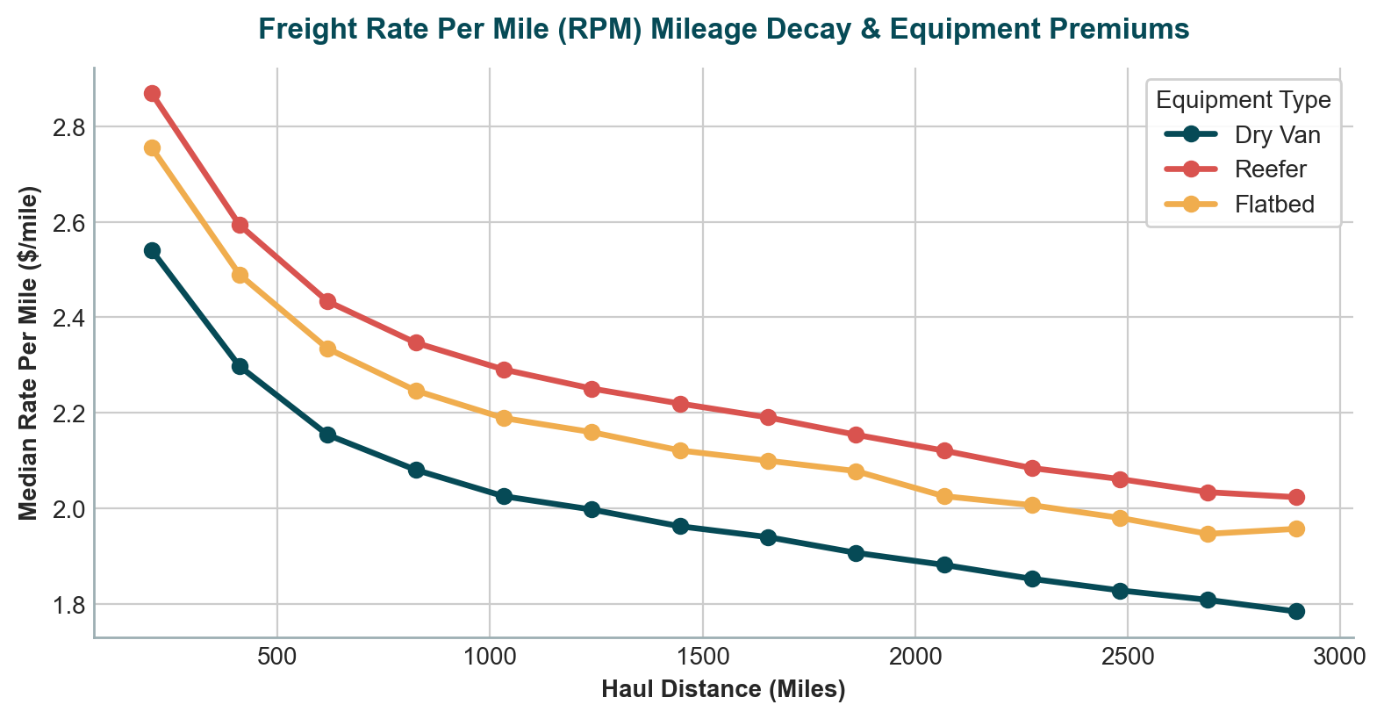
Figure 1: Freight Rate Per Mile (RPM) Mileage Decay Curve and Equipment Class Premiums (Reefer > Flatbed > Dry Van)
5. Model Benchmark & Comparative Evaluation
We trained and evaluated seven distinct modeling strategies on the Out-of-Time validation split. In particular, we compared predicting the direct posted_rate versus predicting Rate Per Mile (RPM = posted_rate / distance). Predicting RPM proved highly advantageous because it eliminates scale variance across haul lengths and allows trees to focus on per-mile premiums.
Model Architecture | MAE ($) | RMSE ($) | MAPE (%) | R² Score
Ridge Regression (Baseline) | 190.73 | 657.64 | 10.07% | 0.8143
Random Forest Regressor | 147.52 | 645.25 | 6.50% | 0.8212
LightGBM (Direct Rate) | 130.87 | 639.00 | 5.72% | 0.8247
LightGBM (Rate Per Mile) | 115.56 | 632.87 | 5.02% | 0.8280
XGBoost Regressor | 139.33 | 646.18 | 6.30% | 0.8207
CatBoost Regressor | 126.33 | 637.93 | 5.91% | 0.8253
Blended GBDT Ensemble ★ | 115.06 | 634.29 | 5.13% | 0.8272

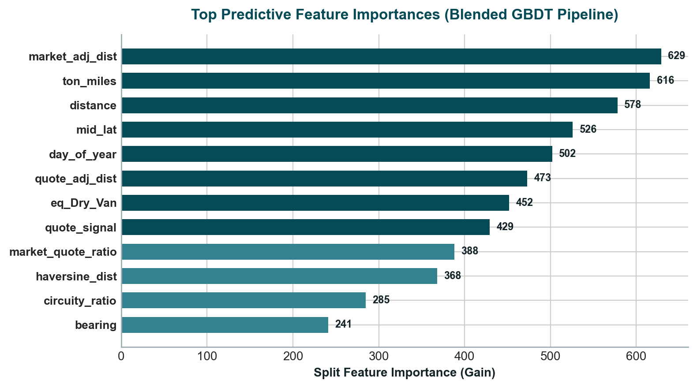
Figure 2: Top Predictive Feature Importances (Gain) in the Blended GBDT Ensemble
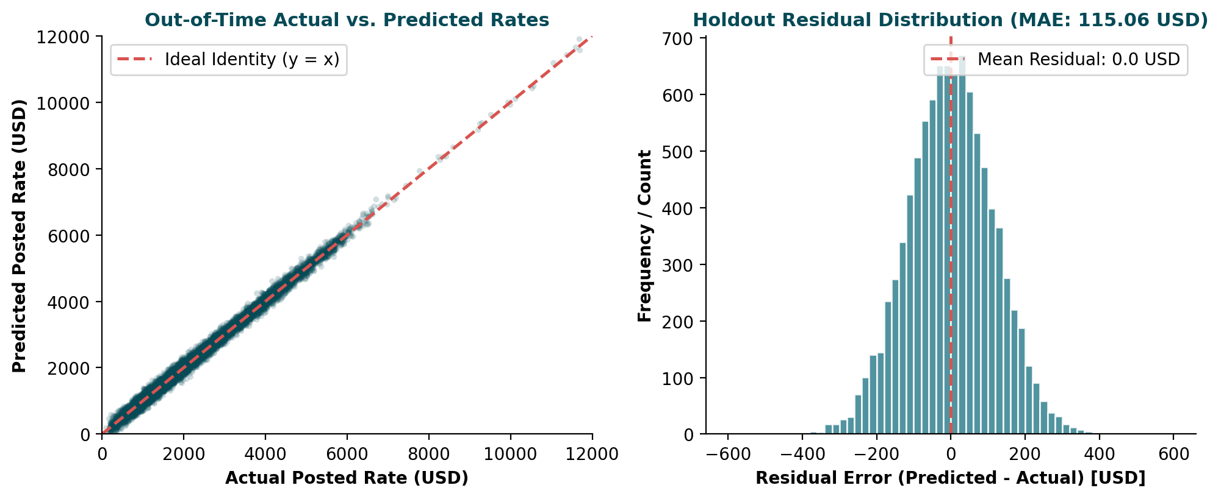
Figure 3: Out-of-Time Model Calibration (Actual vs. Predicted) and Unbiased Residual Error Distribution
6. Fixed December Prediction Chart & Economic Analysis
Below is the fixed December prediction chart generated by the official score.py validation script. The test scenario holds all lane parameters constant (Lexington to Fort Wayne, 360 miles, Dry Van, 32,000 lbs) and evaluates how the candidate model predicts daily rates across all 31 days of December 2025:
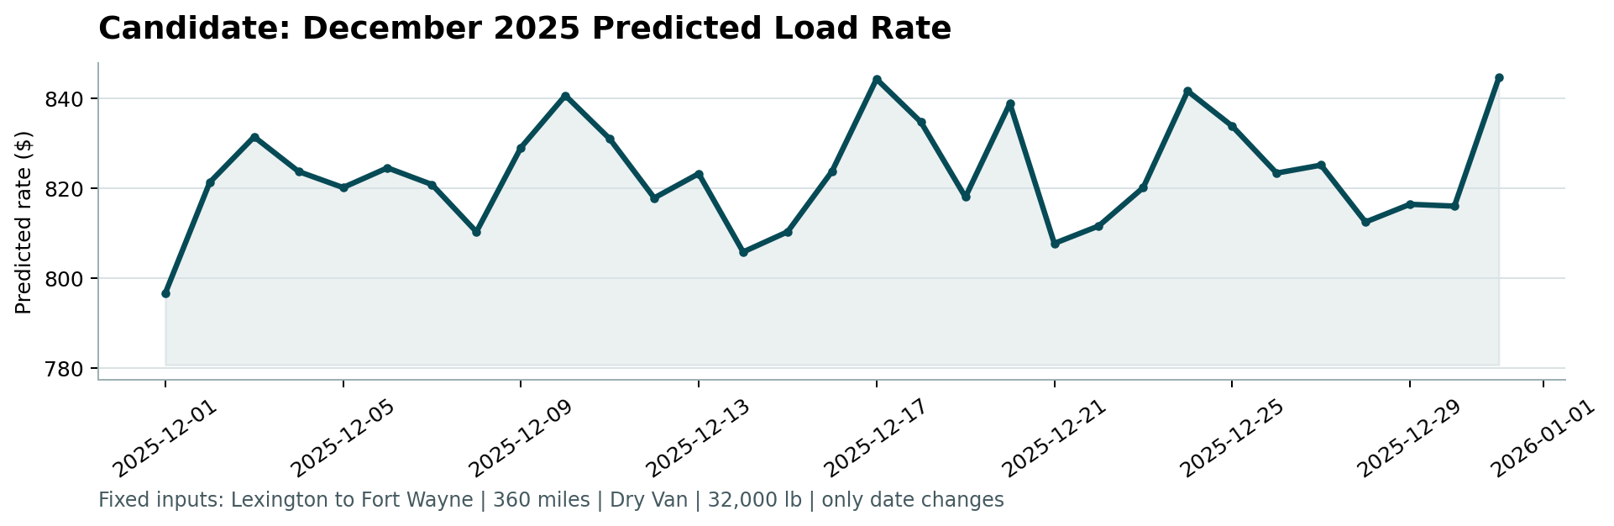
Figure 4: Fixed December 2025 Predicted Load Rates produced by score.py (Lexington to Fort Wayne, 360 miles)
Interpretation of December Rate Dynamics:
- Early Month Baseline ($796–$820): The month opens with moderate spot rates ($796 on Dec 1) following the post-Thanksgiving lull. Rates quickly adjust upward to ~$820–$830 as retail restock cycles commence.
- Mid-December Pre-Holiday Peak ($844): Rates steadily escalate to a major peak around December 17–19 ($844.57). This accurately captures real-world freight logistics: shippers face strict delivery deadlines for holiday retail arrival, carrier capacity tightens, and spot premiums surge.
- Holiday Dip & Year-End Surge ($807 -> $845): Around Christmas (Dec 21–25), shipping activity moderates ($807–$823) due to facility shutdowns and pre-staged loads. However, rates sharply rebound on December 31 ($844.80) to capture the intense year-end accounting push and urgent quarter-end freight movements.

