**Name : احمد مصطفي عباس مصطفي الفوال**

**B.N:139**

**Topic:** **operating system**

**Github link :** [https://github.com/ahmed-elfawal/Ece006](https://l.facebook.com/l.php?u=https%3A%2F%2Fgithub.com%2Fahmed-elfawal%2FEce006%3Ffbclid%3DIwAR1uDAmyW_PWkkQRp0-N0Rk5g8LtAFnADccSpM-_LBDjXZBQYOtzPaGZLgk&h=AT1aHzNMcRKLGJvXVegxLu81QsjRdA40PFdYVf8vuKJwH_kSbUzzKAwiete6GCBv630gNR8OQuXJqj_2XdFoitWCrHNbpriczhPHHPEvBbwLYBwTFcB6IvrB0X5i-BGODJMi)

**Github page :** <https://ahmed-elfawal.github.io/Ece006/?fbclid=IwAR1cbEk8oSFHY1-FH2kEC5Armvaf6Ni1YKPY0x1Ru6drJ8dTdYpaZCmekUk>

**Application brief:**

An operating system is the essential program that oversees all the equipment and other program on a computer. The working framework, too known as an “OS,” interfacing with the computer’s equipment and gives administrations that applications can utilize.

An operating system is the center set of computer program on a gadget that keeps everything together. Working frameworks communicate with the device’s equipment. They handle everything from your console and mice to the Wi-Fi radio, capacity gadgets, and show. In other words, an working framework handles input and yield gadgets. Working frameworks utilize gadget drivers composed by equipment makers to communicate with their gadgets.

**Screeshots :**

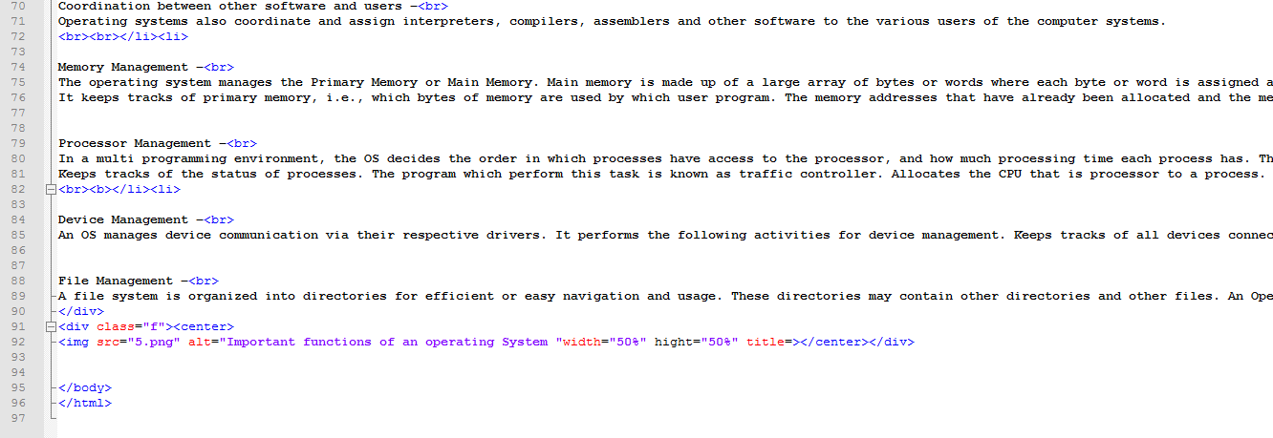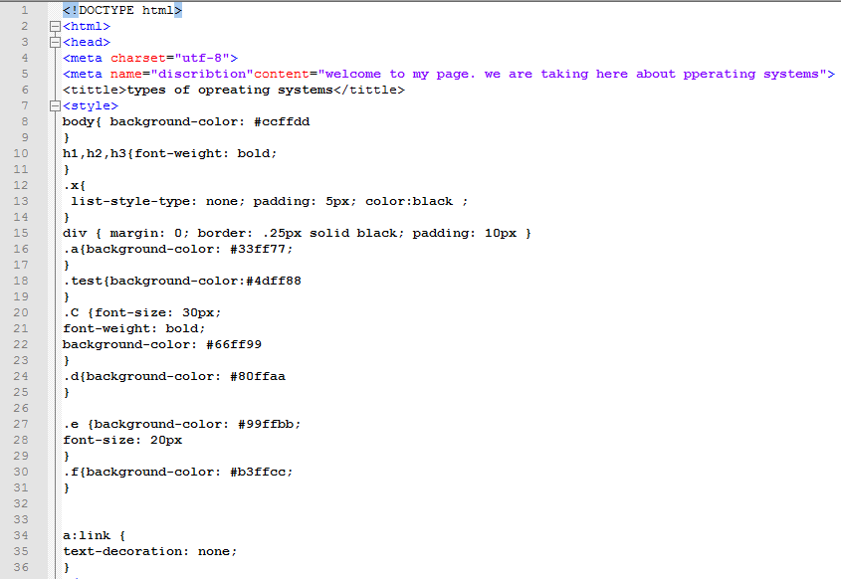

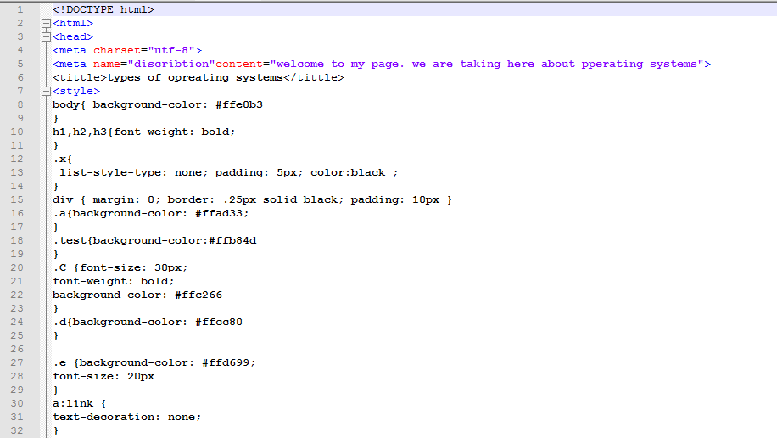

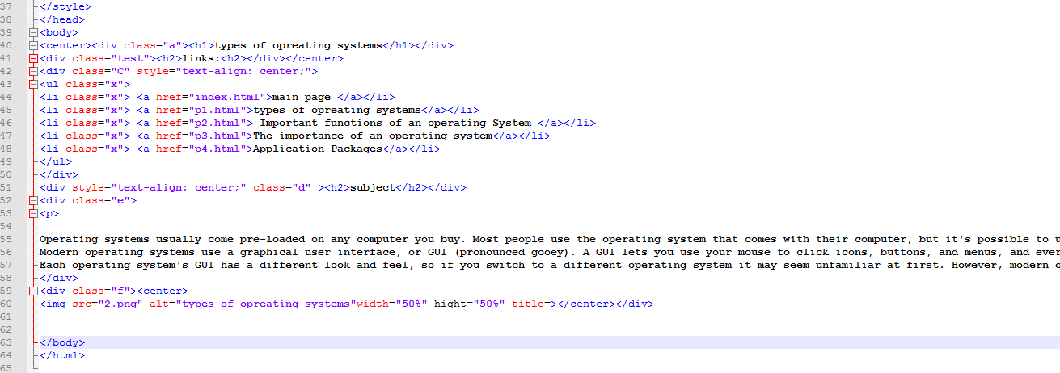

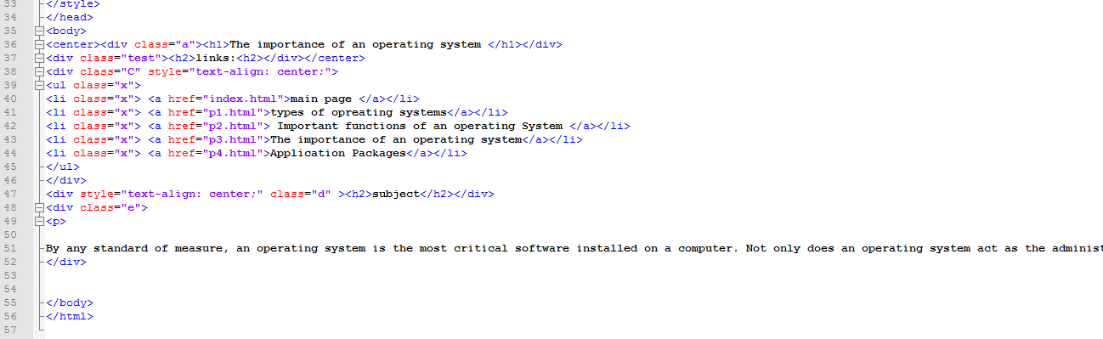

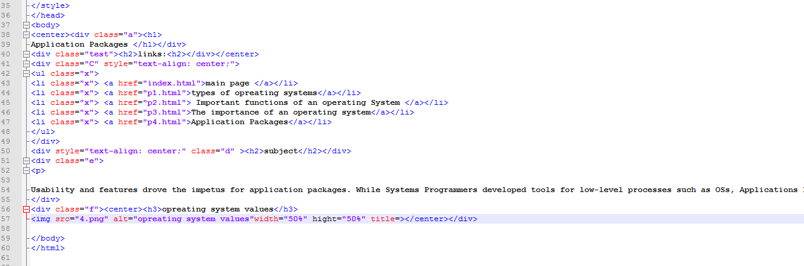

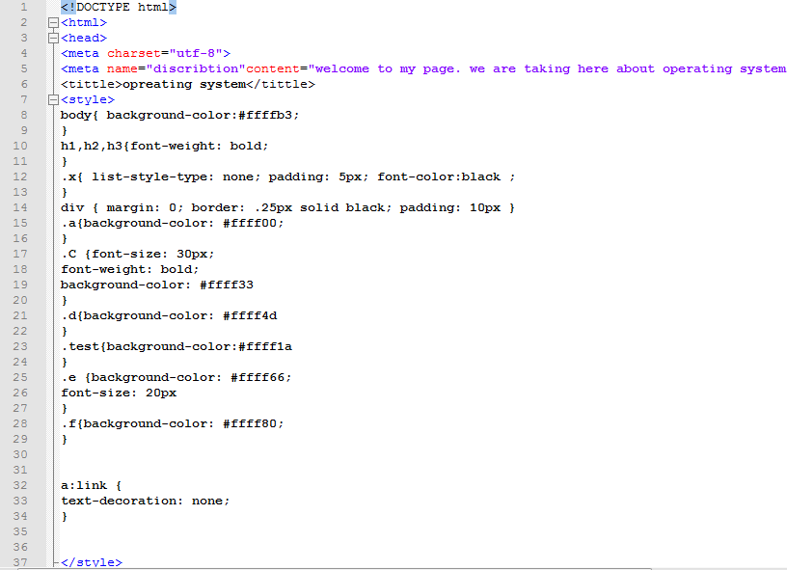

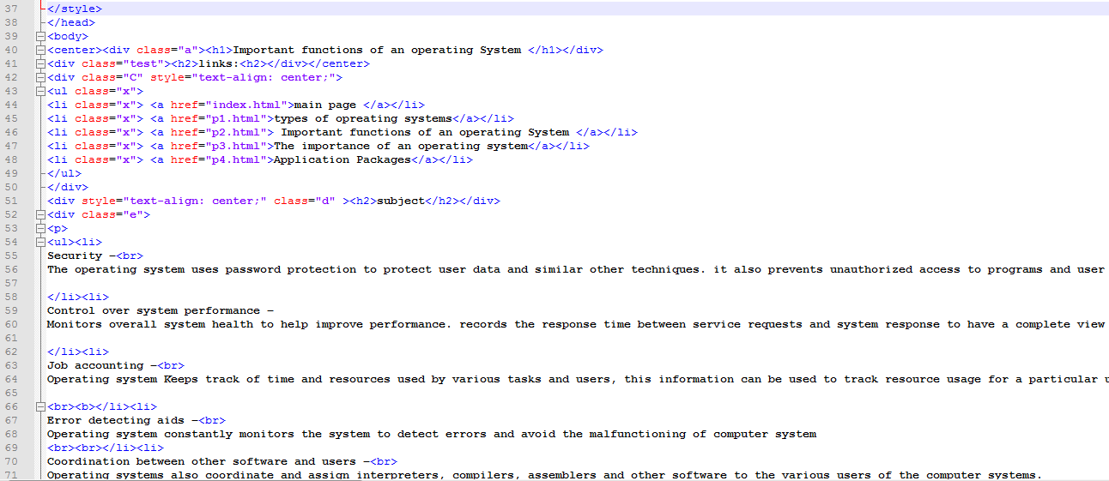

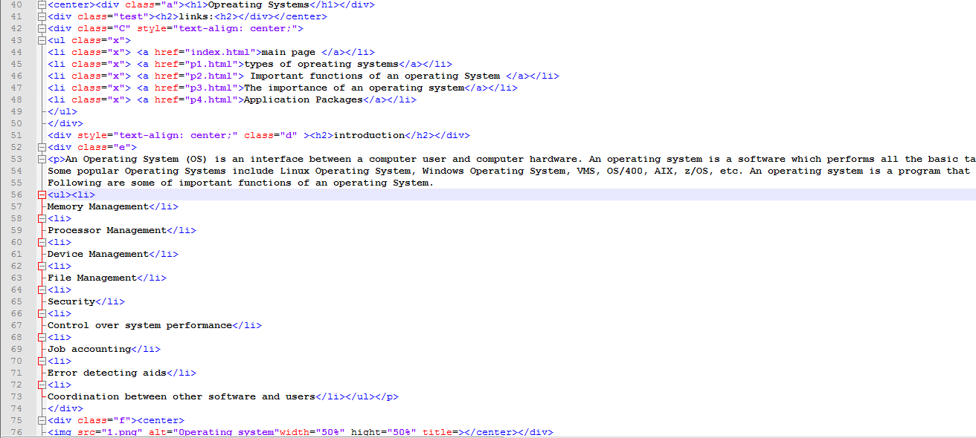

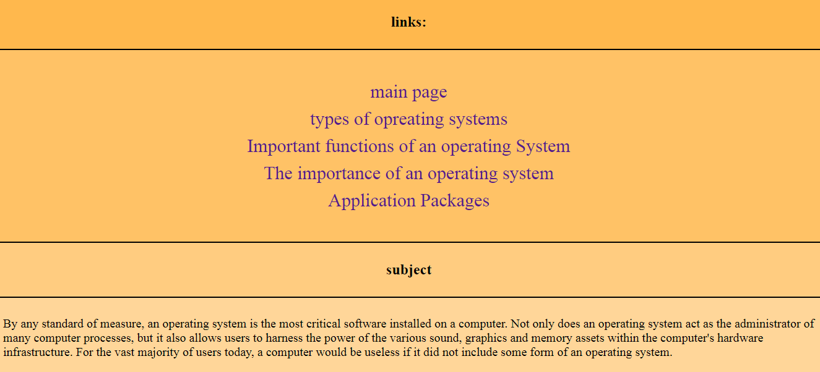

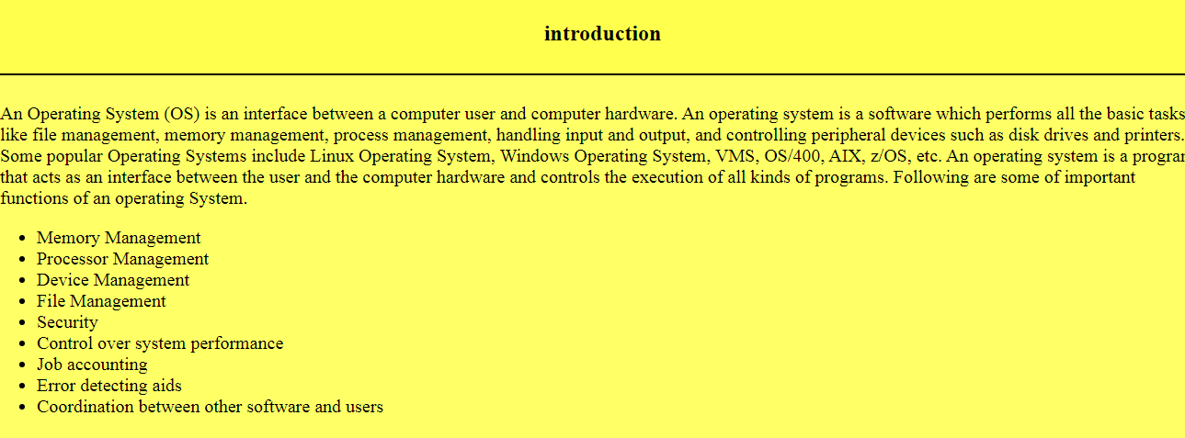

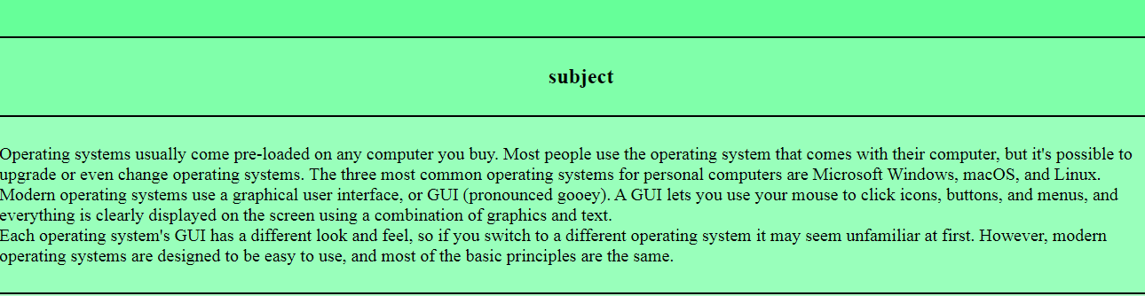

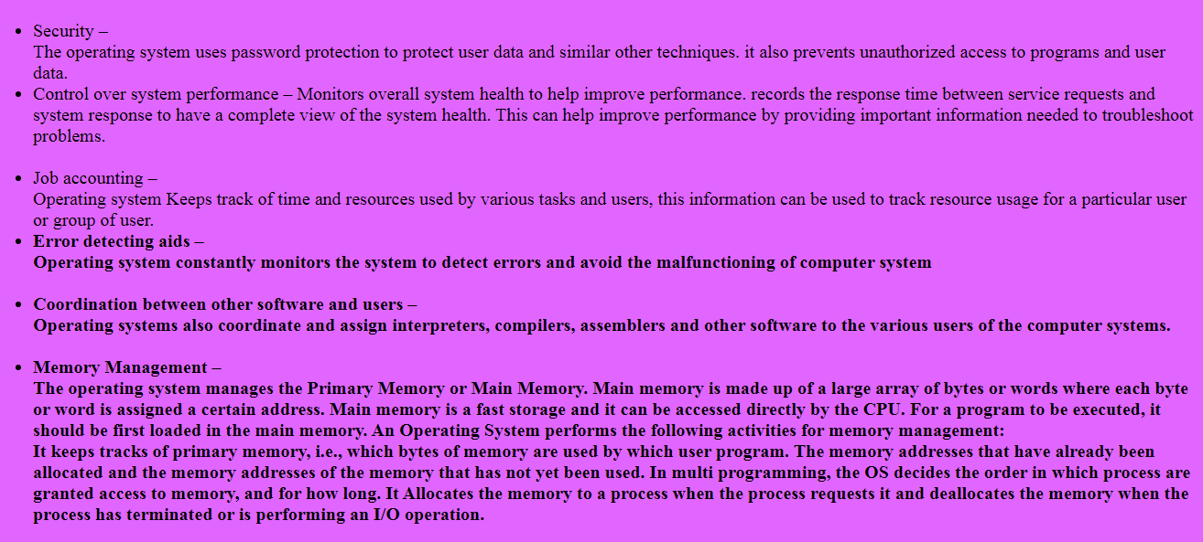

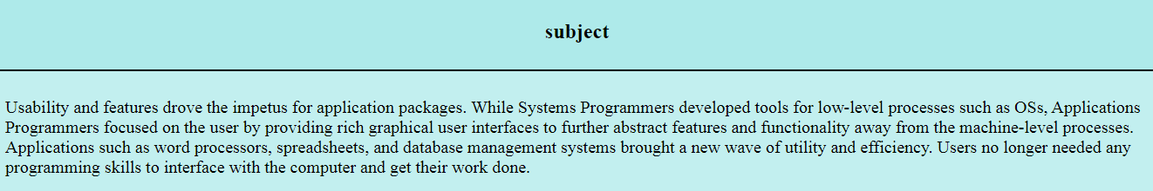

Sources

1-<https://www.howtogeek.com/361572/what-is-an-operating-system/>

2-<https://www.quora.com/What-are-the-pros-and-cons-of-different-operating-systems-Ive-used-Windows-but-how-does-it-compare-to-Linux-and-Apple>

3- <https://greengarageblog.org/15-pros-and-cons-of-linux>

4- <https://wi-phye.com/blog/the-pros-and-cons-of-linux-windows-and-osx/>