Assignment 2.2

Specification:

* 5-bit counter
* Count Value loaded from "IN" port on a positive clock edge when "Load" signal is high, Load has highest priority
* Count value incremented by 1 on a positive clock edge when "Up" signal is high.
* Count value decremented by 1 on a positive clock edge when "Down" signal is high, Down has higher priority than "Up" signal
* Increment stops at 31
* Decrement stops at 0
* "High" flag active high whenever count value is 31
* "Low" flag active high whenever count value is 0

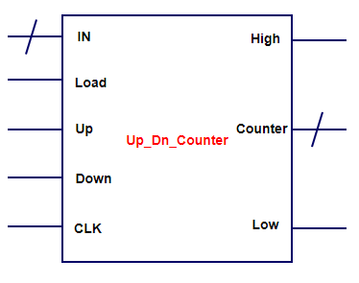

Write a Verilog code equivalent to the above specifications as well as the synthesis diagram of your code

Write a simple Verilog testbench to test your design code.