Weekly Research Progress Report: Bimanual DOM Pipeline
Project: Autonomous Bimanual Soft-Body Slicing (DOM — Dual Robot Arms)
Authors: Ahmed & Shahd
Affiliation: DEX-ROB Lab, School of Electrical & Automation Engineering, Tianjin University
Advisor: Prof. Shan An (安山)
Date: September 20, 2026

1. Executive Summary
This week, we focused on establishing the complete software-to-hardware architecture for our autonomous bimanual deformable object manipulation (DOM) project, verifying baseline simulation in NVIDIA Isaac Sim and Isaac Lab, and benchmarking hardware performance under deformable physics loads.
We completed the system pipeline design spanning 3D volumetric meshing, PhysX FEM deformable physics, dual-arm kinematic coordination via MoveIt 2, and policy learning via Soft Actor-Critic (SAC). We also conducted a comparative evaluation between Isaac Lab and MuJoCo, validating Isaac Lab as our primary engine for GPU-accelerated RL.

2. Bimanual DOM System Architecture
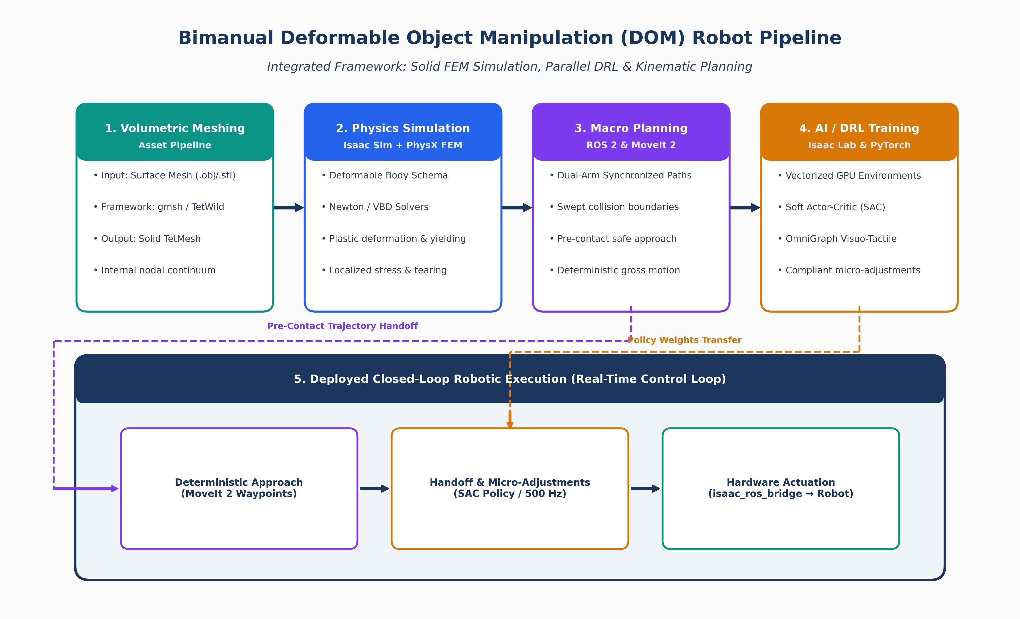
Figure 1: End-to-End System Pipeline Architecture — Bridging Volumetric Meshing, PhysX FEM Simulation, MoveIt 2 Kinematics, Isaac Lab Parallel RL, and Closed-Loop Deployment.
To coordinate the stabilizing manipulator and the cutting end-effector while accounting for soft-body yielding and tearing, we designed an end-to-end 5-stage architecture:
Core Software Stack
Component Layer | Responsibility | Framework / Toolchain | Implementation Role
Volumetric Meshing | Solid TetMesh generation | gmsh / TetWild | Converts hollow surface models into solid tetrahedral meshes.
Physics Simulation | Tearing & deformation | Isaac Sim & PhysX FEM | Simulates nonlinear soft-body elasticity and tearing via Newton/VBD solvers.
Macro Planning | Dual-arm gross motion | ROS 2 (Jazzy) & MoveIt 2 | Generates deterministic, collision-free pre-contact trajectories.
AI / DRL Policy | Parallel simulation training | Isaac Lab & PyTorch | Runs parallel GPU environments to train compliant manipulation policies.
RL Algorithm | Micro-force adjustments | Soft Actor-Critic (SAC) | Optimizes continuous joint adjustments for stable, non-crushing slicing.
Sensory Feedback | Visuo-tactile state feed | OmniGraph (Omniverse) | Extracts real-time normal/shear contact forces and camera streams.
Hardware Bridge | Real-time command dispatch | isaac_ros_bridge / ros2_control | Transmits joint target commands from policy to the physical robot.

Simulator Platform Evaluation: Isaac Lab vs. MuJoCo
To ground our simulation choice in our project requirements, we evaluated Isaac Lab (Unified GPU) against MuJoCo / MuJoCo + Isaac Sim (Hybrid) across our two research phases:
Dimension | 🟩 Isaac Lab (Selected for Phase 1 RL) | 🔵 MuJoCo / MuJoCo + Isaac Sim (Hybrid) | Project Rationale & Context
Architecture | Unified single-process GPU pipeline (PhysX 5/FEM + PyTorch tensors). | Dual-process hybrid (MuJoCo CPU physics synced to Isaac Sim GPU render). | Isaac Lab eliminates CPU-GPU PCIe transfers and IPC bottlenecks during policy rollouts.
RL Training Throughput | Very High (1,000–4,096 parallel GPU envs; 10×–100× faster rollouts). | Moderate to Low (CPU thread bound; IPC synchronization overhead). | Critical for sample-intensive continuous SAC training on dual arms.
Deformable & Tearing Physics | Native PhysX FEM (TetMesh tetrahedralization & mesh cutting). | Approximate / Rigid-body (no native volumetric FEM tearing). | Essential for modeling knife penetration and soft tissue yielding.
Contact Dynamics | Penalty-based contact approximation (PhysX 5). | Gold Standard (analytical complementarity contact solver). | MuJoCo offers higher fidelity for rigid contacts, but lacks FEM tearing.
IL & VLA Compatibility | Growing (OmniHLS, GROOT, Isaac Lab Mimic). | Dominant Standard (native ALOHA, ACT, Diffusion Policy ecosystem). | MuJoCo remains our reference platform for future Phase 2 imitation learning.
Sim-to-Real Transfer | Built-in GPU domain randomization (friction, mass, visual). | Requires manual randomization bridges across both engines. | Streamlines direct zero-copy policy deployment to physical arms.

Strategic Verdict for Our Research:
- (Current — Autonomous Compliant Slicing via DRL): Isaac Lab is selected as the primary platform. End-to-end GPU vectorization is mandatory for sample-efficient SAC convergence, and PhysX FEM natively supports volumetric soft-body tearing under knife contact.

3. Progress Completed This Week
1. Pipeline Architecture & Toolchain Design:
- Finalized the software-to-hardware system architecture connecting 3D volumetric meshing, GPU-accelerated simulation, deterministic planning, and reinforcement learning.
- Selected and integrated the core toolchain: gmsh/TetWild for tetrahedralization, Isaac Sim (PhysX FEM) for soft-body simulation, and ROS 2 Jazzy for robot middleware.
- Completed a comparative architectural evaluation between Isaac Lab and MuJoCo, establishing Isaac Lab as the primary Phase 1 RL engine.
2. Asset Pipeline & Deformable Tearing Workflow:
- Established the workflow for importing solid volumetric meshes (TetMesh) into Isaac Sim using native Deformable Body schemas.
- Configured PhysX FEM tearing mechanics (Newton and Vertex Block Descent solvers) to simulate realistic knife penetration and topological separation without numerical instability.
3. Hierarchical Control Strategy:
- Structured the control pipeline into two coordinated stages:
- Macro Kinematics (MoveIt 2): Handles collision-free, synchronized pre-contact positioning to bring both arms to within 5–10 mm of the target object.
- Micro Dynamic Manipulation (Isaac Lab SAC): Takes over authority upon contact to dynamically regulate knife pressure, slicing velocity, and stabilizing grip forces to prevent slipping or crushing.
4. Visuo-Tactile Sensing & Bridge Verification:
- Designed synthetic sensor extraction via OmniGraph to publish contact normal forces, shear vectors, and RGB-D camera feeds.
- Configured isaac_ros_bridge for zero-copy command dispatch to low-level ros2_control joint controllers.
5. Local Software Environment Deployment:
- Verified Isaac Sim, Isaac Lab, PyTorch, and ROS 2 Jazzy on our development workstation with full GPU acceleration.

4. Hardware Benchmarking & RAM Upgrade Request
During initial benchmarking with deformable body physics and parallel environments, we identified a critical memory bottleneck:
Current Workstation Specifications
- CPU: Intel Core i7-14650HX (16 Cores / 24 Threads)
- GPU: NVIDIA GeForce RTX 5060 Laptop GPU (8 GB VRAM)
- RAM: 16.0 GB DDR5
Operational Bottleneck & Saturation
- When running Isaac Sim along with PyTorch, deformable FEM buffers, and system background processes, system RAM immediately reaches 95%–98% saturation (~15.2 GB / 15.6 GB).
- Consequence: The operating system engages aggressive disk swapping (SSD paging), causing extreme simulation frame drops and triggering Linux kernel Out-Of-Memory (oom-killer) crashes. This currently restricts parallel simulation to single-digit environments.
- While the CPU and 8 GB VRAM GPU perform well, the 16 GB system RAM is the main limiting constraint.

Memory Tier Comparison
Memory Tier | System Allocation | Saturation Level | Expected Concurrency | Operational Stability
16 GB (Current) | ~15.2 GB / 15.6 GB | 98% (Critical) | < 16 Envs | Severe swap thrashing, kernel OOM crashes
32 GB (Proposed) | ~15.5 GB / 31.2 GB | 48% (Stable) | 256 – 512 Envs | Zero paging, unblocked vectorized policy training
64 GB (Ideal) | ~16.0 GB / 62.5 GB | 25% (Optimal) | 1024+ Envs | Full GPU batch capacity, future-proof for VLA

Upgrade Request
- We request an upgrade of the workstation memory to 32 GB DDR5 (minimum requirement) or 64 GB DDR5 (recommended).
- This will completely eliminate disk swapping and allow us to scale parallel simulation environments for reliable policy convergence.

