

**Faculty of engineering - Shoubra**

**Benha University**

**Research Article / Research Project / Literature Review**

in fulfillment of the requirements of

|  |  |
| --- | --- |
| **Department** | Engineering mathematics and physics |
| **Division** |  |
| **Academic Year** | 2019-2020 preparatory |
| **Course name** | Computer |
| **Course code** | ECE001 |

**Title: -**

**Build a website on recent computer engineering topics**

By:

|  |  |  |  |
| --- | --- | --- | --- |
|  | Name | Edu mail | B.N |
| 1 | احمد فراج رمضان سيد | Ahmed195107@feng.bu.edu.eg | 104 |

**Approved by:**

|  |  |
| --- | --- |
| Examiners committee | Signature |
| Dr. Ahmed Bayumi |  |
| Dr. Shady Elmashad |  |
| Dr. Abdelhamid Attaby |  |

**Big data(application brief)**

With the Internet of Things gradually entering our daily lives, everything we make will be transformed into a data set. By linking it with similar data we will be able to use energy more efficiently, develop personalized drugs for our diseases, and improve our ability to communicate. But at the same time it will reduce privacy and its predictions will increase society's direction. No interest, no cost.

Recently we hear a lot about the term big data and the rapid spread of this field in the labor market. But have we ever wondered what Big Data is? To agree in principle, there is more than one definition of the term big data, and as the International Telecommunication Union (ITU) has made clear, there is no precise definition of big data. In general, when we talk about big data, we are talking about data of multiple types, sources and sizes.

What is the importance of big data in our world today and the world of the future?

Big data offers a competitive advantage for organizations if they make good use of them and analyze them because they provide a deeper understanding of their customers and their requirements and this helps in

making decisions within the organization in a more effective way based on the information extracted from customer databases and thus increase efficiency and profit and reduce losses so by using big data analysis tools Walmart was able to improve The results of the search for its products via the Internet increased by 10-15%, while in a report by Mackenzie - a pioneer in the field of business consulting - that the health sector in the United States had been using the techniques of analyzing big data effectively and efficiently, he would have produced more than $ 300 million in annual surplus from The health budget is two-thirds due to a decrease in spending costs by 8% 4. According to a previous opinion poll conducted by the Gartner Foundation, 64% of companies and organizations invested in adopting the use of new technologies to deal with big data in 2013.

Benefiting from big data does not depend on institutions and commercial projects. Rather, it extends to many areas, including energy, education, health, and huge scientific projects, most notably the human genome project (a study of the entire genetic material for humans), which contains 25 thousand genes that in turn contain 3 billion pairs of chemical constituents For DNA.

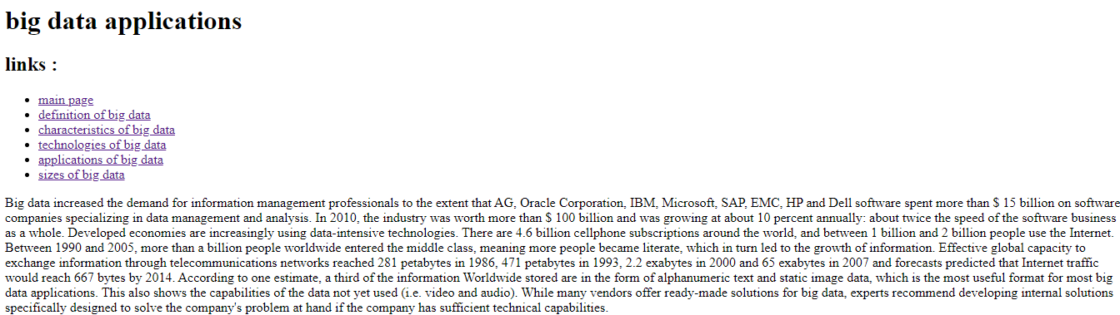**Screenshots**

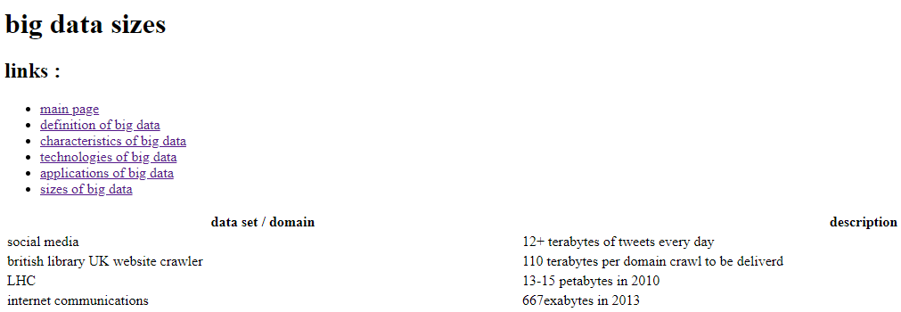

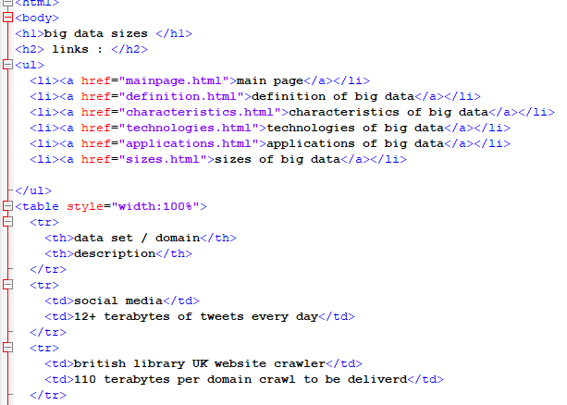**Source code**



**References**

1-Statistical and Machine-Learning Data Mining (Bruce Ratner , CRC Press , 2011)

2-Big Data Analytics (Arvind Sathi , Mc Press , 2012)

3- Data Warehousing in the Age of Big Data(Krish Krishnan , Morgan Kaufmann , 2013)