**Social Media Report**

**1. Executive Summary**

**Key Findings**:

* Total Engagements over this year is 4467589.
* Instagram has the highest engagement.
* Images have the highest engagement of all.
* Quarter 1 was the most effective of all.

**Recommendations**:

* Consider focusing on quarter 4.

**2. Introduction**

The goal of this analysis is to find answers to questions to analyze the company’s social media engagement this year.

**3. Methodology**

* **Data collection**: database of the company.
* **Data analysis**: Descriptive statistics were used to summarize the data.

**4. Results**

Q. What was the total number of likes, shares, comments, and views (for videos) over the year?

A.

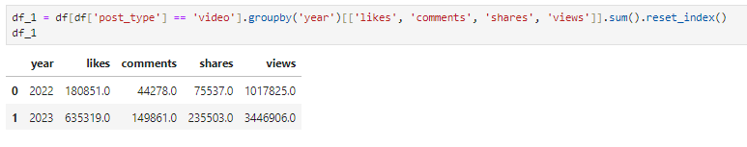

Q. Which platform had the highest engagement? (engagement = likes + shares + comments)

A. Instagram at 1405244.

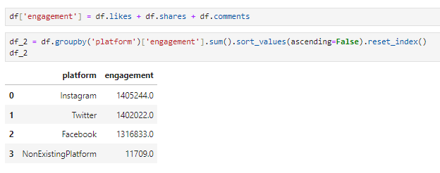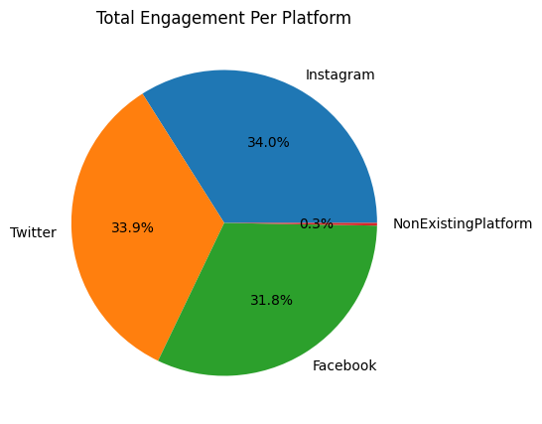

Q. What was the average number of likes, shares, comments, and views per post on each platform?

A.

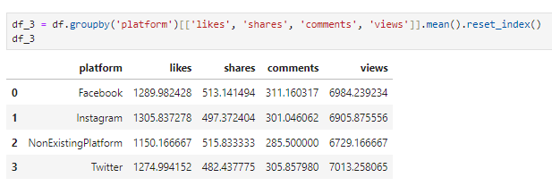

Q. What was the total number of each type of post (video, image, text) on each platform?

A.

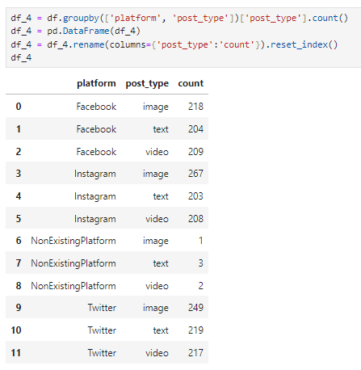

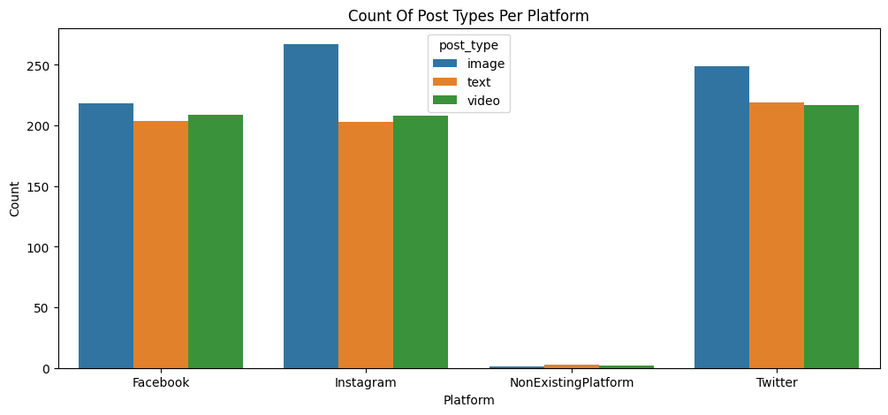

Q. Which type of post had the highest average engagement?

A. Images at 1510201.

Q. What was the total engagement in each quarter of the year?

A. Quarter 1 was the highest at 1025381.

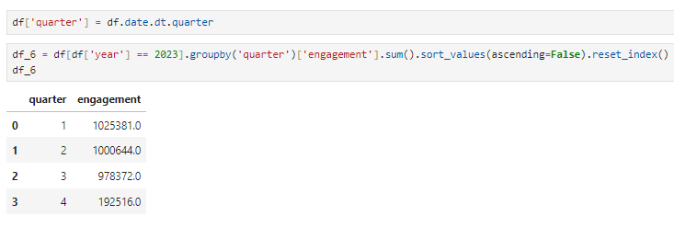

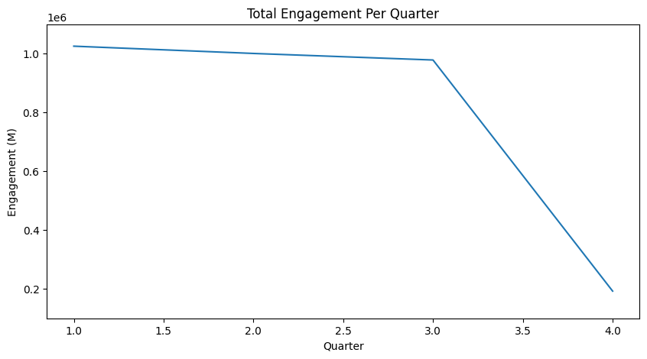

**5. Conclusions**

Based on the analysis, it is recommended that the company focus on quarter 4 because it is so less than others also increasing short videos is the trend right now so that we can increase the engagement.