**Sales Report**

**1. Executive Summary**

**Key Findings**:

* Smartphones had the highest revenue.
* Laptops had the highest average price at 1200$.
* Total quantity sold this year was 5270.
* Electronics had the highest revenue at 509480$.
* Quarter 3 was the most effective of all.

**Recommendations**:

* Invest in Bags and shoes categories.
* Consider offering sales at quarters 1 and 2.

**2. Introduction**

The goal of this analysis is to find answers of questions for the manager of sales to analyze the company’s sales this year.

**3. Methodology**

* **Data collection**: database of the company.
* **Data analysis**: Descriptive statistics were used to summarize the data.

**4. Results**

Q. What was the total revenue generated by the company over the course of the year?

A. Total revenue was 747230

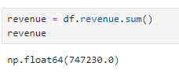

Q. Which product had the highest revenue? How much revenue did it generate?

A. Smartphone at 427800.

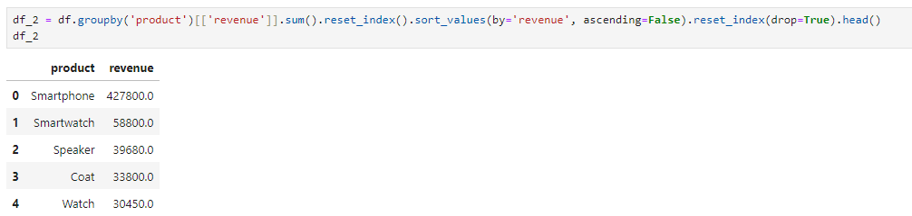

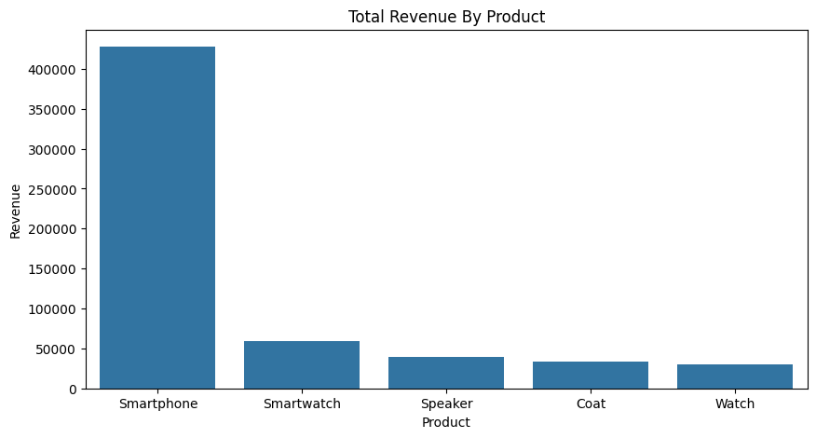

Q. What was the average price of a product sold by the company?

A. Laptop was the highest at 1200$.

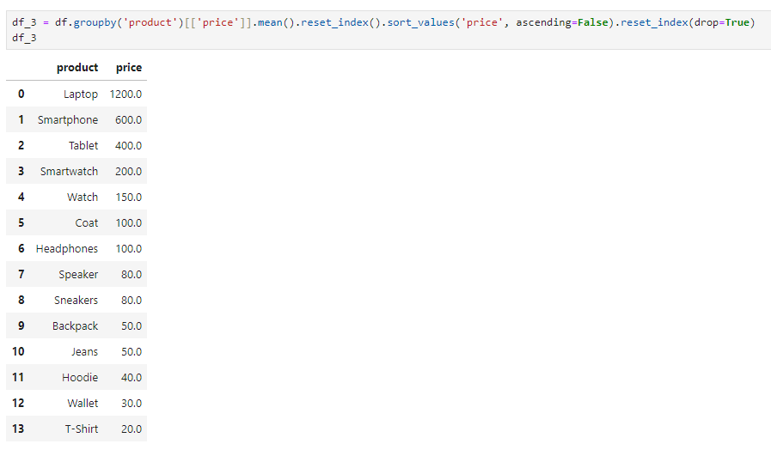

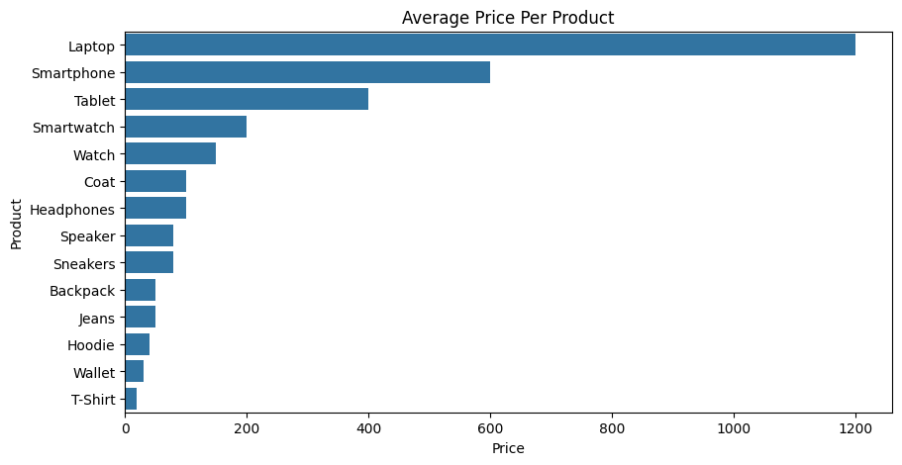

Q. What was the total quantity of products sold by the company?

A. It was 5270.

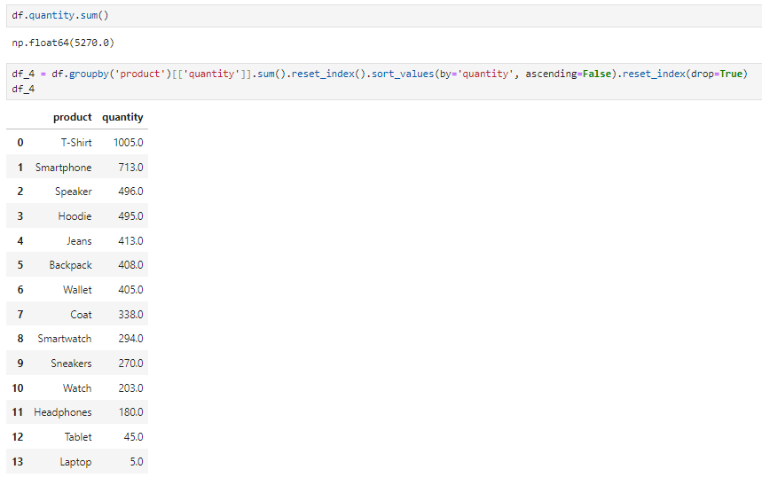

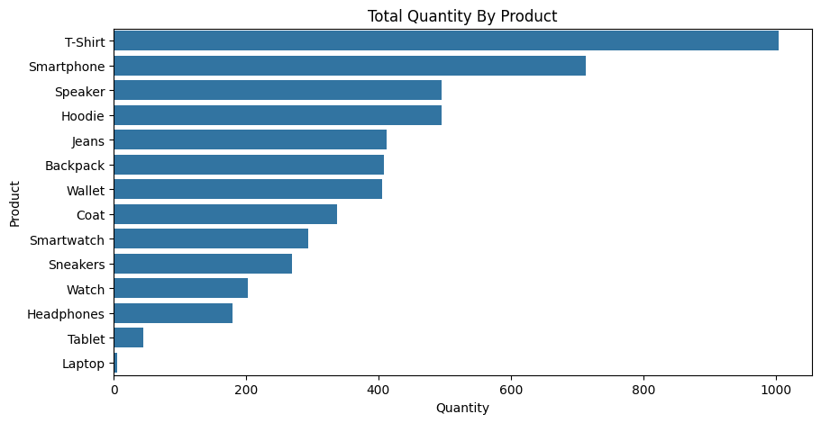

Q. Which category had the highest revenue? How much revenue did it generate?

A. Electronics at 509480$.

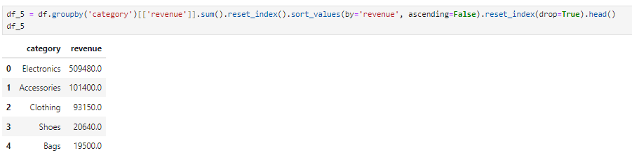

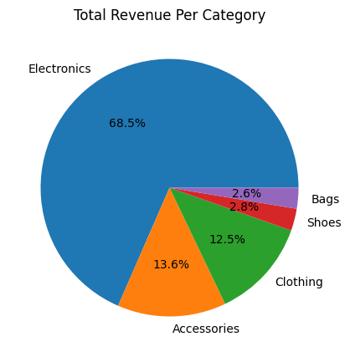

Q. What was the average revenue per sale?

A. The average revenue was 2052$ per sale.

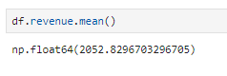

Q. What was the total revenue generated in each quarter of the year?

A. Quarter 3 was the highest at 195430$.

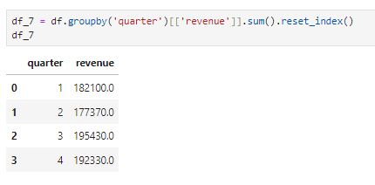

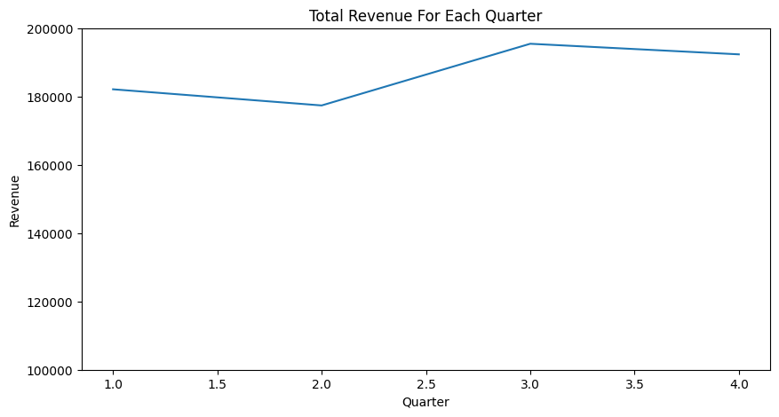

**5. Conclusions**

Based on the analysis, it is recommended that the company focus on improving categories like bags and shoes also trying to invest in ads at the first 6 months of the year, Electronics is doing well because smartphone takes more than half of the revenue, so the company should focus on other products in this category.