SE/WE Course Project
Main Document
for
Mobile/Computer Selling Center System

Submitted to
Dr. Abdelkareem Alashqar
Submitted in Partial Fulfillment of the Requirements for
Software Engineering Course – CSCI 2313
Web and Multimedia Engineering Course – WDMM 3314
By
أحمد خالد عبد الحي أبو شملة - 120209349
https://github.com/ahmed-k-a/MobileComputerSellingCenter

December 2025

Abstract
This document presents the planning, analysis, design, implementation, and testing of a Mobile/Computer Selling Center System developed for the SE/WE Course Project. The purpose of the system is to support essential business operations such as user authentication, product management, and sales processing in a structured and efficient manner.
The intended audience of this report includes software engineering students, system designers, and developers who are interested in understanding the application of software engineering concepts in a real-world system. The project deliverables include system requirements, UML-based analysis and design models, implementation of selected use cases without using software frameworks, and comprehensive system testing. The results demonstrate that the developed system meets its functional requirements and follows standard software engineering practices.
Table of Contents
1. Chapter 1. Project Plan
1.1 Project Overview
1.2 Problem Statement
1.3 Project Objectives
1.4 Software Process Model
1.5 Team Organization
1.6 Risk Analysis
1.7 Hardware and Software Resource Requirements
1.8 Project Schedule
2. Chapter 2. System Requirements
2.1 System Overall Description
2.2 Main Use Case Diagram
2.3 System Specific Requirements
2.4 List of Classes
2.5 Non-Functional Requirements
3. Chapter 3. System Design
3.1 Application Architecture using Package Diagram
3.2 Modules (Packages) Descriptions
4. Chapter 4. System Implementation and Testing
4.1 Coding and Coding Standards
4.2 System Testing
5. References
Chapter 1. Project Plan
1.1 Project Overview
The Mobile/Computer Selling Center System is designed to support electronics shops in managing their daily operations more efficiently. The system handles product registration, inventory tracking, sales processing, customer information management, and report generation. It focuses on reducing manual work, preventing data entry mistakes, and improving customer service. Presents the plan for developing the system, including the problem statement, project objectives, chosen software process model, team structure, risk analysis, required resources, and the initial project schedule.
1.2 Problem Statement
Electronics shops often rely on manual or semi-manual methods to handle products, sales, and customer information. These traditional approaches create several issues, such as inaccurate inventory tracking, slow billing processes, missing customer warranty records, and difficulties in retrieving product information quickly. Employees may also struggle to generate timely sales and stock reports, which affects decision-making and customer service quality. The current operational workflow is inefficient, error-prone, and unable to support the growing number of products and transactions. Therefore, a computerized solution is required to streamline operations and ensure reliable, up-to-date information.
1.3 Project Objectives
The main objective of this project is to build a software system that supports the complete daily operations of a Mobile/Computer Selling Center. The system aims to:
- Maintain accurate product and inventory records.
- Process sales quickly and generate invoices automatically.
- Store customer information for warranty and service purposes.
- Provide fast search and filtering tools to locate products.
- Generate reports that summarize sales, stock levels, and profits.
- Reduce human error and improve the overall efficiency of store operations.
- Support better decision-making through reliable and timely information.
1.4 Software Process Model
This project will follow the Incremental Process Model. The system will be developed and delivered in small, manageable increments. Each increment will introduce new features such as product management, sales processing, customer management, and reporting.
Reason for Choosing the Incremental Model
- Requirements are clear but may need refinement as development progresses.
- The client can test and review each increment before moving to the next.
- It supports early delivery of core functionalities.
- It reduces the impact of changes and lowers rework costs.
- It improves risk management by dividing the system into smaller deliverables.
1.5 Team Organization
# | Name of Team Member | Main Responsibilities
1 | أحمد خالد عبد الحي أبو شملة - 120209349 | Requirements analysis, system design, documentation, implementation, and testing
2
3
..

1.6 Risk Analysis
# | Risk Description | Probability | Impact | Rank | Risk Plan
1 | Misunderstanding system requirements | Mid | High | High | Conduct frequent reviews and clarify requirements early.
2 | Technical difficulties with database or tools | Low | High | High | Prepare alternative tools and review tutorials before implementation.
3 | Data loss during implementation | Low | High | High | Maintain regular backups and use version control.
4 | Delay in completing design or documentation | Mid | Mid | Mid | Create a detailed weekly plan and follow strict milestones.
5 | Over-complexity in system functions | Mid | Mid | Mid | Keep scope focused on essential features and avoid unnecessary additions.
…

1.7 Hardware and Software Resource Requirements
Hardware Requirements
- Personal laptop or desktop computer
- Minimum: 8 GB RAM, 256 GB storage
- Optional: External storage for backups
Software Requirements
- Programming environment (e.g., Java, C#, Python, or any selected language)
- Database system (MySQL / SQLite / SQL Server)
- CASE tools for diagrams (draw.io, Lucidchart, or StarUML)
- Word processing software (MS Word or equivalent)
- PDF converter
- Optional: MS Project or online Gantt chart tools
1.8 Project Schedule
1.8.1 Work Breakdown Structure
# | Task Name | Expected Time | Preceding Task (s)
1 | Requirements Collection | 1 week | –
2 | System Analysis | 1 week | 1
3 | System Design | 2 weeks | 2
4 | Implementation | 4 weeks | 3
5 | Testing & Validation | 1 week | 4
6 | Documentation & Final Review | 1 week | 5
…

1.8.2 Gantt Chart
1.8.3 Network Diagram
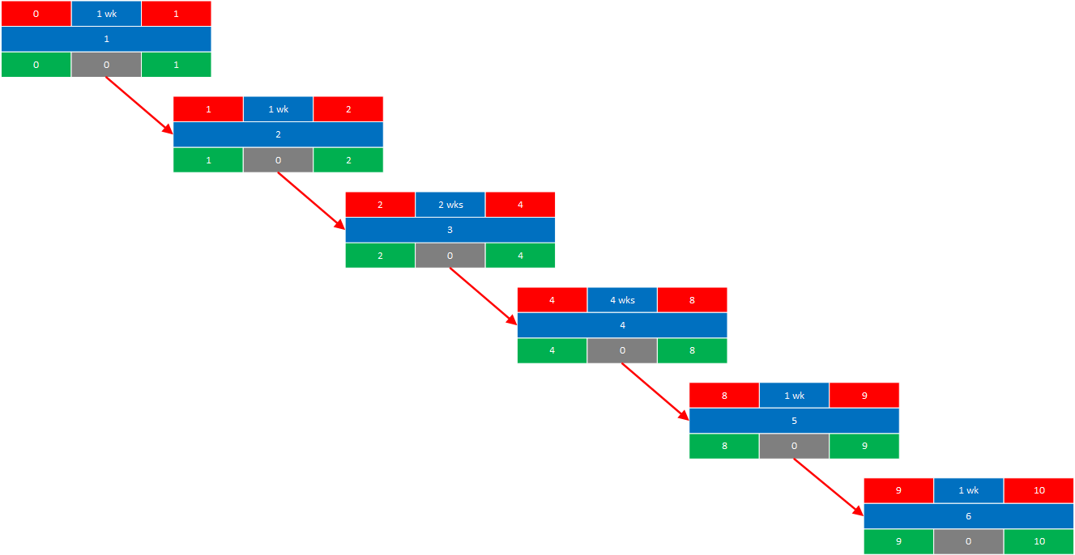

Chapter 2. System Requirements
2.1 System Overall Description
The Mobile/Computer Selling Center System is a computerized information system designed to support the daily operational activities of an electronics retail store. The system manages products such as mobile phones, computers, accessories, and spare parts, and provides functionalities for inventory tracking, sales processing, customer management, and reporting.
The system allows authorized staff members to register and update product information, monitor stock levels, process sales transactions, generate invoices, and store customer details for warranty and service purposes. Managers can use the system to view reports related to sales performance, inventory status, and profits. The system aims to replace manual or semi-manual processes with an efficient, accurate, and user-friendly solution.
2.2 Main Use Case Diagram
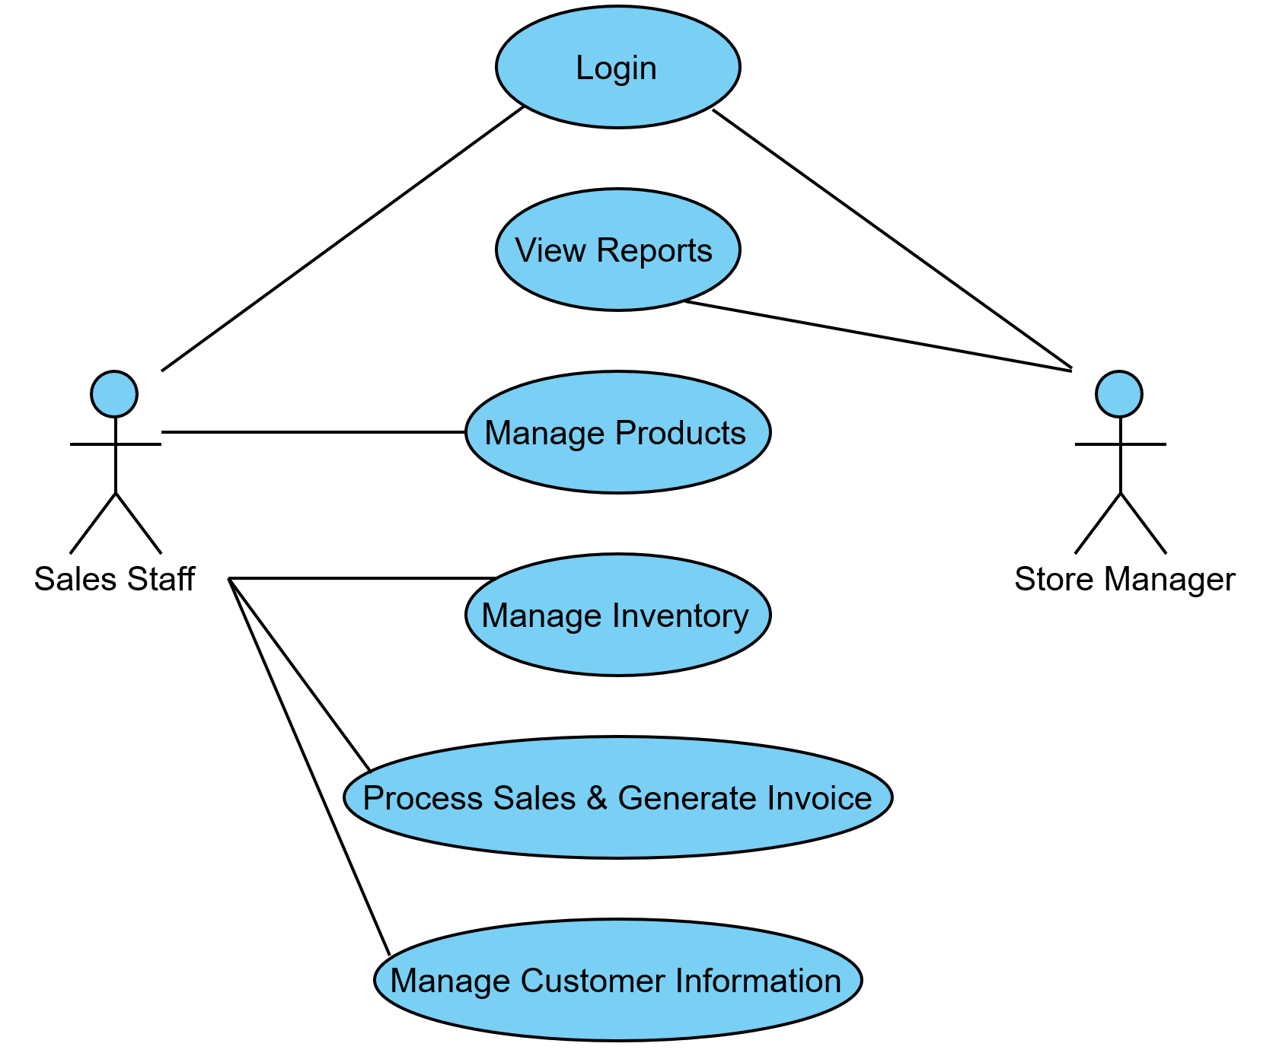

2.3 System Specific Requirements
2.3.1 Function Scenario for Login
ID | 1
Name |  | Login
Description |  | Allows authorized users to access the system using valid credentials.
Priority |  | Must have (1)
Actors |  | Sales Staff, Store Manager
Pre-Conditions |  | - User account must already exist in the system.
Flow of Events
Normal flow |  | - User opens the system login page.  - User enters username and password.  - System validates the credentials.  - System grants access and displays the main dashboard.
Alternative flow |  | If credentials are invalid, the system displays an error message and requests re-entry.
Post-Conditions |  | - User is successfully logged into the system.

2.3.1.1 Sequence Diagram for Login
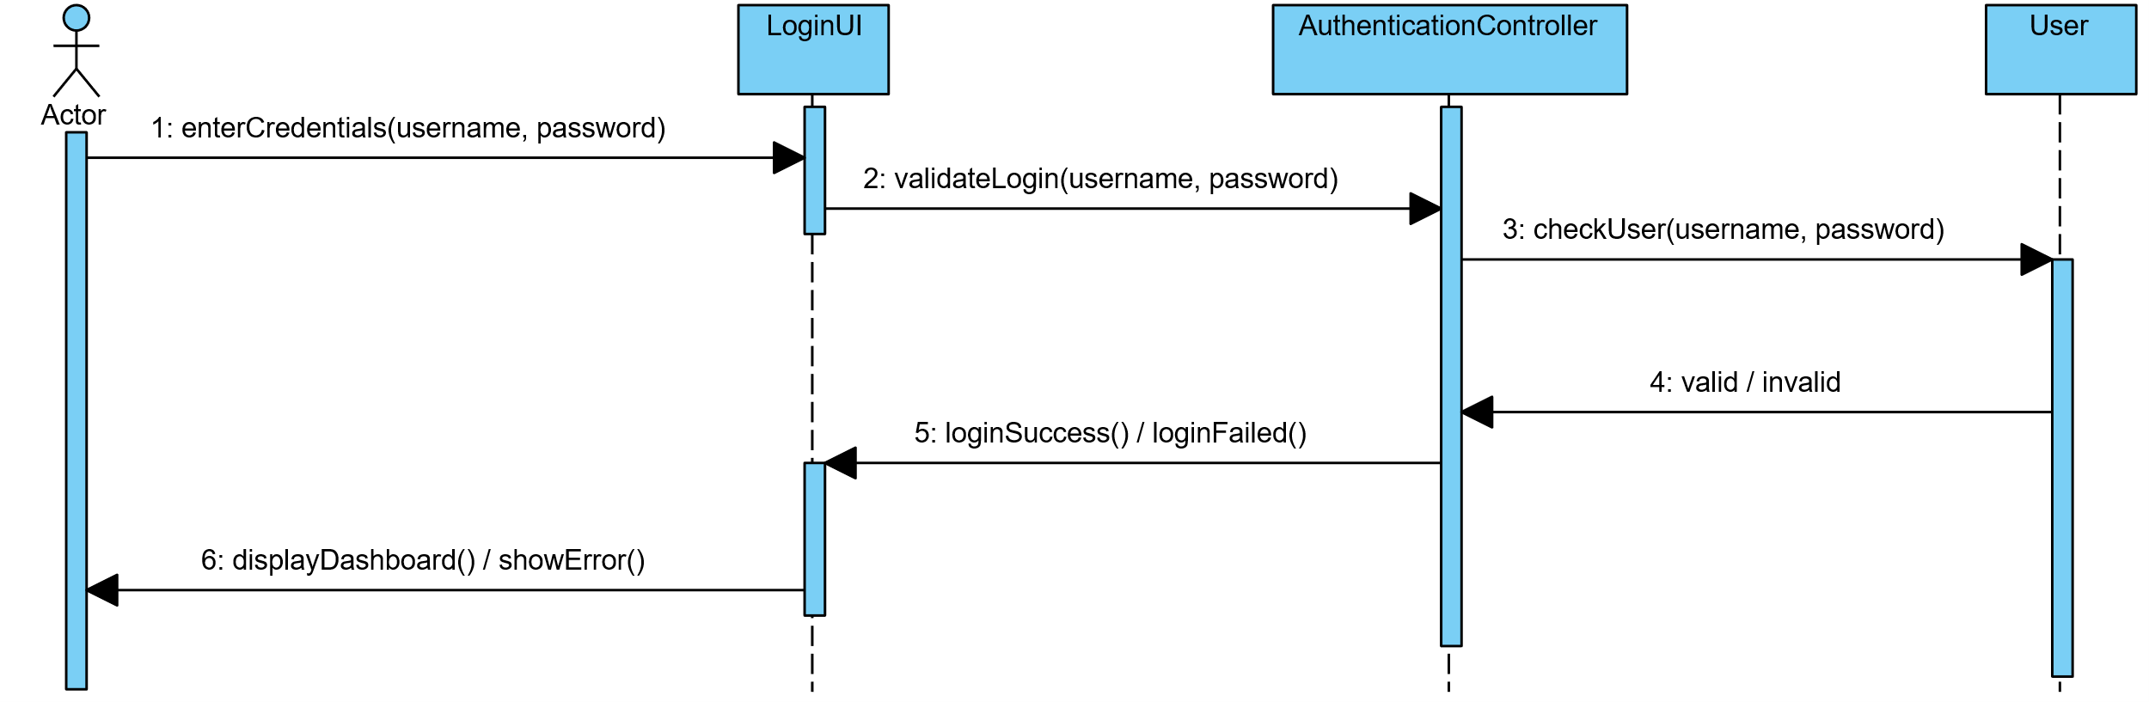

2.3.2 Function Scenario for Manage Products
ID | 2
Name |  | Manage Products
Description |  | Enables staff to add, update, delete, and view product information.
Priority |  | Must have (1)
Actors |  | Sales Staff
Pre-Conditions |  | - User must be logged into the system.
Flow of Events
Normal flow |  | - Staff selects the product management option.  - Staff enters or edits product details (name, category, price, quantity).  - System validates and saves the data.  - System updates the product list.
Alternative flow |  | If required data is missing, the system displays a validation error.
Post-Conditions |  | - Product information is stored or updated successfully.

2.3.2.1 Sequence Diagram for Manage Products
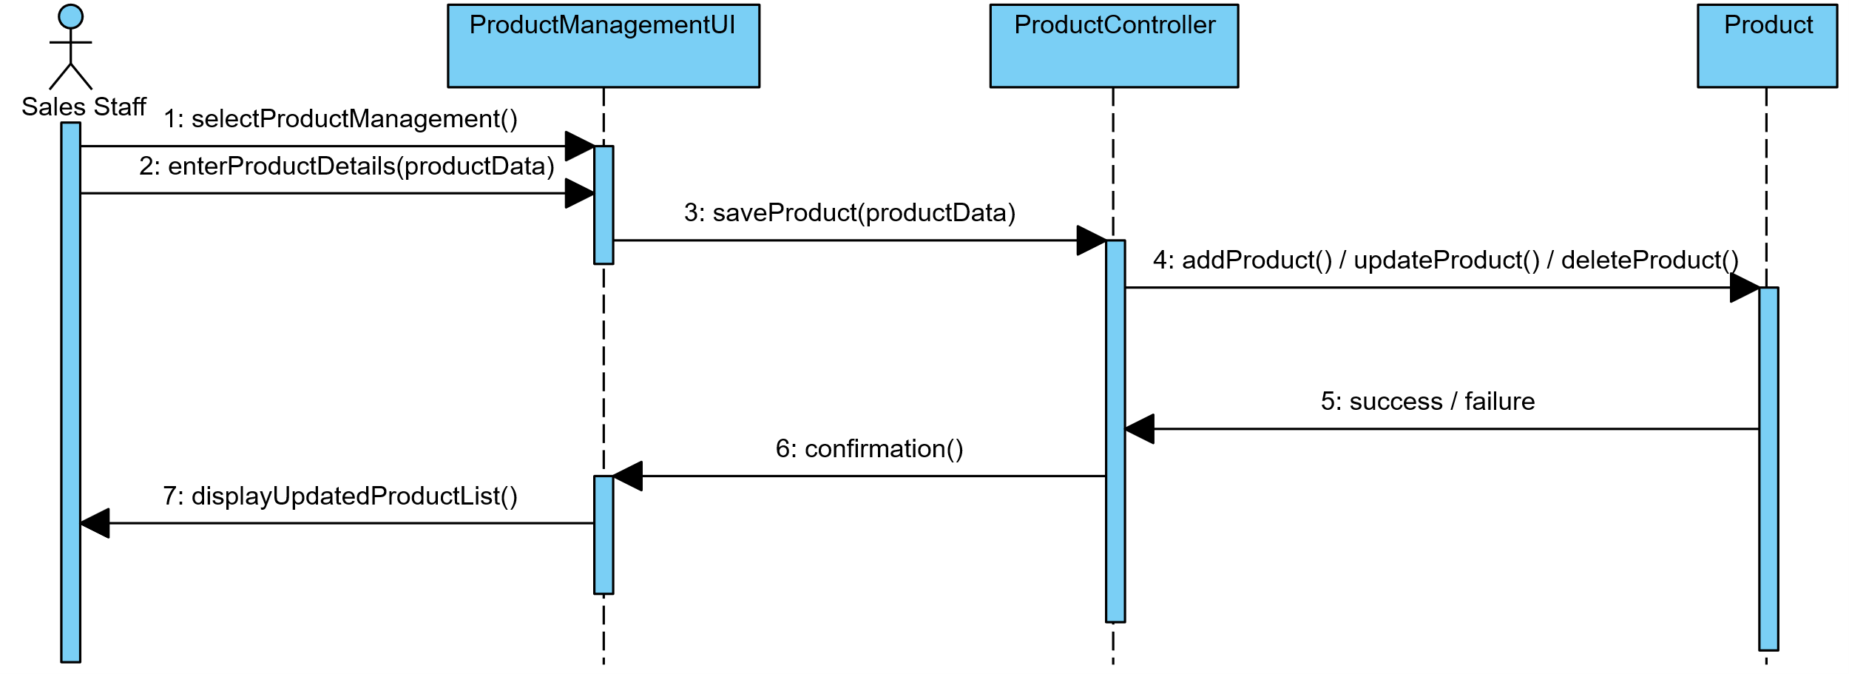

2.3.3 Function Scenario for Process Sale
ID | 3
Name |  | Process Sale
Description |  | Records a sales transaction and generates an invoice.
Priority |  | Must have (1)
Actors |  | Sales Staff
Pre-Conditions |  | - User must be logged in and products must exist.
Flow of Events
Normal flow |  | - Staff selects products for sale.  - System calculates total price.  - Staff confirms payment.  - System generates invoice and updates inventory.
Alternative flow |  | If stock is insufficient, the system displays an error message.
Post-Conditions |  | - Sale is recorded and inventory is updated.

2.3.3.1 Sequence Diagram for Process Sale
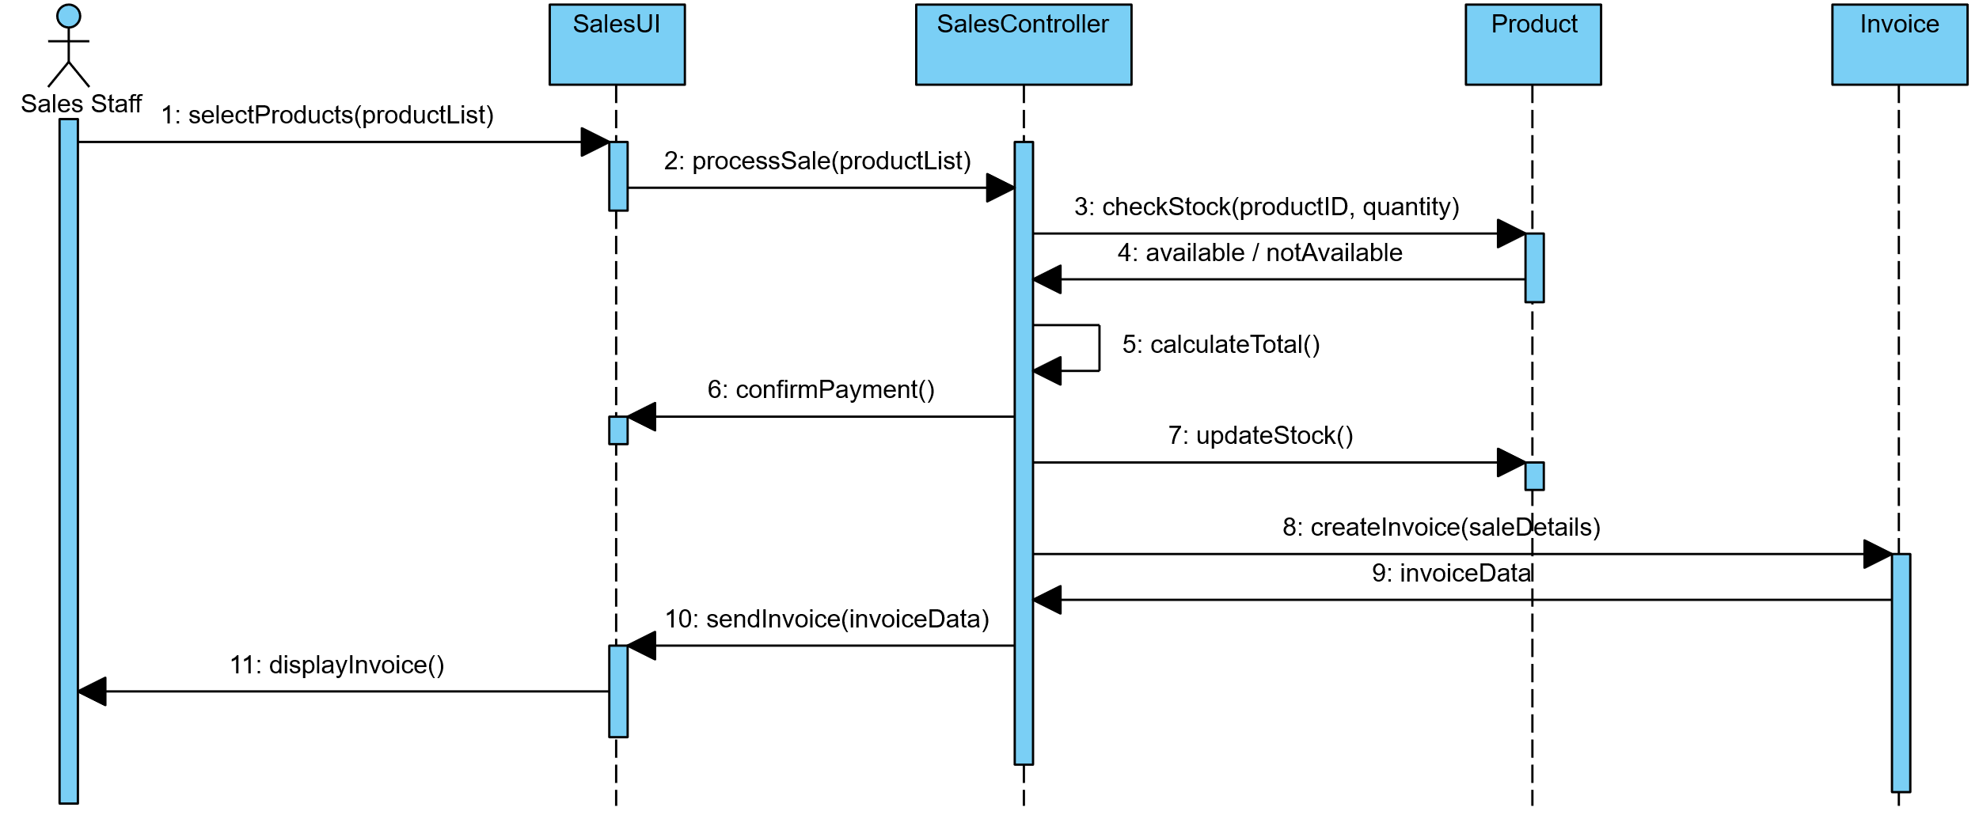
2.4 List of classes
2.4.1 Interface (Boundary) classes
- LoginUI
- ProductManagementUI
- SalesUI
- ReportUI

2.4.2 Entity classes
- User
- Product
- Customer
- Sale
- Invoice
2.4.3 Control (Manager) classes
- AuthenticationController
- ProductController
- SalesController
- ReportController
2.5 Non-Functional Requirements
- Usability: The system shall provide a simple and intuitive user interface suitable for non-technical users.
- Reliability: The system shall ensure accurate transaction processing and data storage.
- Security: Access to the system shall be protected through user authentication.
- Performance: The system shall respond to user actions within an acceptable time.
- Maintainability: The system shall be modular to allow future enhancements and maintenance.
Chapter 3. System Design
3.1 Application Architecture using Package Diagram
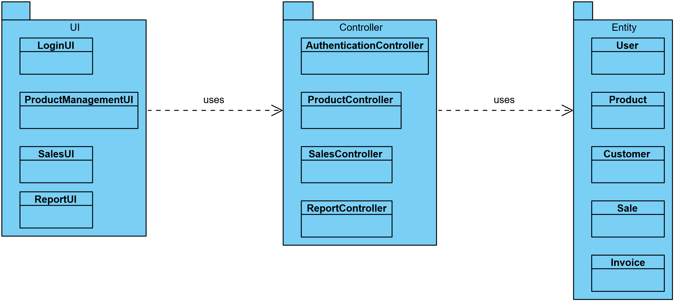

3.2 Modules (Packages) Descriptions
3.2.1 UI package
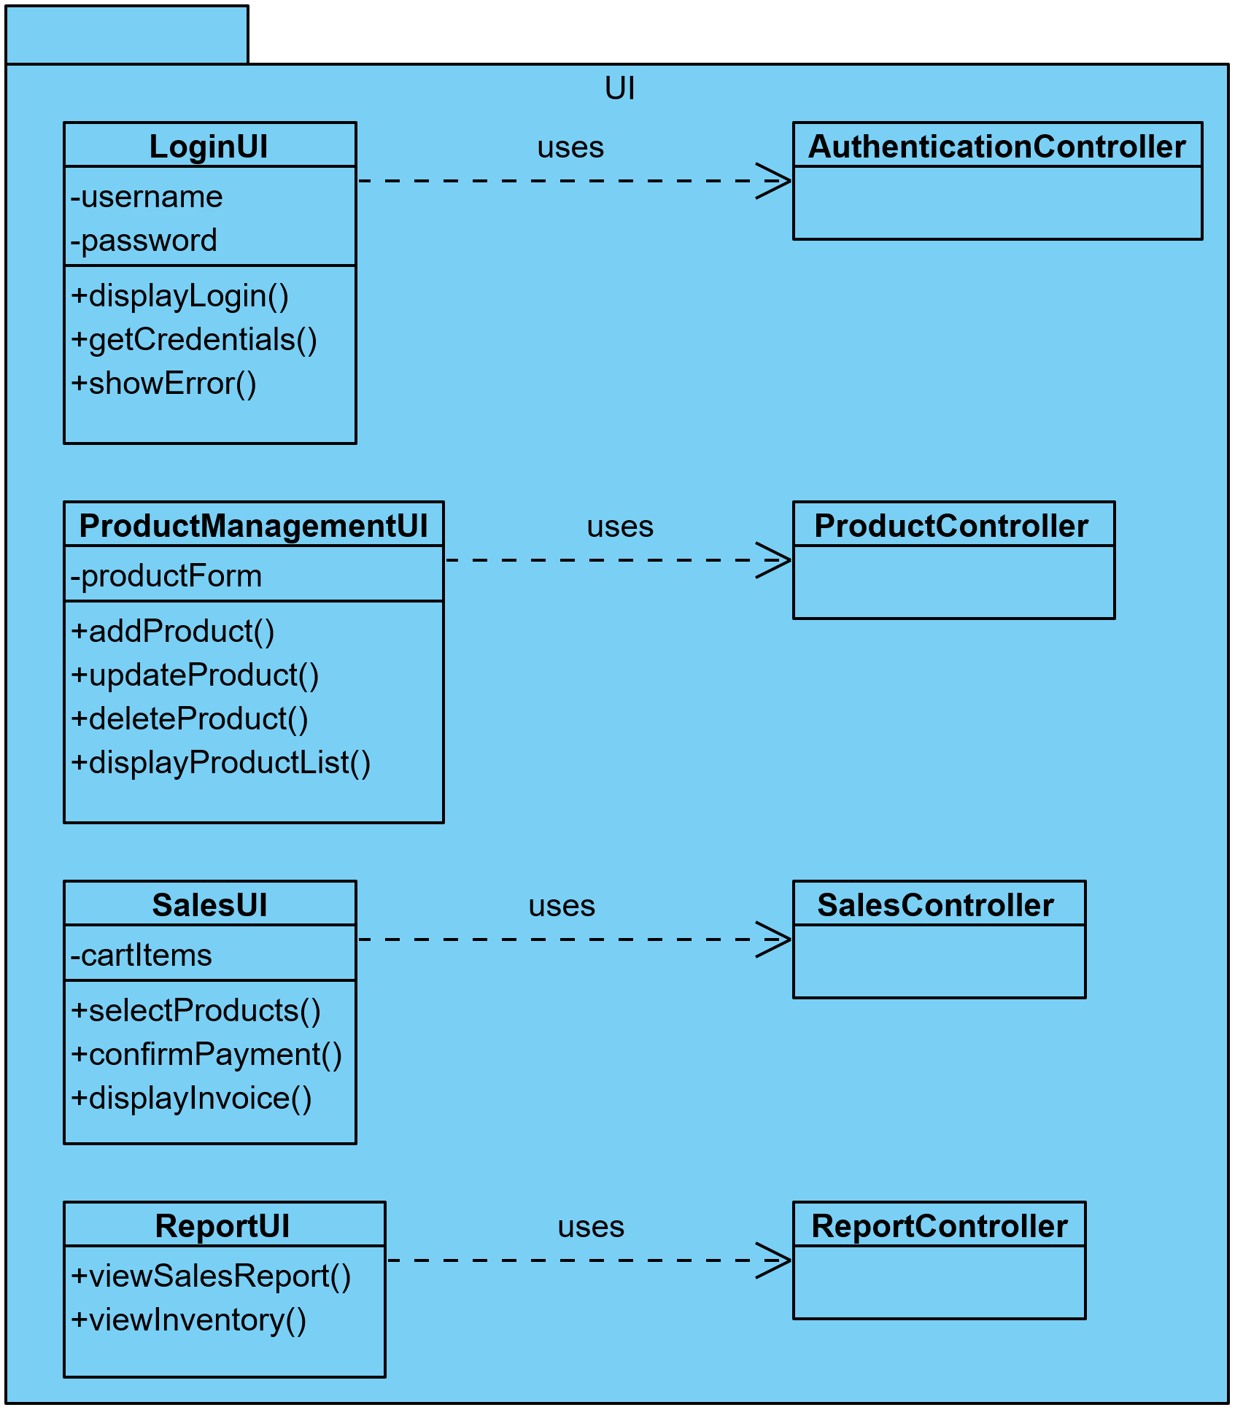
3.2.1.1 LoginUI Class
Instance: uses
Attributes:
- username,
- password
Methods:
- displayLogin(),
- getCredentials(),
- showError()

3.2.1.2 ProductManagementUI Class
Instance: uses
Attributes: productForm
Methods:
- addProduct(),
- updateProduct(),
- deleteProduct(),
- displayProductList()
3.2.1.3 SalesUI Class
Instance: uses
Attributes: cartItems
Methods:
- selectProducts(),
- confirmPayment(),
- displayInvoice()
3.2.1.4 ReportUI Class
Instance: uses
Attributes: —
Methods:
- viewSalesReport(),
- viewInventoryReport()

3.2.2 Controller package
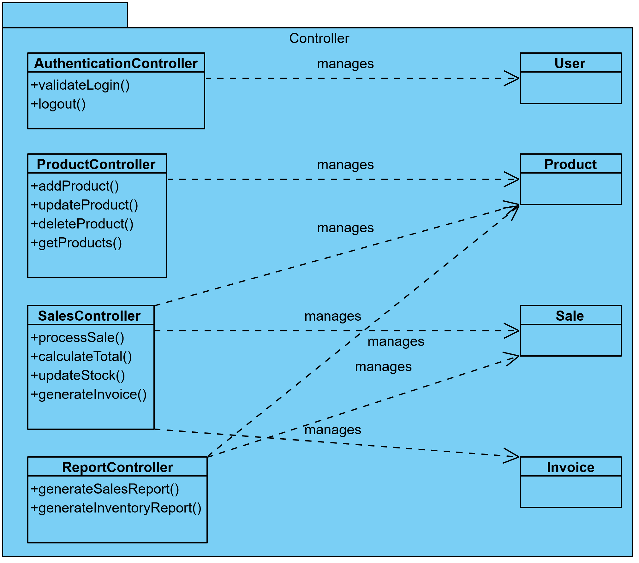
3.2.2.1 AuthenticationController class
Instance: manages
Attributes: —
Methods:
- validateLogin(),
- logout()
3.2.2.2 ProductController class
Instance: manages
Attributes: —
Methods:
- addProduct(),
- updateProduct(),
- deleteProduct(),
- getProducts()

3.2.2.3 SalesController class
Instance: manages
Attributes: —
Methods:
- processSale(),
- calculateTotal(),
- updateStock(),
- generateInvoice()
3.2.2.4 ReportController class
Instance: manages
Attributes: —
Methods:
- generateSalesReport(),
- generateInventoryReport()
3.2.3 Entity package
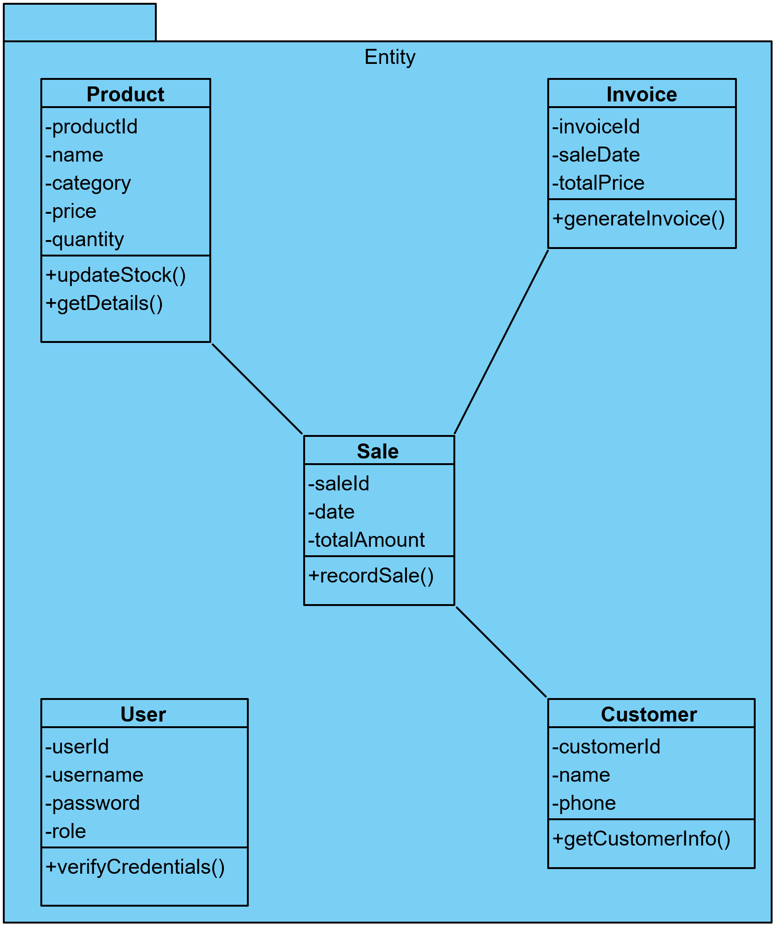

3.2.3.1 User class
Instance: —
Attributes:
- userId : int,
- username : String,
- password : String,
- role : String
Methods: verifyCredentials()
3.2.3.2 Product class
Instance: uses
Attributes:
- productId : int,
- name : String,
- category : String,
- price : double,
- quantity : int
Methods:
- updateStock(),
- getDetails()
3.2.3.3 Customer class
Instance: uses
Attributes:
- customerId : int,
- name : String,
- phone : String
Methods: getCustomerInfo()
3.2.3.4 Sale class
Instance: uses
Attributes:
- saleId : int,
- date : Date,
- totalAmount : double
Methods: recordSale()

3.2.3.5 Invoice class
Instance: uses
Attributes:
- invoiceId : int,
- saleDate : Date,
- totalPrice : double
Methods: generateInvoice()
Chapter 4. System Implementation and Testing
4.1 Coding and Coding Standards
entity/user.py
class User:
def __init__(self, username, password):
self.username = username
self.password = password

def verify_credentials(self, username, password):
return self.username == username and self.password == password

entity/product.py
class Product:
def __init__(self, name, price, quantity):
self.name = name
self.price = price
self.quantity = quantity

controller/authentication_controller.py
from entity.user import User

class AuthenticationController:
def __init__(self):
# Hardcoded user for simplicity
self.user = User("admin", "1234")

def validate_login(self, username, password):
return self.user.verify_credentials(username, password)

controller/product_controller.py
from entity.product import Product

class ProductController:
def __init__(self):
self.products = []

def add_product(self, name, price, quantity):
product = Product(name, price, quantity)
self.products.append(product)

def get_products(self):
return self.products

ui/login_ui.py
class LoginUI:
def get_credentials(self):
username = input("Enter username: ")
password = input("Enter password: ")
return username, password

def show_success(self):
print("Login successful!")

def show_error(self):
print("Invalid username or password.")

ui/product_ui.py
class ProductUI:
def get_product_details(self):
name = input("Product name: ")
price = float(input("Price: "))
quantity = int(input("Quantity: "))
return name, price, quantity

def display_products(self, products):
print("\nProduct List:")
for p in products:
print(f"- {p.name}, Price: {p.price}, Quantity: {p.quantity}")

main.py
from ui.login_ui import LoginUI
from ui.product_ui import ProductUI
from controller.authentication_controller import AuthenticationController
from controller.product_controller import ProductController

# Initialize components
login_ui = LoginUI()
auth_controller = AuthenticationController()
product_ui = ProductUI()
product_controller = ProductController()

# LOGIN USE CASE
username, password = login_ui.get_credentials()

if auth_controller.validate_login(username, password):
login_ui.show_success()

# MANAGE PRODUCTS USE CASE
name, price, quantity = product_ui.get_product_details()
product_controller.add_product(name, price, quantity)

products = product_controller.get_products()
product_ui.display_products(products)
else:
login_ui.show_error()

4.2 System Testing
System testing was conducted to evaluate the functionality of the Mobile/Computer Selling Center System as a complete and integrated application. The objective of this testing phase was to ensure that the system satisfies all functional requirements defined in Chapter 2 and operates correctly in a real usage environment.
The testing process included the following levels:
- Unit Testing: Individual system components such as user authentication and product management functions were tested independently to verify their correctness.
- System Testing: The entire system was tested as one integrated unit to ensure correct interaction between the UI, Controller, and Entity layers.
- Acceptance Testing: The system was tested from the end-user perspective to confirm that it meets user requirements and behaves as expected.
Several scenarios were executed during system testing, including valid and invalid login attempts, adding products with correct and incorrect data, and viewing product information. The results showed that the system responds correctly to user actions, handles errors properly, and performs all required functions successfully.
4.2.1 Test Cases
# | Function | Test Steps | Test Data | Expected Results | Actual Results | Status
1 | Login | Enter valid username and password | admin / 1234 | Login successful | Login successful | Pass
2 | Login | Enter invalid username or password | admin / wrong | Error message displayed | Error message displayed | Pass
3 | Manage Products | Add new product | Laptop, 800, 3 | Product added successfully | Product added successfully | Pass
4 | Manage Products | Add product with missing name | , 500, 2 | Validation error | Validation error | Pass
5 | View Products | Display product list | Existing products | Product list displayed | Product list displayed | Pass
6 | Process Sale | Sell product with sufficient quantity | Laptop, qty=1 | Sale completed | Sale completed | Pass
…
5. References
[1] Dr. Abdelkareem Alashqar, Software Engineering Slides.
[2] Dr. Abdelkareem Alashqar, Recorded Video Lectures of Software Engineering.

