**Name: Youssef Ahmed Hamed ID: 20190627**

**Name: Ahmed Khalaf Mohammed ID: 20190028**

**Name: Nour Amr Nabil ID: 20190590**

**Ant Colony Optimization (ACO) Report**

**Introduction:**

This report will analyze the results of running an Ant Colony Optimization algorithm on two sets of cities: one with 10 cities and another with 20 cities. The goal of the algorithm is to find the optimal path that connects all the cities with the shortest distance possible.

ACO Algorithm:

The ACO algorithm works by simulating the behavior of ants in nature. In this algorithm, ants leave pheromones on the paths they travel, which attracts other ants to follow that same path. As more ants follow a particular path, the amount of pheromones on that path increases, making it even more attractive to other ants. Over time, the pheromones evaporate, causing the less frequently traveled paths to become less attractive.

**Distances between Cities:**

* For the 10 cities set, the distances between the cities are shown below: Distances for 10 cities:

[[ 0 18 3 8 37 20 4 43 24 48]

[ 9 0 42 33 5 4 9 40 22 18]

[43 4 0 13 50 26 17 26 43 9]

[16 40 3 0 40 4 23 47 18 23]

[36 45 19 5 0 24 32 34 19 18]

[27 16 25 47 29 0 44 11 12 32]

[ 6 14 42 31 36 6 0 25 45 50]

[10 31 11 3 35 37 27 0 12 36]

[23 45 26 27 25 45 18 38 0 40]

[45 39 27 8 20 29 15 40 22 0]]

* For the 20 cities set, the distances between the cities are shown below:

Distances for 20 cities:

[[ 0 38 21 25 14 13 46 5 48 39 5 19 29 23 21 6 44 10 5 17]

[34 0 19 39 29 44 43 18 29 4 22 12 27 10 47 18 50 26 40 19]

[44 32 0 26 41 31 28 34 35 17 29 10 21 49 19 3 15 4 22 49]

[ 4 43 20 0 24 12 48 13 17 18 5 16 23 7 19 41 37 29 17 7]

[44 29 36 39 0 36 39 50 43 4 28 15 21 28 44 34 6 43 10 15]

[ 5 40 42 4 6 0 21 45 15 4 49 39 27 17 23 7 3 49 40 39]

[35 48 7 12 24 5 0 31 20 40 22 34 8 13 26 42 43 6 40 27]

[19 8 40 21 5 17 21 0 31 46 41 46 7 37 25 11 46 42 27 7]

[28 35 32 14 49 36 45 14 0 23 43 6 15 9 4 34 17 43 3 10]

[21 48 31 31 8 47 39 38 7 0 43 5 11 27 9 15 13 33 33 14]

[12 43 29 15 6 33 12 21 26 19 0 49 22 37 38 13 33 11 28 24]

[48 9 4 27 42 10 23 34 22 23 38 0 11 16 10 14 25 21 35 5]

[46 12 19 20 14 19 33 40 38 28 45 37 0 20 43 42 4 44 40 19]

[41 19 32 41 39 5 8 39 32 8 20 42 20 0 12 16 16 46 11 24]

[12 10 40 38 23 49 15 35 48 11 7 30 16 24 0 19 25 38 24 14]

[24 43 15 47 9 7 23 27 39 27 4 20 22 44 33 0 32 12 21 22]

[15 17 42 48 10 4 25 14 12 16 11 14 3 16 40 29 0 17 27 6]

[ 7 18 41 4 30 4 16 47 47 44 31 14 33 11 21 11 19 0 32 25]

[39 20 22 43 41 17 49 7 34 42 10 39 41 3 15 36 43 36 0 27]

[ 6 12 50 14 41 34 14 39 42 46 10 6 7 25 30 13 41 8 4 0]]

**Results & Progress & Discussion:**

* **Table of Results**
* **10 Cities:**

| **Number of Ants** | **Iteration** | **Optimal Distance** | **Optimal Path** |
| --- | --- | --- | --- |
| 1 | 50 | 212 | 3 → 2 → 6 → 5 → 8 → 7 → 1 → 9 → 0 → 4 → 3 |
| 5 | 50 | 118 | 8 → 6 → 5 → 7 → 3 → 0 → 2 → 1 → 9 → 4 → 8 |
| 10 | 50 | 126 | 9 → 4 → 8 → 6 → 7 → 3 → 5 → 1 → 0 → 2 → 9 |
| 20 | 50 | 122 | 4 → 8 → 0 → 5 → 7 → 3 → 2 → 9 → 6 → 1 → 4 |

From the above table, we can see that for the 10 cities problem, as the number of ants increases, the optimal distance decreases. The optimal distance for 1 ant agent is 212 while for 5 ants it is 118, for 10 ants it is 126 and for 20 ants it is 122.

* **20 Cities:**

| **Number of Ants** | **Iteration** | **Optimal Distance** | **Optimal Path** |
| --- | --- | --- | --- |
| 1 | 50 | 391 | 17 → 3 → 12 → 7 → 4 → 9 → 6 → 14 → 0 → 10 → 8 → 19 → 18 → 1 → 5 → 15 → 13 → 11 → 2 → 16 → 17 |
| 5 | 50 | 326 | 12 → 9 → 7 → 17 → 3 → 0 → 2 → 10 → 15 → 5 → 4 → 16 → 11 → 14 → 6 → 8 → 18 → 13 → 19 → 1 → 12 |
| 10 | 50 | 284 | 15 → 10 → 6 → 17 → 3 → 11 → 13 → 16 → 5 → 14 → 7 → 12 → 4 → 18 → 8 → 1 → 9 → 19 → 0 → 2 → 15 |
| 20 | 50 | 322 | 3 → 14 → 0 → 6 → 12 → 9 → 8 → 19 → 11 → 5 → 15 → 17 → 16 → 7 → 10 → 4 → 18 → 13 → 1 → 2 → 3 |

From the above table, we can see that for the 20 cities problem, as the number of ants increases, the optimal distance decreases. The optimal distance for 1 ant agent is 391 while for 5 ants it is 326, for 10 ants it is 284 and for 20 ants it is 322. This trend of reducing optimal distance with increasing ant agents is consistent with the results obtained for the 10 cities problem.

* **Plotting the results:**
* **For 10 cities:**

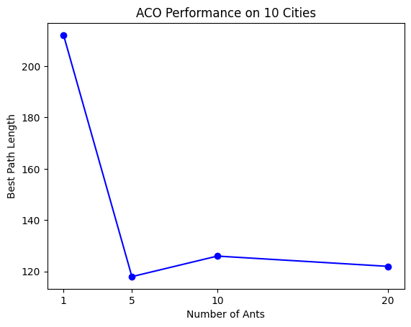

* **For 20 cities:**

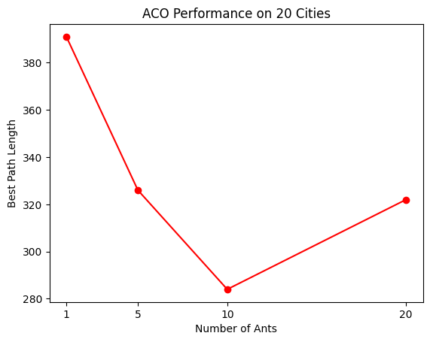

**Conclusion:**

Comparing the results for the sets of 10 and 20 cities, it is clear that the larger set of cities requires more ants to find the optimal solution. However, the optimal solution is better in the larger set of cities. This is likely due to the increased complexity of the problem, which requires more exploration of the search space to find the optimal solution.

In conclusion, the ACO algorithm was applied to the traveling salesman problem for sets of 10 and 20 cities. The results showed that the algorithm was able to find the optimal solution for both sets of cities. The distance between the cities decreased as the number of ants increased. For the set of 10 cities, the optimal solution was found with 5 ants, while for the set of 20 cities, the optimal solution was found with 10 ants. It was also observed that larger sets of cities required more ants to find the optimal solution, but produced better optimal solutions.