COMPANY X DATA DEPARTEMENT REPORT

# Executive summary

We exported the sales data from our database and we conducted some analysis on it to gain insights into some of our sales operations and study ways of enhancing our services based on a certain scope.

## Scope:

* Customer loyalty
* Strength and weak points
* Performance
* Customer experience

## Data specs:

Here are the tables we used to conduct our analysis

* Orders table
* Returns table
* People table

# The analysis

## Customer loyalty

* WHAT IS THE MOST SHIP MODE USED BY CUSTOMERS?

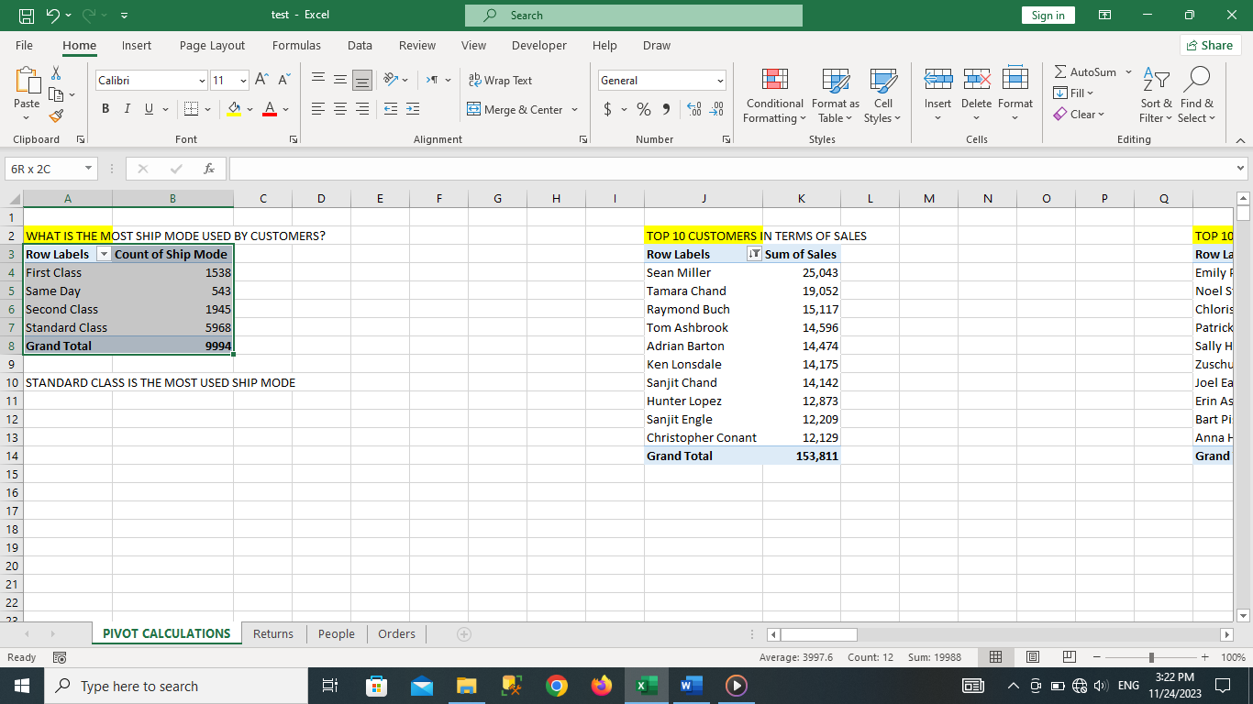

Based on the table above we counted the numbers of times each shipping mode occurred in the orders table

And we found that the standard class shipping mode was the most one used by our customers by 72.97%.

### Recommendation

* We should focus more promotions on the standard shipping mode as it is the most used
* We should find ways to reduce the cost of the standard shipping mode and make sure it is profitable as it is the most used shipping mode
* First class shipping mode was the least used shipping mode which might be better to revise the cost the possible scenarios where it might be removed