**Name : Ahmed Khaled Mohamed Kamel**

**B.N: 56**

**Date : 27/5/2020**

**Topic:** **Internet Of Things**

**GitHub link :** <https://github.com/ahmed-khaled-mohamed/ece001>

**GitHub page :** <https://ahmed-khaled-mohamed.github.io/ece001/>

**Application brief :** Internet of Things (IoT) is a computational concept that describes a scenario where everyday physical objects are related to the Internet and can identify themselves to other devices or processes, via an IP address. The Internet of Things is important because the object that can represent itself digitally becomes something larger than the object itself. The object is no longer only related to the process; It now connects with surrounding objects and database data, allowing for "big data" analyzes and statistics. In particular, “things” may communicate independently with other things and other devices, such as sensors in manufacturing environments or a smartphone tracker. The Internet of Things has evolved from the convergence of wireless technologies, micro-electromechanical systems, small services and the Internet. This convergence demolished the walls between operational technology and information technology, allowing automated data not generated to be analyzed to obtain insights that would lead to improvements. The consumer of the Internet of Things has taken another revolutionary path, either by connecting - for example, bike speed sensors - or inventing it recently. In other cases, as in health care, things existed but were not widely used, such as the patient's health.

**Internet of Things: countless use cases**

There are countless use cases where IoT can be deployed, as is the case in manufacturing, vehicles, and even future situations such as smart cities and energy. For example, manufacturing has been operating store floor equipment for decades with sensors that control machine operations, but these sensors were relatively stupid and were not IP enabled and were not able to communicate outside of their domestic operations.

This situation is changing. Manufacturing equipment is now produced using IP-enabled sensors, which can communicate with each other, collecting and disseminating data in real time. There are many benefits to the manufacturer such as: product rotation control, restocking automation, production line monitoring, real-time quality assurance alerts, etc. A smart city is defined as a city that monitors and fully integrates the conditions of its vital infrastructure, such as roads, bridges, tunnels, railways, airports, ports, water, energy, and major buildings. With the use of IoT technology, city planners can better optimize their resources, plan preventive maintenance, security monitoring and emergency response control, through advanced surveillance systems and smart sensors integrated with data collected and evaluated in real time. Increasingly, there will be an emphasis on energy consumption behavior. Because of the volatile nature, this display requires a smart and flexible electric grid capable of interacting with energy fluctuations by controlling electrical energy sources, whether created or stored, and by appropriate configuration. The smart device network and network infrastructure will largely depend on the concepts of the Internet of Things. The smart grid will be implemented on a type of "Internet" where each power packet is managed in a similar manner to the data packet, through routers and gateways that can independently decide the best packet path to reach its destination, based on standard transmitters and receivers, gateways and protocols. Internet connection vehicles give context to the Internet Vehicles (ivo) connected to the concept of Internet Energy (IoE) which will represent future directions for smart transportation and mobility applications. Creating new customer-focused transactions and services will provide new ecosystems based on trust, security, mobility and convenience.

IoT can play a health care role with smart devices used in many situations. Elderly or disabled people can live independently with falls detectors and / or monitor physical activity through body sensors; Patient monitoring sensors for hospitals or care homes, smart sensors to control conditions in medical volumes and devices to monitor UV radiation on people.

**How things can communicate**

From an operational perspective, smart devices can communicate across multiple models, such as one to another This is where two or more devices can communicate directly with each other through different network protocols, including Internet Protocol (IP), Bluetooth, Z-Wave or Zigbee . This type of protocol is usually used with low data rate requirements such as light bulbs, light switches, and door locks. Another way to communicate is via the device to the cloud. The IoT device connects directly to an online cloud service to exchange data. Wired Ethernet is usually used for Wi-Fi connections between device and IP network. This type of connection is used by smart TVs. The device to the gateway is a method where the device communicates through the application layer gateway as a channel to access a cloud service. The portal provides security and other functions such as protocol translation. a

**Screenshots :**

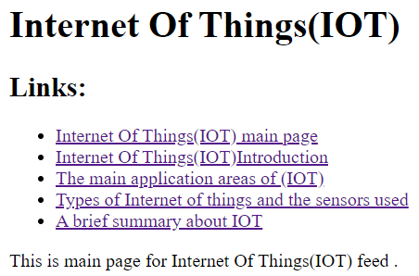

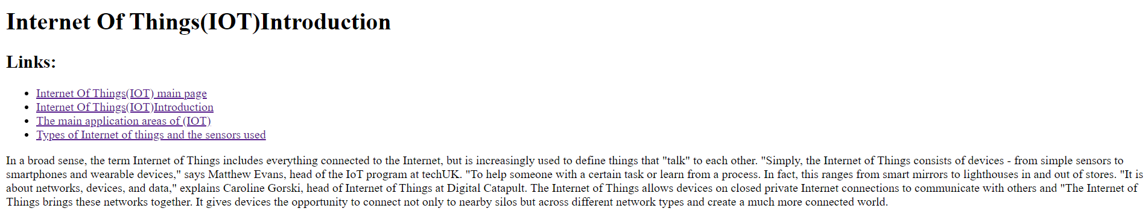

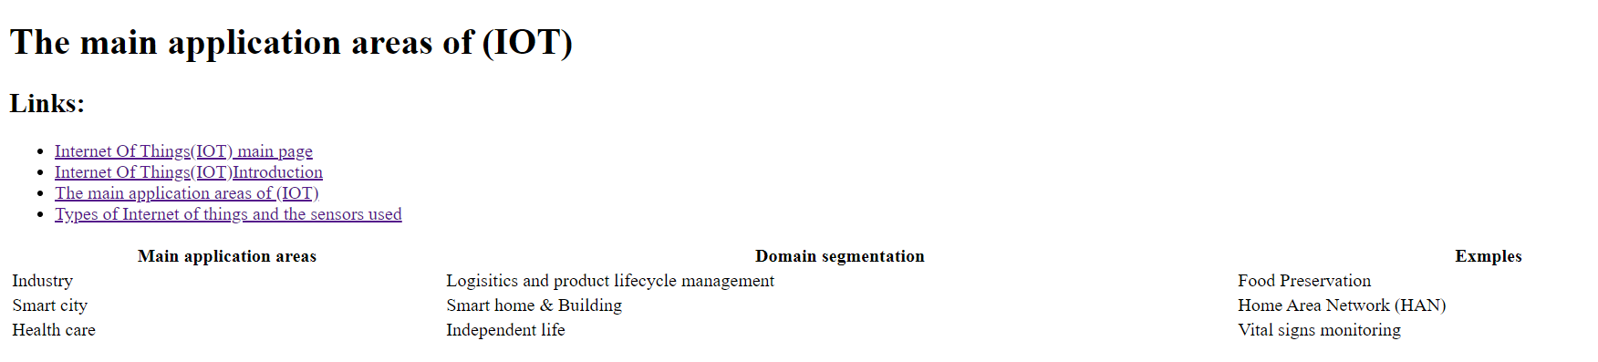

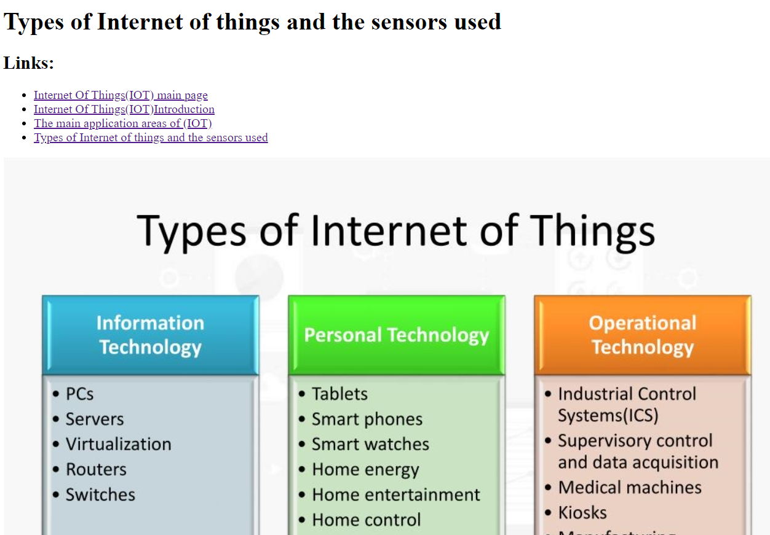

**Source code screenshots:**

