Architectures

Task | Name | Architecture | Extra
Object Detection | R-CNN | 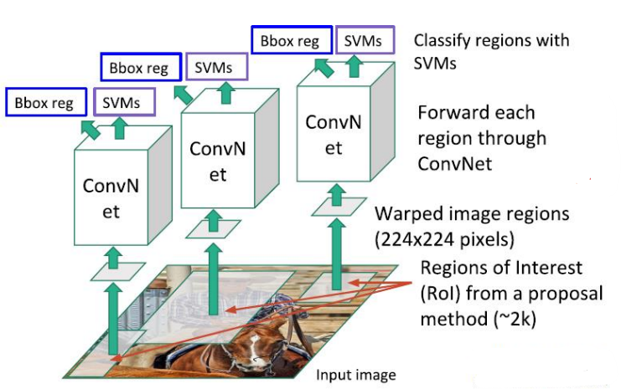 | Region Proposal | Speed | Classification function
Object Detection | R-CNN |  | Selective Search | Slow  (2000 forward passes) | SVM
Object Detection | Fast R-CNN | 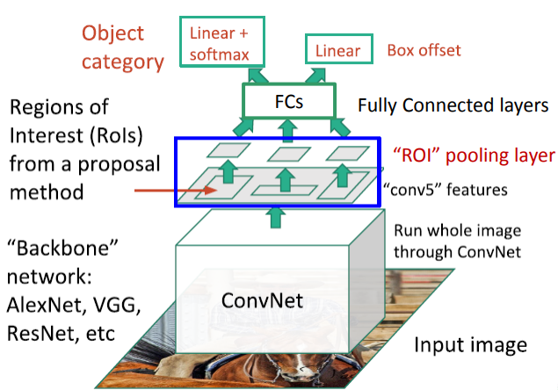 | Selective Search | Fast | Softmax
Object Detection | Faster R-CNN | 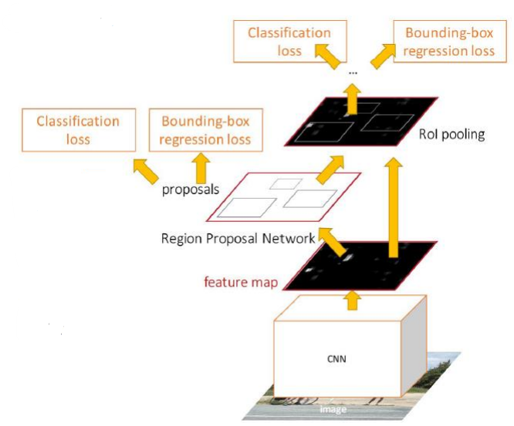 | Region Proposal Network | Faster | Softmax
Object Detection | YOLO | - | Uses the whole Image  No Region Proposal | Realtime (45 fps) | -
Semantic Segmentation | Fully Convolutional Network (FCN) | 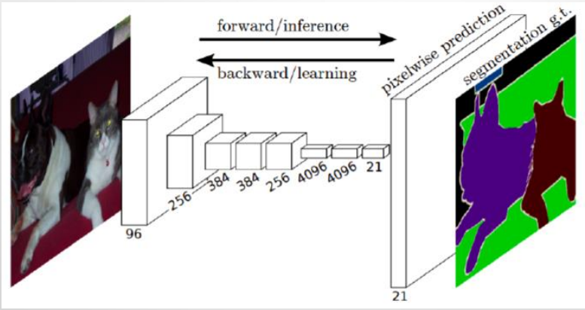 | • Summary:  Use CNN for encoding (downsampling) the image then upsample the final output to image size  • Improvements:  • Skip connections: pass earlier CNN outputs to upsampling layer
Semantic Segmentation | Deconvolution Network | 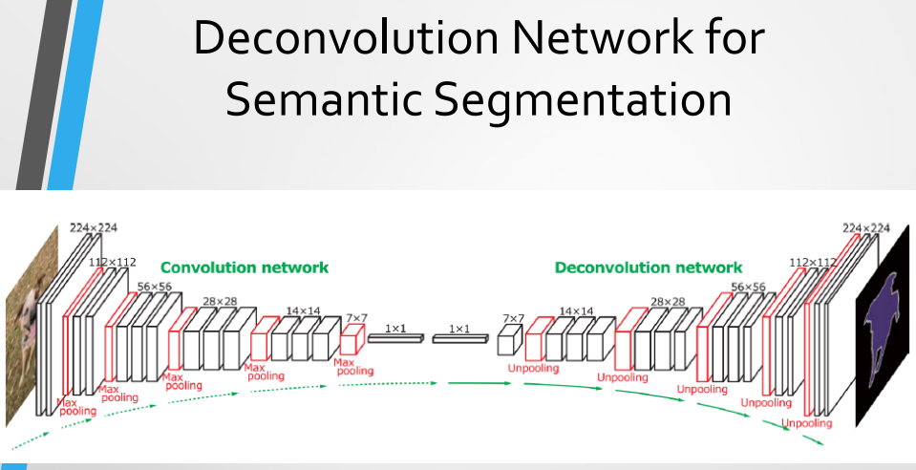 | • Summary:  Design network as a bunch of convolutional layers, with downsampling and upsampling inside the network!  • Improvements:  • Uses UnPooling and Deconvolution in multiple stages to upsample the predictions
Semantic Segmentation | U-Net | 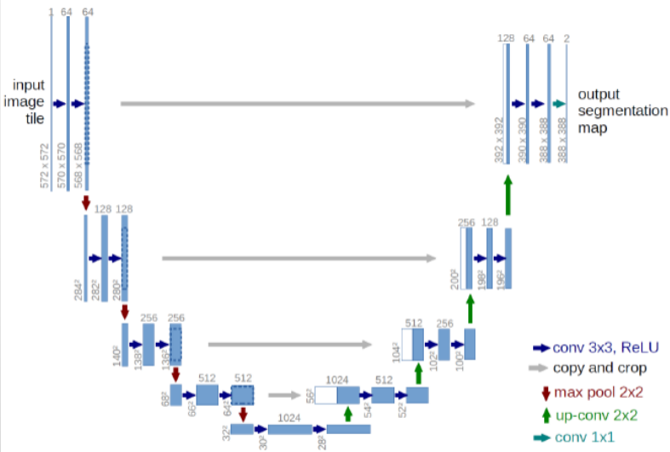 | • Summary:  Discard un-pooling and keep up-sampling (deconvolution), in addition to skip connections from same down-sampling layer to up-sampling layer
Instance Segmentation | Mask R-CNN | 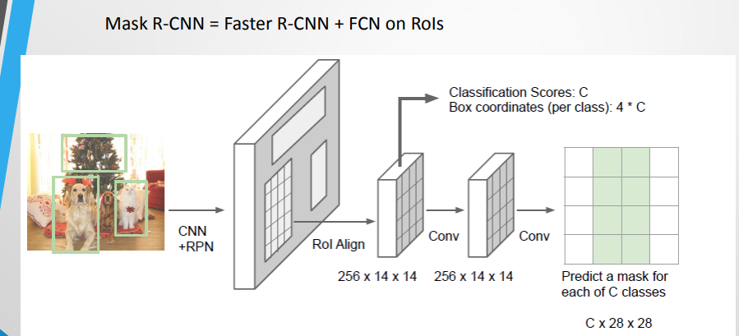 | • Summary:  Faster R-CNN + FCN on ROIs

Algorithms

Task | Name | Algorithm | Extra
Edge Detection | Canny Edge Detector | 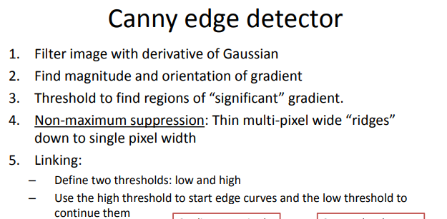
Feature Detection | Harris Detector | 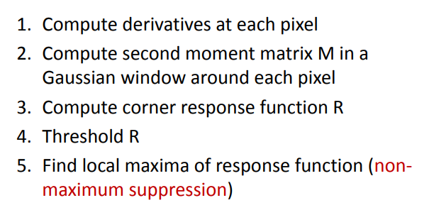  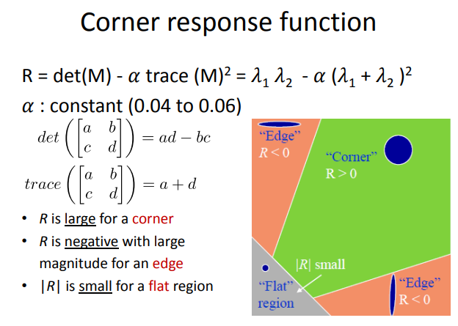 | - Rotation Invariant  - Scale Variant
Feature Detection | SIFT | 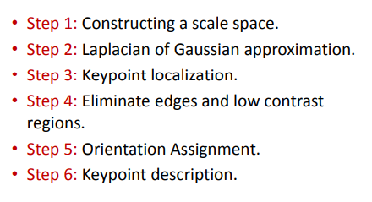 | - Rotation Invariant  - Scale Invariant
Feature Matching | RANSAC | 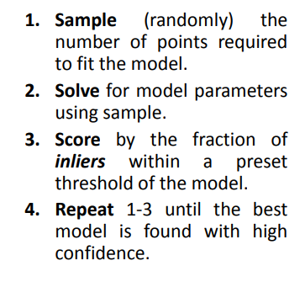 | 