Smart Parking Garage Gate System
Test Case Report — CSE411 / CSE323 Spring 2026

Test Results Summary
TC# | Name | Result
TC-01 | Manual OPEN – stops on release | PASS
TC-02 | Manual CLOSE – stops on release | PASS
TC-03 | Manual from STOPPED_MIDWAY | PASS
TC-04 | Auto OPEN from IDLE_CLOSED | PASS
TC-05 | Auto CLOSE from IDLE_OPEN | PASS
TC-06 | Auto mode from STOPPED_MIDWAY | PASS
TC-07 | Obstacle during auto-closing | PASS
TC-08 | Obstacle overrides held CLOSE | PASS
TC-09 | Obstacle ignored during opening | PASS
TC-10 | Open Limit stops gate | PASS
TC-11 | Closed Limit stops gate | PASS
TC-12 | Wrong limit ignored | PASS
TC-13 | Security OPEN overrides Driver CLOSE | PASS
TC-14 | Security CLOSE overrides Driver OPEN | PASS
TC-15 | Driver panel conflict – stopped state | PASS
TC-16 | Driver panel conflict – moving state | PASS
TC-19 | Queue delivers events without loss | PASS
TC-20 | Mutex protects shared state | PASS
TC-21 | Semaphore signals limit activation | PASS

Detailed Test Cases
TC-01 — Manual OPEN – stops on release [PASS]
Category | Manual Mode
Objective | Gate moves while OPEN held; stops on release before limit
Precondition | System running, state = IDLE_CLOSED
Steps | 1. Hold DrvOPN (PF4) > 400 ms  2. Observe GREEN LED ON  3. Release button before Open Limit
Expected | GREEN LED turns ON while held. On release → STOPPED_MIDWAY, all LEDs off (BLUE on).
Actual | GREEN LED ON while held. On release GREEN off, BLUE on -> STOPPED_MIDWAY
Serial Output | [Btn] DRV_OPEN pressed | [Gate] OPENING | [Btn] DRV_OPEN rel ms: 850 | [Gate] Mode: MANUAL stop | [Gate] STOPPED_MIDWAY
Notes | —
Screenshot:
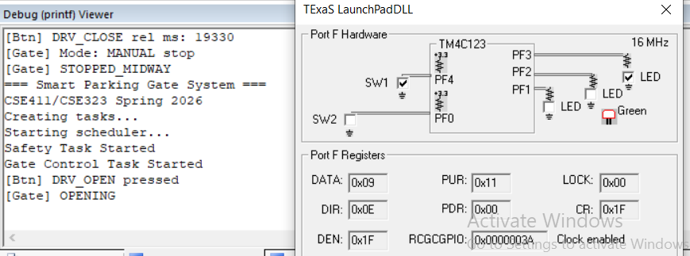
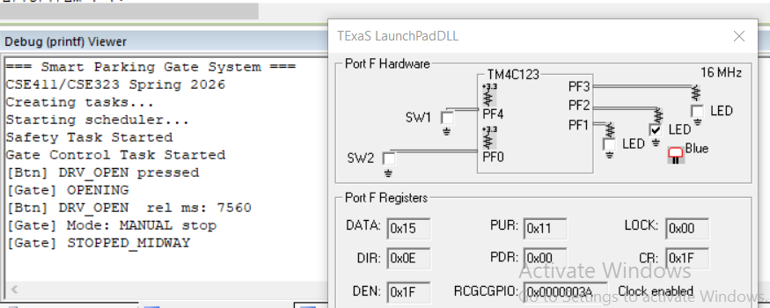

TC-02 — Manual CLOSE – stops on release [PASS]
Category | Manual Mode
Objective | Gate moves while CLOSE held; stops on release before limit
Precondition | State = IDLE_OPEN
Steps | 1. Hold DrvCLS (PE0) > 400 ms  2. Observe RED LED ON  3. Release before Closed Limit
Expected | RED LED ON while held. On release → STOPPED_MIDWAY, BLUE LED on.
Actual | RED LED ON while held. On release RED off, BLUE on -> STOPPED_MIDWAY
Serial Output | [Btn] DRV_CLOSE pressed | [Gate] CLOSING | [Btn] DRV_CLOSE rel ms: XXXX | [Gate] Mode: MANUAL stop | [Gate] STOPPED_MIDWAY
Notes | —
Screenshot:
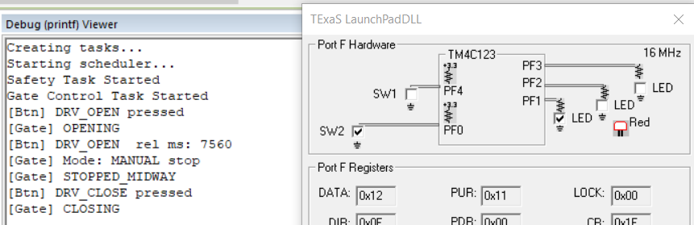

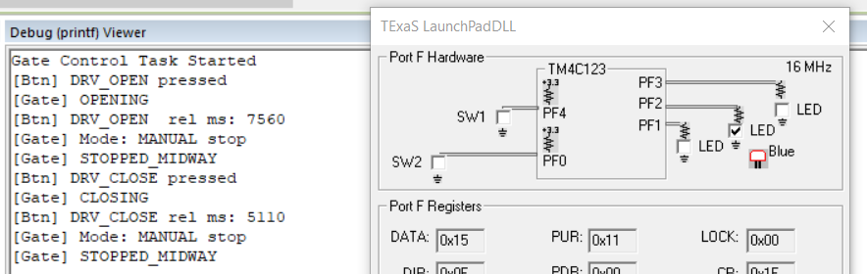

TC-03 — Manual from STOPPED_MIDWAY [PASS]
Category | Manual Mode
Objective | Manual control works in both directions from STOPPED_MIDWAY
Precondition | State = STOPPED_MIDWAY
Steps | 1. Hold DrvOPN > 400 ms, release → STOPPED_MIDWAY  2. Hold DrvCLS > 400 ms, release → STOPPED_MIDWAY
Expected | Gate responds in both directions. Stops each time button is released.
Actual | Gate opens and closes correctly from STOPPED_MIDWAY in manual mode, stops on release each time.
Serial Output | [Btn] DRV_OPEN pressed | [Gate] OPENING | [Gate] Mode: MANUAL stop | [Gate] STOPPED_MIDWAY | [Btn] DRV_CLOSE pressed | [Gate] CLOSING | [Gate] Mode: MANUAL stop | [Gate] STOPPED_MIDWAY
Notes | —
Screenshot:
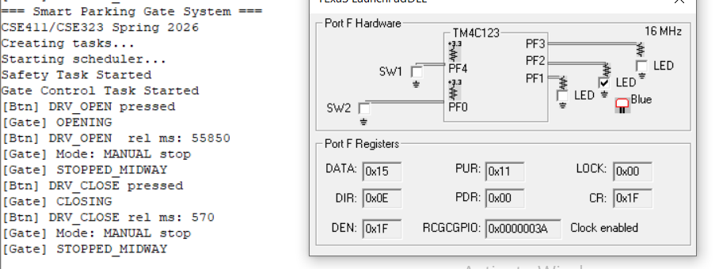

TC-04 — Auto OPEN from IDLE_CLOSED [PASS]
Category | Auto Mode
Objective | Tap OPEN causes gate to move all the way until Open Limit pressed
Precondition | State = IDLE_CLOSED
Steps | 1. Tap DrvOPN < 400 ms  2. Observe GREEN LED stays ON after release  3. Press OPN LIM (PB1)
Expected | GREEN LED stays ON after tap. After OPN LIM → IDLE_OPEN, all LEDs off.
Actual | GREEN LED stays ON after tap. Gate moved to IDLE_OPEN after Open Limit pressed.
Serial Output | [Btn] DRV_OPEN pressed | [Gate] OPENING | [Btn] DRV_OPEN rel ms: <400 | [Gate] Mode: AUTO | [Input] Open Limit pressed | [Gate] IDLE_OPEN
Notes | —
Screenshot:
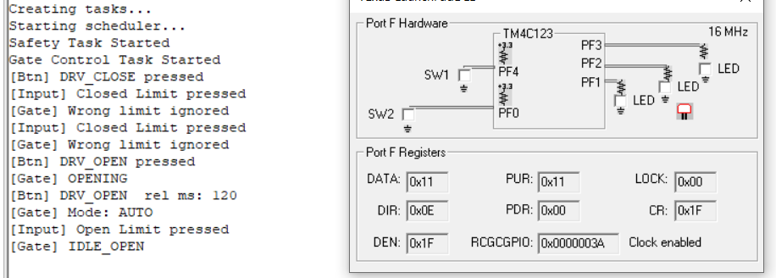

TC-05 — Auto CLOSE from IDLE_OPEN [PASS]
Category | Auto Mode
Objective | Tap CLOSE causes gate to move until Closed Limit pressed
Precondition | State = IDLE_OPEN
Steps | 1. Tap DrvCLS < 400 ms  2. GREEN LED should be off, RED LED ON  3. Press CLS LIM (PD0)
Expected | RED LED stays ON after tap. After CLS LIM → IDLE_CLOSED, all LEDs off.
Actual | RED LED stays ON after tap. Gate moved to IDLE_CLOSED after Closed Limit pressed.
Serial Output | [Btn] DRV_CLOSE pressed | [Gate] CLOSING | [Btn] DRV_CLOSE rel ms: <400 | [Gate] Mode: AUTO | [Input] Closed Limit pressed | [Gate] IDLE_CLOSED
Notes | —
Screenshot:
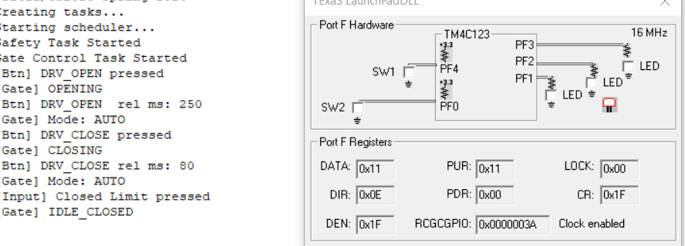

TC-06 — Auto mode from STOPPED_MIDWAY [PASS]
Category | Auto Mode
Objective | Auto mode works from mid-position
Precondition | State = STOPPED_MIDWAY
Steps | 1. Tap DrvOPN < 400 ms → GREEN stays on  2. Press OPN LIM → IDLE_OPEN  3. Reset to STOPPED_MIDWAY  4. Tap DrvCLS < 400 ms → RED stays on  5. Press CLS LIM → IDLE_CLOSED
Expected | Both directions work from STOPPED_MIDWAY in auto mode.
Actual | Auto mode works from STOPPED_MIDWAY in both directions.
Serial Output | [Btn] DRV_OPEN pressed | [Gate] OPENING | [Gate] Mode: AUTO | [Input] Open Limit pressed | [Gate] IDLE_OPEN | [Btn] DRV_CLOSE pressed | [Gate] CLOSING | [Gate] Mode: AUTO | [Input] Closed Limit pressed | [Gate] IDLE_CLOSED
Notes | —
Screenshot:
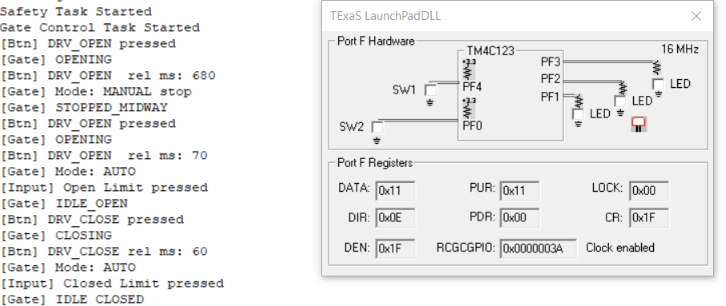

TC-07 — Obstacle during auto-closing [PASS]
Category | Obstacle
Objective | Obstacle triggers stop → reverse 500ms → STOPPED_MIDWAY
Precondition | State = CLOSING (RED LED ON, auto mode)
Steps | 1. Tap DrvCLS → CLOSING  2. Press OBSTACLE (PD1)  3. Observe: RED off, GREEN+BLUE blink ~500ms  4. After 500ms observe BLUE solid
Expected | Immediate stop, reverse (GREEN+BLUE blink 500ms), then STOPPED_MIDWAY (BLUE solid).
Actual | Obstacle triggered reversal: RED off, GREEN+BLUE blink 500ms, then STOPPED_MIDWAY.
Serial Output | [Btn] DRV_CLOSE pressed | [Gate] CLOSING | [Gate] Mode: AUTO | [Input] OBSTACLE pressed | [Safety] OBSTACLE! Reversing... | [Gate] REVERSING | [Safety] Reverse done | [Gate] STOPPED_MIDWAY
Notes | —
Screenshot:
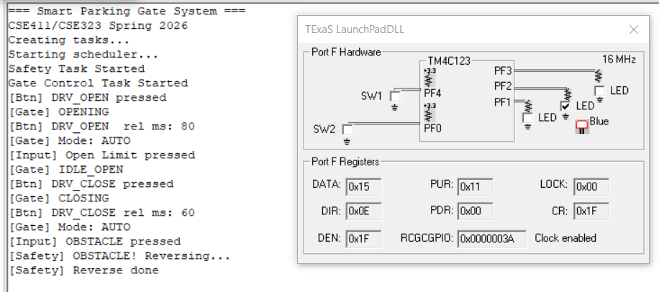

TC-08 — Obstacle overrides held CLOSE [PASS]
Category | Obstacle
Objective | Safety overrides even a manually held CLOSE button
Precondition | State = CLOSING (RED LED ON, manual mode – button held)
Steps | 1. Hold DrvCLS (manual mode)  2. While RED LED ON, press OBSTACLE  3. Observe reversal behavior
Expected | Same as TC-07 – obstacle overrides the held button.
Actual | Safety override works even with CLOSE held manually. Gate reversed and stopped.
Serial Output | [Btn] DRV_CLOSE pressed | [Gate] CLOSING | [Input] OBSTACLE pressed | [Safety] OBSTACLE! Reversing... | [Gate] REVERSING | [Safety] Reverse done | [Gate] STOPPED_MIDWAY
Notes | —
Screenshot:
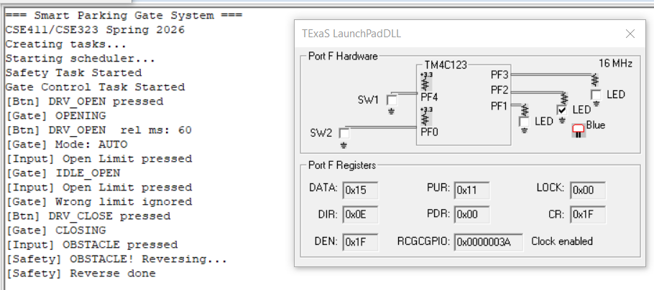

TC-09 — Obstacle ignored during opening [PASS]
Category | Obstacle
Objective | Obstacle has no effect while gate is OPENING
Precondition | State = OPENING (GREEN LED ON)
Steps | 1. Tap DrvOPN → OPENING  2. Press OBSTACLE  3. Observe GREEN LED
Expected | GREEN LED stays ON, gate continues opening. Obstacle is ignored.
Actual | Obstacle ignored during OPENING. GREEN LED stayed ON, gate continued opening.
Serial Output | [Btn] DRV_OPEN pressed | [Gate] OPENING | [Input] OBSTACLE pressed | [Safety] Obstacle ignored | GREEN LED remains ON
Notes | —
Screenshot:
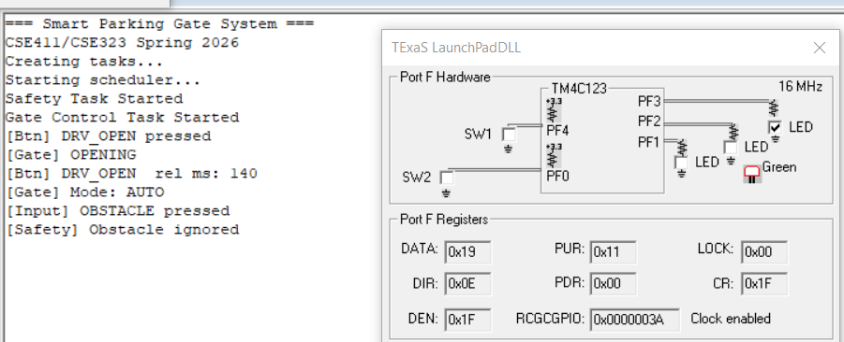
TC-10 — Open Limit stops gate [PASS]
Category | Limit Buttons
Objective | Open Limit button transitions OPENING → IDLE_OPEN
Precondition | State = OPENING (GREEN LED ON)
Steps | 1. Tap DrvOPN → OPENING  2. Press OPN LIM (PB1)
Expected | GREEN LED turns OFF → IDLE_OPEN, all LEDs off.
Actual | Open Limit pressed during OPENING -> IDLE_OPEN. GREEN LED turned off.
Serial Output | [Btn] DRV_OPEN pressed | [Gate] OPENING | [Input] Open Limit pressed | [Gate] Open limit hit | [Gate] IDLE_OPEN
Notes | —
Screenshot:
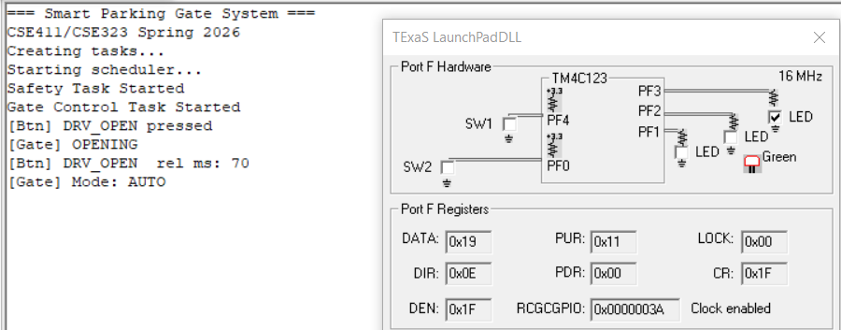
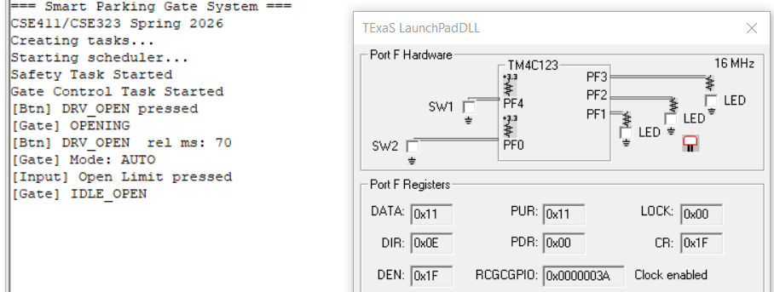
TC-11 — Closed Limit stops gate [PASS]
Category | Limit Buttons
Objective | Closed Limit transitions CLOSING → IDLE_CLOSED
Precondition | State = CLOSING (RED LED ON)
Steps | 1. Tap DrvCLS → CLOSING  2. Press CLS LIM (PD0)
Expected | RED LED turns OFF → IDLE_CLOSED, all LEDs off.
Actual | Closed Limit pressed during CLOSING -> IDLE_CLOSED. RED LED turned off.
Serial Output | [Btn] DRV_CLOSE pressed | [Gate] CLOSING | [Input] Closed Limit pressed | [Gate] Closed limit hit | [Gate] IDLE_CLOSED
Notes | —
Screenshot:
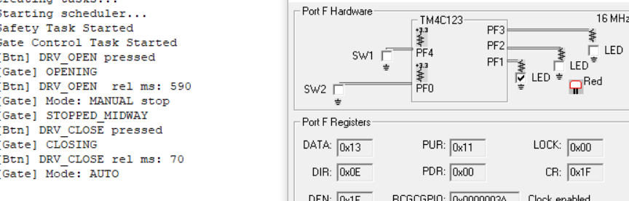
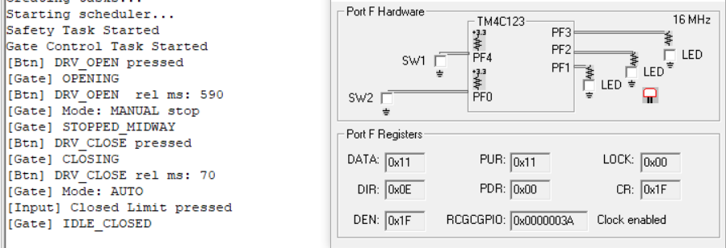

TC-12 — Wrong limit ignored [PASS]
Category | Limit Buttons
Objective | Pressing wrong limit while moving has no effect
Precondition | State = OPENING (GREEN LED ON)
Steps | 1. Tap DrvOPN → OPENING  2. Press CLS LIM (PD0) – wrong limit
Expected | GREEN LED stays ON, gate continues opening. No state change.
Actual | Closed Limit pressed during OPENING had no effect. Gate continued opening.
Serial Output | [Btn] DRV_OPEN pressed | [Gate] OPENING | [Gate] Wrong limit ignored | GREEN LED remains ON
Notes | —
Screenshot:
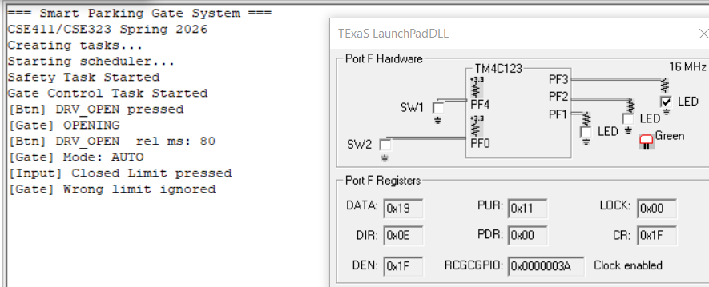

TC-13 — Security OPEN overrides Driver CLOSE [PASS]
Category | Security Priority
Objective | Security command wins when both panels active
Precondition | State = IDLE_CLOSED or CLOSING
Steps | 1. Hold DrvCLS (Driver CLOSE active)  2. Simultaneously press SecOPN (Security OPEN)  3. Observe LEDs
Expected | GREEN LED turns ON – gate opens. Security command overrides driver.
Actual | Security OPEN overrides Driver CLOSE. Gate opened (GREEN on).
Serial Output | [Btn] DRV_CLOSE pressed | [Gate] CLOSING | [Btn] SEC_OPEN pressed | [Gate] Security owns CLOSING | [Gate] OPENING
Notes | —
Screenshot:
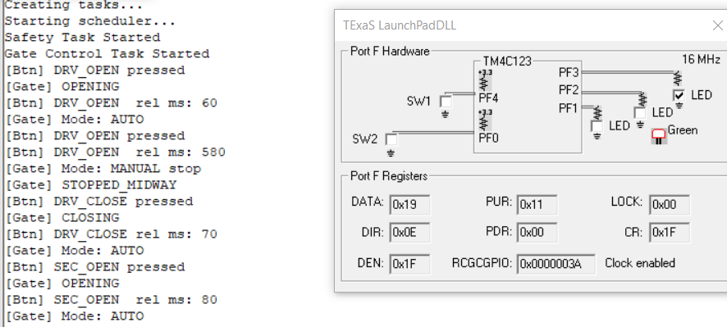
TC-14 — Security CLOSE overrides Driver OPEN [PASS]
Category | Security Priority
Objective | Security CLOSE wins over Driver OPEN
Precondition | State = IDLE_OPEN or OPENING
Steps | 1. Hold DrvOPN (Driver OPEN active)  2. Simultaneously press SecCLS (Security CLOSE)  3. Observe LEDs
Expected | RED LED turns ON – gate closes. Security command overrides driver.
Actual | Security CLOSE overrides Driver OPEN. Gate closed (RED on).
Serial Output | [Btn] DRV_OPEN pressed | [Gate] OPENING | [Btn] SEC_CLOSE pressed | [Gate] CLOSING
Notes | —
Screenshot:
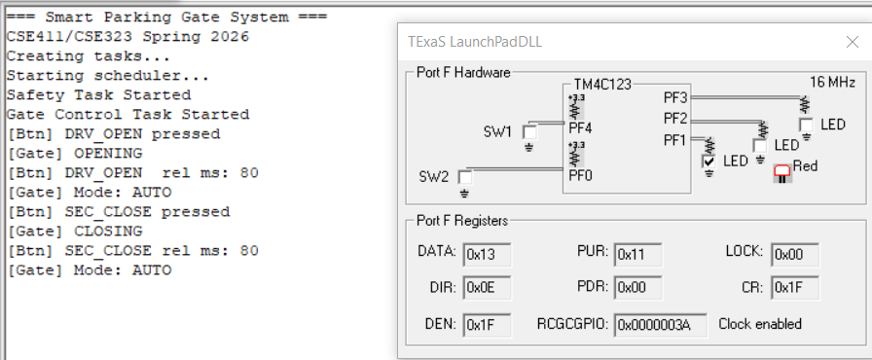

TC-15 — Driver panel conflict – stopped state [PASS]
Category | Conflict
Objective | Simultaneous OPEN+CLOSE on driver panel → safe stop
Precondition | State = IDLE_CLOSED or STOPPED_MIDWAY
Steps | 1. Press DrvOPN and DrvCLS simultaneously
Expected | No motion. BLUE LED on → STOPPED_MIDWAY.
Actual | Driver OPEN+CLOSE simultaneously -> STOPPED_MIDWAY. BLUE LED on.
Serial Output | [Input] Driver CONFLICT | [Gate] CONFLICT -> STOP | [Gate] STOPPED_MIDWAY
Notes | —
Screenshot:
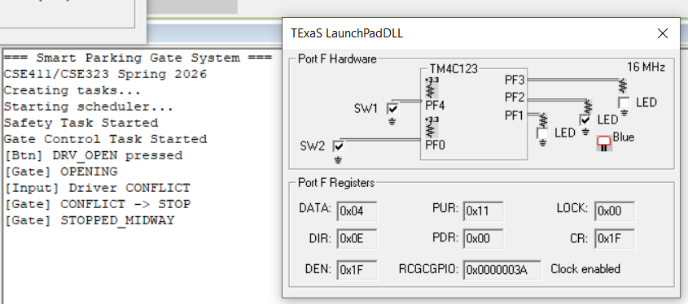

TC-16 — Driver panel conflict – moving state [PASS]
Category | Conflict
Objective | Simultaneous OPEN+CLOSE while gate moving → stops safely
Precondition | State = OPENING or CLOSING
Steps | 1. Start gate moving (tap DrvOPN → OPENING)  2. Press DrvCLS while still moving
Expected | Gate stops → STOPPED_MIDWAY. BLUE LED on.
Actual | Driver OPEN+CLOSE while moving -> STOPPED_MIDWAY. Gate stopped safely.
Serial Output | [Gate] OPENING | [Input] Driver CONFLICT | [Gate] CONFLICT -> STOP | [Gate] STOPPED_MIDWAY
Notes | —
Screenshot:
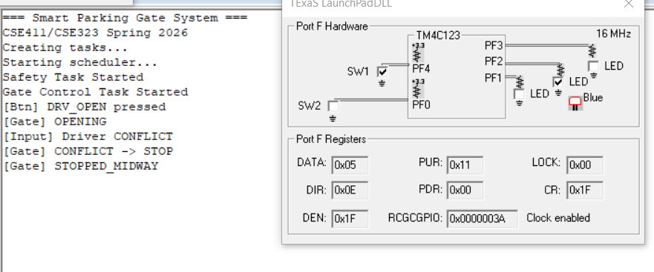
TC-19 — Queue delivers events without loss [PASS]
Category | RTOS Mechanisms
Objective | Rapid button presses are all received by Gate Control
Precondition | System running
Steps | 1. Press multiple buttons rapidly in succession  2. Observe serial output – each press should be logged
Expected | Serial window shows every button press logged with no missing events.
Actual | All rapid button presses logged in serial window. No events dropped.
Serial Output | All [Btn] press events appear in serial output with no gaps.
Notes | —
Screenshot:
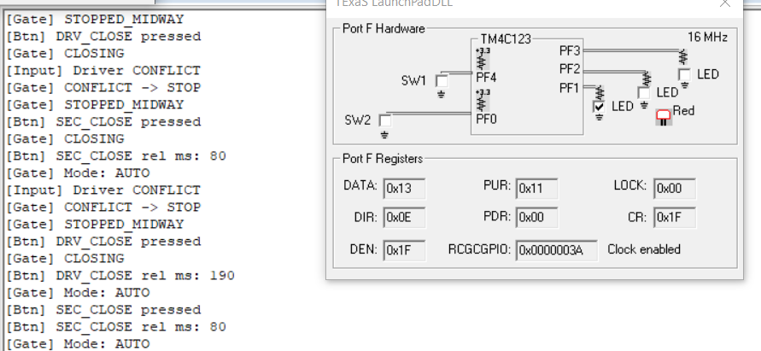

TC-20 — Mutex protects shared state [PASS]
Category | RTOS Mechanisms
Objective | g_gate_state is never corrupted under concurrent access
Precondition | System running normally
Steps | 1. Trigger obstacle during closing (Safety Task writes state)  2. Simultaneously trigger button events (Gate Control reads state)  3. Observe correct behavior with no corruption
Expected | State transitions are always valid. No undefined states observed.
Actual | No state corruption observed. All transitions valid during concurrent obstacle + button events.
Serial Output | State transitions remained valid. Mutex protected shared state correctly.
Notes | —
Screenshot:
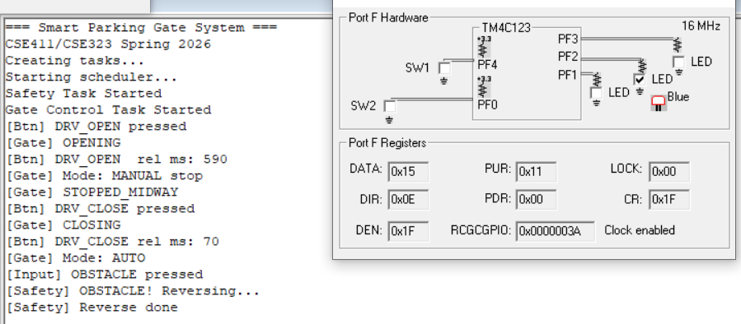

TC-21 — Semaphore signals limit activation [PASS]
Category | RTOS Mechanisms
Objective | xSemLimit semaphore is given on limit press and consumed correctly
Precondition | State = OPENING
Steps | 1. Start auto-opening  2. Press OPN LIM → semaphore given by Input Task  3. Gate Control receives it and stops
Expected | Gate stops immediately at IDLE_OPEN. Semaphore mechanism works alongside queued event.
Actual | Gate stopped immediately at IDLE_OPEN. Semaphore signalled by Input Task consumed by Gate Control.
Serial Output | [Input] Open Limit pressed | [Gate] Open limit hit | [Gate] IDLE_OPEN
Notes | —
Screenshot:

