Cairo University  
Faculty of Computers and Information



**CS251**

**Software Engineering I**

Play and learn

Software Design

Ahmed Hesham El-Metwally

Ahmed Mostafa Ismail

Mina Nabil Zaki

Ahmed Gamal Elmoslhy

Month & Year

Contents

Team 3

Document Purpose and Audience 3

System Models 3

I. Class diagrams 3

Important Algorithm 5

II. Sequence diagrams 5

Class - Sequence Usage Table 7

Ownership Report 8

Policy Regarding Plagiarism: 8

References 8

Authors 8

# Team

|  |  |  |  |
| --- | --- | --- | --- |
| **ID** | **Name** | **Email** | **Mobile** |
| 20140045 | Ahmed Mostafa Ismael | Popup.1996@yahoo.com | 01112982922 |
| 20140048 | Ahmed Hesham El-Metwally | Ahmedmostafa.fci16@gmail.com | 01159259192 |
| 20140010 | Ahmed Gamal El-Moslhy | Minanabil78@yahoo.com | 01228075138 |
| 20140286 | Mina Nabil Zaki | ahmed_midoo250@yahoo.com | 01284233613 |

# Document Purpose and Audience:

The document is an introduction to the class diagram and the sequence diagram of the website. We expect CEO, Project Managers, Analysts…etc. to read this document.

This documents will include the class diagram and the sequence diagram. The class diagram will divide our website into individual classes which is essential in the website implementation. The Sequence diagram will illustrate the flow of each function our website offers.

# System Models

## I. Class diagrams

Main Class Diagram: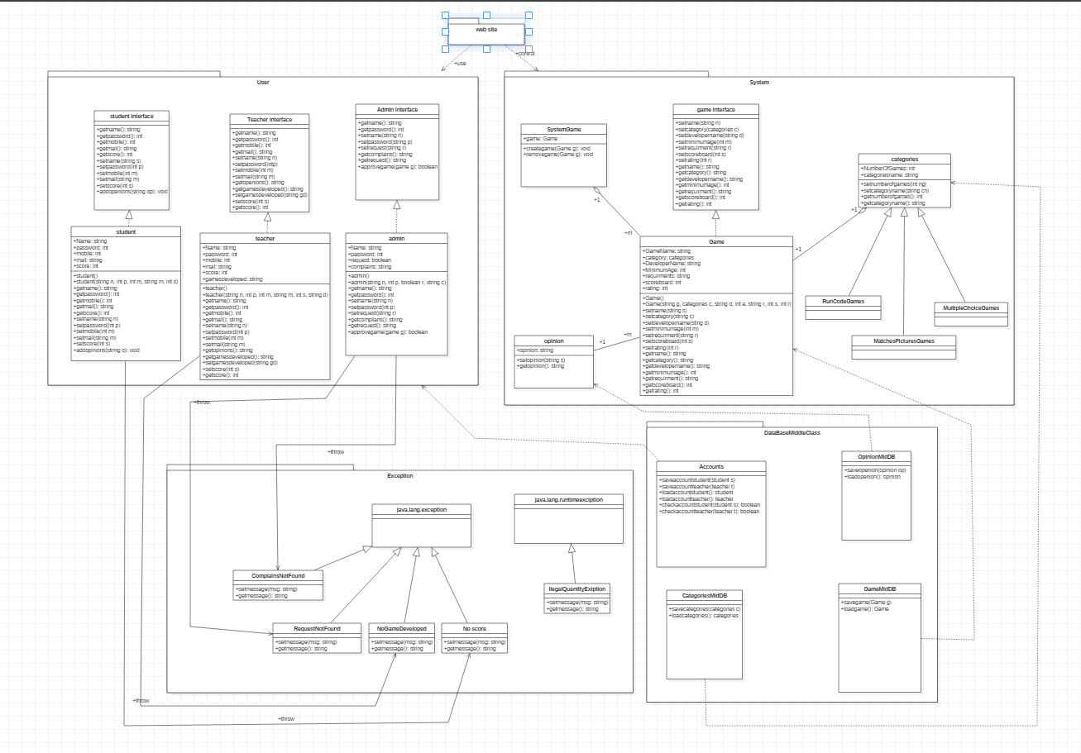

Package User:

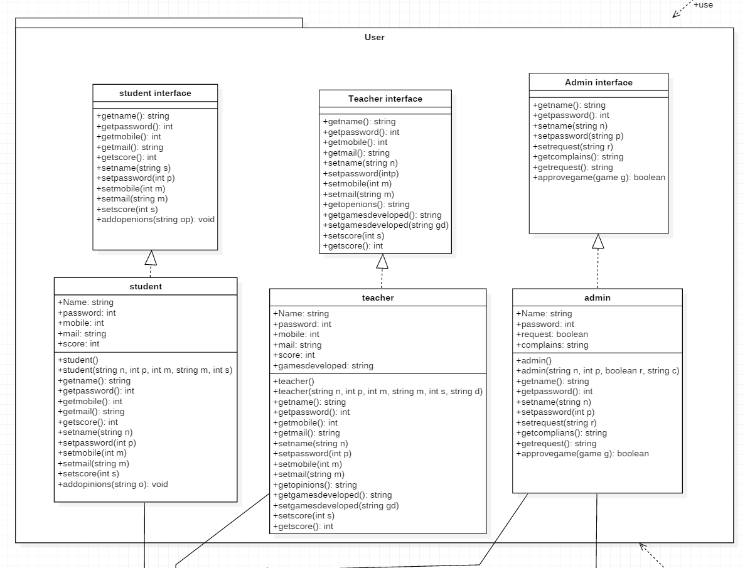

Package System:

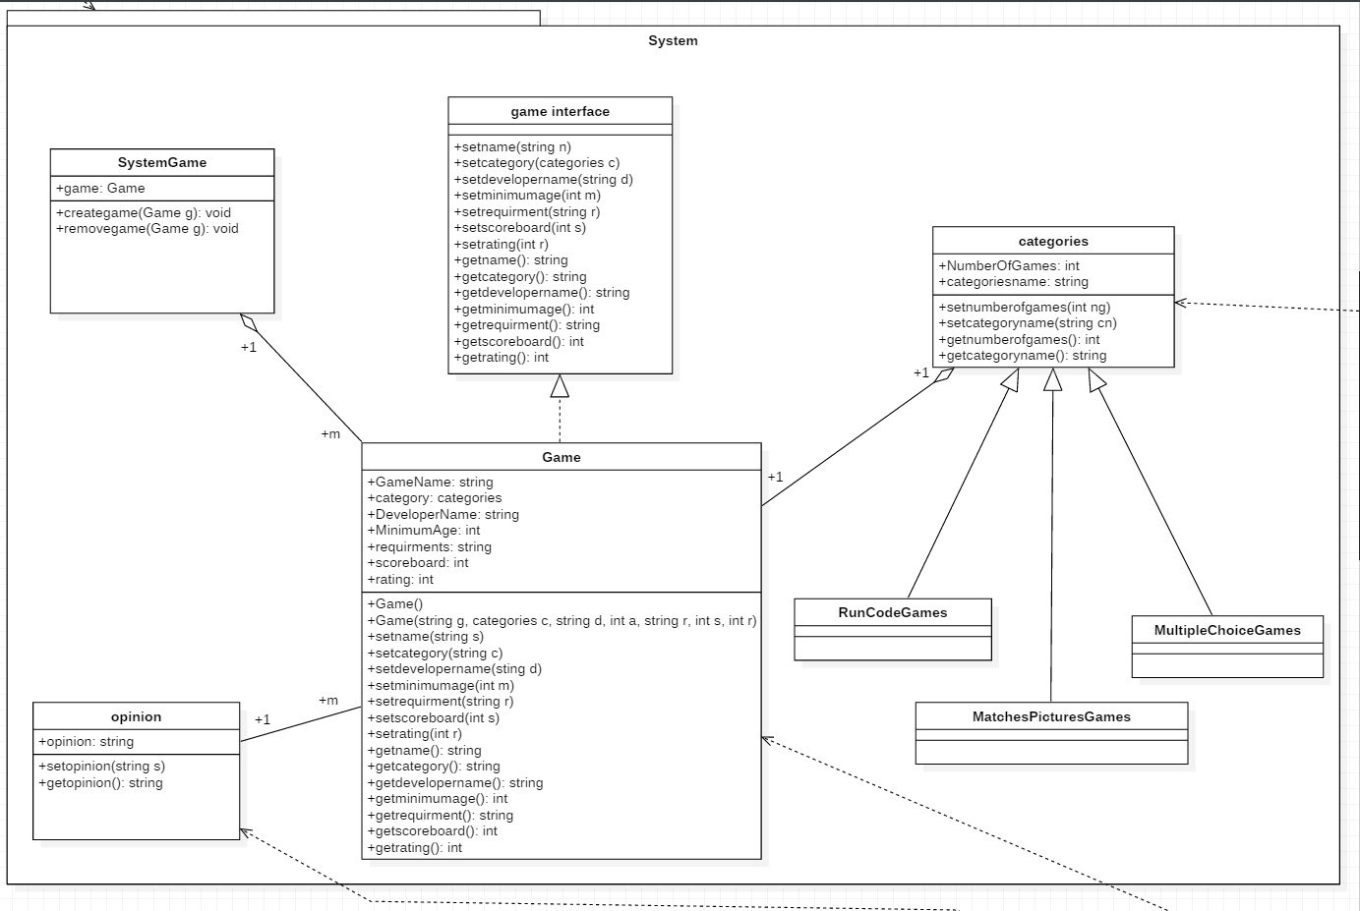

Package Exception:

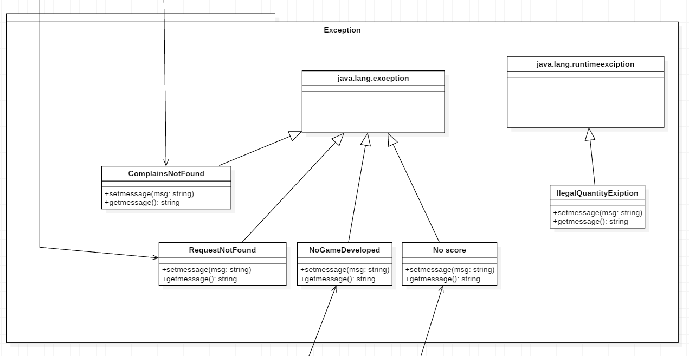

Package DatabaseMiddleClass:

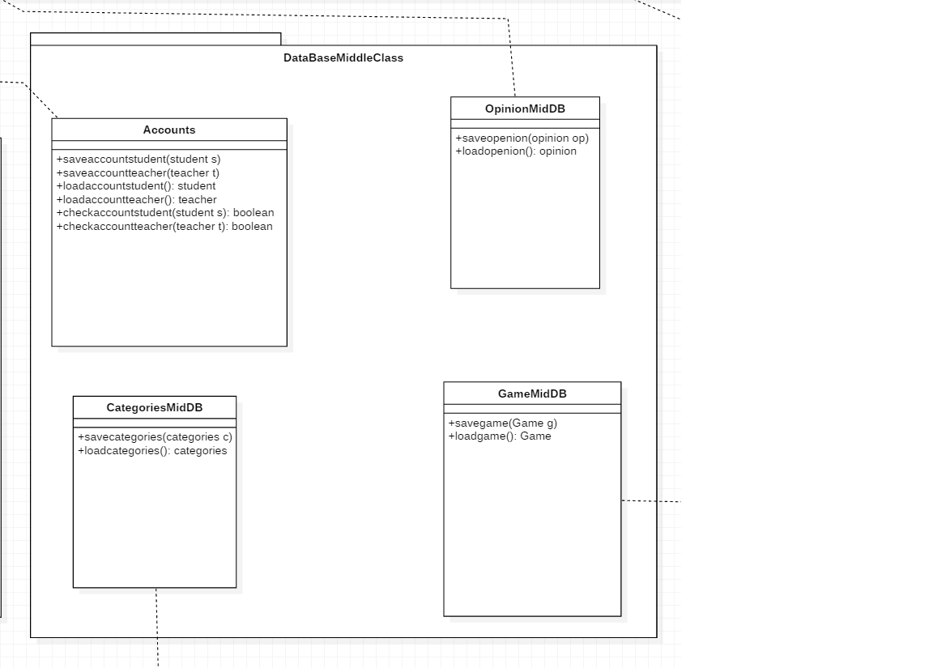

| **Class ID** | **Class Name** | **Description & Responsibility** |
| --- | --- | --- |
| 1 | **Teacher** | **Description:**  This class includes the personal information of the teacher and The number of games developed.  **Responsibilities:**  This class manages the teacher’s data and mainly used in login and create game. |
| 2 | **Student** | **Description:**  This class mainly contains the personal information of the student, scores and achievements of the games played by the student.  **Responsibilities:**  This function manages the student’s data mainly used in login and scoreboard. |
| 3 | **Admin** | **Description:**  This class contains Admin’s data. It contains also the complains and game requests.  **Responsibilities:**  This class is responsible for receiving the complains and the games requests sent by the teachers. |
| 4 | **Opinion** | **Description:**  This class includes the opinions submitted by the students.  **Responsibilities:**  This call is responsible for managing the comments for each game. |
| 5 | **Rating** | **Description:**  This class includes the rating of the games submitted by the students for each game.  **Responsibilities:**  This class is responsible for managing the ratings of each game. |
| 6 | **Accounts** | **Description:**  This class joins the database with the accounts of both the students and teachers.  **Responsibilities:**  This class is responsible for loading, searching and saving accounts to the database. |
| 7 | **Game** | **Description:**  This Class holds the variables of the game selected.  **Responsibilities:**  This class is responsible for controlling the game and holding the progress of the game. |
| 8 | **Game midDB** | **Description:**  This class joins the game class with the database.  **Responsibilities:**  This class is responsible for loading and saving a certain game from/to the database. |
| 9 | **Category midDB** | **Description:**  This class joins the category class with the database.  **Responsibilities:**  This class is responsible for loading and saving the categories from the database. |
| 10 | **Opinion midDB** | **Description:**  This class joins the opinions class with the database.  **Responsibilities:**  This class is responsible for loading and saving opinions to each game selected. |

## II. Sequence diagrams

**1. Registration Sequence Diagram:**

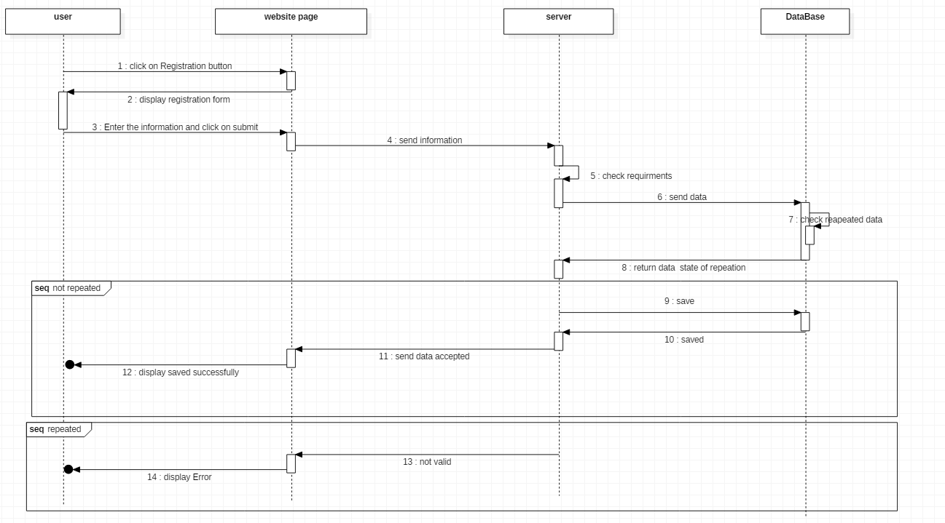

2. Login Sequence Diagram:

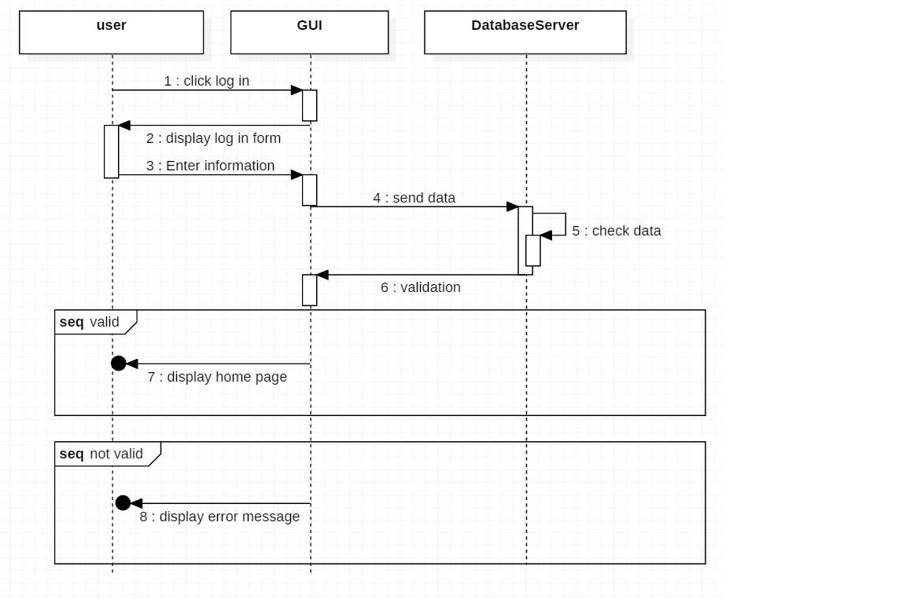

3. Play Sequence Diagram:

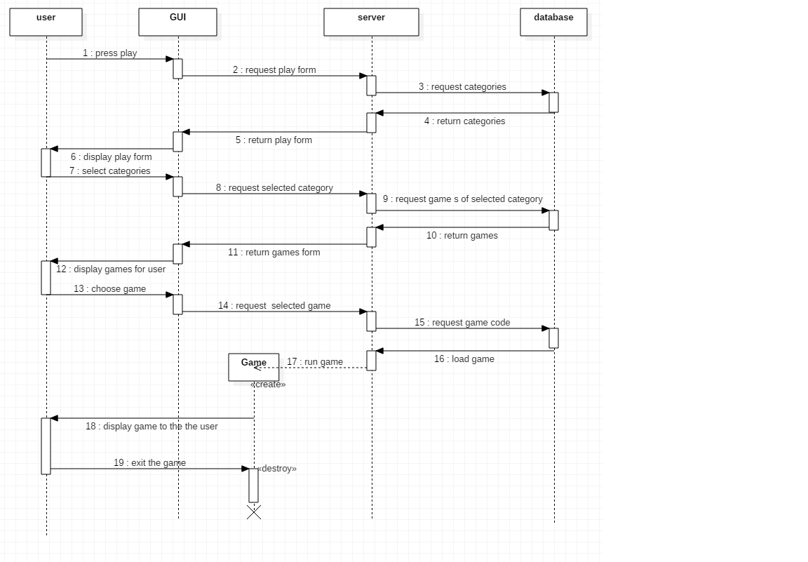

4. Create Game Sequence Diagram:

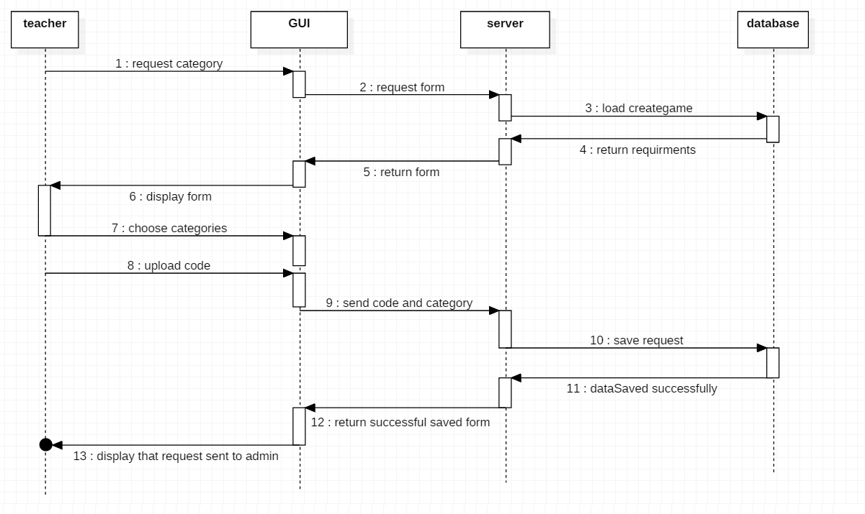

5. Complain Sequence Diagram:

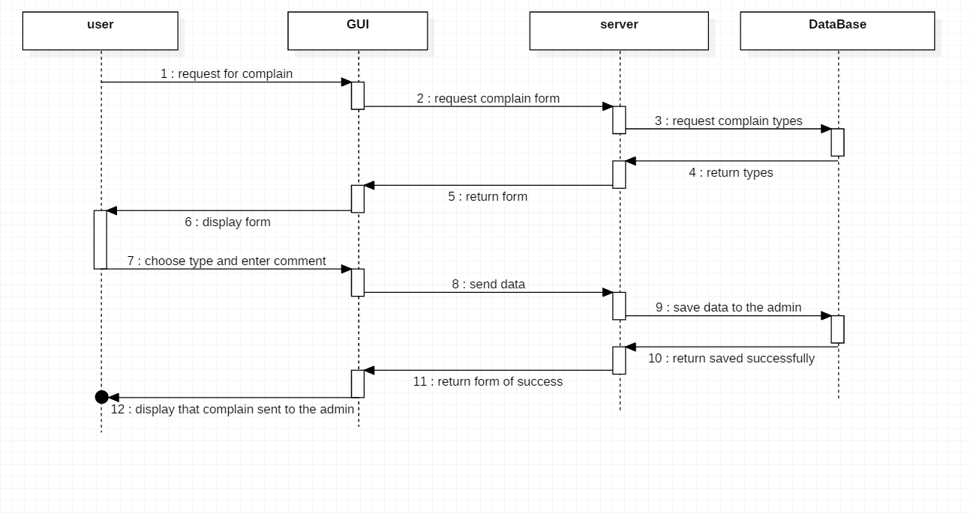

6. Opinion Sequence Diagram:

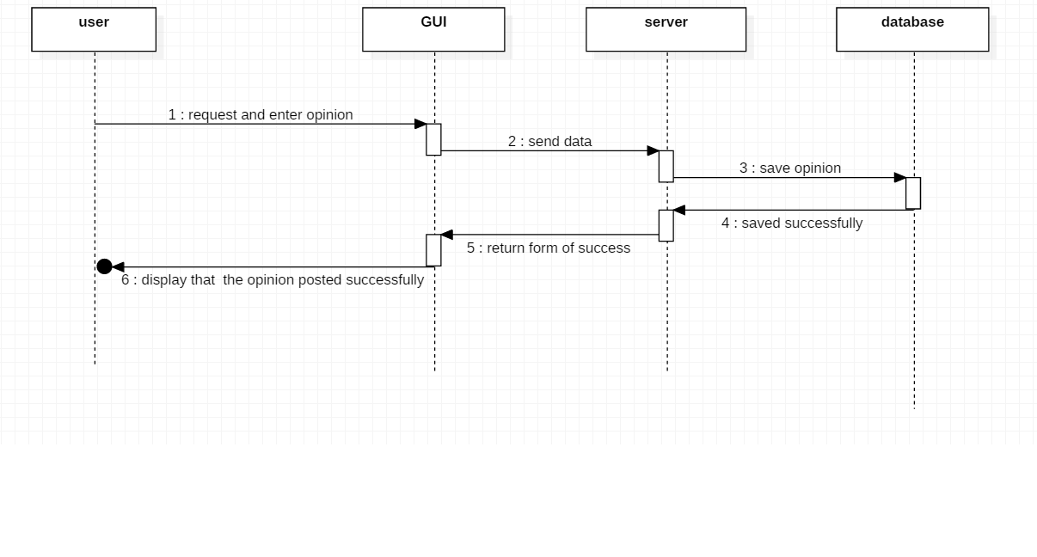

7. Rating Sequence Diagram:

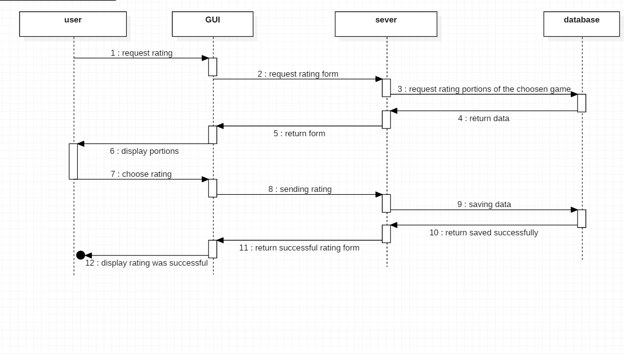

8. Display Personnal Information Sequence Diagram:

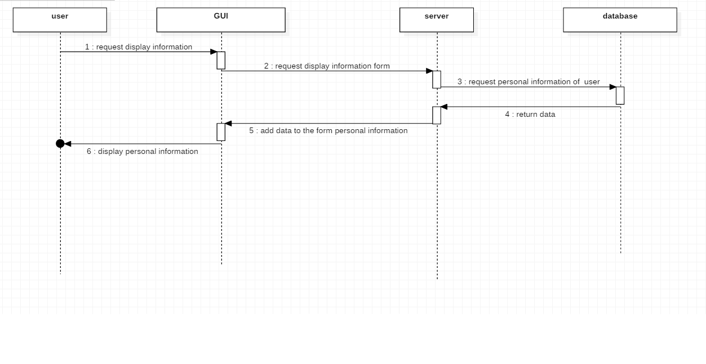

### Class - Sequence Usage Table

| **Class Name** | **Sequence Diagrams** | **Overall used methods** |
| --- | --- | --- |
| Student | 1,2,3,5,6,7,8 | SaveAccountsStudent , LoadAccountsStudent ,  AddOpinion , SetOpinion, SetRating , SetComplain, DisplayInformation |
| Teacher | 1,2,3,4,7,8 | SaveAccountsTeacher , LoadAccountsTeacher , SetRequest , CreateGame , RemoveGame , SetComplain |
| Admin | 4,5 | GetRequest , GetComplain |
| SystemGame | 3,4 | CreateGame, RemoveGame, |
| Opinion | 6 | SetOpinion , GetOpinion |

# Ownership Report

|  |  |
| --- | --- |
| **Item** | **Owners** |
| Class Diagram | *Ahmed Hesham, Ahmed Gamal* |
| Sequence Diagram | *Ahmed Mostafa, Mina Nabil* |

# Policy Regarding Plagiarism:

**Students have collective ownership and responsibility of their project. Any violation of academic honesty will have severe consequences and punishment for ALL team members.**

# References

* http://www.mhhe.com/engcs/compsci/pressman/graphics/Pressman5sepa/common/cs1/design.pdf

# Authors

* Mostafa Saad and Mohammad El-Ramly (Edited by Mohamed Samir)