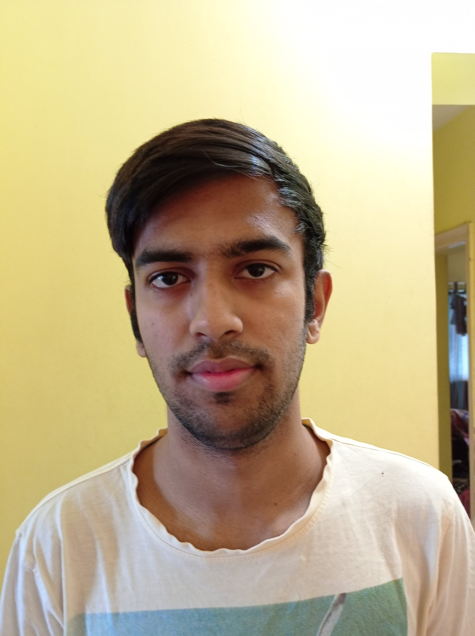

Ahmed Mir | 0000 | mirahmed503@gmail.com

# About Me

I am a problem solving student that is fully driven with charisma, attitude and self-confidence

# Courses done

Java for beginners Python

# Skills

* Java
* Python
* Problem-solving
* Communication