VECAD ELITE INTERNSHIP 2025
WEEK 2
NAME | : Ahmed Mohamed Abdalla Ahmed
MATRIC | : A24KE0429
SUPERVISOR | : Dr Mohd Anuar Md Ali

Objectives:
The main objective for the second internship week was to convert the first-week design into a working multi-sensor prototype. I focused on assembling the available modules, checking the quality of soldered connections and wiring, and verifying every sensor through controlled tests before relying on the full system. The goal was not simply to make a display show values; it was to prove that each reading was obtained from the intended component and could be communicated reliably to the STM32 NUCLEO-L476RG board.
A second objective was to establish a dependable I2C hardware and software layer. The BME280, BH1750, VL53L0X, and SSD1306 OLED were intended to share the same I2C bus, so each device needed to respond at its expected address without disturbing the others. I aimed to use an I2C scanner, module-specific test programs, and serial output to distinguish between software issues, incorrect connections, insufficient power, pull-up problems, and an actual faulty module. This process was necessary before integration because a single defective or incorrectly supplied module can prevent the shared bus from operating correctly.
The final objective was to prepare the prototype for structured occupancy data collection. This required adding the two PIR sensors, LEDs, push buttons, and active buzzer; defining the EMPTY, LOW, and HIGH occupancy labels; and confirming that the firmware could start and stop labelled recording sessions. I also aimed to prepare the serial logging method so that measurements could be saved as CSV files for later data cleaning and AI training, rather than being lost in the serial monitor.

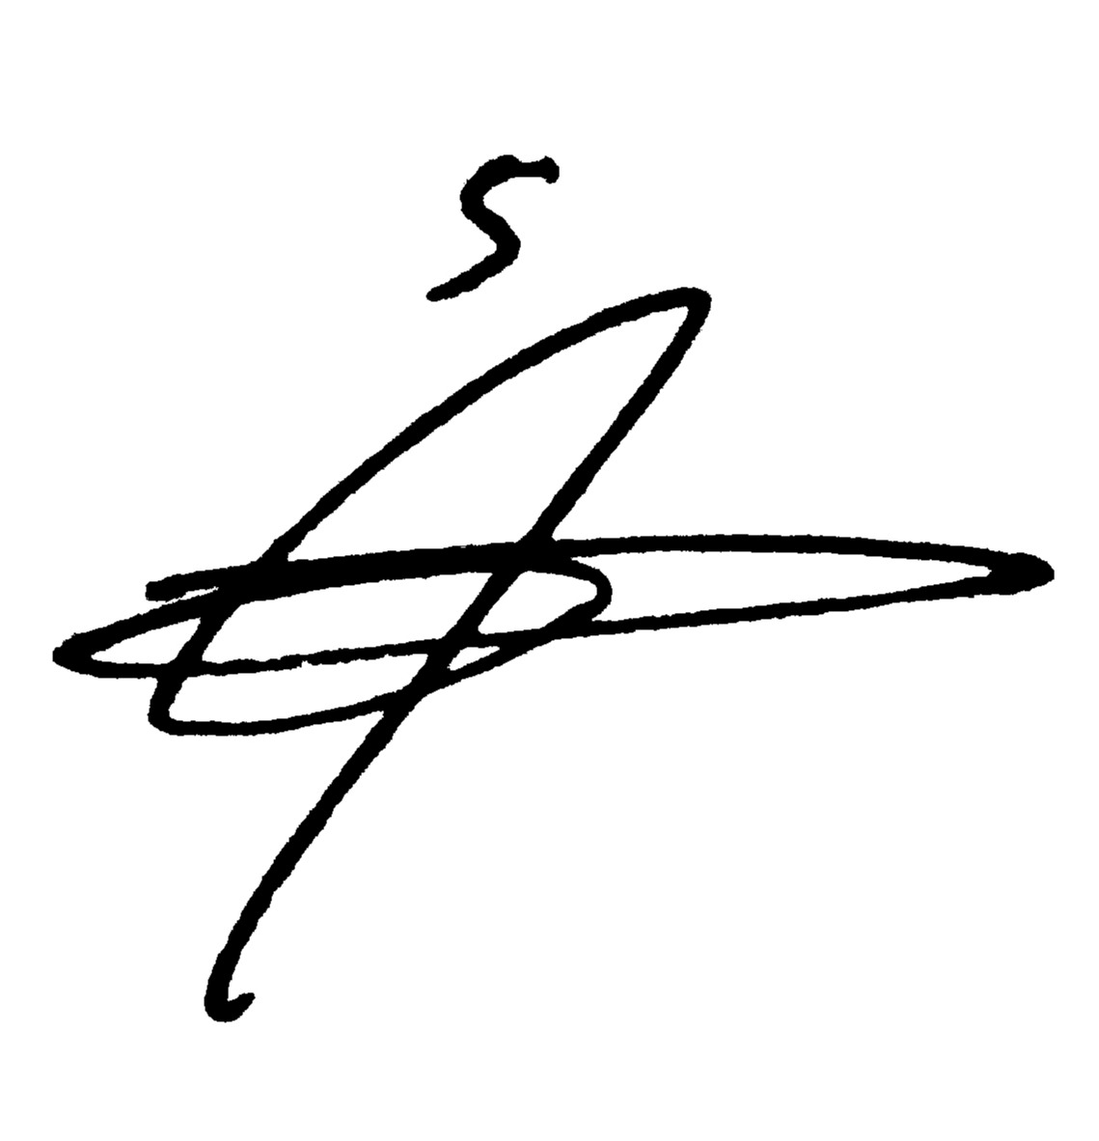  Student's Name/Signature:  Date: 18/9/2026 | Supervisor's Name/Signature:  Date:

VECAD ELITE INTERNSHIP 2025
WEEK 2
NAME | : Ahmed Mohamed Abdalla Ahmed
MATRIC | : A24KE0429
SUPERVISOR | : Dr Mohd Anuar Md Ali

Summary of weekly activities:
At the beginning of the week, the ordered components became available and I started the practical assembly stage. The work took more time than expected because I did not initially have all of the required soldering tools and had to prepare or borrow the appropriate equipment before the headers could be attached properly. I treated this stage carefully because poor solder joints can create intermittent faults that look like software problems. After fitting the headers, I inspected the modules, connected them one at a time, and avoided integrating all of them at once. This made it possible to identify the source of a problem instead of having many unknowns in the same circuit.
The BME280 environmental sensor was one of the first modules that I tested. I confirmed that it could return temperature, relative humidity, and pressure values and used the serial output to check that the data changed in a reasonable way. The OLED display was then brought up using the SSD1306 driver, and I confirmed that measured values and simple status messages could be displayed. These first tests established that the STM32 I2C peripheral, the basic wiring, and the OLED library could work together. They also gave me a useful way to show live system status without depending only on a computer terminal.
I developed and used an I2C scanner to examine every valid address on the selected STM32 I2C bus. The scanner was especially useful because it reported the normal seven-bit device address as well as the left-shifted address required by the STM32 HAL functions. When modules were connected correctly, the expected devices could be recognised from their addresses: the BH1750 at 0x23, the VL53L0X at 0x29, the SSD1306 OLED at 0x3C, and the BME280 at 0x76. This gave a clear and repeatable hardware check before running each sensor's application code.
The VL53L0X distance sensor required additional firmware work because its vendor API includes platform files intended for several operating systems. I selected the STM32-compatible I2C platform implementation and removed the Windows-specific communication and logging sources that caused compilation errors. After the driver was built successfully, the sensor reported distance and range status values through the serial monitor and the OLED display. I learned to interpret a valid range status separately from an invalid or out-of-range reading, rather than treating every numeric value as a real distance.

Student's Name/Signature:  Date: 18/9/2026 | Supervisor's Name/Signature:  Date:

VECAD ELITE INTERNSHIP 2025
WEEK 2
NAME | : Ahmed Mohamed Abdalla Ahmed
MATRIC | : A24KE0429
SUPERVISOR | : Dr Mohd Anuar Md Ali

Summary of weekly activities:
The BH1750 light-sensor test became an important troubleshooting exercise. The first module did not answer on the I2C bus even after the wiring, pull-up configuration, supply, and addresses had been checked on both the NUCLEO board and an Arduino. Instead of continuing to modify code without evidence, I compared it with another known working sensor and repeated the scan. The replacement BH1750 was detected at address 0x23 and produced sensible lux values that changed when the lighting level changed. This result showed that the original issue was most likely the module itself rather than the I2C scanner or the STM32 software. It also reinforced the value of isolating a suspected device and testing it with a second platform.
I also tested the two PIR motion sensors, the LEDs, push buttons, and active buzzer. The PIR modules provided a digital logic signal when motion was detected, but their behaviour had to be observed after the warm-up period and under real room conditions. I learned that their delay, sensitivity, mounting direction, and air movement can affect the output, so a single PIR transition should not automatically be treated as a reliable occupancy decision. The active buzzer was verified with a simple GPIO test program. This test confirmed the logic level required by the particular module and prevented the main program from leaving the buzzer on continuously because of an inverted active-low connection.
After the individual checks, I combined the sensor modules into one prototype and confirmed that the shared I2C bus could identify all four required devices. The main firmware was extended to read the two PIR inputs, BME280 values, ambient light, and distance information while also driving the OLED, LEDs, buttons, and buzzer. I introduced the three recording labels - EMPTY, LOW, and HIGH - so that a session could be given its correct class before logging began. The LEDs and display made the selected state visible, while the buttons allowed the operator to change the label and start or stop a recording session without repeatedly editing the code.
To support later AI work, I prepared a serial-data logger in Python. The STM32 firmware emitted a CSV-style header and labelled data rows containing the session identifier, microcontroller time, PIR values, distance data, environmental readings, light level, validity flag, and occupancy label. The Python logger listened on the virtual COM port and saved each complete session as a CSV file. I then planned a balanced collection routine for EMPTY, LOW, and HIGH occupancy under different conditions such as lights on or off and air-conditioning on or off. By the end of the week, the prototype had moved from individual module tests to a stable integrated data-collection system.

Student's Name/Signature:  Date: 18/9/2026 | Supervisor's Name/Signature:  Date:

