

**Faculty of engineering - Shoubra Benha University**

# Research Article / Research Project / Literature Review

in fulfillment of the requirements of

|  |  |
| --- | --- |
| **Department** | Engineering Mathematics and Physics |
| **Division** | ----------- |
| **Academic Year** | 2019-2020 Preparatory |
| **Course name** | Computer |
| **Course code** | ECE001 |

**Title: -**

Internet of Things

By:

|  |  |  |  |
| --- | --- | --- | --- |
|  | Name | Edu mail | B.N |
| 1 | احمد اسامه احمد عبد العظيم | Ahmed195022@feng.bu.edu.eg | 21 |

## Approved by:

|  |  |
| --- | --- |
| Examiners committee | Signature |
| Dr.Ahmed Bayoumi |  |
| Dr.Shady Elmashad |  |
| Dr. Abdelhamid Attaby |  |

# Table of contents

|  |  |
| --- | --- |
| **Subject / section** | **Page** |
| Introduction | 2 |
| Literature Review | 3 |
| Source code | 6 |
| screenshot | 8 |

# List of Figures

|  |  |  |
| --- | --- | --- |
| **Figure I.D** | **Description** | **Page** |
| Fig.1 | Source code 1 | 6 |
| Fig.2 | Source code 2 | 6 |
| Fig.3 | Source code 3 | 7 |
| Fig.4 | Page1 | 8 |
| Fig.5 | Page2 | 8 |
| Fig.6 | Page3 | 9 |

**Introduction**

The world lived in the era of computing and desktop and personal computers, and this wave that lasted for nearly 15 years was the nature of that era. For example, Microsoft’s message at the time was “a device on every office and in every home” and it succeeded in achieving it in a way Whole. With the development of processors and screens, we moved to the era of mobility, where the appearance of the iPhone in the beginning of 2007 marked the launch of the new era of technology and the new era of computing. From that time until the moment, we carry in our pockets what can do tasks that exceed those of a huge desktop computer that sits on our offices 10 years ago.

**Internet of Things** (IOT), is a modern technical method that aims to attract things represented by devices and sensors and connect them to the Internet to transmit data between them without human intervention, and that is automatic if the thing is in the geographical area covered by the Internet.

Examples of this are adjusting the heating means within a building from operating and closing, as it also applies to lighting and the operation of some machines and production means and follow-up on them in advance; Thus, pre-reporting the possibility of an error or malfunction in the devices before they occur and remedy them,

 It is noteworthy that the Internet of Things lists many of the everyday things that can be combined with it and apply the principle of working on it.

Such as industrial machines, wearable devices, and more.

The next period of technological life will spread as it is the best way to make life more efficient than before.

# 

# Literature Review

**The concept of things in the Internet of things**

Everything in the full sense of the word comes under the concept of Internet of things, clothes, furniture, household utensils, body parts, streets, and various household items such as fridge, washing machine, alarms, buildings entrances and air conditioners, and the list extends to include everything from other things such as goods and products available on the shelves of shops.

Even animals! Anything that a processor and internet connection can stick to is something in the IoT world. For example, a lot of cows farms around the world are beginning to connect the bodies of cows to the Internet to monitor their health and the percentage of some hormones in their body, which indicates the best time to milk them, which contributes to making accurate decisions to improve the production process.

The establishment of the Internet of Things system depends on the abundance of many major components, these are smart devices that support the web for the purposes of harnessing it to process data, sensors, and communications devices of various kinds to collect data from their environment and transfer it to the beneficiary. The secret of the business is that all IoT devices communicate with special sensors to capture and analyze the necessary data. Then return the important information without any human intervention, there are no special protocols for connecting to the network and web-supported devices.

The Internet of Things enables people to effectively and easily control things closely and remotely. For example, the user can operate and control his car's engine from his

computer. One can control the duties of washing with his washing machine, and he

can also learn the contents of the refrigerator remotely through the use of Internet calling. However, these are examples of the primitive form of the Internet of Things. The advanced form is that different "things" understand each other using the Internet protocol :

For example, the fridge can correspond with the shopping center and purchase and deliver supplies without human intervention.

**IoT applications**

The scope of application of IoT technology is very broad in daily life and the most important:

* Smart and wearable devices.
* Automatic arrangement of people's daily appointments.
* Detecting fumes rising nearby, and sirens sounding.
* Monitor the availability of fuel in heating stations and alert in the event of completion.
* Guidance on where to find parking spaces when searching for it automatically.
* The ability to see some of the natural conditions prevailing in a place by the network, such as the quality and quality of the soil.
* Disclosing the inventory of manufacturing materials, to know their small numbers and inform them about them.

**Internet of Things use**

**Healthcare**

As patients can be monitored remotely and their cases recorded in electronic records,

it can also be activated in wearable devices to impose control on exercise and sleep style of patients and also can contribute to saving many lives when reporting a pre-existing risk to the patient's health before death occurs .

**Buying and selling:**

Both the consumer and the merchant benefit as the merchant monitors the goods available to him in the store and sales and purchases, while the consumer is provided with the last of the goods provided.

**Factories and companies**

This is represented by the polarization of data on machines in the factory divisions, materials and equipment accumulated on the shelves in warehouses, and the role of the Internet of Things here is to track the available resources in terms of their accessibility and problems there and others; This entails ensuring that the business is performed efficiently and effectively.

**Source code**

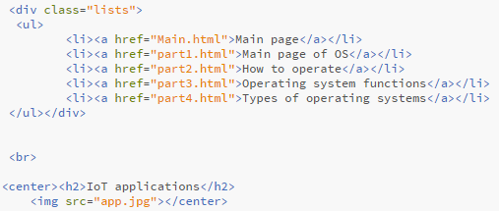

Fig.1

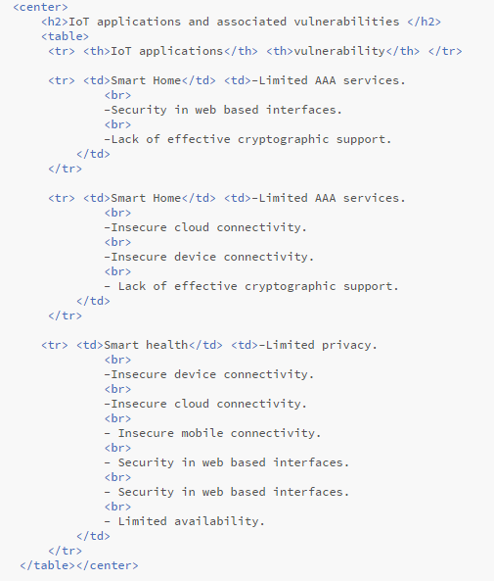

Fig.2

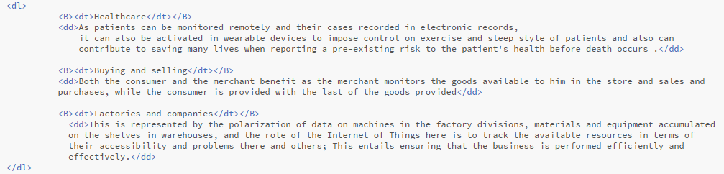

Fig.3

**Screenshot**

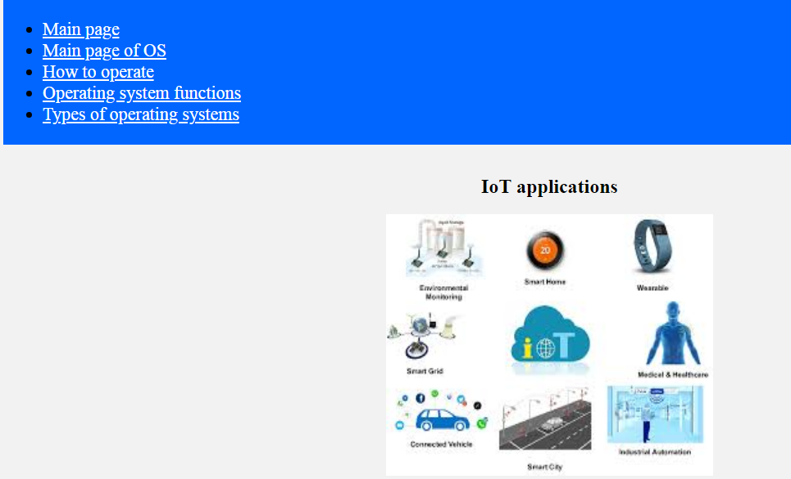

Fig.4

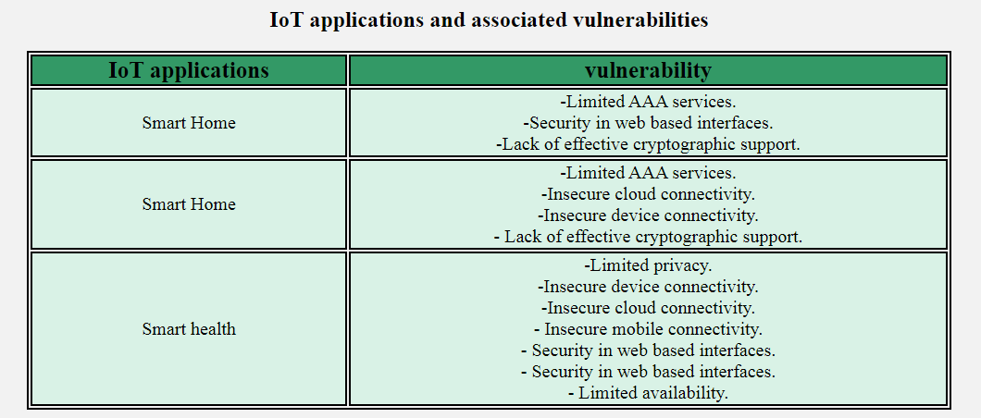

Fig.5

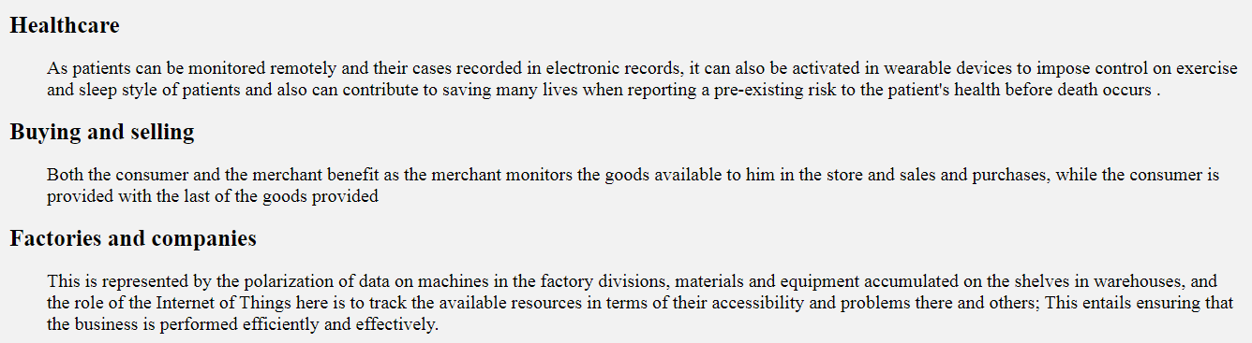

Fig.6

**References**

1. <https://www.iotforall.com/what-is-iot-simple-explanation/>

2- <https://www.oracle.com/internet-of-things/what-is-iot.html>

3- <https://www.investopedia.com/terms/i/internet-things.asp>

4- <https://dzone.com/articles/top-10-uses-of-the-internet-of-things>