
Programming for Artificial Intelligence
Semester Project Proposal

Title:
PlantEye – Vision-Based Plant Disease Detector

Project Overview
PlantEye is an autonomous mobile robot designed to help farmers and gardeners identify plant diseases early. The robot moves around a garden or farm, detects plants using sensors, captures images of their leaves, and uses artificial intelligence to diagnose any diseases. Once a disease is found, the system provides specific treatment recommendations to help save the crops.
Plant diseases cause significant crop losses every year. Early detection can make the difference between a healthy harvest and losing an entire crop. This project aims to make disease detection easier and more accessible, especially for small-scale farmers who might not have access to expensive agricultural technology.

Key Features
1. Autonomous and Remote-Controlled Navigation
The robot moves independently without human control but we can also control the car using a remote, then the car uses sensors to avoid obstacles and find its way around the garden.
2. Automatic Plant Detection
Built-in ultrasonic sensors detect when a plant is nearby, triggering the camera to capture images.
3. Wireless Image Transfer
Photos are sent from the robot to a laptop through WiFi, eliminating the need for cables or manual transfers.
4. AI-Powered Disease Detection
A pre-trained deep learning model analyzes leaf images and identifies specific diseases with high accuracy.
5. Treatment Recommendations
After identifying a disease, the system displays appropriate treatment methods and cures.
6. Real-Time Processing
The laptop processes images immediately and provides instant feedback about plant health.
7. Continuous Operation
The robot can scan multiple plants in sequence, moving from one to the next automatically.

System Modules
Module 1: Navigation and Obstacle Avoidance
This module handles all the robot's movement. Two DC motors power the wheels, allowing the robot to move forward, backward, and turn. The ultrasonic sensor constantly measures distances to nearby objects. When it detects something within range, the robot stops and checks if it's a plant or just an obstacle to avoid.
Components used: DC Motors, L298N Motor Driver, HC-SR04 Ultrasonic Sensor, Standard ESP32 Dev Module
Module 2: Image Capture and Communication
When a plant is detected, the ESP32-CAM module takes over. It captures high-quality images of the plant's leaves from an optimal angle. Once the image is captured, it gets sent to the laptop through WiFi using the MQTT protocol, which is reliable and efficient for this type of data transfer.
Components used: ESP32-CAM Module, WiFi Connection
Module 3: Disease Detection and Cure Suggestion
This is where the AI does its work. The laptop receives the plant image and runs it through two models. First, YOLOv8n helps with object detection and path planning. Then, MobileNetV2, which is specifically trained on plant diseases, analyzes the leaf and identifies any problems. The model compares the image against thousands of examples it has learned from. When it finds a match, it uses a database to look up the appropriate treatment and displays everything on screen.
Components used: Laptop, YOLOv8n Model, MobileNetV2 Model, Disease-Cure Database

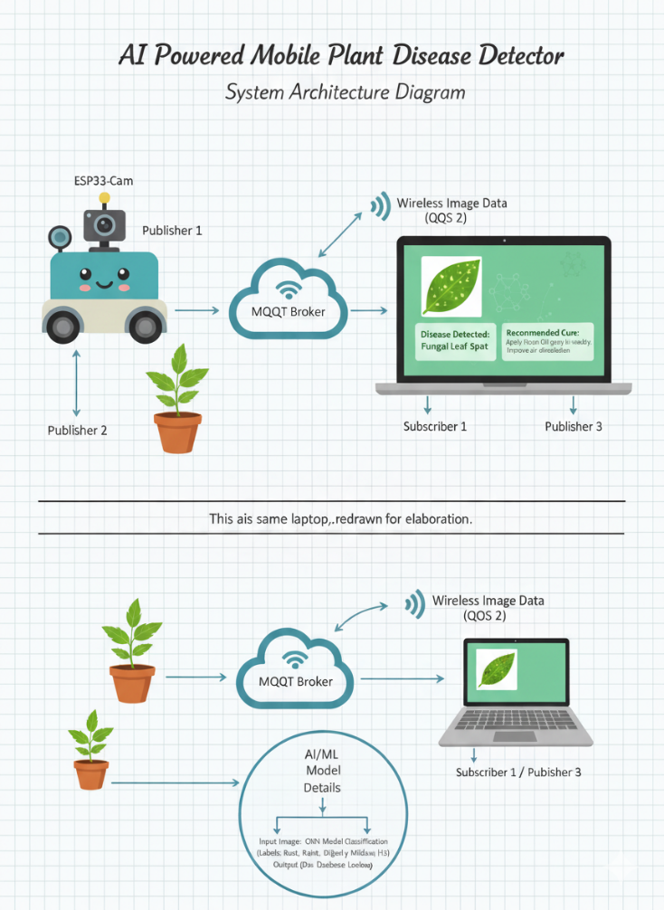
System Architecture Diagrams

Block Diagram1: System architecture showing the data flow from robot to MQTT broker to laptop for AI processing.
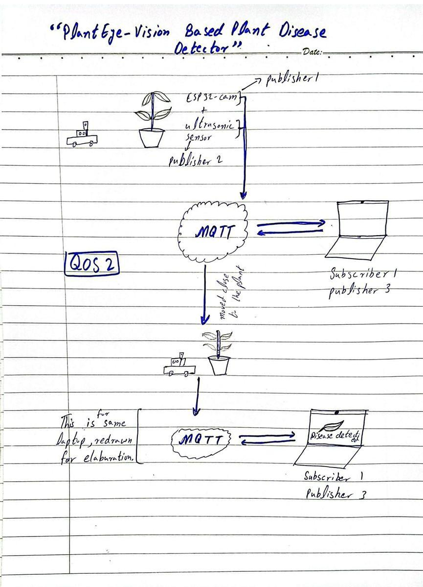
Block Diagram2: Communication flow diagram illustrating MQTT protocol implementation with Quality of Service level 2.

Hardware Components
Main Components:
- ESP32-CAM Module (Camera + WiFi)
- Standard ESP32 Dev Module
- HC-SR04 Ultrasonic Sensor
- L298N Motor Driver
- 4x DC Motors with Wheels
- Robot Chassis with Mounts
Supporting Components:
- 7.4V or 9V Battery Pack
- Power Regulator (5V supply)
- Jumper Wires and Breadboard
- Laptop (model execution)

Circuit Design
The circuit design uses two ESP32 modules working together. The standard ESP32 handles motor control through the L298N driver, which regulates power to both DC motors. The ultrasonic sensor connects to this ESP32 as well, feeding distance measurements that help with navigation decisions.
The ESP32-CAM runs independently, focusing solely on image capture and transmission. Both modules communicate with the laptop through MQTT, creating a reliable network where each component has a specific job. The battery pack supplies power to all components through the motor driver, which also acts as a power distribution point. A voltage regulator keeps the power supply stable at 5V to protect the sensitive electronics.
Important Note: All components share a common ground connection to prevent electrical issues and make sure signals are properly communicated between different parts of the system.
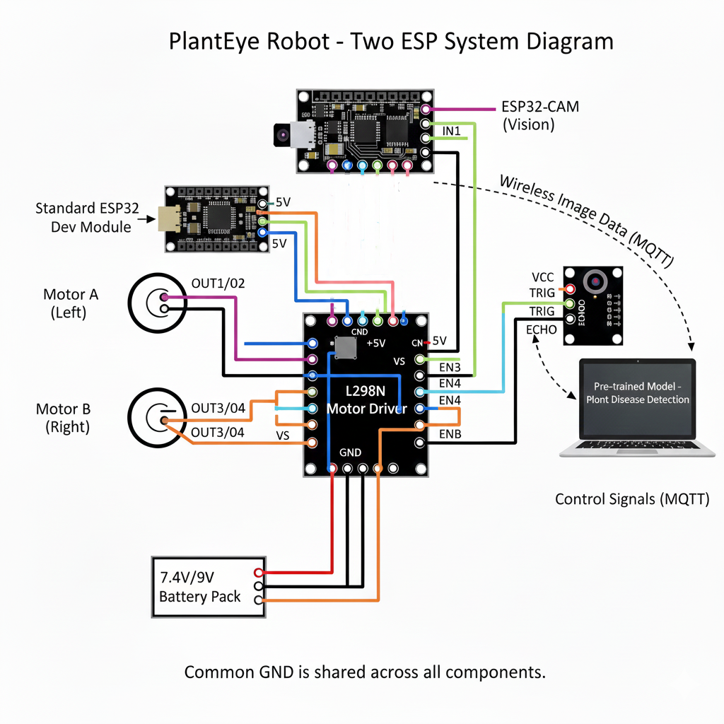
Circuit Diagram: Shows complete wiring connections between ESP32, modules, motor driver,
ultrasonic senor, and the power supply.

How It Works
Step 1: Robot Movement
The robot starts moving forward with both motors running. The ultrasonic sensor continuously sends out sound waves and measures how long they take to bounce back. This tells the robot how far away objects are. The robot moves at a steady pace, searching for plants to examine.
Step 2: Plant Detection
When the sensor detects something within a certain range, the robot stops. The system then analyzes whether this object is actually a plant or just a wall or other obstacle. If it's identified as a plant, the process moves forward. If not, the robot adjusts its path and continues searching.
Step 3: Image Capture
Once a plant is confirmed, the ESP32-CAM activates. The camera focuses on the plant's leaves, which usually show the clearest signs of disease. If needed, a servo motor adjusts the camera angle to get the best possible shot. The camera captures a high-resolution image suitable for detailed analysis.
Step 4: Wireless Transmission
The captured image is immediately sent to the laptop through WiFi. The system uses MQTT protocol with Quality of Service level 2, which means the image is guaranteed to arrive exactly once without loss or duplication. This takes only a few seconds even for large image files.
Step 5: AI Analysis
The laptop receives the image and feeds it into the MobileNetV2 model. This neural network has been trained on thousands of plant disease images. It looks for patterns like discoloration, spots, wilting, or unusual textures. The model processes the image layer by layer, extracting features and comparing them to known disease signatures. Within seconds, it produces a diagnosis with a confidence score.
Step 6: Results Display
If a disease is detected, the laptop screen shows the disease name along with detailed information. A database lookup retrieves the recommended treatment, which might include specific fungicides, changes in watering habits, or other interventions. If the plant is healthy, the system displays that too. Either way, the user gets clear, actionable information.

Step 7: Continue Scanning
After displaying the results, the robot receives a signal through MQTT to continue. It moves forward to find the next plant, and the whole process repeats. This allows the robot to scan an entire garden or field autonomously, checking dozens of plants without any human intervention.

Simulation and Testing Results
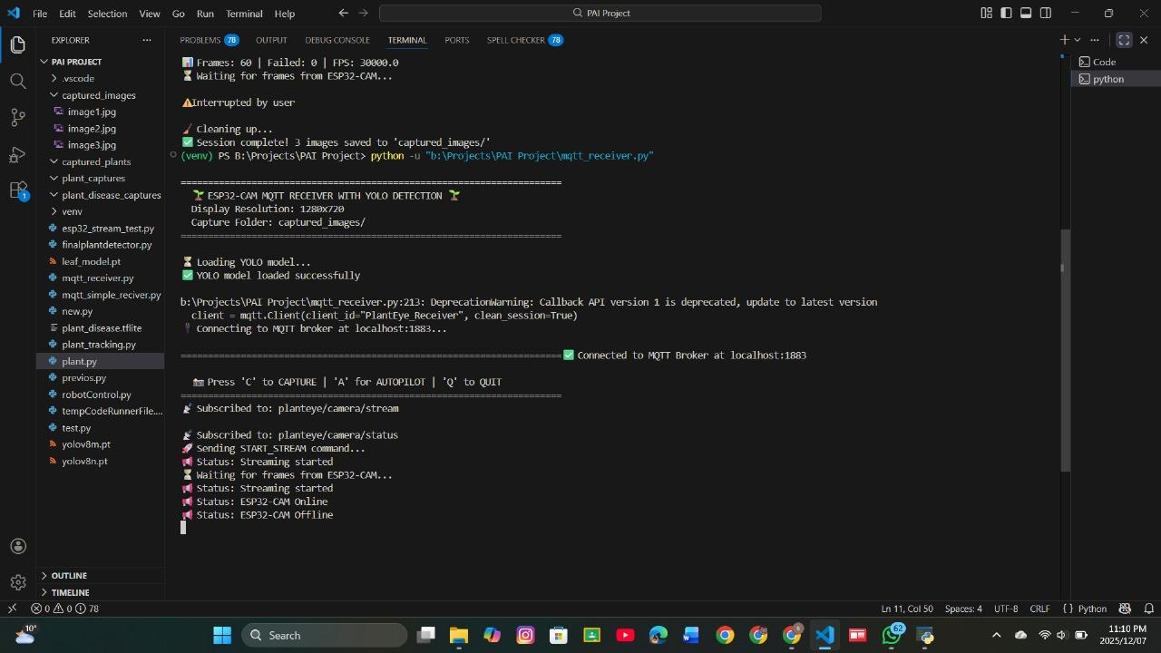
AI Model Testing
Successful image transmission through MQTT broker demonstrating QoS 2 reliability

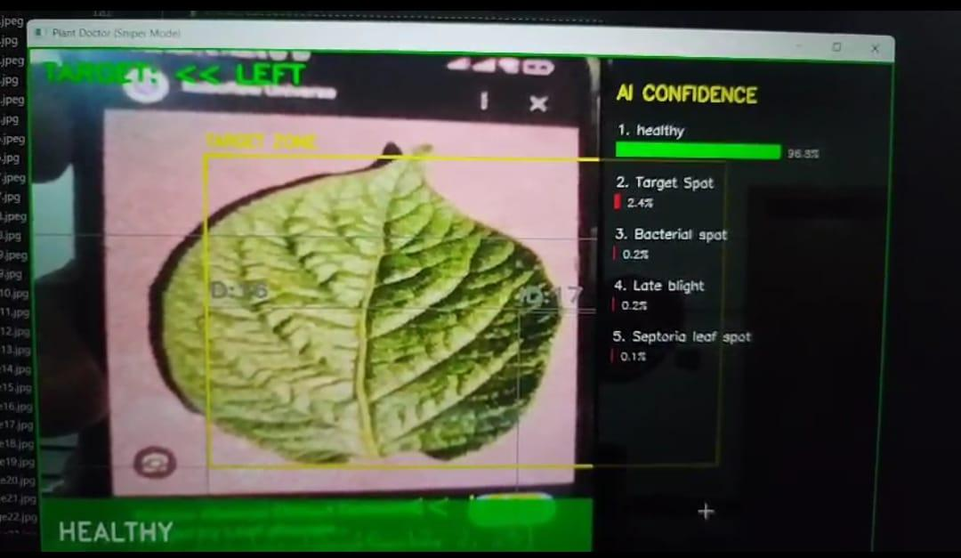
Model output displaying disease classification with confidence scores and recommended treatments
Physical Implementation
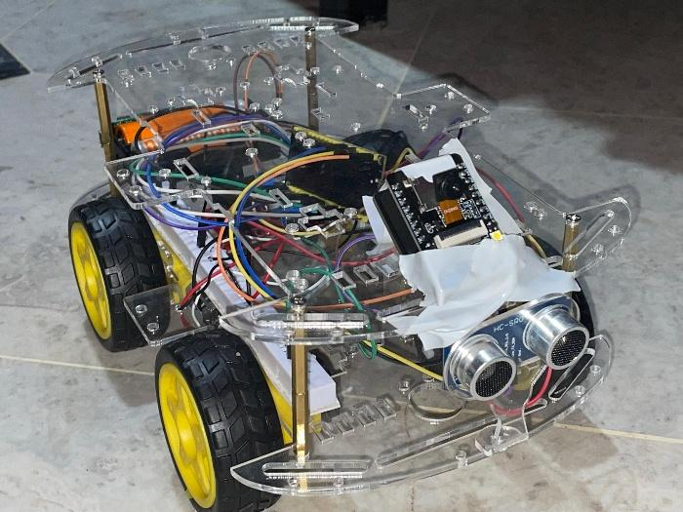
Completed PlantEye robot with all hardware components integrated on chassis
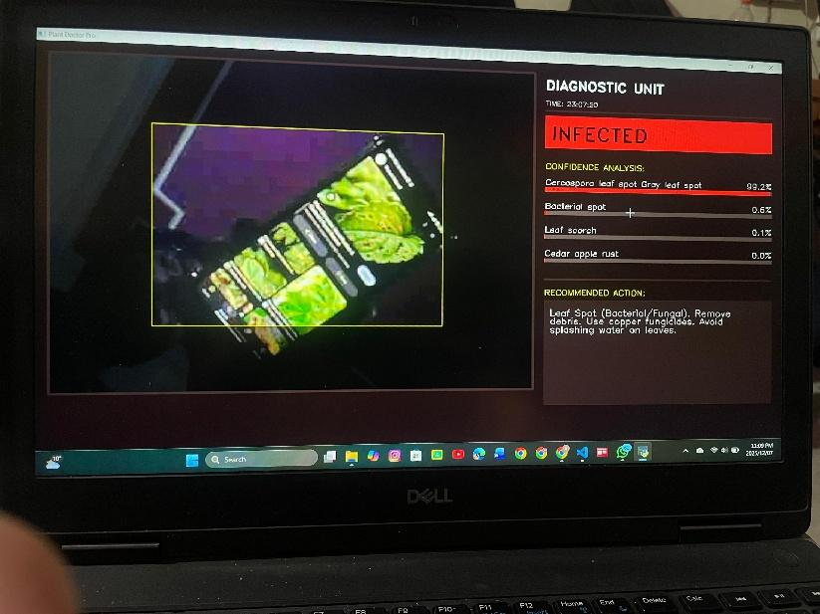
Real-time disease detection results displayed on laptop with treatment recommendations
Technical Challenges and Solutions
Challenge 1: Hardware Integration
Getting the ESP32-CAM to work alongside motor control and sensors is tricky. The camera needs a stable power supply and careful timing to avoid interference with the motors.
Solution: We use two separate ESP32 modules. One focuses on movement, the other on imaging. This separation prevents conflicts and makes the system more reliable.
Challenge 2: Camera Positioning
Plants come in different heights and shapes. Getting a good photo angle automatically is difficult.
Solution:
Challenge 3: Disease Detection Accuracy
There are thousands of plant diseases, and many look similar. The model needs extensive training data to tell them apart reliably.
Solution: We use MobileNetV2, which is specifically designed for image classification on limited hardware. It's been pre-trained on large datasets of plant diseases, giving it a strong foundation for accurate identification.
Challenge 4: Processing Power
The ESP32 isn't powerful enough to run complex AI models. Processing images on the robot itself would be extremely slow or impossible.
Solution: All AI processing happens on the laptop. The robot only captures and sends images. This approach is practical and keeps costs down while maintaining high performance.
Challenge 4: Battery Holder Burnout
During initial testing, one of our battery holders burned out due to excessive current draw when all components were running simultaneously. This was a major setback that halted our progress and raised safety concerns about the power system.
Solution: We replaced the damaged battery holder with a higher quality, more expensive one that could handle the current load safely. The new battery holder had better heat dissipation and more robust connections, which prevented any further burnout issues. We also implemented a voltage regulator to ensure stable power delivery to all components.
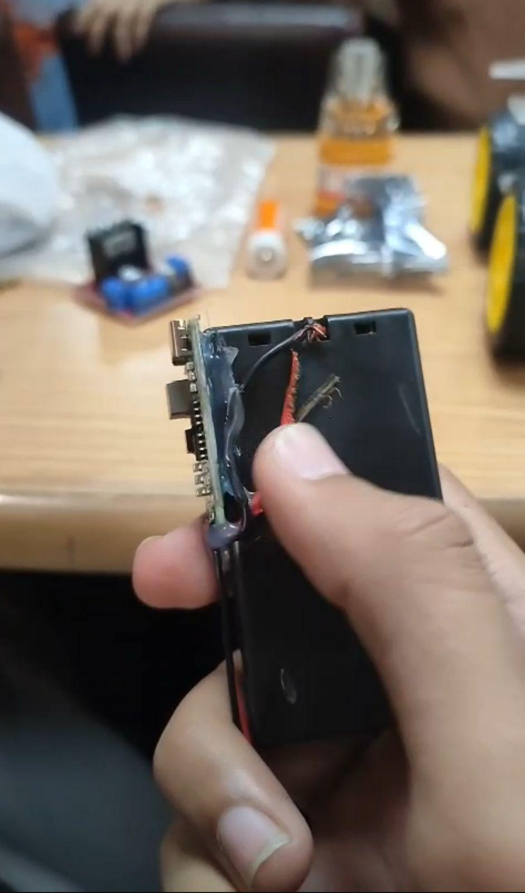
Battery holder burnout during initial testing due to excessive current draw.
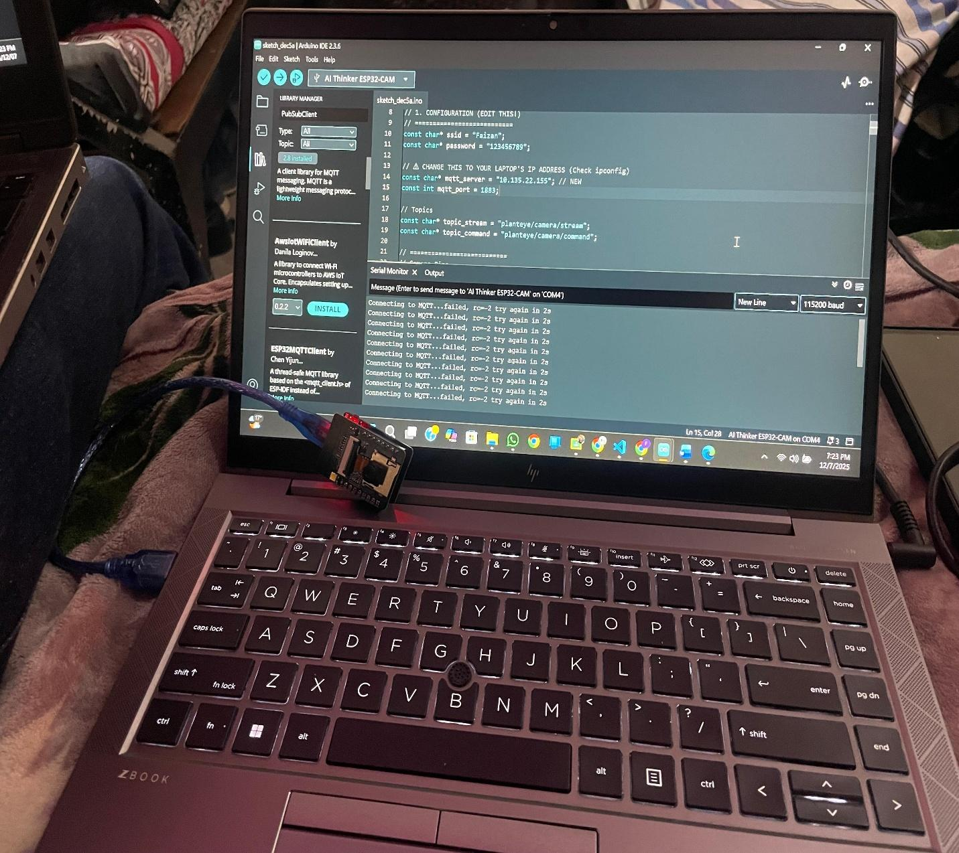
E.g Our model couldnt connect to the mqtt server correctly, displaying this specific output at the terminal.

Practical Applications
This system is designed with small-scale farmers and home gardeners in mind. Someone with a modest garden can place the robot in the morning and let it scan all their plants while they focus on other tasks. The robot provides a detailed health report, highlighting which plants need attention and what treatments to apply.
For farmers, early disease detection means they can treat problems before they spread to the entire crop. This can save significant money on lost yields and reduce the need for widespread pesticide use. Instead of treating the whole field, they can target specific problem areas.
The system could also be educational. Agricultural students could use it to learn about different plant diseases and their treatments. The visual feedback and detailed information make it a practical teaching tool.

Future Improvements
While the current version is functional, there's room for enhancement. Adding GPS tracking would let the robot map out which plants have diseases and their exact locations. This would help farmers keep records and track disease progression over time.
Integrating soil moisture sensors could provide a more complete picture of plant health. Sometimes what looks like disease is actually just stress from improper watering or nutrient deficiency.
A mobile app could replace the laptop requirement, making the system more portable. Users could see results on their phone and access historical data about their plants.
Expanding the disease database to cover more plant species would make the system more versatile. Currently focused on common crops, it could eventually handle ornamental plants, trees, and more specialized varieties.

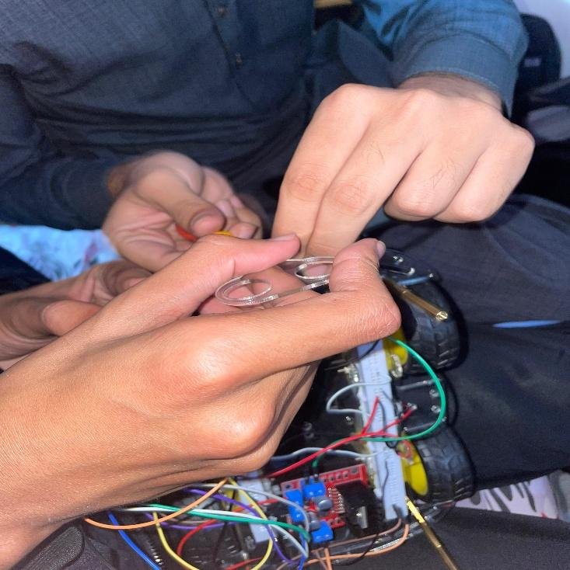
Behind the Scenes - Development Process
Team members assembling the robot chassis and securing DC motors to the base
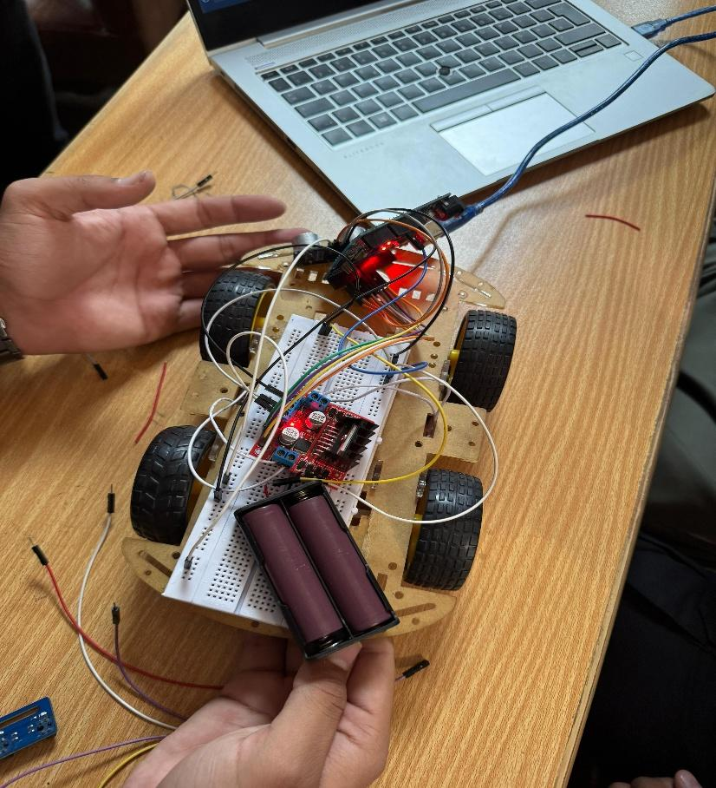
Initial circuit prototyping and testing on breadboard before permanent assembly

Conclusion
PlantEye represents a practical approach to agricultural technology. It combines robotics, computer vision, and artificial intelligence to solve a real problem that farmers face every day. The system is built from affordable, accessible components, making it feasible for implementation without huge investment.
By automating disease detection, we hope to help farmers protect their crops more effectively. The early warning system gives them time to act before minor problems become major losses. While there's still work to do in refining the accuracy and expanding the capabilities, the core concept is proven and functional.

