Team 15

Team Members:

* Ahmed Hossam Mohammed Sedky Sec:1 Bn:2
* Ahmed Mohammed Abd elftatah sec:1 Bn:5
* Ehab Wahba Abdelrahman sec:1 Bn:22
* Mo’men Maged Mohammed sec:2 Bn:11
* Mohanad Alaa Ragab sec:2 Bn:31

Emai to contact: [hossedky@gmail.com](mailto:hossedky@gmail.com)

1. Face Detection

* Results

computation time = 0.3 sec

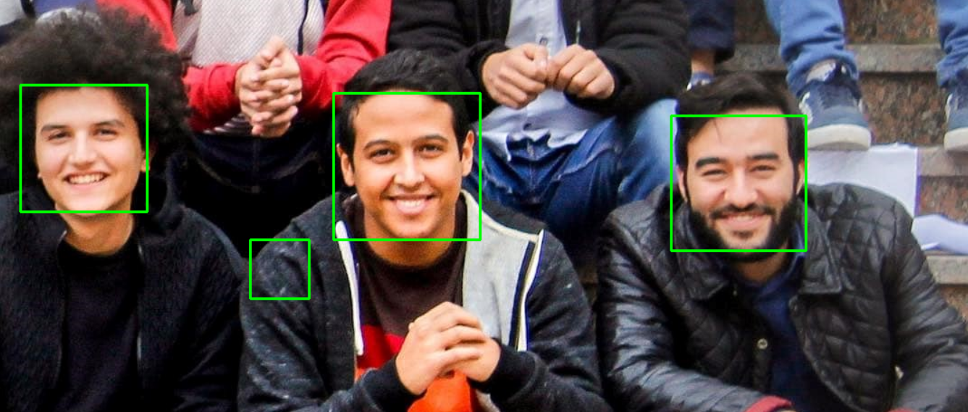

* Discussion:

We use cv2 to detect faces in input image

1. Face Recognition

* Results:

Computation time = 1.5 sec

Accuracy score =91.46%

* Discussion:

The algorithm of face recognition is abbreviated in these steps:

1. Reshape the whole images to 1D vectors
2. Construct data matrix in shape of ( No. of pixels \* No. of images )
3. Get the Mean Image (Average Column)
4. Subtract the mean image from All images.
5. Get the Covariance matrix
6. Normalize the eigen vectors (each eigen vector is column of same size of pixels number)
7. Keep all vectors summing up eigen values to 90% and remove the rest
8. map all images to new components and it will be in shape (column

vector of remaining eigen vectors length)

Computation time = 2.9 sec

* ROC curve and AUC