Team 15

Team Members:

* Ahmed Hossam Mohammed Sedky Sec:1 Bn:2
* Ahmed Mohammed Abd elftatah sec:1 Bn:5
* Ehab Wahba Abdelrahman sec:1 Bn:22
* Mo’men Maged Mohammed sec:2 Bn:11
* Mohanad Alaa Ragab sec:2 Bn:31

Emai to contact: [hossedky@gmail.com](mailto:hossedky@gmail.com)

1. Convert RGB images to LUV color space

* Results

computation time = 3.1 sec

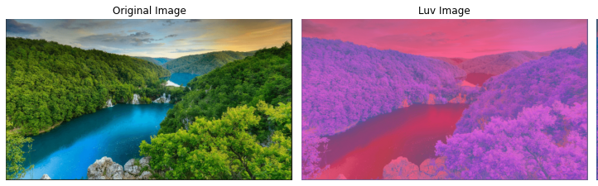

* Discussion:

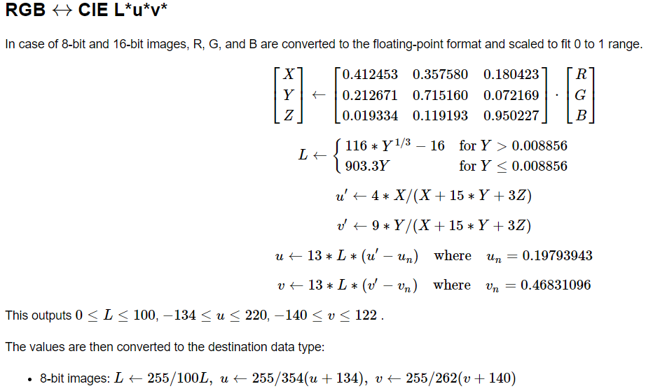We follow these steps to convert RGB to LUV

1. Kmeans clustering

* Results:

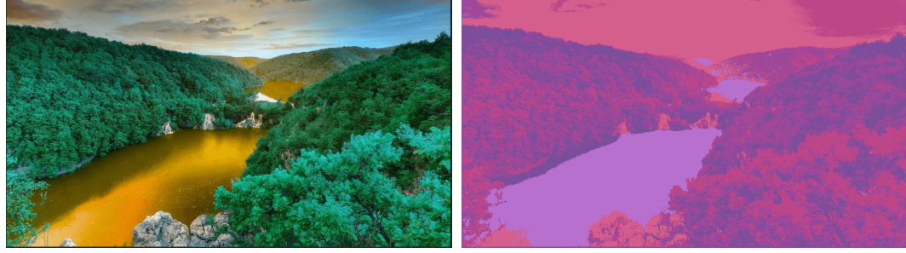Computation time = 185 sec

* Discussion:

The algorithm of K-means clustering is abbreviated in these steps:

1. Select a value of the number of clusters and number of max iterations
2. Select random points in the image as centroids
3. Associate each data point with the nearest center
4. Calculate the mean of centroids of all pixels in the cluster
5. Repeat number 2,3,4
6. Stop when we reach max iteration or the centroid of clusters doesn’t change

3- Region growing algorithm

* Results:

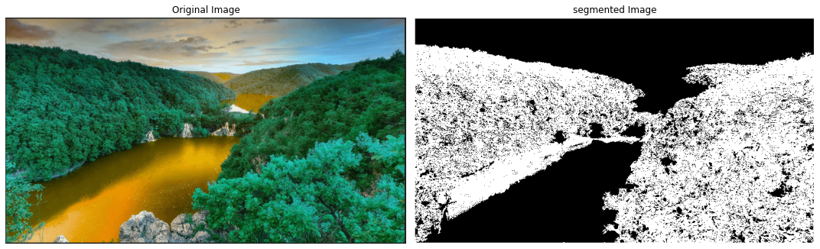Computation time = 2.9 sec

* Discussion:

The algorithm of K-means clustering is abbreviated in these steps:

1. Get random seed
2. Get the 8 neighbors to this seed
3. Compare neighbors to the seed within certain threshold add them to the region else don’t add
4. Repeat comparing new seed with its neighbors and add new neighbors to the region then pop the current point from the stack of the seed list

4 – Agglomerative clustering

* Results:

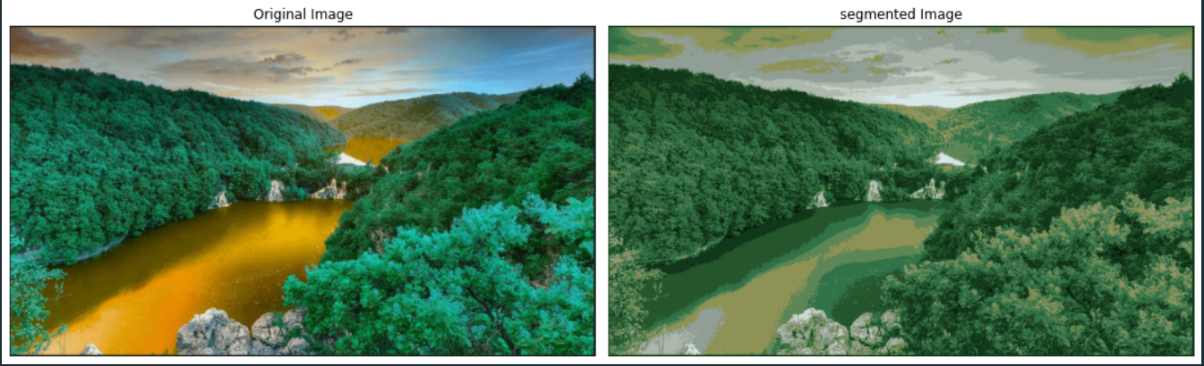Computation time: 3 minutes and 15 seconds

* Discussion:

1. Dividing the image pixels into initial number of groups (can be modified by user) based on color similarity
2. Find the closest pair of clusters by calculating the average of cluster’s points and merge the closest clusters together
3. Repeat the previous step till we obtain the required number of clusters

5 – Mean shift method

* Results:

Computation time: 1 minute and 23 seconds

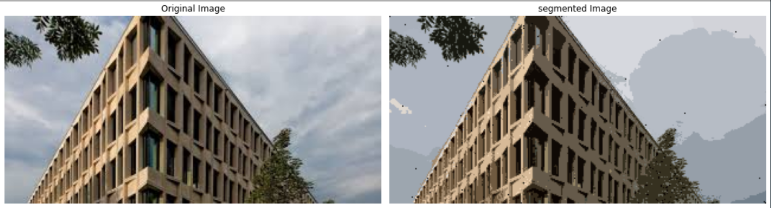

* Discussion:

1 - Calculate the RGB feature space

2 - calculate the Euclidean distance of all the other pixels in the images with the current mean then check if the distance calculated is within the threshold. If yes taking those rows and adding

them to a list below_threshold_arr.

3 - For all the rows found and placed in below_threshold_arr list, calculating the average of Red, Green, Blue and index positions.

4 - find the row in below_threshold_arr that has i, j nearest to mean_i and mean_j

5 - When found, color all the rows in below_threshold_arr with the color of the row in below_threshold_arr that has i,j nearest to mean_i and mean_j

6 - Threshold

1. Threshold techniques
2. Otsu threshold : threshold value is the value that produces the maximum variance between background and object.

Steps :

         Get histogram of the image

         Calculate PDF and CDF for each pixel value to use it for calculating variance

         Iterate over all possible threshold values

         For each threshold value calculate variance between background and object

         Final threshold value is value that produces the  maximum variance

1. Optimal threshold : threshold is the mean of background and object means, initial threshold is calculating , then optimization of threshold value occur till reaching the best threshold value.

Steps:

           Calculate initial threshold value is calculated

           Background mean is the mean of  four corner pixels

           Foreground mean is the mean of the image except corner pixels

           Initial threshold is the mean of the two means

           Optimal threshold value is calculated

           Background mean is the mean of pixels less than the intial threshold value

           Foreground mean is the mean of pixels more than the intial threshold value

           Optimal threshold value is the mean of the two means

           Compare the optimal and intial threshold values if not equal then calculate optimal threshold value again using the pre_calculated optimal threshold.

           Final threshold value when the changing in threshold value become .

1. Spectral threshold: double threshold is applied

Steps:

            Histogram of image is calculated

            Calculate variance between background and object

            Two thresholding values are calculated high and low according to variance

            Double thresholding occur that pixels values higher than high threshold value are set to 255

            Pixels that lower than low threshold value are set to 0

            Pixels between the two thresholds are set to predefined number

1. Threshold types
2. Global threshold : threshold value applied to the whole image.

        Apply threshold over the whole image

           Pixels which have values less than threshold value are set to zero

           Pixels which have values more than threshold value are set to 255 or 1

1. Local threshold : divide image into regions and apply global threshold to every region so every region has unique threshold value.

* 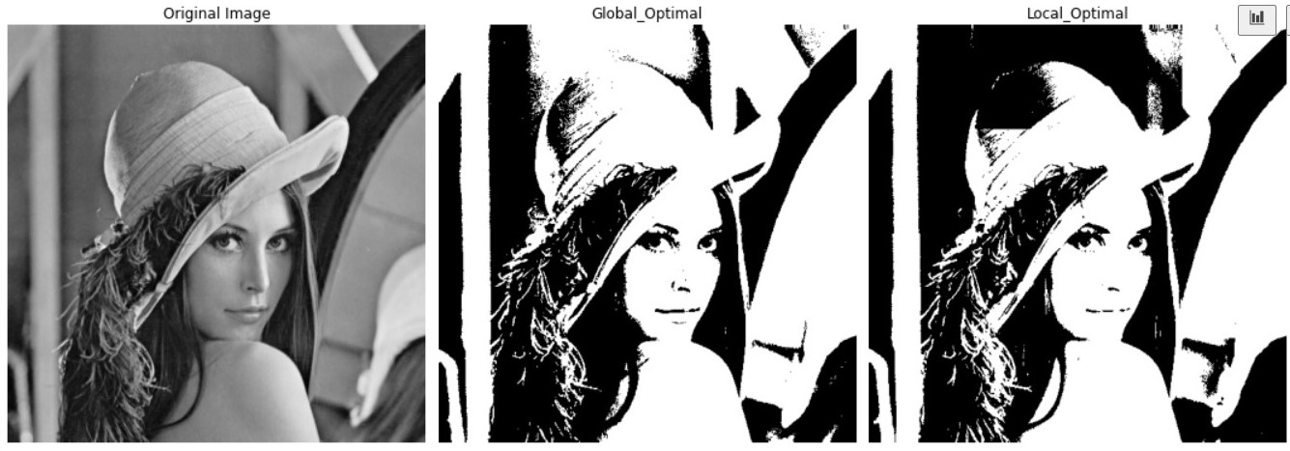Results

