Team 15

Team Members:

* Ahmed Hossam Mohammed Sedky Sec:1 Bn:2
* Ahmed Mohammed Abd elftatah sec:1 Bn:5
* Ehab Wahba Abdelrahman sec:1 Bn:22
* Mo’men Maged Mohammed sec:2 Bn:11
* Mohanad Alaa Ragab sec:2 Bn:31

Emai to contact: [hossedky@gmail.com](mailto:hossedky@gmail.com)

1. Convert RGB images to LUV color space

* Results

computation time = 3.1 sec

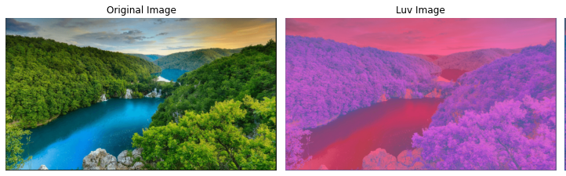

* Discussion:

We follow these steps to convert RGB to LUV

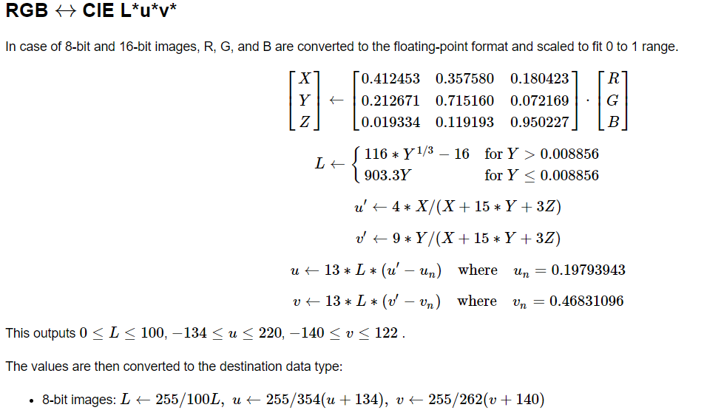

1. Kmeans clustering

* Results:

Computation time = 185 sec

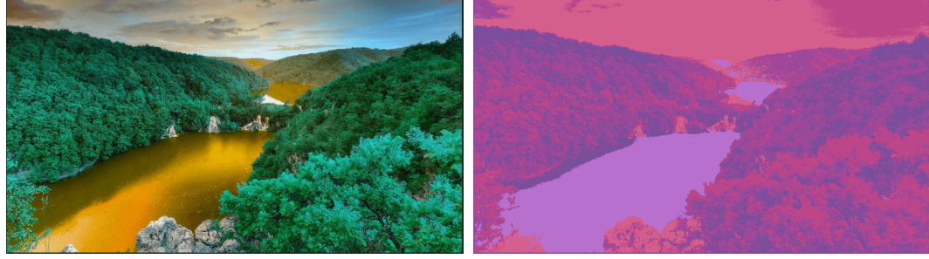

* Discussion:

The algorithm of K-means clustering is abbreviated in these steps:

1. Select a value of the number of clusters and number of max iterations
2. Select random points in the image as centroids
3. Associate each data point with the nearest center
4. Calculate the mean of centroids of all pixels in the cluster
5. Repeat number 2,3,4
6. Stop when we reach max iteration or the centroid of clusters doesn’t change

3- Region growing algorithm

* Results:

Computation time = 2.9 sec

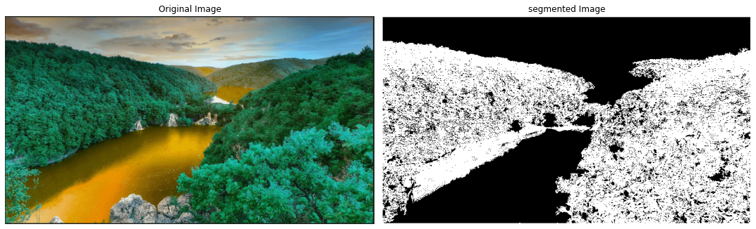

* Discussion:

The algorithm of K-means clustering is abbreviated in these steps:

1. Get random seed
2. Get the 8 neighbors to this seed
3. Compare neighbors to the seed within certain threshold add them to the region else don’t add
4. Repeat comparing new seed with its neighbors and add new neighbors to the region then pop the current point from the stack of the seed list