**http & https host**

**ahmed ashraf Ibrahim**

1. **http host :**

Using XAMPP GUI >> Open config >> Browse[Apache] >> conf >> extra >> httpd-vhosts.conf file

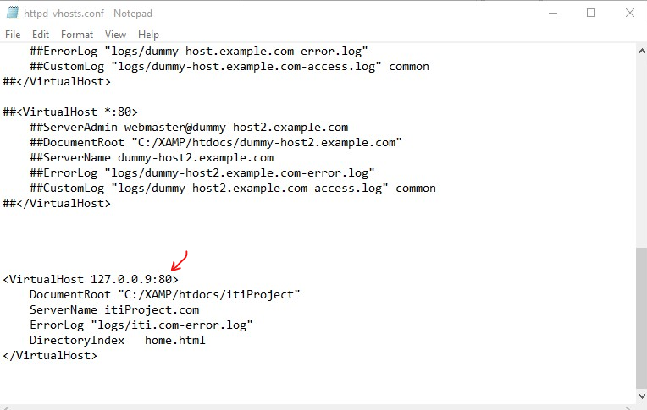

/C >> /windows >> /System32 >> /drivers >> /etc

Open hosts file in Notepad as Administrator

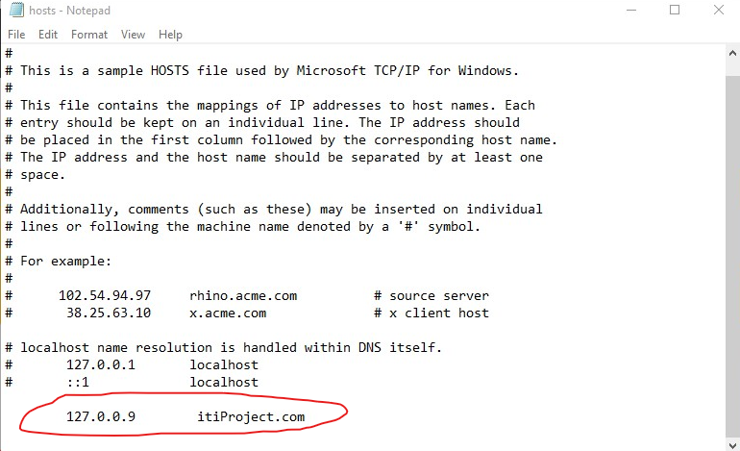

**Run in http :**

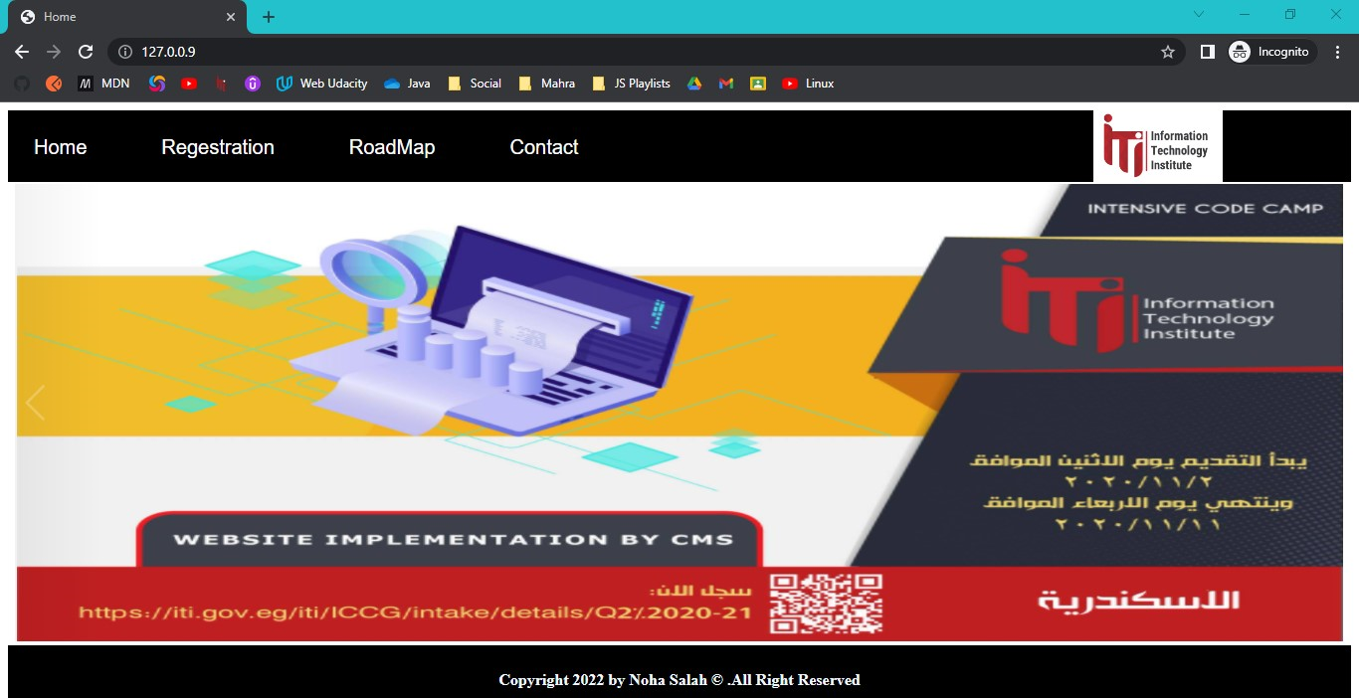

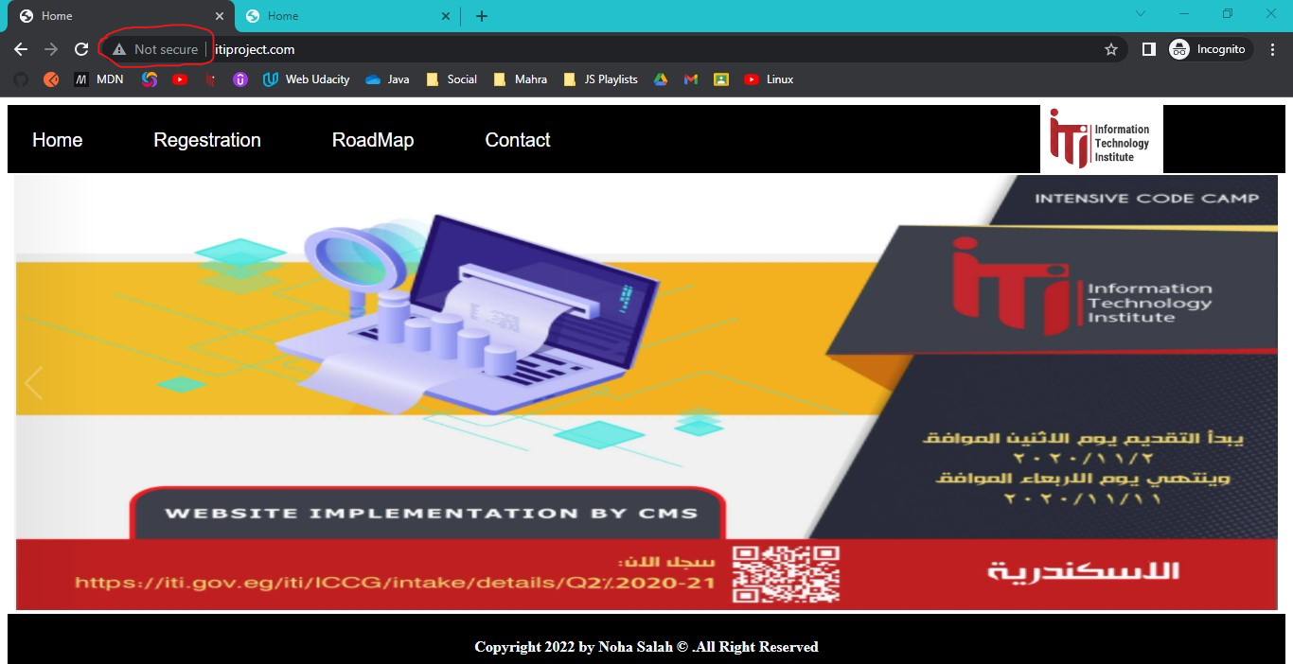

1. **http host :**

Using XAMPP GUI >> Open config >> Browse[Apache] >> conf >> extra >> httpd-vhosts.conf file

**$$ Change :80 port to :443 port for secure protocol**

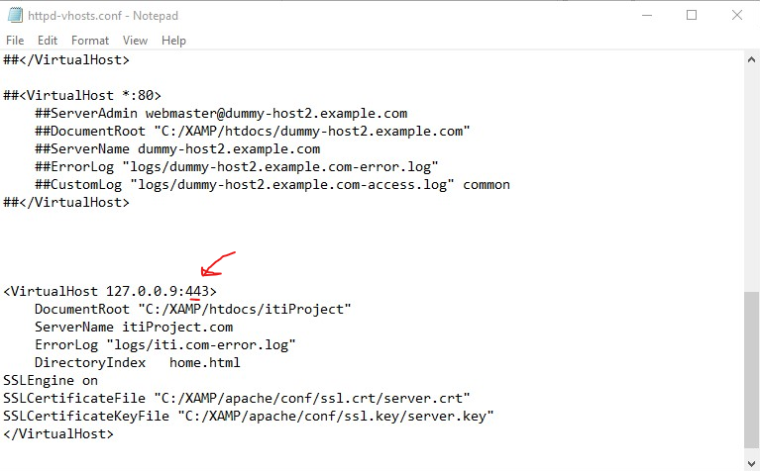

**Run in https :**

