# Conference Management System



# Master in Information Technology

## Session: 2017-2019

**Submitted To:**

Minhaj University Lahore

Department Of Computer Science & Information Technology

**Submitted By:**

2017f-mulmit-012

**Supervised By:**

Mr. Muhammad Saif Lecturer CS & IT

**Department Of Computer Science & Information Technology**

# IN THE NAME OF



# THE MOST MERCIFUL THE MOST GRACIOUS THE MOST BENEFICIENT

“That man has nothing but what he strives for, and that his striving will be seen, and that afterwards he will be repaid for it with the fullest repayment, and that to thy Lord is the goal.”

(AL- Quran)

## DEDICATION

“We would like to dedicate this study to Allah, Muhammad (S.A.W) and then to our parent’s prayers and sacrifices for today accomplishment of final year project. We dedicate this to our parents and our respected teachers who guide us to make this achievable. We are under the debt of our parents and thankful for their cooperation. And finally dedicate to our beloved friends for their presence, support, guidance and encouragement.”

## ACKNOWLEDGEMENT

I express my thanks and gratitude to Allah almighty and our parents, other family members and friends without whose uncontained support, I could not have made this career in project development.

I wish to place on record our deep sense of gratitude to our project supervisor **Sir. saif** who helped us throughout the project work and motivated us constantly. I also express our gratitude to **HOD Name sir saleem** (Head of Department of CS and IT) for his motivation and valuable suggestion throughout the MIT program. I also extend our thanks to other Faculty member for their cooperation during our program.

Finally, i would like to thank our friends for their cooperation to complete this project.

Std Name farah baby……

## ABSTRACT

Web based conference organization and management is one of the most popular applications over the Internet developed recently. Conferences are events that bring knowledge and people together. There is however a lot of informational exchange, organizational and administrative work to be carried out before such an event can be a success. Up to best of my knowledge, currently, there is no such system available for working in local market for this local problem which can provide automation to an extent. To tackle this problem, I am going to develop an automated web based conference management system. Automation of certain management activities will be done in order to take the pain out of such event organization.

### DECLARATION

It’s stated that Students of MIT Computer Science session 2012-2016 at Minhaj University Lahore hereby declare that the matter printed in this documentation titled “conference management system” is our own work in the fulfill meant of MIT program under Minhaj University Lahore.

The supervision is provided by head of department Mir. Saleem sahb and guidance is provided by our project supervisor **Mr. Muhammad saif** under their very good supervision, guidance and command we are able to produce this work.

The information and data presented in this document is authentic and legitimate to the best of our Knowledge. We have performed this project with our own effort. We have also mentioned the resources in the reference list from which we have taken help and gotten to guidance.

Registration No: 2017f-mulmit-012

Signature of Candidate ____________________________

### CERTIFICATE

This is to certify that the research work contained in this documentation titled “Conference

Management System” has been carried out and completed by the joint efforts of Reg. No: 2017fmulmit-012 under my supervision and command.

It is now my judgment that this project and this documentation is of sufficient standard to warrant its acceptance by Minhaj University Lahore for MIT degree in the subject of Information Technology.

**Date**: ______________________ **Supervisor:**

Submitted Through:

_______________________________

Head, Faculty of CS & IT

**Department of Computer Science and Information Technology**

### PROJECT BRIEF

|  |  |
| --- | --- |
| Project Name | Conference Management System |
| Undertaken By | Farah Baby |
| Session | 2017-2019 (Fall) |
| Supervised By | Lecturer, Department of CS & IT |
| Duration |  |
| Source Language | HTML ,CSS , PHP , javascipt, Jquery,Ajex |
| Tools/Frameworks | Bootstrap , Xampp  Microsoft Visio , Microsoft Office |

**TABLE OF CONTENTS**

(Will be updated once document completed)

**CHAPTER 1**

**INTRODEUCTION TO PROJECT**

## 1 INTRODUCTION TO PROJECT

In our system users and administrators will only need a browser and an Internet connection to use the system. We will be handling thousands of abstracts and delegate registrations. CMS will be a flexible enough, so easy to use, having clean interface and has many features to make it suitable for various conference models depending upon the nature of conference that may be a scientific, artistic or religious. Delegate registrations & payments, abstracts, full papers and presentations, the review process, the conference agenda, the book of abstracts & proceedings and other important announcement will be a click away from the user. System will provide automation to some extent to the process given below

**Definitions, Acronyms and Abbreviations:**

|  |  |
| --- | --- |
| **Term/ Abbreviation** | **Description** |
| **CMS** | Conference Management System |
| **DB** | Database |
| **GUI** | Graphic User Interface |
| **SQL** | Structure Query Language |

**1.1 Problem Statement:**

Usually conference committee starts its working at least nine month before the event happening day, there for a lot of human effort is needed during that time frame. When you’re investing in conference management/administration, you’re investing in the quality of your event. But you’re also investing in your own time and that of your committee. You have too many important tasks to do between now and conference day to be fiddling around with a system that isn’t the right fit for your event.

|  |  |
| --- | --- |
| **The problem of** | Managing the whole conference in a single unit. |
| **Affects** | Conference Participants, Reviewers, Conference Management  Team |
| **the impact of which is** | Typical system is very time consuming, and very slow system |
| **A successful solution would be** | Proposed system is error free, robust, and efficient. The system will maintained the record of everything related with CMS. |

**1.2 OVERVIEW**

## Project overview statement

The conference management system you will have directly impact an institution’s experience of running a research conference at every level. It also has a reputational impact – you want to provide the best possible system for authors submitting, reviewers reviewing and delegates registering that won’t show you in a bad light

This document contains the requirements of CMS to automate their system. All the requirements are firstly gathered from CMS and then functionalities of system are concluded. CMS will facilitate we can save their time and can be save from many difficulties.

### 1.3 STAKEHOLDER ANALYSIS

#### 1.3.1 Skills of Team Member

|  |  |  |
| --- | --- | --- |
| **Name** | **Skills** | **Email** |
| Farah Baby | Database design, PHP5, CSS3 (Cascading Style Sheet), HTML5, JavaScript, PHP, Laravel, Adobe  Photoshop, SQL Database, MS Office Professional 2012, MS Visio, Manual and  Automated testing | farahonline2@gmail.com |

**1.3.2 INVOLVED STAKE HOLDER:**

|  |  |  |
| --- | --- | --- |
| **Name** | **Represents** | **Role** |
| Admin (Primary Actor) | The main person which will have complete  control over the system | Administrator |
| Reviewer (Primary Actor) | This person will use the system directly and will use features of the system. | Can reject and accept paper after submitting and update the record accordingly |
| Participant (Primary Actor) | This person will use the system directly. He will use the features of the system. | Can Register, pay and get involved in the real time happening of the conference and many more |

**Users:**

|  |  |
| --- | --- |
| **Name** | **Description** |
| Admin | Admin will interact directly with the system and will view reports and progresses. |
| Reviewer | Member of scientific committee will also interact directly with the system and will view all the data he wishes to view and may update the database of CMS. |
| Participant | Users will also interact directly with the system and will use the features of the system. |

|  |  |
| --- | --- |
|  | **Admin** |
| Representative | IT Manger of Conference Chair |
| Description | Admin is an experienced and deeply involved with this field in his past 10 years. |
| Type | Primary |
| Responsibilities | The main responsibilities of this stakeholder are to manage all the records relating Reviewer and Participant. |
| Success Criteria | This stakeholder defines the success of system that his manual system will be automated successfully. |
| Involvement | Deep involvement of this stakeholder is that he will describe all the procedures that are used in manual system to the development team. He is main source for requirement gathering. |
| Deliverables | No deliverables should be given by this stake holder. He will give us all the key information relating the system. |
| Comments  Issues | Making him/her speak as much as he/she can so that we can elicit maximum information relating our system. |

|  |  |
| --- | --- |
|  | **Reviewer** |
| Representative |  |
| Description | Review research papers |
| Type | Primary |
| Responsibilities | Review every research paper under his theme and update record accordingly within given time |
| Success Criteria | Depends upon automation of the system |
| Involvement | The stakeholder is a key person to give us total feedback and all the requirements relating our project and he will help us in contacting other |
|  | employees for requirement gathering. |
| Deliverables | No deliverables should be given by this stakeholder. He will give us all the key information relating the functionality of the system. |
| Comments  Issues | Continuous meeting with him will explore all the system requirements and features of the system. |

|  |  |
| --- | --- |
|  | **Participant** |
| Representative |  |
| Description | End User of the system |
| Type | Primary |
| Responsibilities | He will use the system directly and update the record through front end use |
| Success Criteria | If the stakeholder will totally satisfy with system, it will be success of project otherwise project will fail. |
| Involvement | The stakeholder is a key person to give us total feedback and all the requirements relating our project and he will help us in contacting other employees for requirement gathering. |
| Deliverables | Filling Surveys. He will give us all the key information relating the functionality of the system. |
| Comments  Issues | Continuous meeting with him will explore all the system requirements and features of the system. |

**Key Stakeholder/User Needs:**

The current manual system is not providing fast and reliable information about LHD system. When the information is needed the stakeholders want that there should be an automatic, efficient, reliable, and secure system that will provide all the necessary details that are stored in the DB.

### 1.4 OBJECTIVE

#### Product Perspective

Web-based Conference Management System (CMS) will be designed to solve the old fashioned conference management problems and to allow the conference organizers to get the benefit of using the high technology with relatively little effort. As such, the CMS aims to solve communication, organization, delegation problems through use of the web technology. A large number of conference management procedures can effectively be realized and administered by the CMS. In this way, instead of sending forms and papers via postal service and fax, participants send them by using the Internet.

|  |  |
| --- | --- |
| **Benefit** | **Supporting Features** |
| **Admin , Reviewer,**  **Participants** | All the actions required will be available on just a click away from all the stockholders |

**1.5 SCOPE OF THE SYSTEM:**

Our system will solve many problems; authors can reach this service at anytime from anywhere. They can repeat the process as much as they want. Announcements will be carried out over the web site and sent using e-mail, immediately reach the relevant community. Any possible rescheduling or any possible error correction requirements can be maintained easily. Reverse is also possible; interested persons can find answers to their questions immediately. CMS will be used to invite the interested parties to a meeting at the start of the conference. Through e-mail, it can reach thousands of people within minutes. CMS can also make use of automatically personalized e-mails. E-mails can be sent as a reflection of any event done on the CMS web site. In short, CMS will be designed and automated (not fully automated) to provide fully computerized information technology solution to conference organization problems. It is however necessary to map the requirements, processes and event management to a web based computer software and application solution in order to automate certain aspects of conference organization. There exist two view-points from organizational aspects:

1. Automation as seen by the conference organizers
2. Automation as seen by the users (mainly authors and reviewers)

Conference organizers need to automate as many events as possible for running the conference preparation, information exchange, manuscript submission, review process, results analysis and announcements, registration and other processes. Users want to obtain the relevant information as easily as possible, submit papers painlessly, and obtain review results including reviewers’ comments as soon as they are available. They also want to be able to register to the conference, book their accommodation and reserve places at social events. A third group of conference associates exist: these are the reviewers. Reviewers want to be able to reach the manuscripts easily, and send in their review results effortlessly within the specified time period and using the forms and formats for reporting back the results, all these concerns will be tackle down in our system.

### 1.6 PROJECT ESTIMATION

#### 1.6.1 PROJECT TIME ESTIMATIO

|  |  |  |  |  |  |  |  |  |  |
| --- | --- | --- | --- | --- | --- | --- | --- | --- | --- |
|  | **T** | **tentative Timetable** | | | |  |  | |  |
| Sr.# |  | 2018 | | |  |  | 2019 | |  |
| 1 | Phase Name | Oct | Nov | Dec | Jan | Feb | Mar | Apr | May |
| 2 | Idea and  Discussion |  |  |  |  |  |  |  |  |
| 3 | Idea Validation & Project  Proposal |  |  | ✓ |  |  |  |  |  |
| 4 | Requirement Elicitation /  Software Requirement  Specification |  |  |  |  |  |  |  |  |
| 5 | Software Design |  |  |  | ✓ |  |  |  |  |
| 6 | Coding &  Development |  |  |  |  |  |  |  |  |
| 7 | Testing |  |  |  |  |  |
|  |  |  |  |
| 8 | User Manual and other documents |  |  |  |  |  |  |  |  |
| 9 | Final viva and project submission |  |  |  |  |  |  |  |  |

#### 1.6.2 PROJECT COST ESTIMATION

By viewing its domain and functionality this project is very feasible. We estimate cost to our front end and back end application on the basis of estimated line of codes for our application is as follows

Slandered Rate is 20$/hr.

Estimated cost for application is:

Estimated Time=60 hours

Estimated cost=60x20

Estimated cost=1200 USD

Server configurations:

After installing all features and services from a local vendors=50 USD.

Total estimated cost becomes;

1200+50= 1250 USD

**CHAPTER 2**

**SYSTEM ANALYSIS**

**2.1 INTRODUCTION:**

Conference management system is a web based application. It is designed to make the lives of conference organizers easier. It is a comprehensive and powerful to use as a solution for online management of conference. This web based solution for conference management system provides abstract submissions, registration system, reviewer process, file uploading and so on. The major advantages of conference management system are flexibility, easiness and variety of features that make the complex processes more clear and suitable for different kind of conference models.

**2.2 PROBLEM EXISTING:**

Technology is changing the world and to ease the stress of event planning it is important to take advantage of new technological advances. To manage a better conference, there should be a better conference management software.

Without an online conference system, each phase of the papers submission, evaluation and assigning people to a specific title have been realizing in a traditional way. Besides, there were some difficulties in controlling over the processes is like documenting the lists of participants with their personal information, payment status and so on.

Automation is a big concern.

#### 2.3 PROPOSED SYSTEM

It is direct effect to qualitative structure of components of conference like general structure of participants, authors with a designed fields and experienced chair and track chair. Conference management software can also track chair with important tools like automated task management. This will save them so much time and keep on track.

Applying a new conference system is easy. There is a form to fill out which includes conference title, subject of conference, short description, start date, end date, place, submission start and end date and information about fee. After this application, all processes needed for conference management will be able to be done.

**2.4 DEVELOPMENT METHODOLOGY:**

For this study, the developer will use the PADIM (Planning, Analysis, Design,

Implementation and Maintenance) approaches in the development process, as shown in figure System Development Approach [1]. In planning stage, we establish a high-level of intended study so that they can see the overall proposed system. Besides that, developer must be able to determine the goals of this development system in order to ensure the development system going smoothly and follow the sequence of the process. Thus, this goal also can help the developer to finish the system within the time given. In analysis stage, the developer will do the analysis through the system process in order to ensure the system is free of errors and correct the defects that will affect its effectiveness. In design stage, we will do the code generation of developing this system. While in implementation stage, we will do unit testing and also module testing in order to measure the quality and performance of the system. Finally, in maintenance stage, the developer will do some maintenance if found any fault with the system. The adopted model is very similar to Waterfall Model (System Development Life Cycle), as we have enough time to work in.

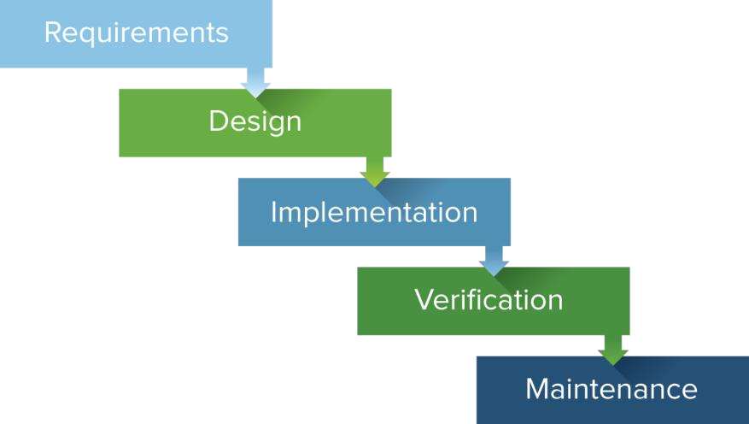

#### 2.5 SPECIFY FUNCTIONAL REQUIREMENT

Following is the list of functional Requirements.

CMS is a conference management system, suitable for handling large events including these key features

**Delegate Payments**

Collect online payments directly into your bank account.

##### Participant Management

Collect data, files and surveys from participants. Create personalized documents for the users (e.g. letters of invitation). Registration and passes to every participants before event happening day.

##### Abstracts and Papers submission and status

Collect abstracts, extended abstracts, full papers and presentations. Conference management system that allows reviewers to download, comment and review on paper, and then upload their reviews.

##### Review Process

Use available functions to facilitate the distribution of abstracts / papers to the reviewers. Track the progress of the reviews.

**Access Control and users account handling**

Set permissions on various functions, based on dates or users' roles.

##### Flexible Reporting

Export all collected data to Excel and pdf. Use filters to export targeted records. Reviewers can export their assigned submissions.

##### Powerful Email and SMS verification and confirmation Module

Target any group of participants with customized, personalized emails. Editable templates are provided for common tasks.

##### 2.5.2 NON FUNCTIONAL REQUIREMENTS

A Non-functional requirement is a description of a property or characteristic that a system must exhibit or a constraint that it must exhibit. Most important nonfunctional requirement of our system are given below

* + 1. Security: Login access level, where only administrators can do (CRUD) operations. And user information is kept hidden. Security is a big concern as we will be dealing with payments.
    2. Availability: System should be available at all times except on scheduled maintenance time. The system interface must be made out of a consist level of colors and have all the main operations buttons easy to find by the users. Usability is also very important as we will have international delegation interacting with the system frequently.
    3. Integrity: System must only deal with validated user data.
    4. Usability: User interface will be so simple to use for even novices user. Proper user manuals will be provided as system has certain automation.

**2.6 USE CASE MODELING:**

In software and systems engineering, a **use case** is a list of actions or event steps, typically defining the interactions between a role (known in the Unified **Modeling** Language as an actor) and a system, to achieve a goal. The actor can be a human or other external system.

**2.6.1 USE CASE DEPENDENCY DIAGRAM:**

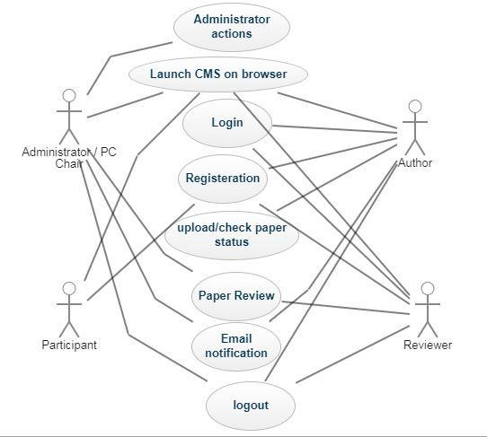

**2.7 BEHAVIORAL MODELING:**

In order to model the behavioral and structural dynamics of CMS, we adopted the Unified Modeling Language (UML). UML is a standardized, general-purpose modeling language in the field of software engineering. It includes a set of graphical notations to create visual models of object-oriented software-intensive systems. For the description and communication of user requirements and functionality of a given software system, one can use UML’s Use Case, Class, Component, Sequence and Activity diagrams [2]. This section documents the relevant UML diagrams for capturing the function and structure of CMS.

##### 2.7.1 SEQUENCE/STATE DIAGRAMS

###### User

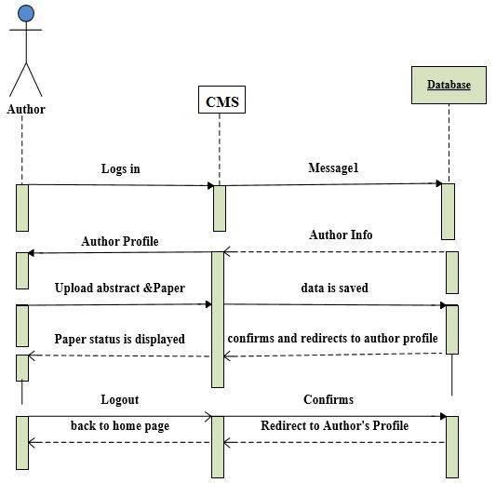

###### Admin / Conference Chair

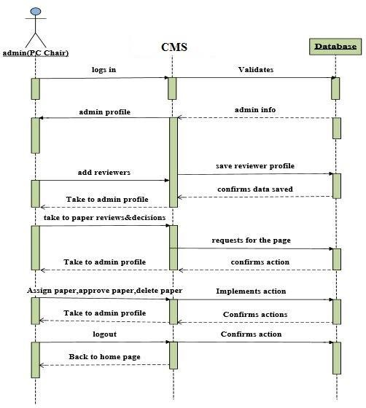

###### Reviewer

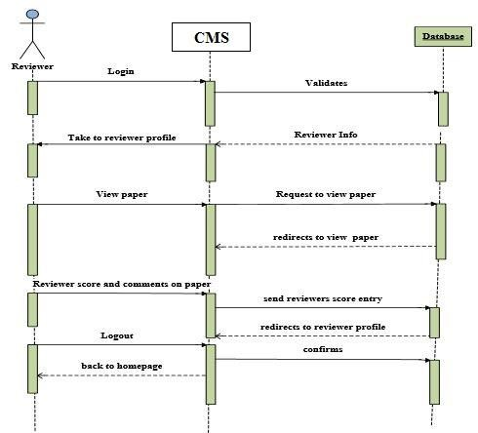

#### 2.9 SOFTWARE AND HARDWARE REQUIREMENTS

##### 2.9.1 Hardware Requirements

|  |  |  |  |  |
| --- | --- | --- | --- | --- |
| **Item** | **Web server (minimal)** | **Web server**  **(recommended)** | **Combined Web & Database Server (minimal)** | **Combined Web & Database Server (recommended)** |
| **Processor** | 1,6 GHz CPU | 2 x 1,6 GHz CPU | 2 x 1,6 GHz CPU | 4 x 1,6 GHz CPU |
| **RAM** | 1,75 GB RAM | 3,5 GB RAM | 3,5 GB RAM | 7 GB RAM |
| **HDD** | 1x 40 GB of free space or more is recommended for the webshop data (non-system drive is preferred)  1x 40 GB of free space or more is recommended for the software that is listed in the software requirements (system  drive) | | | |

##### 2.9.2 Software Requirements

Frameworks: Bootstrap & Laravel.

Database: PostgreSQL

Operating System: windows 10

**CHAPTER 3**

**INTRODEUCTION TO PROJECT**

#### 3.1 PHYSICAL ERD

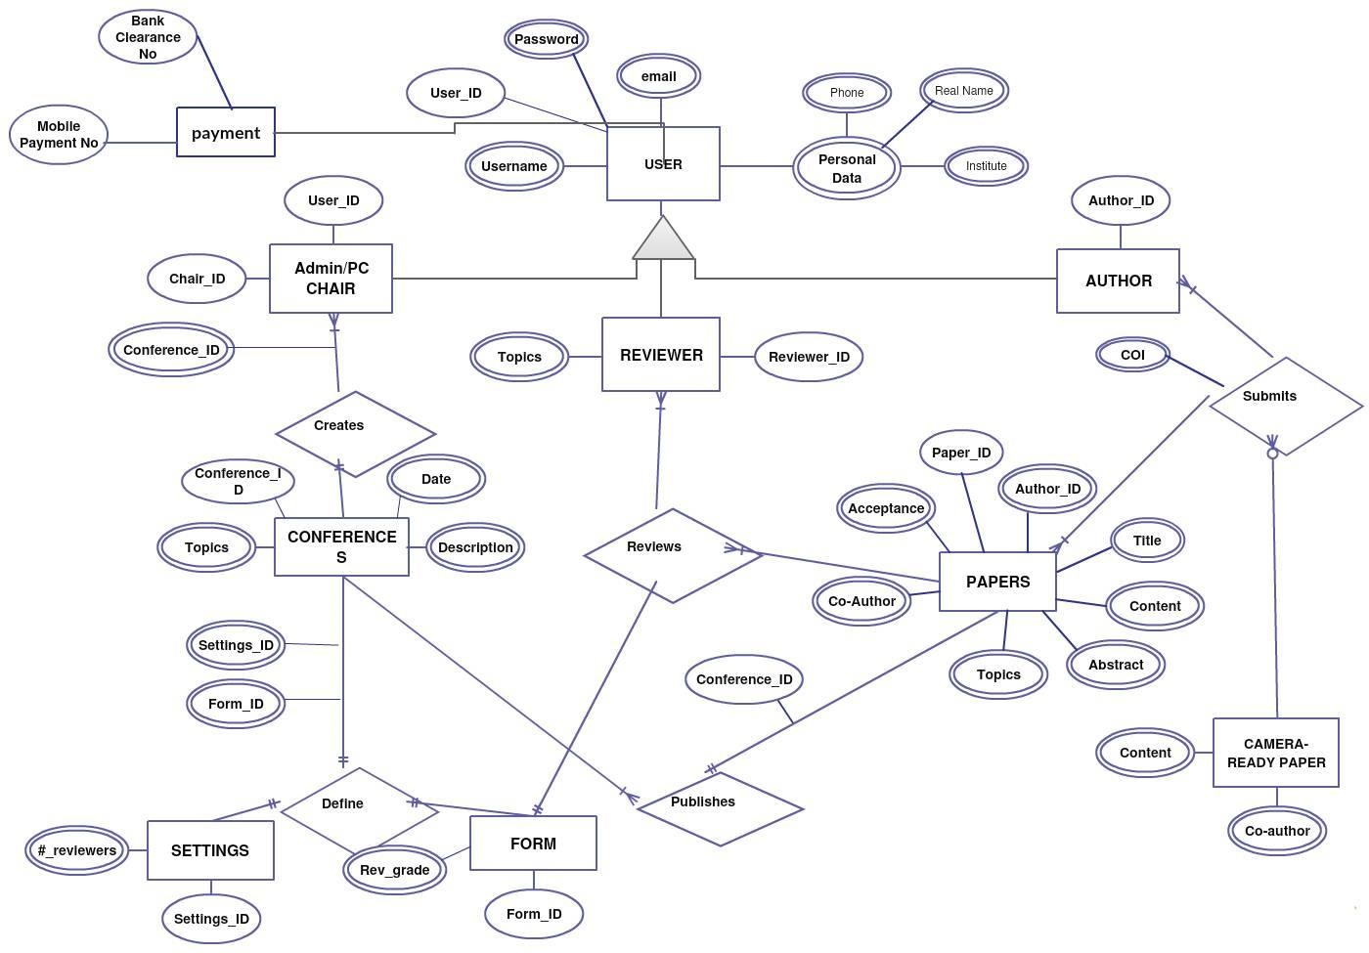

**3.2 PROCESS MODEL**

### ACCESS CONTROL FOR DATA WHICH REQUIRES THE PARTICIPANT

#### AUTHENTICATION

The following commands specify access control identifier and they are typically used to authorized and authenticate the client.

#### USER NAME (USER)

The identification user is that which is required by the server to access to its system files. The command will normally be the first command transmitted by the client after the control connections are made (some server may require this).

#### PASSWORD (PASS)

This command must be immediately proceeded by the client name and command, and, for some sites complete the client’s authentication for access control. Since the password information is quite sensitive, it is desirable in general to “mask” It or suppress type out.

#### 3.2.1 DECOMPOSITION DIAGRAM

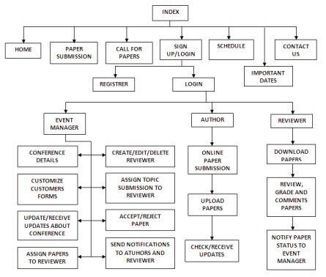

#### 3.2.3 DATA FLOW DIAGRAM

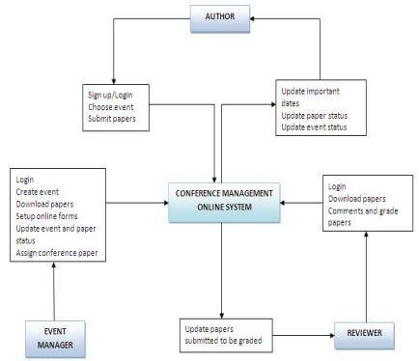

#### 3.4 ARCHITECTURE DIAGRAM

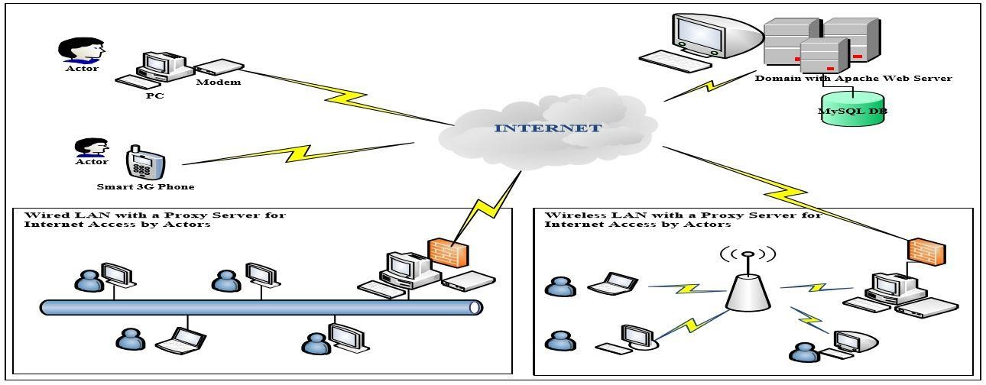

CHAPTER 4

IMPLEMENTATIONS

CHAPTER 5

Testing

**5.1 Software Testing**

Software testing is defined as an activity to check whether the actual results match the expected results and to ensure that the software system is Defect free. It involves execution of a software component or system component to evaluate one or more properties of interest.

Software testing also helps to identify errors, gaps or missing requirements in contrary to the actual requirements. It can be either done manually or using automated tools. Some prefer saying Software testing as a White Box and Black Box Testing.

In simple terms, Software Testing means Verification of Application Under Test (AUT).

**5.2 White Box Testing**

White Box Testing is defined as the testing of a software solution's internal structure, design, and coding. In this type of testing, the code is visible to the tester. It focuses primarily on verifying the flow of inputs and outputs through the application, improving design and usability, strengthening security. White box testing is also known as Clear Box testing, Open Box testing, Structural testing, Transparent Box testing, Code-Based testing, and Glass Box testing. It is usually performed by developers.

It is one of two parts of the "Box Testing" approach to software testing. Its counterpart, Blackbox testing, involves testing from an external or end-user type perspective. On the other hand, Whitebox testing is based on the inner workings of an application and revolves around internal testing.

The term "Whitebox" was used because of the see-through box concept. The clear box or Whitebox name symbolizes the ability to see through the software's outer shell (or "box") into its inner workings. Likewise, the "black box" in "Black Box Testing" symbolizes not being able to see the inner workings of the software so that only the end-user experience can be tested.

**5.2.1What do you verify in White Box Testing?**

White box testing involves the testing of the software code for the following:

* Internal security holes
* poorly structured paths in the coding processes
* The flow of specific inputs through the code
* Expected output
* The functionality of conditional loops
* Testing of each statement, object, and function on an individual basis

The testing can be done at system, integration and unit levels of software development. One of the basic goals of white box testing is to verify a working flow for an application. It involves testing a series of predefined inputs against expected or desired outputs so that when a specific input does not result in the expected output, you have encountered a bug.

**5.2.2How do you perform White Box Testing?**

To give you a simplified explanation of white box testing, we have divided it into two basic steps. This is what testers do when testing an application using the white box testing technique:

STEP 1) UNDERSTAND THE SOURCE CODE

The first thing a tester will often do is learn and understand the source code of the application. Since white box testing involves the testing of the inner workings of an application, the tester must be very knowledgeable in the programming languages used in the applications they are testing. Also, the testing person must be highly aware of secure coding practices. Security is often one of the primary objectives of testing software. The tester should be able to find security issues and prevent attacks from hackers and naive users who might inject malicious code into the application either knowingly or unknowingly.

Step 2) CREATE TEST CASES AND EXECUTE

The second basic step to white box testing involves testing the application's source code for proper flow and structure. One way is by writing more code to test the application's source code. The tester will develop little tests for each process or series of processes in the application. This method requires that the tester must have intimate knowledge of the code and is often done by the developer. Other methods include Manual Testing.

# 5.3 Black Box Testing

**BLACK BOX TESTING**, also known as Behavioral Testing, is a [software testing method](http://softwaretestingfundamentals.com/software-testing-methods/) in which the internal structure/design/implementation of the item being tested is not known to the tester. These tests can be functional or non-functional, though usually functional.

# 

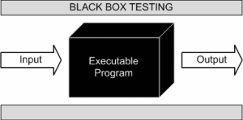

This method is named so because the software program, in the eyes of the tester, is like a black box; inside which one cannot see. This method attempts to find errors in the following categories:

* Incorrect or missing functions
* Interface errors
* Errors in data structures or external database access
* Behavior or performance errors
* Initialization and termination errors

This method is named so because the software program, in the eyes of the tester, is like a black box; inside which one cannot see. This method attempts to find errors in the following categories:

* Incorrect or missing functions
* Interface errors
* Errors in data structures or external database access
* Behavior or performance errors
* Initialization and termination errors

## Example

A tester, without knowledge of the internal structures of a website, tests the web pages by using a browser; providing inputs (clicks, keystrokes) and verifying the outputs against the expected outcome.

CHAPTER 6

IMPLEMENTATIONS

#### 6.1 CONCLUSION

In conclusion, this Conference Management Online System provides a lot benefits as it allow Event Manager to organize the submission of conference papers submitted by the Authors. The system hopefully would provide the necessary functions to the Event Manager in order to manage the event effectively, efficiently and thus knowing that the system will function smoothly. Besides that, it would be nice and interesting if we would have integrated third party applications in our system. This could be done in future.

**UNIQUE SELLING POINT**

Automation of our system makes us unique from others.

### LIMITATIONS

For the system constraint, some problem was faced regarding the coding for the system to be functioning because more understanding is needed in developing the system and it would be difficult to get all the information because of the information sensitivity of the existing system.

#### 6.2 REFERENCE

**Reference books:**

Software Engineering - A Practitioner's Approach by Roger S. Pressman 6th Edition

**Reference sites:**

1. Munassar, Nabil Mohammed Ali, and A. Govardhan. "A comparison between five models of software engineering." *International Journal of Computer Science Issues (IJCSI)* 7.5 (2010): 94.
2. Medvidovic, Nenad, et al. "Modeling software architectures in the Unified Modeling Language." *ACM Transactions on Software Engineering and Methodology (TOSEM)* 11.1 (2002): 2-57.