

**Ain Shams University**

**Faculty of Engineering**

**Computer and System department**

**Bankers Algorithm**

**Submitted by:**

Ahmed Mohamed Ahmed Abd El-Hamed Hassan

Code: 1700157

Section: 1

**Safe State Tests:**

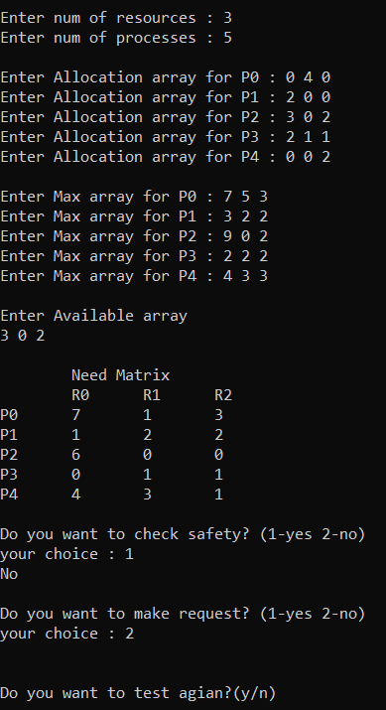

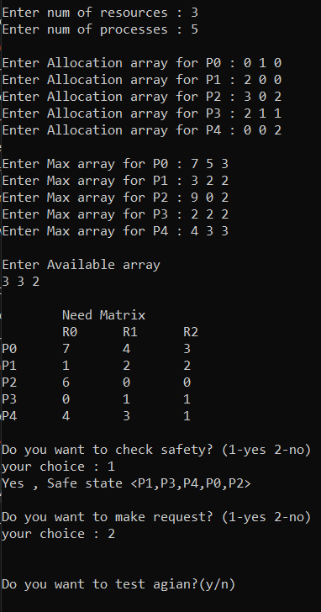

**Requests Tests:**

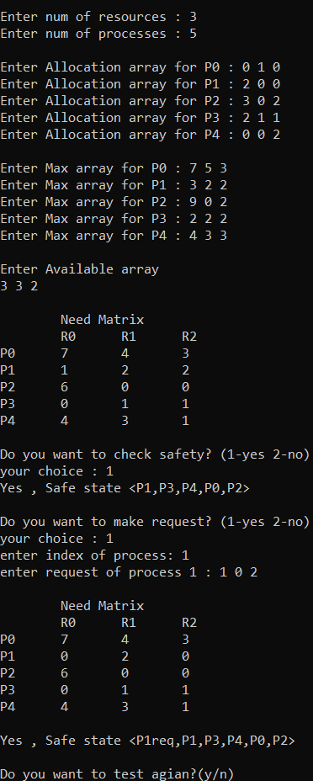

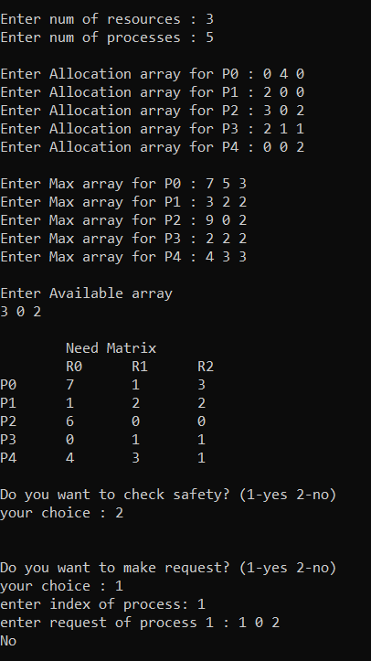

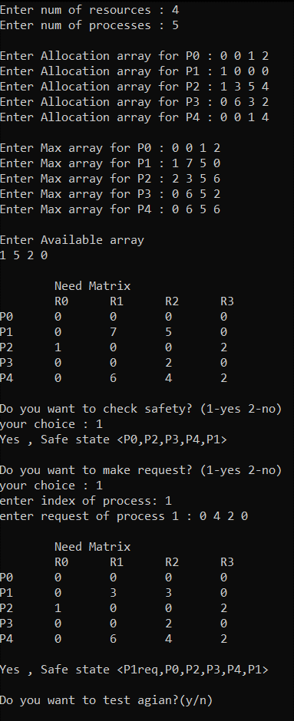

**GUI:**

Check the safety of the system.

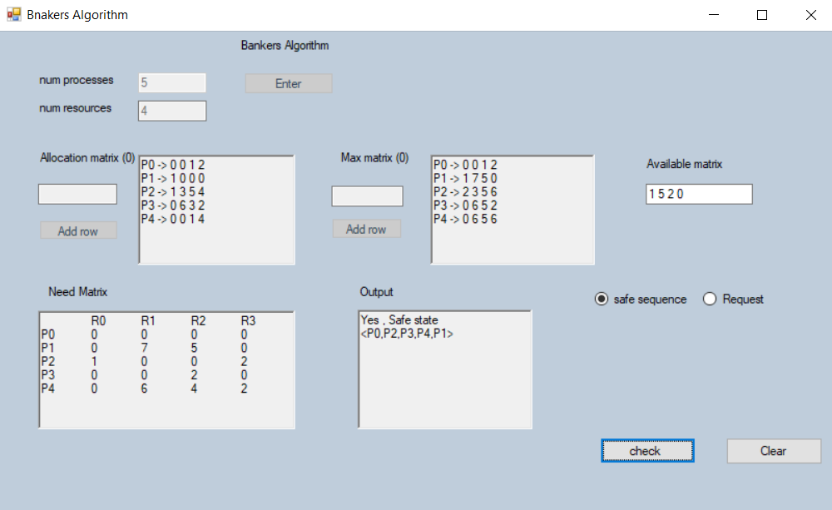

Check the request.

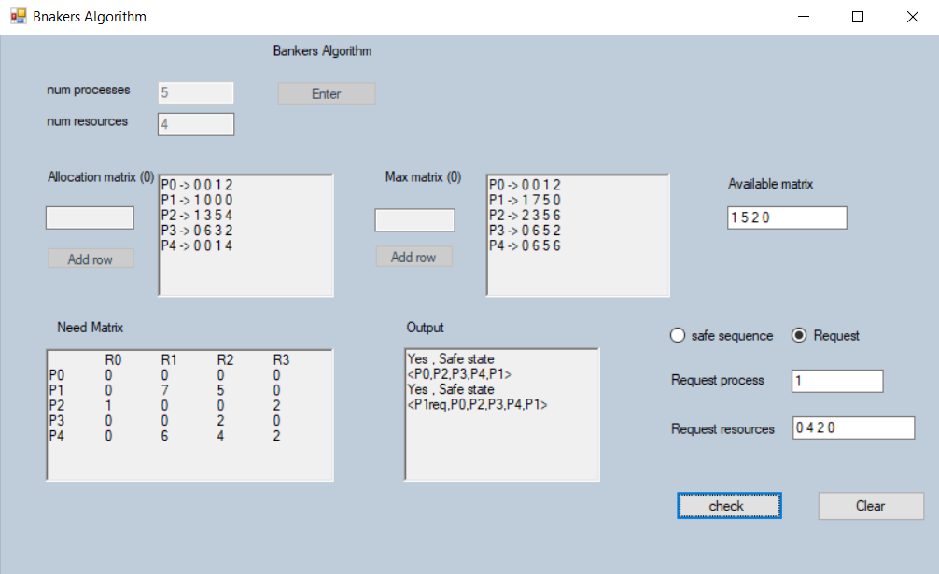

**How to use the GUI:**

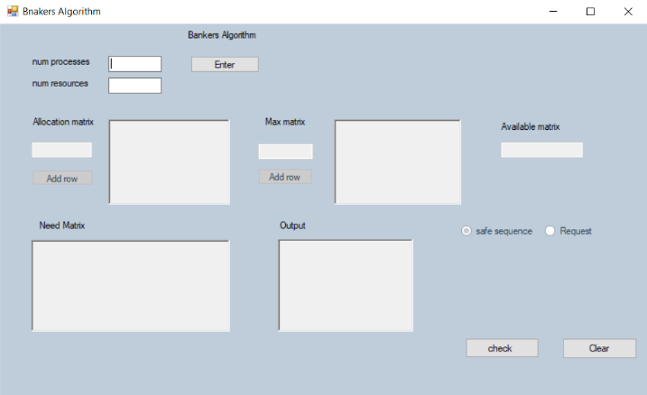

* First Enter the number of processes and resources in their fields
* Then, press Enter.

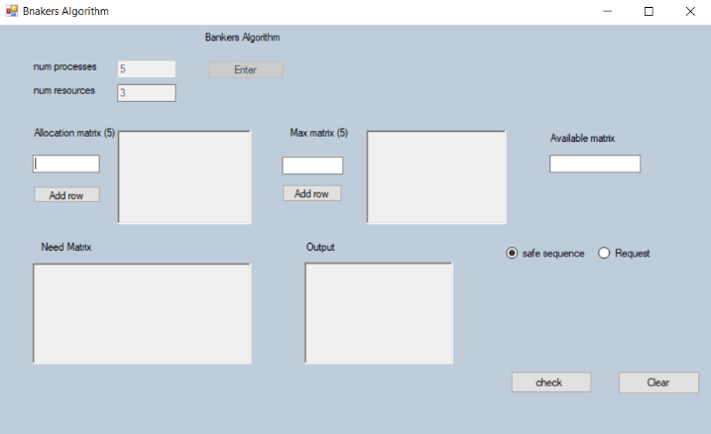

* Now the Allocation matrix, Max matrix and Available matrix will be Enabled.
* In the Allocation matrix and Max matrix you will need to press (Add row) button after entering each row in the test field. (enter values with space separated ex: 1 2 3).
* After that enter the Available matrix space separated values.
* Now if you want to check the safety, you need to check the safety option and click on check button.

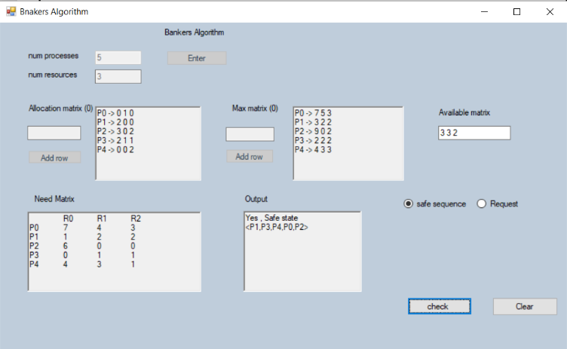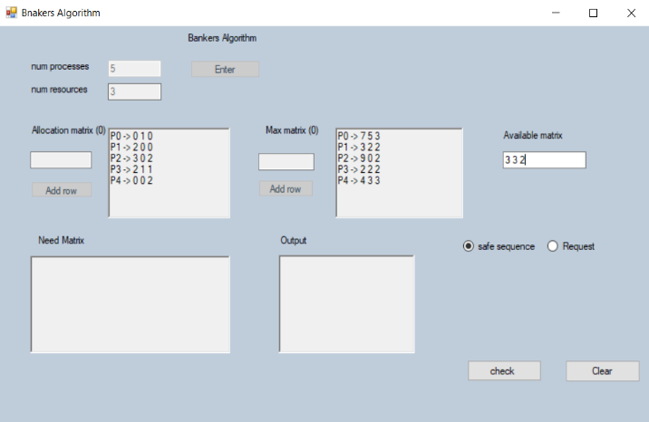

* If you want to check request, you need to choose the request option and insert your request in the specified fields. Then, press check button.

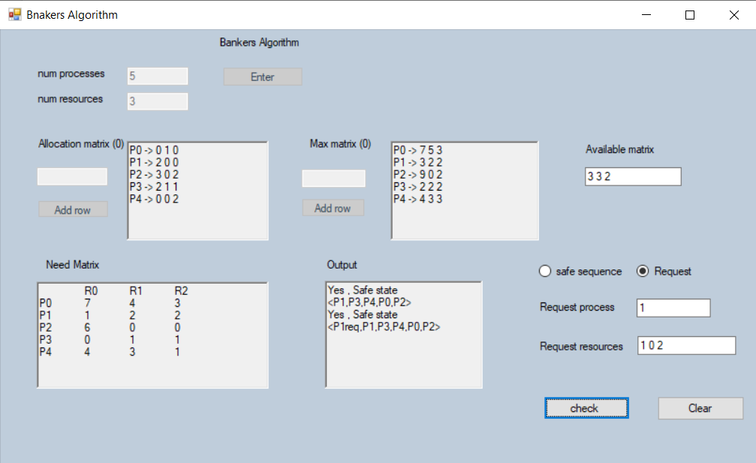

* At the end if you want to check another system press clear button to restart it.

Link of files:

<https://github.com/ahmed192a/bankers-Algorithm.git>

3

5

0 4 0

2 0 0

3 0 2

2 1 1

0 0 2

7 5 3

3 2 2

9 0 2

2 2 2

4 3 3

3 0 2

4

5

0 0 1 2

1 0 0 0

1 3 5 4

0 6 3 2

0 0 1 4

0 0 1 2

1 7 5 0

2 3 5 6

0 6 5 2

0 6 5 6

1 5 2 0

3

5

0 1 0

2 0 0

3 0 2

2 1 1

0 0 2

7 5 3

3 2 2

9 0 2

2 2 2

4 3 3

3 3 2

Test cases used: