* Name:احمد بشار احمد جمعه
* B.N:34
* Topic Title: Artificial intelligence
* The date:
* Github link:
* Githup page:

Topic summary

What is Artificial Intelligence?

Artificial intelligence (AI) is wide-ranging branch of computer science concerned with building smart machines capable of performing tasks that typically require human intelligence. AI is an interdisciplinary science with multiple approaches, but advancements in [machine learning](https://builtin.com/machine-learning) and deep learning are creating a paradigm shift in virtually every sector of the tech industry.

From SIRI to self-driving cars, artificial intelligence (AI) is progressing rapidly. While science fiction often portrays AI as robots with human-like characteristics, AI can encompass anything from Google’s search algorithms to IBM’s Watson to autonomous weapons.

Artificial intelligence today is properly known as [narrow AI (or weak AI)](https://en.wikipedia.org/wiki/Weak_AI), in that it is designed to perform a narrow task (e.g. only facial recognition or only internet searches or only driving a car). However, the long-term goal of many researchers is to create [general AI (AGI or strong AI)](https://en.wikipedia.org/wiki/Artificial_general_intelligence). While narrow AI may outperform humans at whatever its specific task is, like playing chess or solving equations, AGI would outperform humans at nearly every cognitive task

Screen shots

Pages:

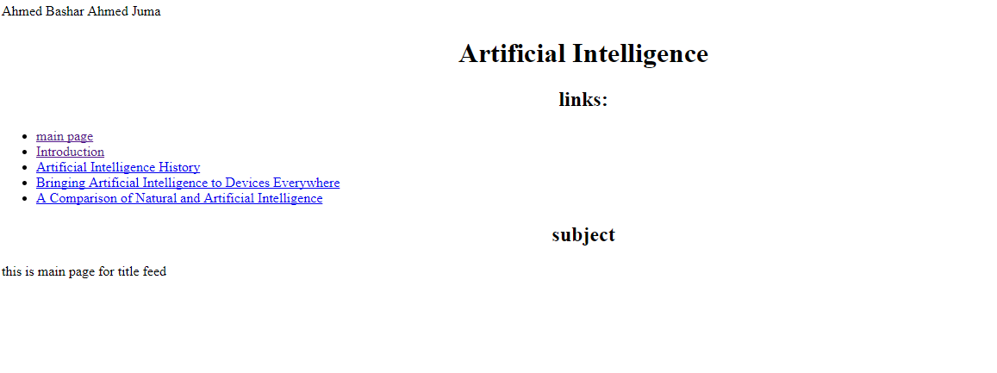 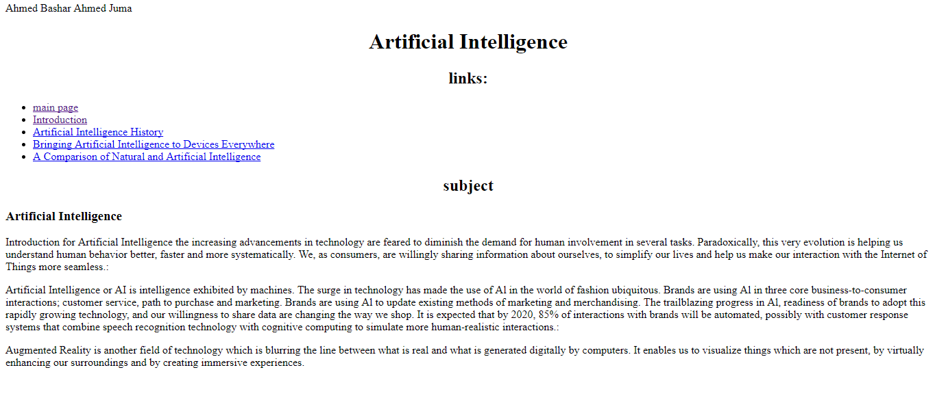 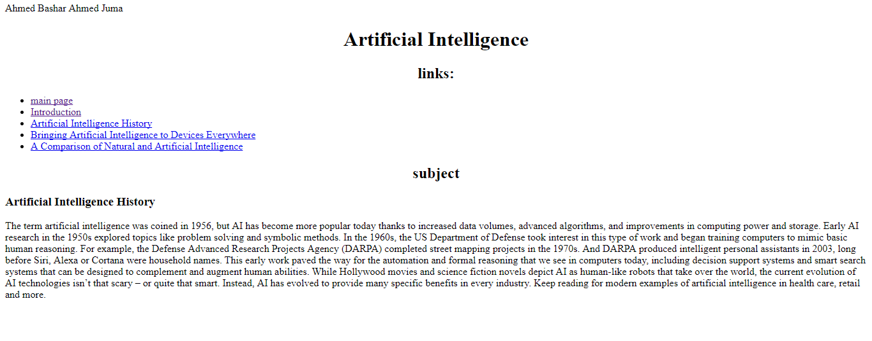 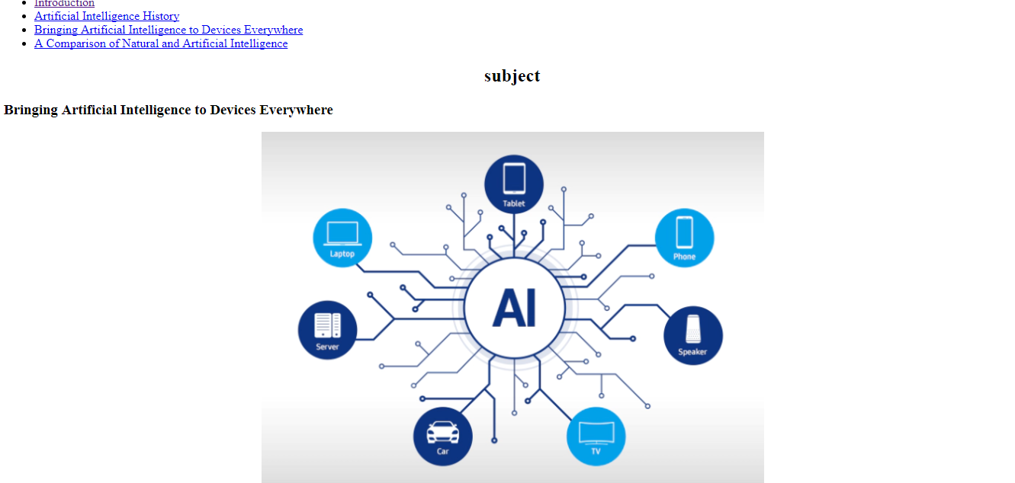 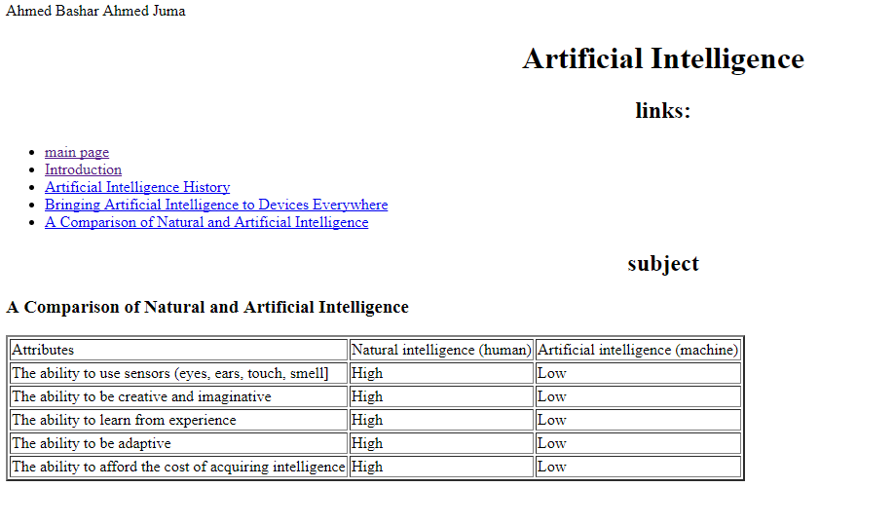

Codes

