BDA400 / Data Science Tools and Techniques
Assignment 2
Technical Analysis using R, Preliminary Stage (5%)
Submitted by: Sameea Ahmed
Course: BDA400 - Data Science Tools and Techniques
Due: Session 3
Date: September 16, 2026
GitHub Repository:
https://github.com/ahmed1sameea-art/TechnicalAnalysis
File path: /Assignment2

AI Assistance Declaration
Portions of this assignment (script comments, function scaffolding, and this report's structure) were drafted with the assistance of an AI tool (Claude). All data downloads and statistical calculations were performed exclusively by R and its packages (base R, quantmod, TTR) at run time against live data — no numeric results were computed, estimated, or supplied by the AI. Every setup step below (GitHub account, R/RStudio installation, package installation, and script execution) was carried out on the student's own computer, and the accompanying screenshots are taken directly from that machine.

1. Objective
- Set up a GitHub account and repository.
- Install R and RStudio on a local PC.
- Download and install R packages for technical analysis.
- Write utility functions to read and compute statistics on data.
- Configure and initialize the technical analysis process.
- Display imported data and calculated statistics.
- Document the setup and analysis process.

2. GitHub Account and Repository Setup
A GitHub account was set up (or already available) for Sameea Ahmed, and a new repository named ‘TechnicalAnalysis’ was created to store all assignments for this course, with one subdirectory per assignment (this stage's files live under /Assignment2).
Repository URL:
https://github.com/ahmed1sameea-art/TechnicalAnalysis
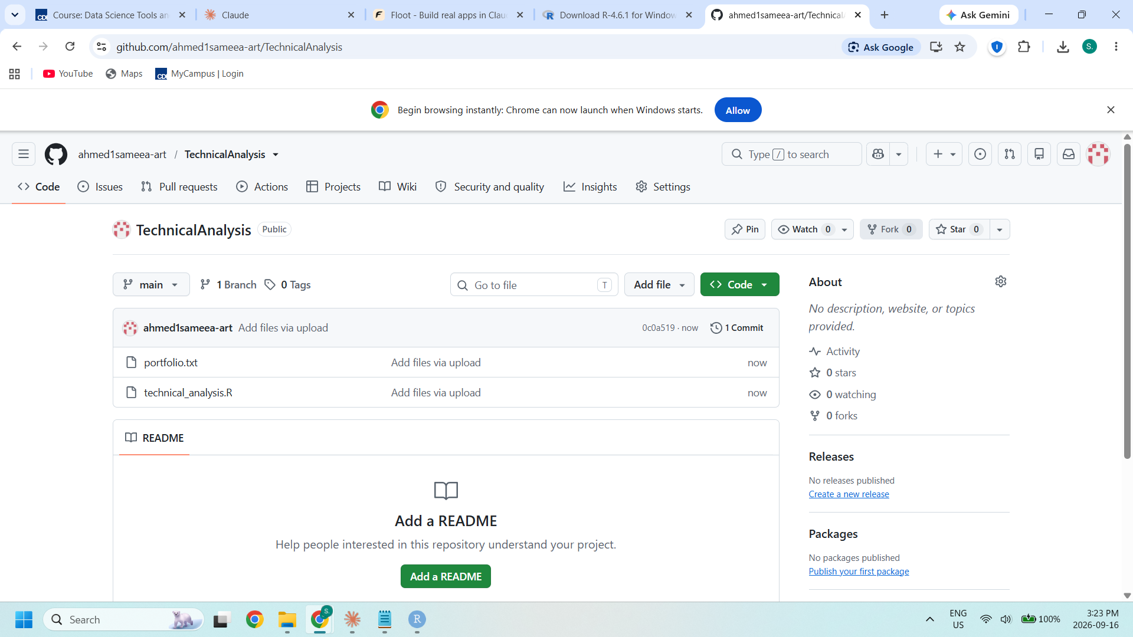
Figure 1. The 'TechnicalAnalysis' GitHub repository with Assignment 2 files uploaded.

3. Installing and Configuring R and RStudio
R was downloaded from the official CRAN mirror (cran.rstudio.com) and installed using the default options for Windows. RStudio Desktop was then downloaded from posit.co/download/rstudio-desktop and installed the same way, using the default installation path, components, and Start Menu entry.
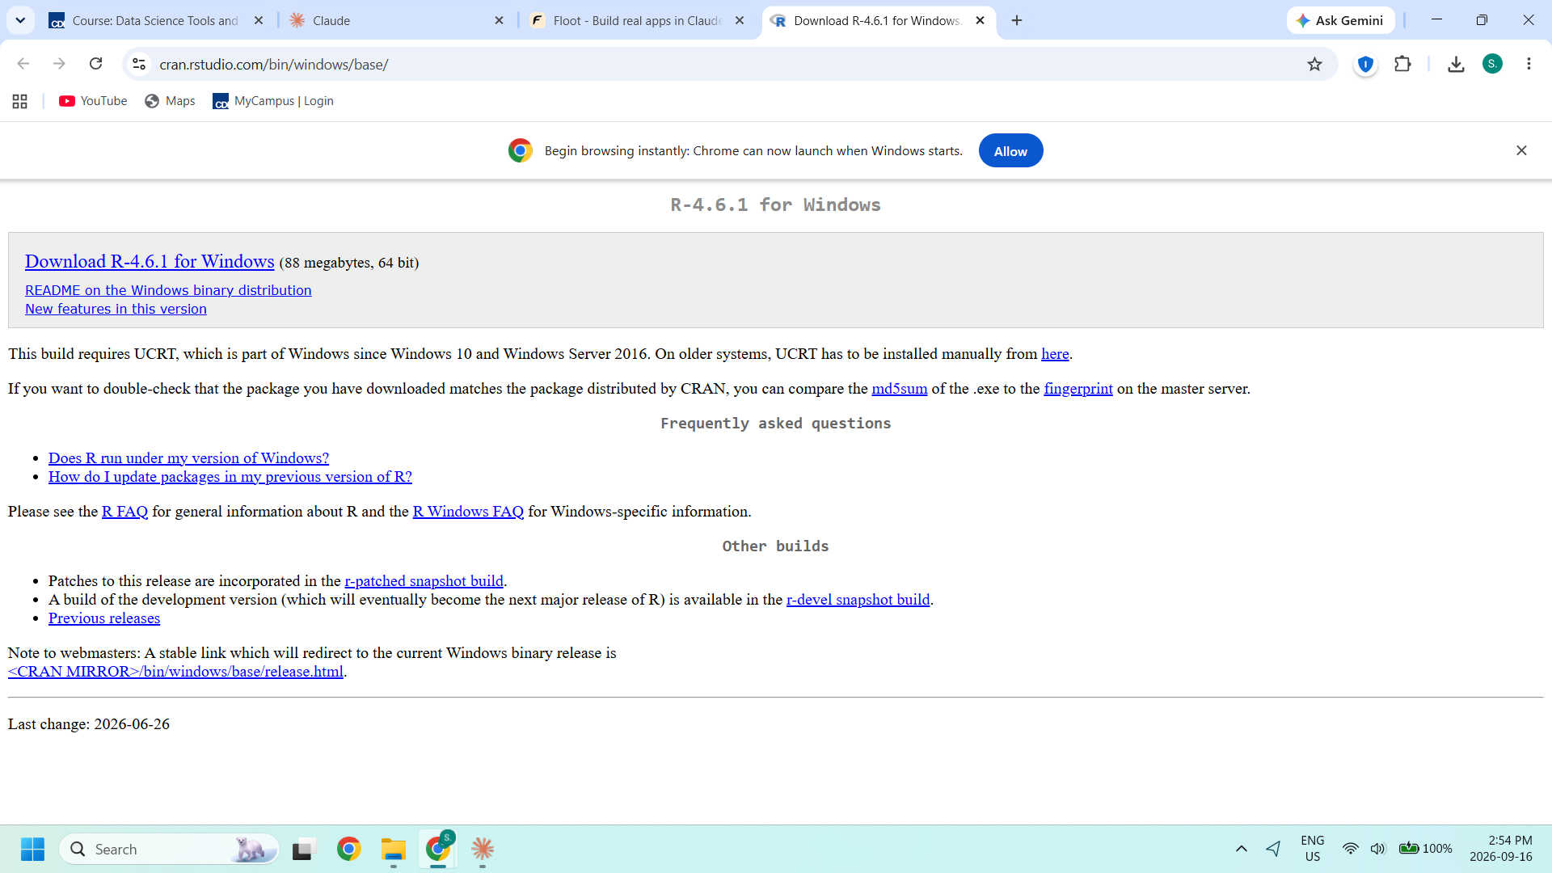
Figure 2. CRAN download page for R-4.6.1 for Windows (64-bit).
Both installations completed successfully: R 4.6.1 was confirmed at C:\Program Files\R\R-4.6.1, and RStudio was confirmed at C:\Program Files\RStudio. Opening RStudio shows it running R 4.6.1 in the Console pane (see Figure 5).

4. Downloading and Installing R Packages for Technical Analysis
The packages required for technical analysis — 'quantmod' (quantitative financial modelling, used to import stock data) and 'TTR' (Technical Trading Rules, used for moving averages and other indicators) — were installed from the RStudio Console with:
install.packages(c("quantmod", "TTR"))
Both packages, plus their dependencies (xts, zoo, curl, jsonlite, etc.), installed and unpacked successfully with no errors, as shown in the Console output and the Packages pane below.
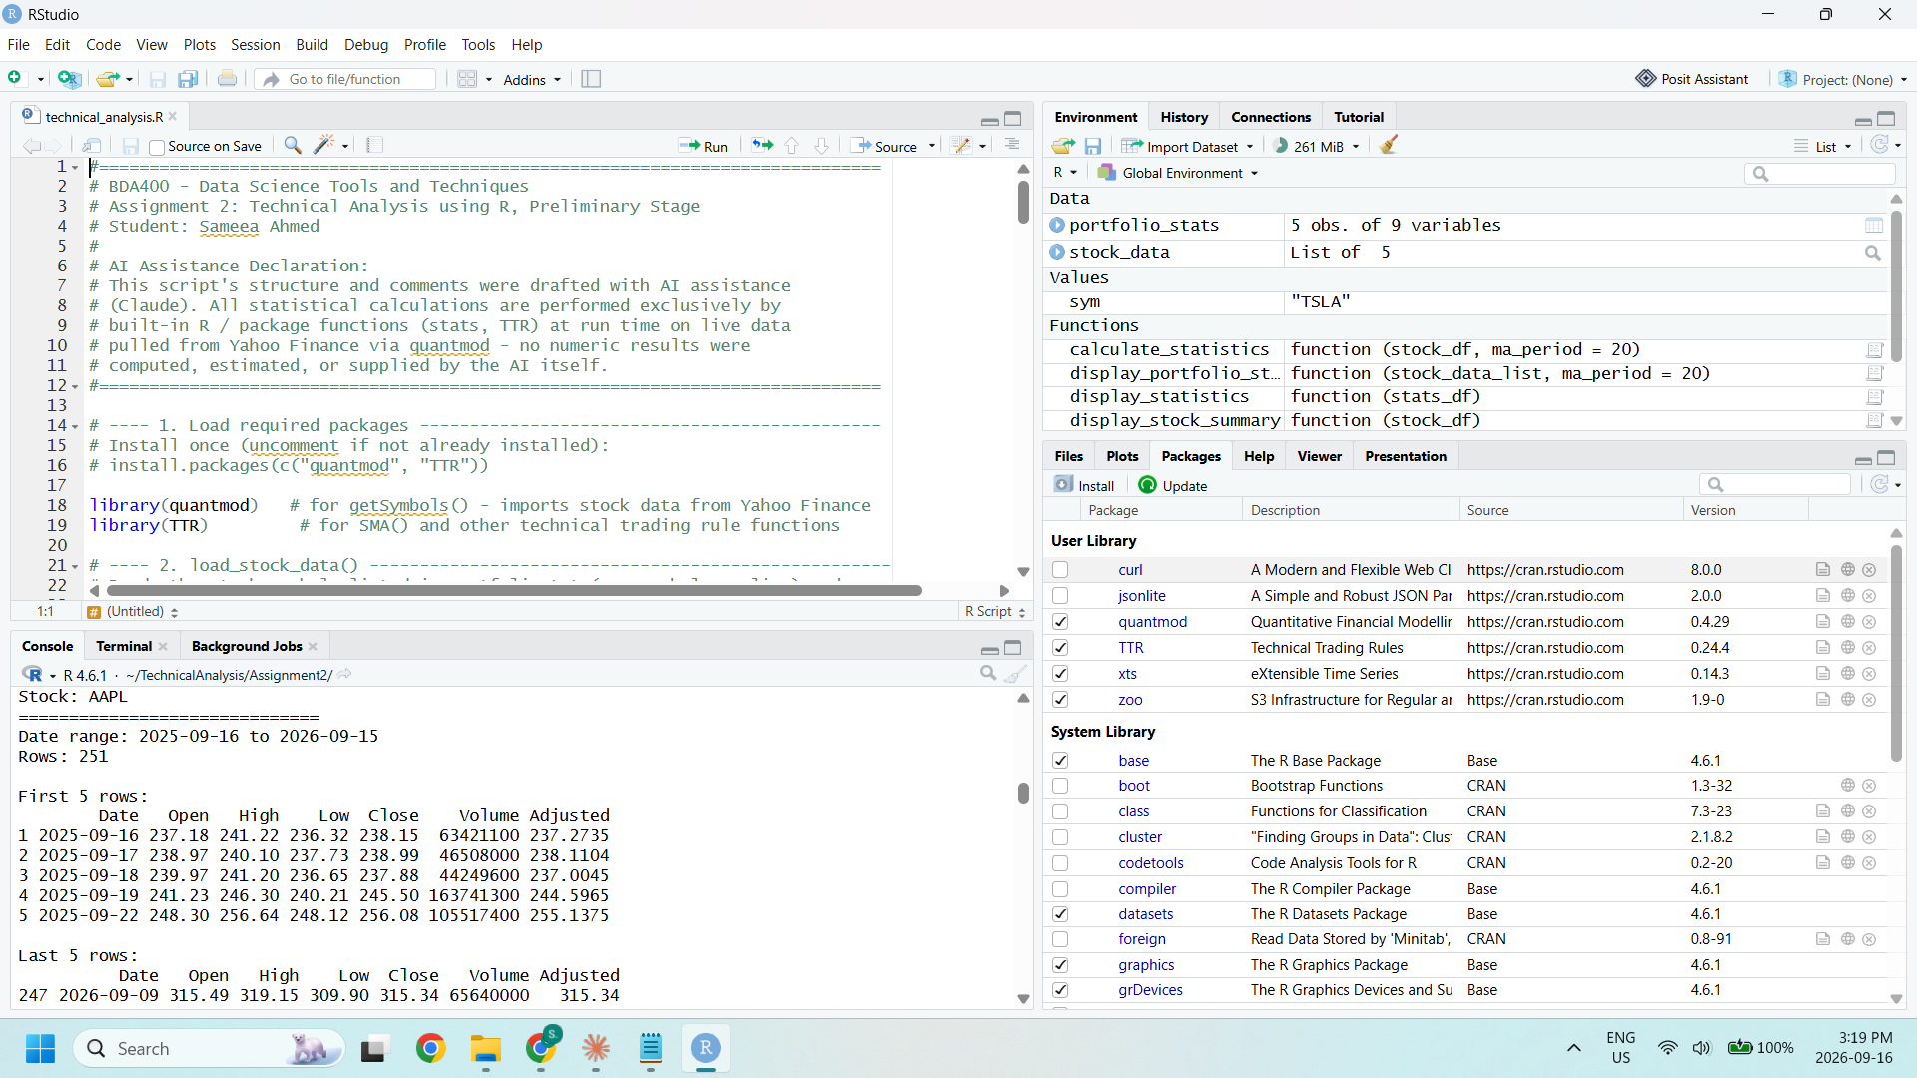
Figure 3. RStudio Packages pane confirming 'quantmod' and 'TTR' are installed and loaded.

5. Project Configuration and Initialization
A text file named 'portfolio.txt' was created to list the stock symbols making up the individual portfolio for this assignment, one symbol per line:
AAPL
MSFT
GOOGL
AMZN
TSLA

6. Writing a Function to Import and Load Stock Data
The function load_stock_data() reads the stock symbols from portfolio.txt and imports each stock's historical price data using the quantmod package's getSymbols() function, storing the result for each symbol as a separate data frame inside a named list.
load_stock_data <- function(portfolio_file = "portfolio.txt",
from_date = Sys.Date() - 365,
to_date = Sys.Date()) {
symbols <- trimws(readLines(portfolio_file, warn = FALSE))
symbols <- symbols[symbols != ""]
stock_data_list <- list()
for (sym in symbols) {
result <- getSymbols(sym, src = "yahoo", from = from_date,
to = to_date, auto.assign = FALSE)
df <- data.frame(Date = zoo::index(result), zoo::coredata(result))
colnames(df) <- gsub(paste0("^", sym, "\\."), "", colnames(df))
attr(df, "symbol") <- sym
stock_data_list[[sym]] <- df
}
return(stock_data_list)
}

7. Writing a Function to Compute Basic Statistics
The function calculate_statistics() takes one stock's data frame and computes the required statistics on its closing price: a rolling moving average (via TTR::SMA), mean, mode, median, and standard deviation, returning them as a structured one-row data frame.
calculate_statistics <- function(stock_df, ma_period = 20) {
close_prices <- stock_df$Close
moving_avg <- TTR::SMA(close_prices, n = ma_period)
data.frame(
Symbol = attr(stock_df, "symbol"),
Mean_Close = round(mean(close_prices, na.rm = TRUE), 2),
Median_Close = round(median(close_prices, na.rm = TRUE), 2),
Mode_Close = round(get_mode(close_prices), 2),
SD_Close = round(sd(close_prices, na.rm = TRUE), 2),
Latest_MA20 = round(tail(moving_avg[!is.na(moving_avg)], 1), 2)
)
}
(get_mode() is a small helper defined in the script, since base R has no built-in statistical-mode function.)

8. Displaying Imported Data and Calculated Statistics
Several display utilities were written to present the data the way stock data is commonly shown (summary tables, head/tail views, and charts, similar to how Yahoo Finance presents price history): display_stock_summary() prints each stock's date range and first/last 5 rows; display_statistics() and display_portfolio_statistics() print the calculated statistics as tables; and plot_stock_with_ma() charts the closing price against its moving average.
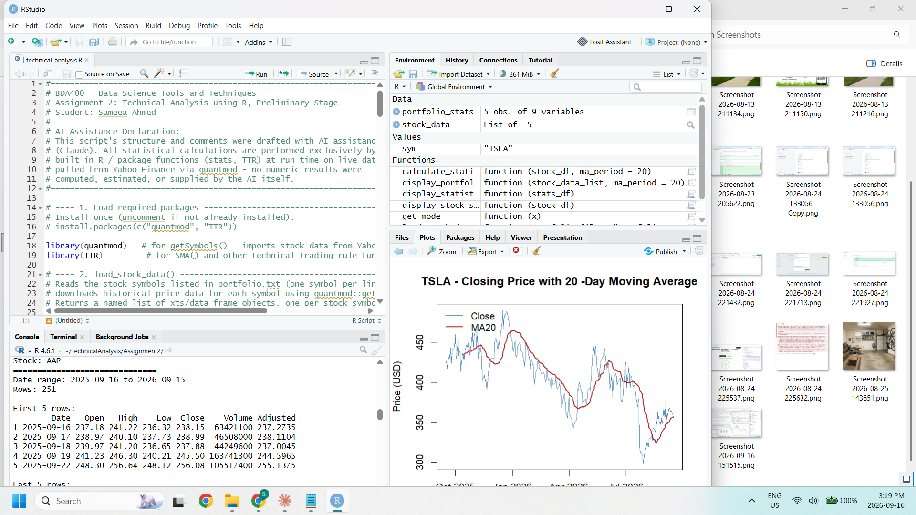
Figure 4. Console output of display_stock_summary() showing the imported AAPL data frame (date range, first/last 5 rows, structure).
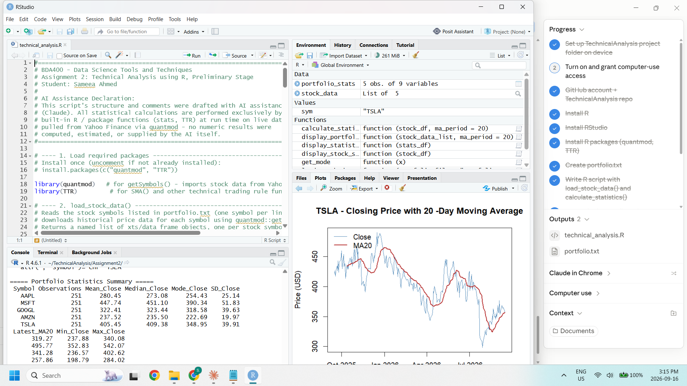
Figure 5. Console output of the Portfolio Statistics Summary table (mean, median, mode, SD, MA20 for all 5 stocks) alongside the TSLA closing-price / 20-day moving-average plot.
Running the full script (source()) downloads live data for all 5 symbols from Yahoo Finance, prints each stock's raw data and the full portfolio statistics table, plots each stock's price with its moving average, and saves the summary table to portfolio_statistics_summary.csv.

9. Documentation
This report documents every step of the setup and preliminary analysis process listed in the assignment instructions, with screenshots captured directly from the student's own GitHub account, R/RStudio installation, and RStudio session. The deliverables below are all included in the GitHub repository under /Assignment2:
- portfolio.txt — list of stock symbols
- technical_analysis.R — R script with load_stock_data(), calculate_statistics(), and display/plot functions
- This report (SameeaAhmed_BDA400_A02.docx)

Appendix A: Full R Script (technical_analysis.R)
The complete script is included in the GitHub repository at /Assignment2/technical_analysis.R and reproduced in full below for reference.
#==============================================================================
# BDA400 - Data Science Tools and Techniques
# Assignment 2: Technical Analysis using R, Preliminary Stage
# Student: Sameea Ahmed
#
# AI Assistance Declaration:
# This script's structure and comments were drafted with AI assistance
# (Claude). All statistical calculations are performed exclusively by
# built-in R / package functions (stats, TTR) at run time on live data
# pulled from Yahoo Finance via quantmod - no numeric results were
# computed, estimated, or supplied by the AI itself.
#==============================================================================

# ---- 1. Load required packages ----------------------------------------------
# Install once (uncomment if not already installed):
# install.packages(c("quantmod", "TTR"))

library(quantmod) # for getSymbols() - imports stock data from Yahoo Finance
library(TTR) # for SMA() and other technical trading rule functions

# ---- 2. load_stock_data() ----------------------------------------------------
# Reads the stock symbols listed in portfolio.txt (one symbol per line) and
# downloads historical price data for each symbol using quantmod::getSymbols().
# Returns a named list of xts/data frame objects, one per stock symbol.

load_stock_data <- function(portfolio_file = "portfolio.txt",
from_date = Sys.Date() - 365,
to_date = Sys.Date()) {

if (!file.exists(portfolio_file)) {
stop(paste("Portfolio file not found:", portfolio_file))
}

# Read stock symbols, one per line, ignoring blank lines/whitespace
symbols <- readLines(portfolio_file, warn = FALSE)
symbols <- trimws(symbols)
symbols <- symbols[symbols != ""]

cat("Loading data for", length(symbols), "symbols:", paste(symbols, collapse = ", "), "\n")

stock_data_list <- list()

for (sym in symbols) {
cat(" -> Downloading", sym, "...\n")
result <- tryCatch({

# getSymbols with auto.assign = FALSE returns the xts object directly
# instead of assigning it to a variable named after the symbol in .GlobalEnv
getSymbols(sym, src = "yahoo", from = from_date, to = to_date, auto.assign = FALSE)
}, error = function(e) {
warning(paste("Failed to download", sym, "-", conditionMessage(e)))
NULL
})

if (!is.null(result)) {
# Store as a data frame with Date as an explicit column, keeping the
# symbol name attached so downstream functions know which stock it is
df <- data.frame(Date = zoo::index(result), zoo::coredata(result))
colnames(df) <- gsub(paste0("^", sym, "\\."), "", colnames(df))
attr(df, "symbol") <- sym
stock_data_list[[sym]] <- df
}
}

cat("Finished loading", length(stock_data_list), "of", length(symbols), "symbols.\n")
return(stock_data_list)
}

# ---- 3. calculate_statistics() ------------------------------------------------
# Takes a single stock's data frame (as produced by load_stock_data) and
# computes basic descriptive statistics on the Closing price: a rolling
# moving average, mean, mode, median, and standard deviation.
# Returns a one-row data frame summarizing the stock.

# Helper: R has no built-in mode() function for statistical mode, so we
# define one that works on numeric price data (returns the most frequent
# value, rounded to 2 decimals to group near-identical closing prices).
get_mode <- function(x) {
x <- round(x, 2)
freq_table <- table(x)
as.numeric(names(freq_table)[which.max(freq_table)])
}

calculate_statistics <- function(stock_df, ma_period = 20) {

if (!"Close" %in% colnames(stock_df)) {
stop("Input data frame must contain a 'Close' column.")
}

close_prices <- stock_df$Close
symbol <- attr(stock_df, "symbol")

if (is.null(symbol)) symbol <- "UNKNOWN"

# Moving average via TTR::SMA (Simple Moving Average)
moving_avg <- TTR::SMA(close_prices, n = ma_period)

stats_summary <- data.frame(
Symbol = symbol,
Observations = length(close_prices),
Mean_Close = round(mean(close_prices, na.rm = TRUE), 2),
Median_Close = round(median(close_prices, na.rm = TRUE), 2),
Mode_Close = round(get_mode(close_prices), 2),
SD_Close = round(sd(close_prices, na.rm = TRUE), 2),
Latest_MA20 = round(tail(moving_avg[!is.na(moving_avg)], 1), 2),
Min_Close = round(min(close_prices, na.rm = TRUE), 2),
Max_Close = round(max(close_prices, na.rm = TRUE), 2)
)

# Attach the full moving-average series as an attribute in case the
# caller wants to plot it later, without cluttering the summary table
attr(stats_summary, "moving_average_series") <- moving_avg

return(stats_summary)
}

# ---- 4. Display utility functions --------------------------------------------
# Several ways of displaying the imported data / calculated statistics,
# reflecting the different ways stock data is commonly presented
# (e.g. Yahoo Finance-style summary tables and time series views).

# 4a. Print a compact summary of a stock's raw data frame (head/tail + str)
display_stock_summary <- function(stock_df) {
symbol <- attr(stock_df, "symbol")
cat("\n==============================\n")
cat("Stock:", symbol, "\n")
cat("==============================\n")
cat("Date range:", as.character(min(stock_df$Date)), "to", as.character(max(stock_df$Date)), "\n")
cat("Rows:", nrow(stock_df), "\n\n")
cat("First 5 rows:\n")
print(head(stock_df, 5))
cat("\nLast 5 rows:\n")
print(tail(stock_df, 5))
cat("\nStructure:\n")
str(stock_df)
}

# 4b. Print the calculated statistics table for one or more stocks
display_statistics <- function(stats_df) {
cat("\n----- Calculated Statistics -----\n")
print(stats_df, row.names = FALSE)
}

# 4c. Combine statistics for every stock in the portfolio into one table
display_portfolio_statistics <- function(stock_data_list, ma_period = 20) {
all_stats <- do.call(rbind, lapply(stock_data_list, calculate_statistics, ma_period = ma_period))
rownames(all_stats) <- NULL
cat("\n===== Portfolio Statistics Summary =====\n")
print(all_stats, row.names = FALSE)
return(all_stats)
}

# 4d. Plot a stock's closing price with its moving average overlaid
plot_stock_with_ma <- function(stock_df, ma_period = 20) {
symbol <- attr(stock_df, "symbol")
ma <- TTR::SMA(stock_df$Close, n = ma_period)
plot(stock_df$Date, stock_df$Close, type = "l", col = "steelblue",
main = paste(symbol, "- Closing Price with", ma_period, "-Day Moving Average"),
xlab = "Date", ylab = "Price (USD)")
lines(stock_df$Date, ma, col = "firebrick", lwd = 2)
legend("topleft", legend = c("Close", paste0("MA", ma_period)),
col = c("steelblue", "firebrick"), lty = 1, lwd = c(1, 2), bty = "n")
}

#==============================================================================
# 5. MAIN - configure and run the preliminary technical analysis process
#==============================================================================

# Read the portfolio and download each stock's historical data
stock_data <- load_stock_data("portfolio.txt")

# Display the raw imported data for every stock
for (sym in names(stock_data)) {
display_stock_summary(stock_data[[sym]])
}

# Calculate and display statistics for every stock in the portfolio
portfolio_stats <- display_portfolio_statistics(stock_data, ma_period = 20)

# Plot each stock's price with its moving average (opens one plot per stock)
for (sym in names(stock_data)) {
plot_stock_with_ma(stock_data[[sym]], ma_period = 20)

}

# Save the statistics summary to CSV for easy inclusion in the report
write.csv(portfolio_stats, "portfolio_statistics_summary.csv", row.names = FALSE)
cat("\nSaved portfolio_statistics_summary.csv\n")

