BDA400 – Data Science Tools and Techniques
CDI College
Assignment 6
Technical Analysis using R – Visualization Phase (15%)
Student: Sameea Ahmed
Due: Session 15
September 2026
Assignment repository
https://github.com/ahmed1sameea-art/TechnicalAnalysis
Assignment 6 files: /Assignment6
Project description
An interactive R Shiny portfolio dashboard that fetches historical stock prices from Yahoo Finance, displays them as candlestick, line, area or OHLC charts, overlays the Moving Average, RSI and MACD indicators written in Assignment 5 (each switchable on or off), and applies trading rules – led by a moving average crossover – to annotate the chart with Buy, Sell and Hold signals. It is the third and final stage of the three-part Technical Analysis project.

1. Overview
This assignment completes the three-part Technical Analysis project that is stored in one public GitHub repository:
- Stage 1 – Assignment 2 (Preliminary): loaded the portfolio in portfolio.txt (AAPL, MSFT, GOOGL, AMZN, TSLA) with quantmod and summarised it (technical_analysis.R).
- Stage 2 – Assignment 5 (Development): wrote the indicator functions from scratch in base R – sma(), ema(), macd(), rsi(), crossover(), crossunder() and others.
- Stage 3 – Assignment 6 (Visualization, this submission): Assignment6/app.R, a Shiny dashboard that uses the Stage 2 functions to visualise the data and generate annotated trading signals.
The whole app is one R script, organised into commented sections that match Steps 1 to 4 of the instructions. It was run in RStudio (R 4.6.1, Windows) with live Yahoo Finance data, and every screenshot in this document comes from that run.

2. Deliverables
Deliverable | Where
R script with all dashboard code | Assignment6/app.R
Cover page (name, title, description, repository link) | This document (page 1) and Assignment6/README.md in the repository
Link to the assignment repository | https://github.com/ahmed1sameea-art/TechnicalAnalysis
Screenshots of the running app | Assignment6/screenshots/ (captured by capture_screenshots.R)
Indicator functions re-used from Assignment 5 | sma.R, ema.R, macd.R, rsi.R, crossover.R, crossunder.R (repository root)

3. Step 1 – Data Collection and Setup

3.1 Data source
Yahoo Finance is the main data source, accessed with quantmod::getSymbols(src = "yahoo"). As a second source, the user can upload a CSV file (Date, Open, High, Low, Close, Volume) – for example a file exported from Yahoo Finance or a broker – which is useful when working offline.

3.2 Install and load packages
The script installs any missing package automatically and then loads shiny, ggplot2 and quantmod (quantmod also loads xts, zoo and TTR). The Assignment 5 indicator files are then sourced from the repository root; if they are missing the app falls back to equivalent TTR functions so it still runs.
required_packages <- c("shiny", "ggplot2", "quantmod")
for (pkg in required_packages) {
if (!requireNamespace(pkg, quietly = TRUE)) install.packages(pkg)
}
library(shiny); library(ggplot2); library(quantmod)

a5_files <- c("sma.R", "ema.R", "macd.R", "rsi.R", "crossover.R", "crossunder.R")

3.3 Fetch historical stock data (with error handling)
fetch_stock_data() downloads the symbol, start date and end date chosen in the dashboard. It includes the following safeguards:
- Errors (such as an unknown ticker or no internet) are caught and shown in the app as a clear message instead of crashing it (Figure 9).
- clean_ohlc() standardises column names, removes duplicate dates, carries the last known price forward over missing values and drops rows that are still incomplete.
- Extra history is downloaded before the chosen start date, so the 50-bar moving average, RSI and MACD are already valid on the first visible bar.
- Downloads are cached in memory, so changing a widget does not download the same data again.
stock_data <- tryCatch(
suppressWarnings(getSymbols(stock_symbol, src = "yahoo",
from = start_date, to = end_date, auto.assign = FALSE)),
error = function(e) stop("Could not download '", stock_symbol, "' ..."))
stock_data <- clean_ohlc(stock_data) # missing values, duplicates, column names

4. Step 2 – Visualizing Stock Data

4.1 Shiny app skeleton
The app uses the standard fluidPage() UI and server(input, output) function, and ends with shinyApp(ui, server). It has a sidebar of controls and four tabs: Price Chart, Trading Signals, Portfolio Overview and Data.

4.2 Interactive widgets
Widget | Purpose
radioButtons – Data source | Yahoo Finance or Upload CSV
selectizeInput – Stock symbol | Portfolio symbols from portfolio.txt, or type any ticker
dateRangeInput("date_range") | Select Date Range (default 2023-01-01 to 2023-07-01, as in the handout)
selectInput("time_frame") | Daily, Weekly or Monthly (to.weekly() / to.monthly())
selectInput – Chart type | Candlestick, Line, Area or OHLC Bars
checkboxGroupInput("technical_indicators") | Switch Moving Averages, RSI and MACD on or off
numericInput / radioButtons | MA periods and SMA/EMA type, RSI period, MACD fast/slow/signal
selectInput – Strategy; sliderInput | Trading rule, and the RSI oversold/overbought levels
checkbox + radioButtons – Annotations | Show signals only when they change, or a Buy/Sell/Hold state on every bar

4.3 Visualize stock data
In output$stock_chart <- renderPlot(), the data is filtered to the selected date range and time frame, and a ggplot is built from it. The geoms added depend on the chart type: geom_line() for a line chart, geom_area() for an area chart, geom_segment() + geom_rect() for candlesticks (green up, red down), and three geom_segment() layers for OHLC bars. Four KPI cards above the chart show the last close, the change over the range, the latest RSI and the current signal state.
filtered_data <- subset(ind, Date >= as.Date(input$date_range[1]) &
Date <= as.Date(input$date_range[2]))
p <- ggplot(data = filtered_data, aes(x = Date, y = Close))
if (input$chart_type == "Line") p <- p + geom_line(...)
else if (input$chart_type == "Candlestick") p <- p + geom_segment(...) + geom_rect(...)
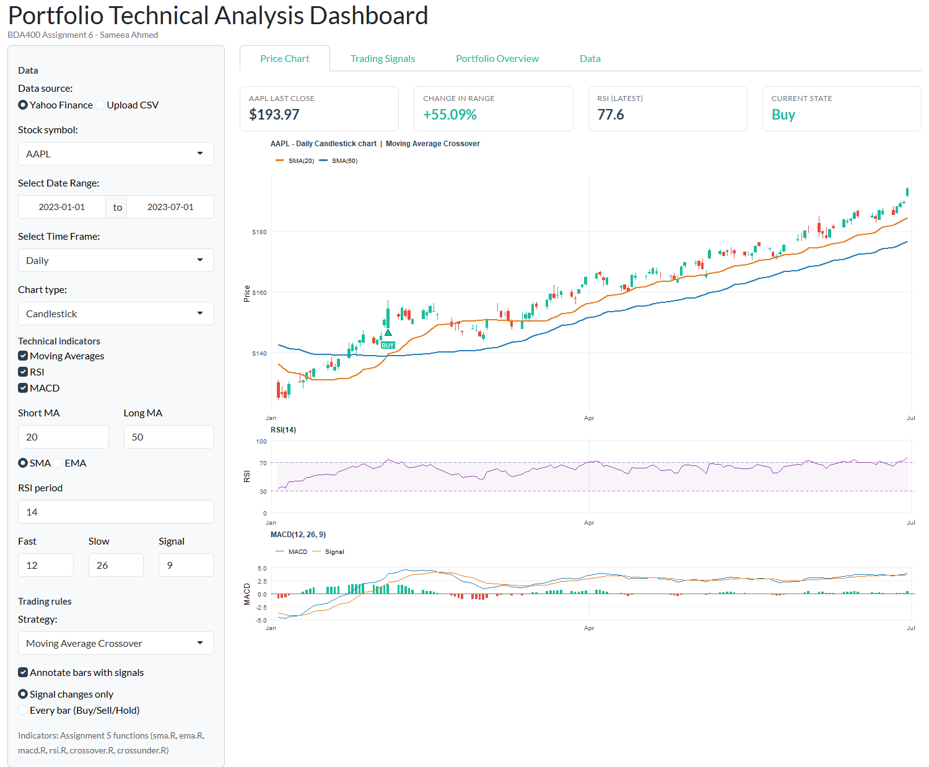
Figure 1 – AAPL daily candlestick chart (Jan–Jul 2023) with SMA(20)/SMA(50), RSI(14) and MACD(12, 26, 9)
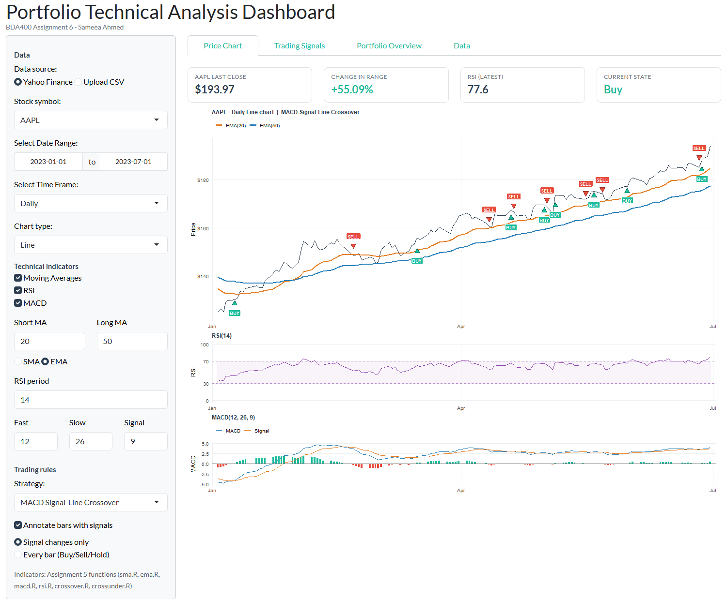
Figure 2 – Line chart with EMA(20)/EMA(50) and the MACD signal-line strategy
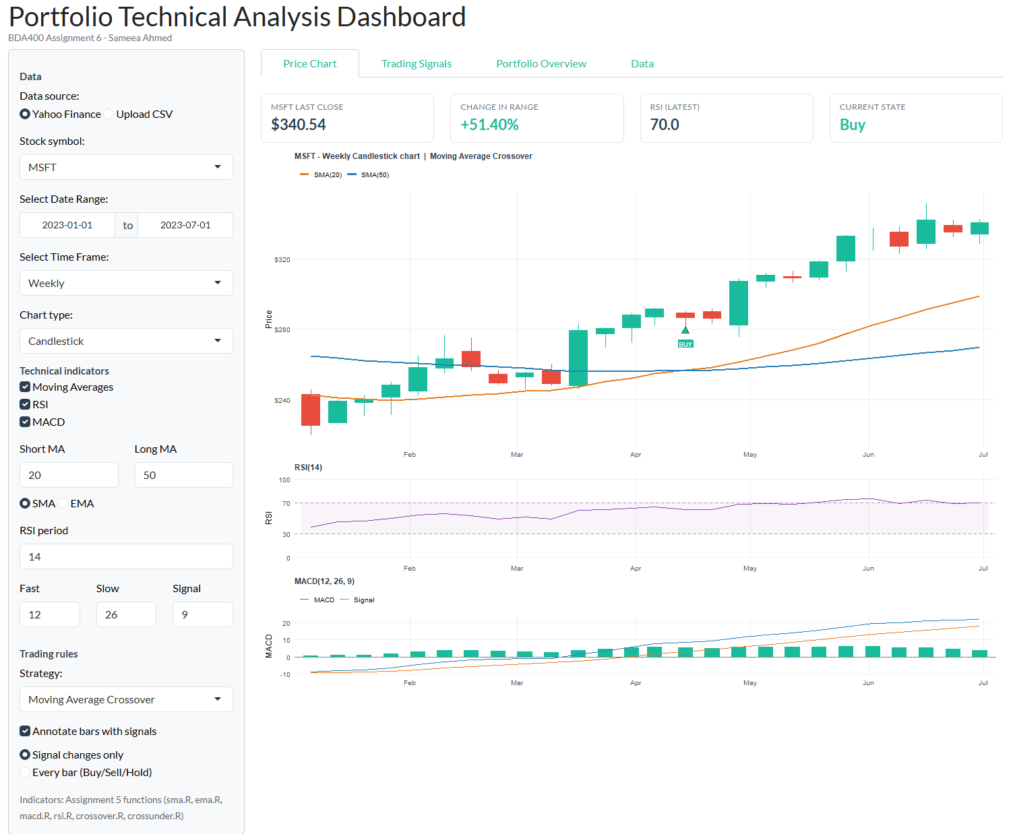
Figure 3 – MSFT on the Weekly time frame (candlestick)

5. Step 3 – Overlay Technical Indicators

5.1 Indicators added as layers
The indicators are calculated with my Assignment 5 functions (the note at the bottom of the sidebar confirms which functions were loaded):
- Moving Averages – sma() or ema() for the short and long periods, added as two line layers on top of the price chart.
- RSI – rsi() with Wilder smoothing, drawn in its own 0–100 panel with dashed oversold/overbought lines and a shaded band.
- MACD – macd() returns the MACD line, signal line and histogram; these are drawn in a panel with green/red histogram bars.
RSI and MACD use a different scale from price (0–100 and around zero), so they are stacked directly under the price chart with the same date axis. This keeps all the layers readable on one chart.

5.2 Turning each overlay on and off
Each indicator is added only if it is ticked in the checkbox group, following the pattern in the handout. The chart height adjusts automatically when panels are added or removed (compare Figures 1 and 4).
if ("Moving Averages" %in% input$technical_indicators) {
p <- p + ggnewscale_line(ma_long) # short + long MA layers
}
if ("RSI" %in% input$technical_indicators) panels <- c(panels, list(p_rsi))
if ("MACD" %in% input$technical_indicators) panels <- c(panels, list(p_macd))
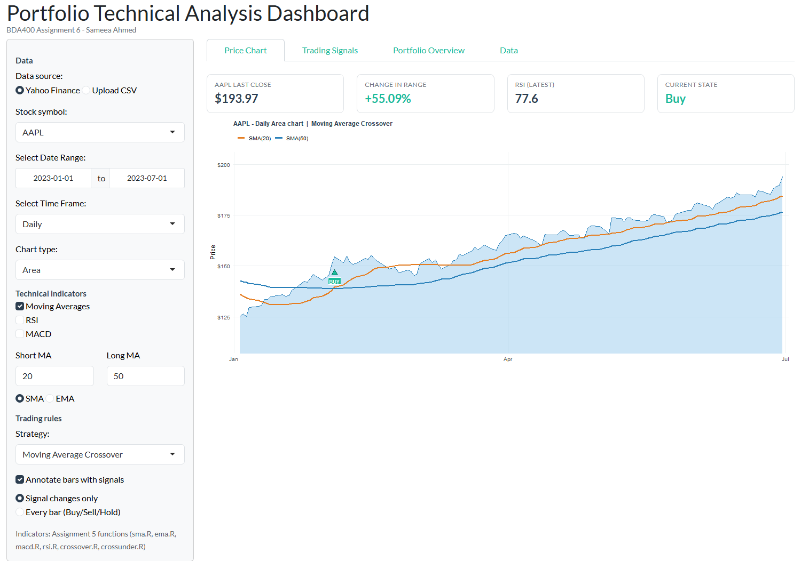
Figure 4 – Area chart with RSI and MACD switched off (only the Moving Averages overlay is on)

6. Step 4 – Trading Rules and Annotations

6.1 Basic trading rule – Moving Average Crossover
The required rule follows the handout: if the short-term MA is above the long-term MA the state is Buy, if it is below the state is Sell, and otherwise Hold. The actual trade signal is placed on the bar where the state changes, detected with my crossover() and crossunder() functions. A small wrapper (safe_cross()) skips the warm-up bars where the averages are still NA.
short_ma <- moving_average(close, p$short_n, p$ma_type) # default SMA(20)
long_ma <- moving_average(close, p$long_n, p$ma_type) # default SMA(50)
state <- ifelse(short_ma > long_ma, "Buy", ifelse(short_ma < long_ma, "Sell", "Hold"))
buy <- safe_cross(short_ma, long_ma, crossover) # short crosses ABOVE long
sell <- safe_cross(short_ma, long_ma, crossunder) # short crosses BELOW long
filtered_data$Signal <- ifelse(buy, "Buy", ifelse(sell, "Sell", "Hold"))

6.2 Additional customizable rules
Strategy | Buy when | Sell when
Moving Average Crossover | Short MA crosses above long MA | Short MA crosses below long MA
RSI Overbought / Oversold | RSI climbs back above the oversold level | RSI falls back below the overbought level
MACD Signal-Line Crossover | MACD crosses above its signal line | MACD crosses below its signal line
MA Crossover + RSI Filter | MA buy crossover while RSI < overbought | MA sell crossover while RSI > oversold
All of the periods and RSI levels can be changed in the sidebar, and the signals update straight away.

6.3 Annotating the bars
Buy signals are marked with a green ▲ and a BUY label under the bar's low; Sell signals with a red ▼ and a SELL label above the bar's high (geom_point() + geom_label()). The "Every bar" option instead labels each bar with its Buy/Sell/Hold state (B/S/H) in a strip along the bottom of the chart, which matches the handout's geom_text(label = Signal) example without the labels covering the candles.
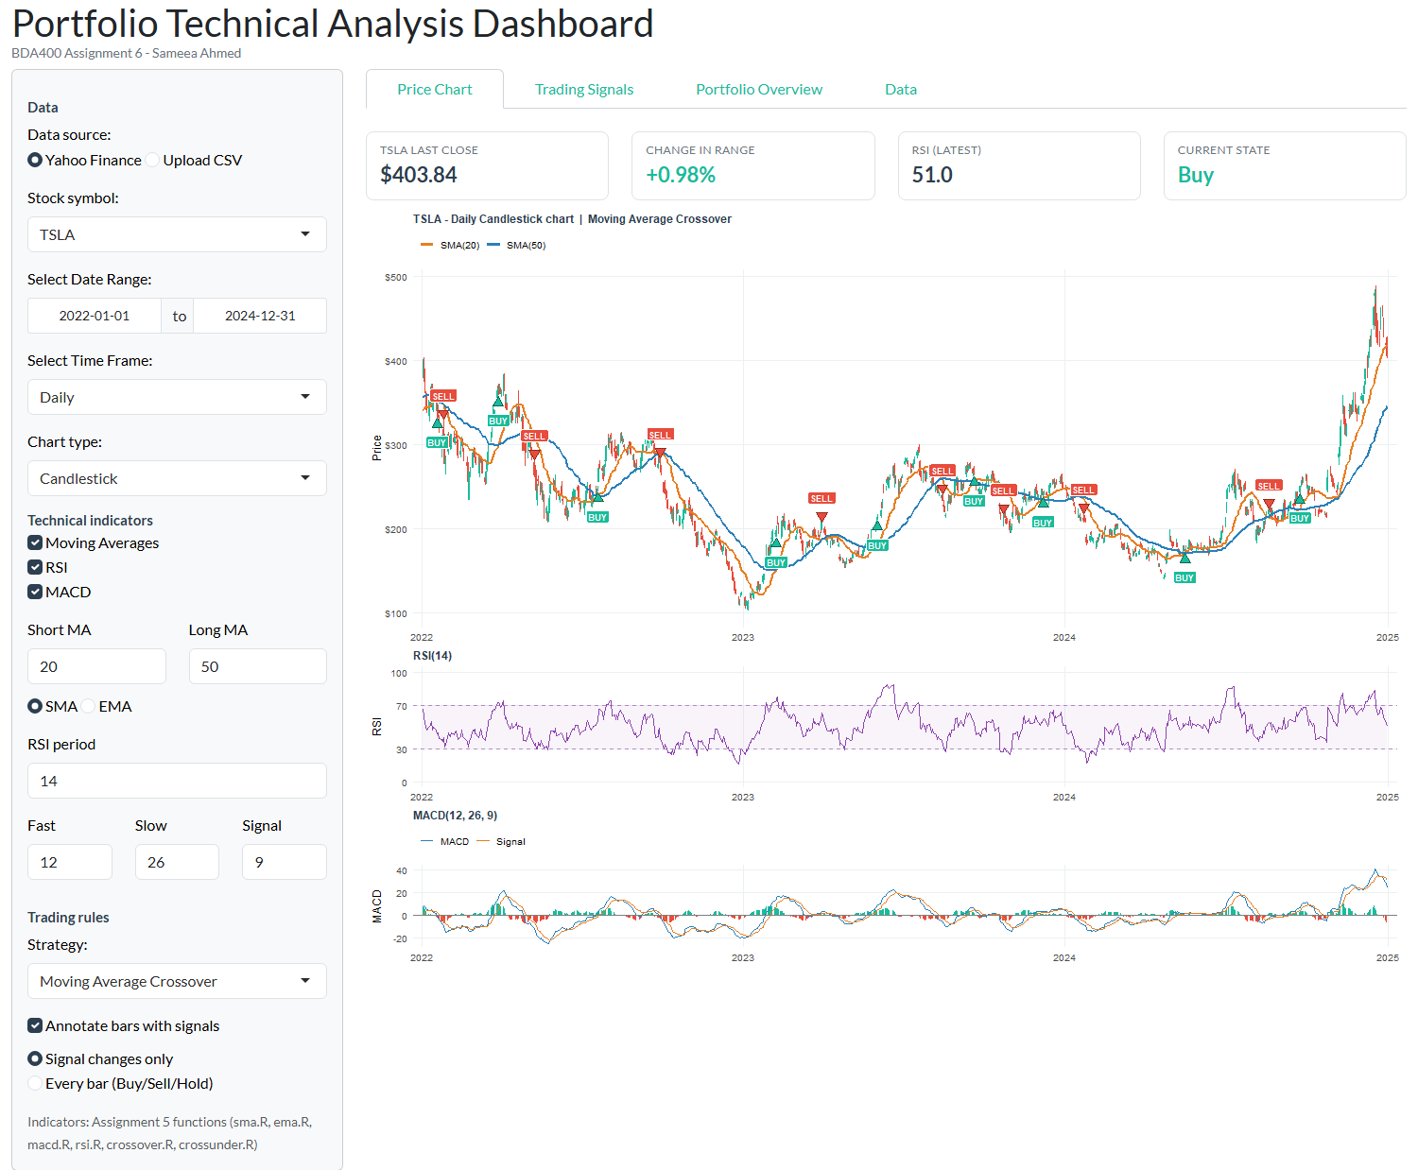
Figure 5 – TSLA 2022–2024: Moving Average Crossover BUY/SELL annotations on the candlestick chart
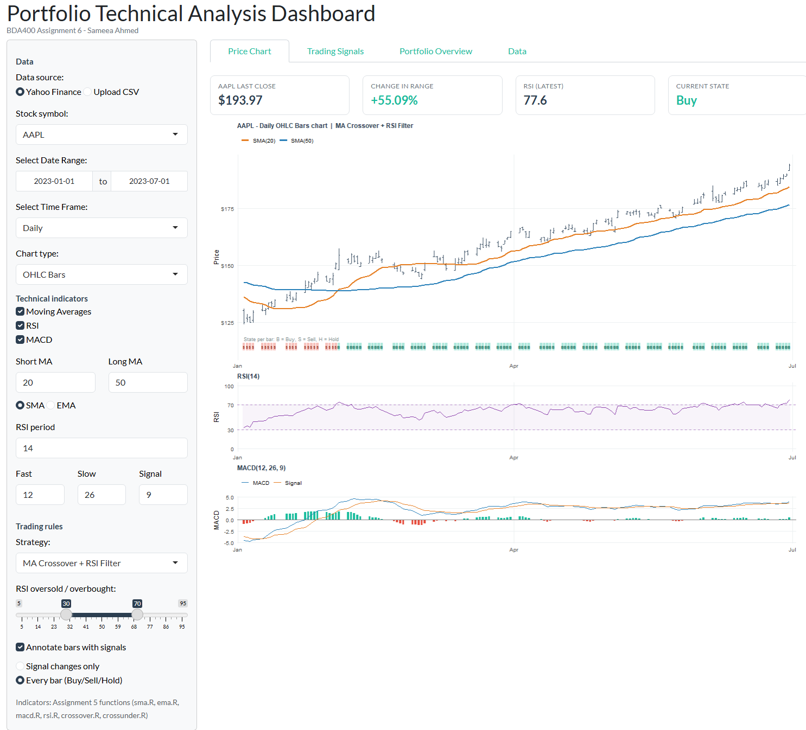
Figure 6 – OHLC bars with the Buy/Sell/Hold state shown for every bar (MA Crossover + RSI Filter)

6.4 Trading Signals tab
This tab lists every bar where a trade is triggered, with the price and indicator values at that point. It also runs a simple long-only test calculated by R: buy on the bar after a BUY, exit on the bar after a SELL, and compare the result with buy-and-hold. This test is only an illustration and ignores trading costs.
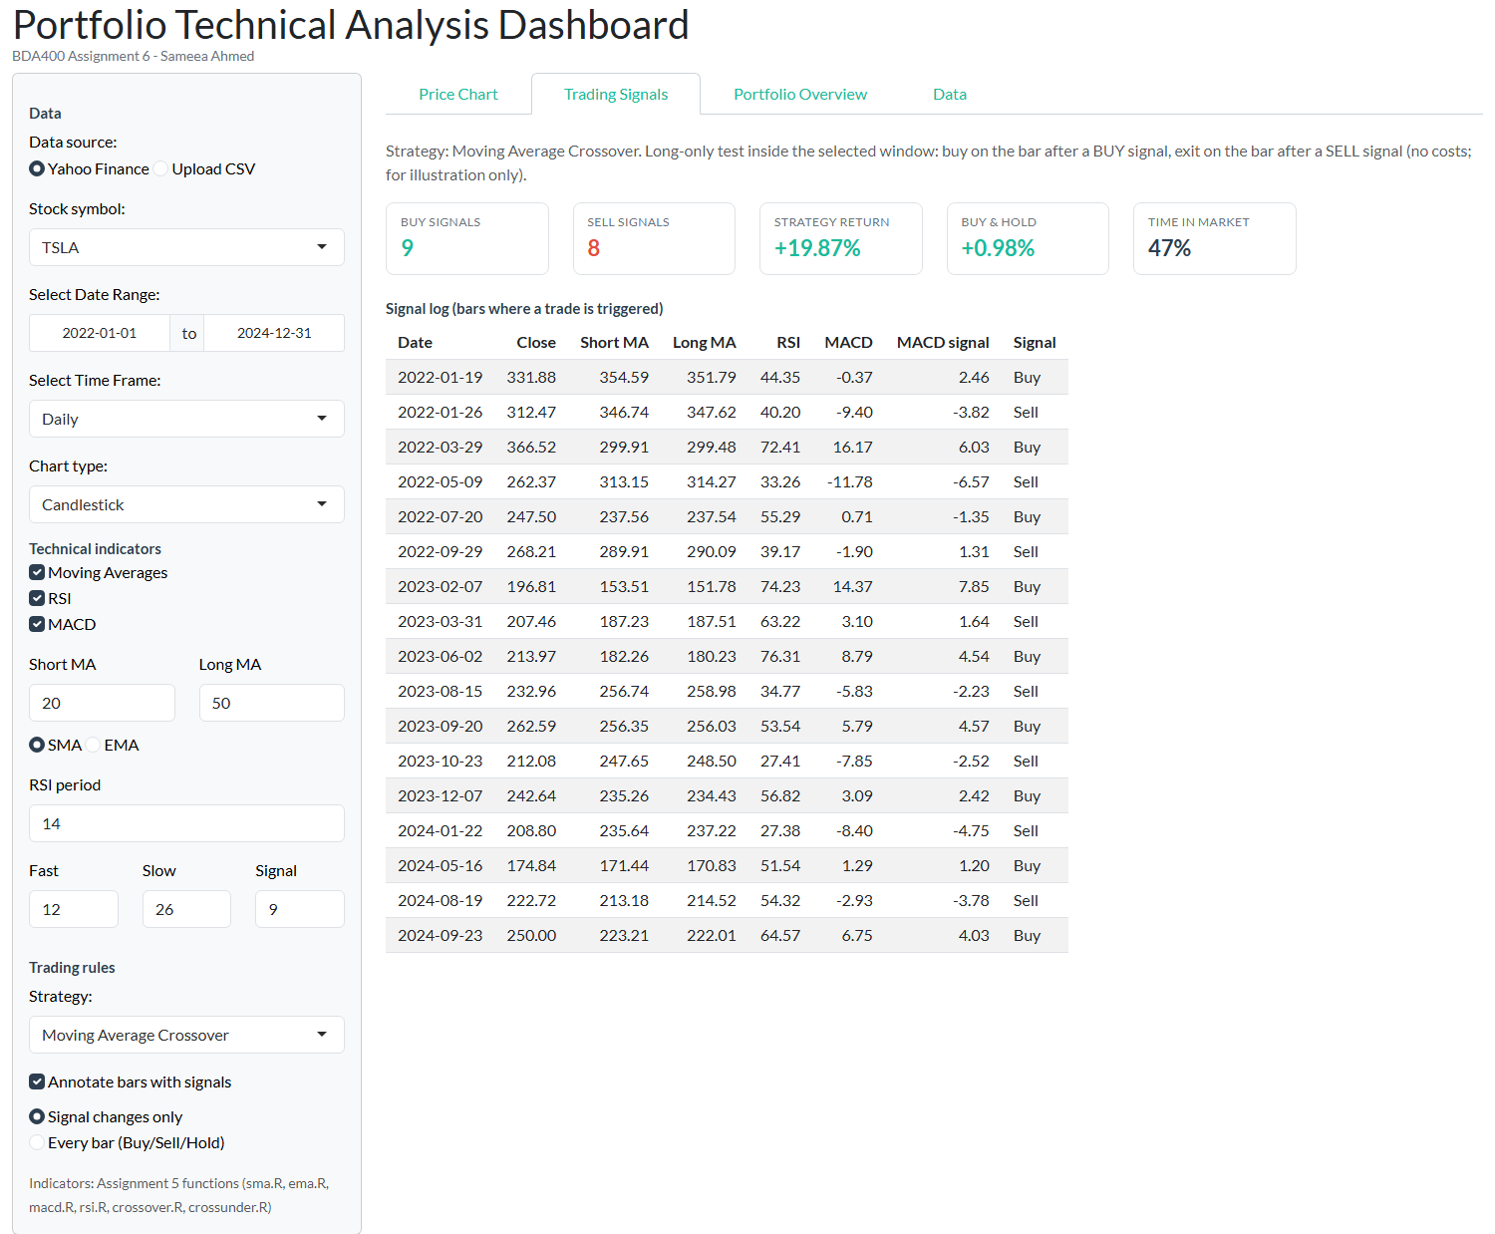
Figure 7 – Signal log for TSLA 2022–2024: signals alternate Buy/Sell at each crossover

7. Portfolio Overview and Error Handling
The Portfolio Overview tab downloads every symbol in portfolio.txt for the selected dates. It plots them rebased to 100 so their performance can be compared, and a table shows each stock's first and last close, return, high, low and current moving-average state. If a symbol fails to download it is skipped and the rest are still shown.
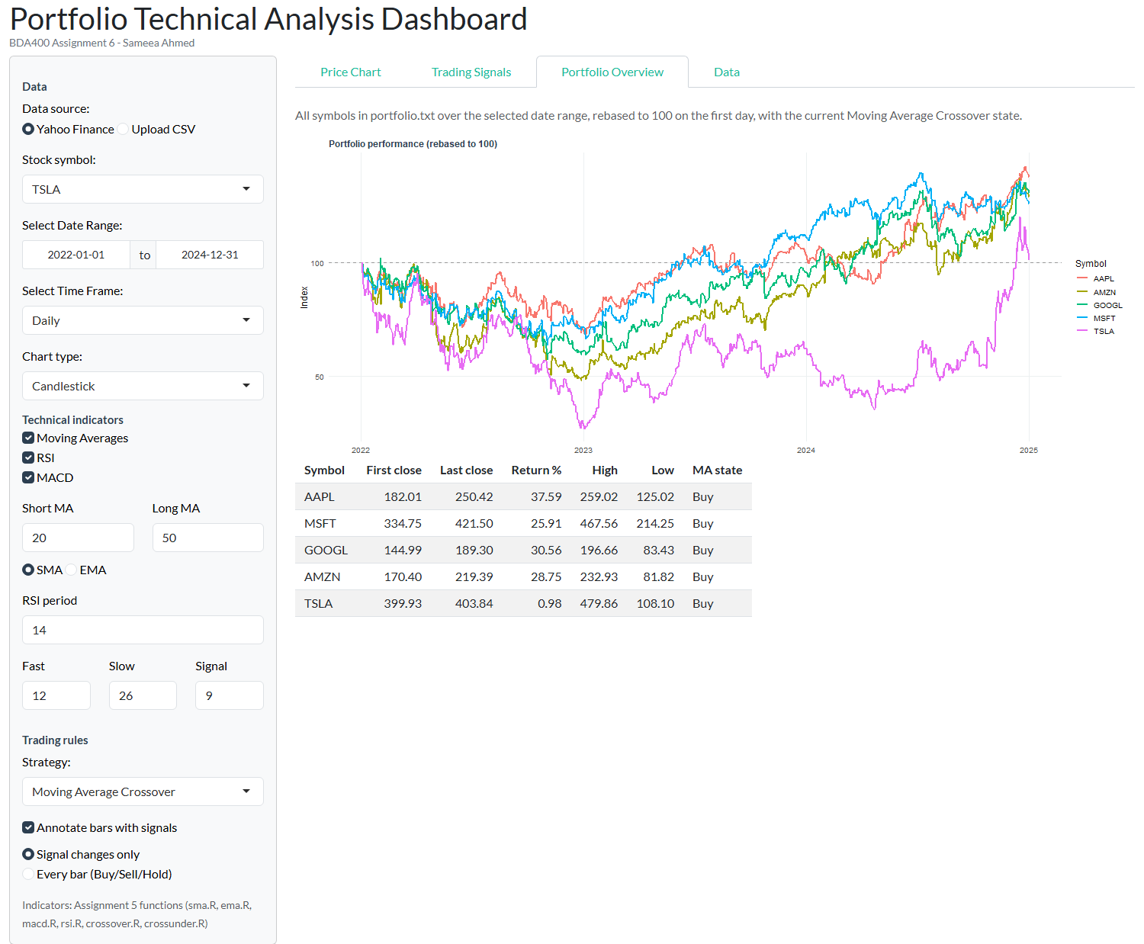
Figure 8 – Portfolio Overview (AAPL, MSFT, GOOGL, AMZN, TSLA, Jan–Jul 2023)
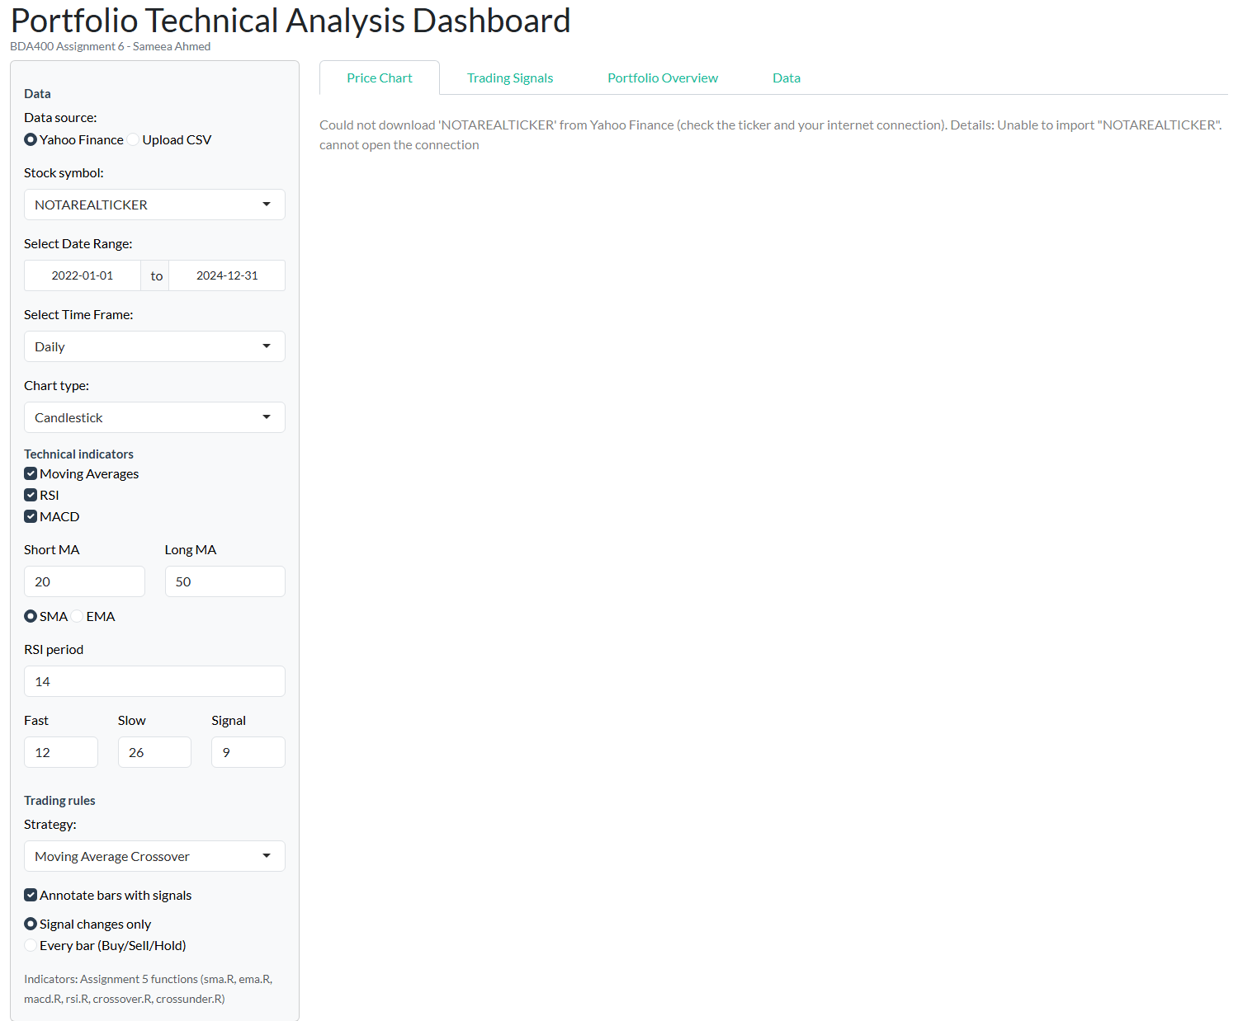
Figure 9 – An invalid ticker shows a clear error message instead of crashing the app

8. How to Run
- Install R (4.1 or newer) and RStudio, then clone the repository.
- Open Assignment6/app.R in RStudio and click Run App, or run shiny::runApp("Assignment6") from the repository root.
- Missing packages are installed automatically on the first run. An internet connection is needed for Yahoo Finance; otherwise choose Upload CSV.
- Optional: source("Assignment6/screenshots/capture_screenshots.R") re-creates the screenshots in this document.

9. Testing and Verification
- Ran the app in RStudio (R 4.6.1, Windows) with live Yahoo Finance data for AAPL, MSFT, TSLA and the full portfolio – all four chart types, all three time frames, every indicator toggle and all four strategies rendered without errors.
- Checked that the signals in the Trading Signals tab alternate Buy/Sell and fall on the bars where the short MA line crosses the long MA line on the chart (Figures 5 and 7).
- Checked the indicators against TTR as an independent reference: sma() matches TTR::SMA() exactly, and rsi() converges to TTR::RSI() once past its warm-up (which the extra downloaded history covers).
- Tested error cases: an invalid ticker, a start date after the end date, a date range with too few bars, a CSV with a missing value, and a CSV without the required columns.

10. AI Assistance Declaration
The structure, user-interface layout, code comments, README and this document were drafted with AI assistance (Claude) and reviewed by me. The AI did not compute any results. Every price, indicator value, signal, return and statistic shown in the dashboard and in the screenshots was calculated by R at run time from data downloaded from Yahoo Finance. The trading signals are for educational purposes only and are not investment advice.

