**Name**: ahmed khalil ahmed lotfy eltelmsany

**B.N**: 15

**Date**: 5/6/2021

**Topic: mobile computing**

**Application breif**: Mobile computing is a generic term that refers to a variety of devices that allow people to access data and information from wherever they are. Mobile computing transports data, voice, and video over a network via a mobile device.

Mobile devices can be connected to a [local area network](https://www.thebalancesmb.com/computer-networks-and-internet-connections-for-business-2533592)(LAN), or they can take advantage of Wi-Fi or wireless technology by connecting via a wireless local area network (WLAN). Mobile phone services also provide mobile computing through their service plans.

The Benefits of Mobile Computing

There are many benefits to mobile computing including the ability to get directions, entertain yourself when bored, do business, and more, including:

* **Connectivity:** You can stay connected to all sources at all times.
* **Social Engagement:** You can interact with a [variety of users](https://www.thebalancecareers.com/how-to-develop-a-social-media-policy-1919167) via the Internet.
* **Personalization:**You can tailor your mobile computing to your individual needs.

Mobile Devices

"Mobile device" is a generic term used to refer to a wide range of devices that allow people to access data and information from anywhere at any time. These devices come in a range of sizes, from those that fit in your pocket, such as cell phones, to tablets, to laptops. Mobile computing can use cellphone connections to make phone calls, as well as to connect to the Internet. The list of mobile devices include:

* Laptops
* Smartphones
* Tablets
* eReaders (i.e. Kindle)
* Handheld Gaming Devices (i.e. Nintendo 3DS)
* Wearable Devices (i.e. Apple Watch)

**Screen shots**

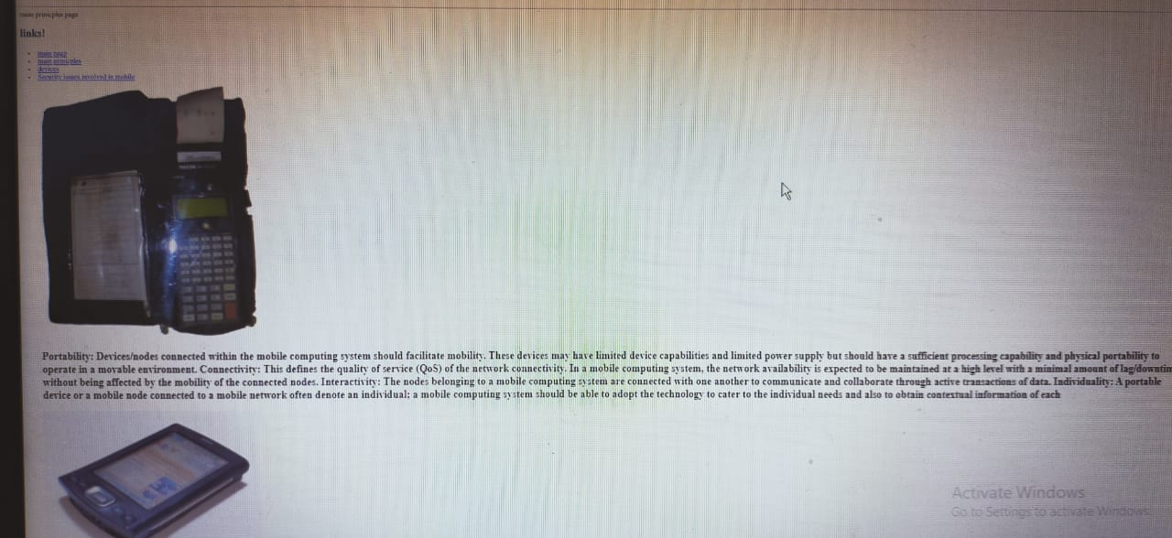

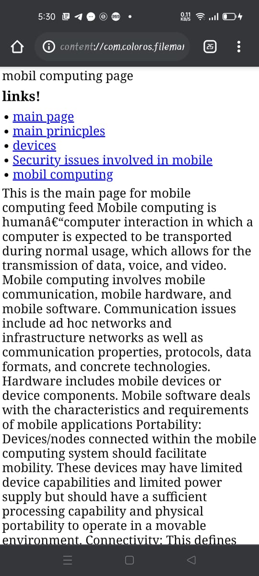

**Source of code**

