Data Analytics — Project 3
SQL Data Analysis Report
DecodeLabs Industrial Training | Batch 2026
Dataset: E-Commerce Orders | 1,200 Rows | 14 Columns

Project Overview
Goal: Use SQL queries to extract actionable insights from an e-commerce orders dataset.
Tool Used: DB Browser for SQLite
Dataset: Dataset_Cleaned.xlsx — 1,200 orders with columns: OrderID, Date, CustomerID, Product, Quantity, UnitPrice, ShippingAddress, PaymentMethod, OrderStatus, TrackingNumber, ItemsInCart, CouponCode, ReferralSource, TotalPrice.

SQL Queries & Results
Query 1: Preview Data
Purpose:
Display the first 10 rows to verify the dataset was imported correctly.
SQL Code:
SELECT * FROM data
LIMIT 10;
Result Screenshot:
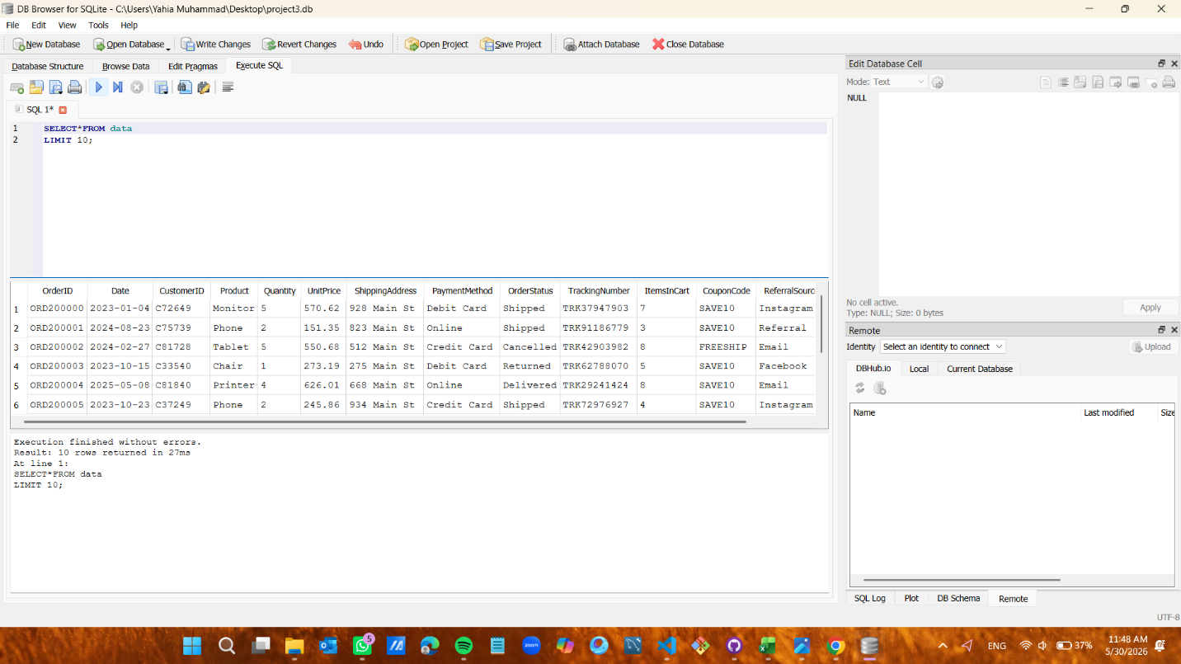
Key Insight:
The dataset contains 1,200 orders with 14 columns including: Product, Price, Payment Method, and Order Status.

Query 2: Total Orders Count
Purpose:
Count the total number of orders in the dataset.
SQL Code:
SELECT COUNT(*) AS Total_Orders
FROM data;
Result Screenshot:
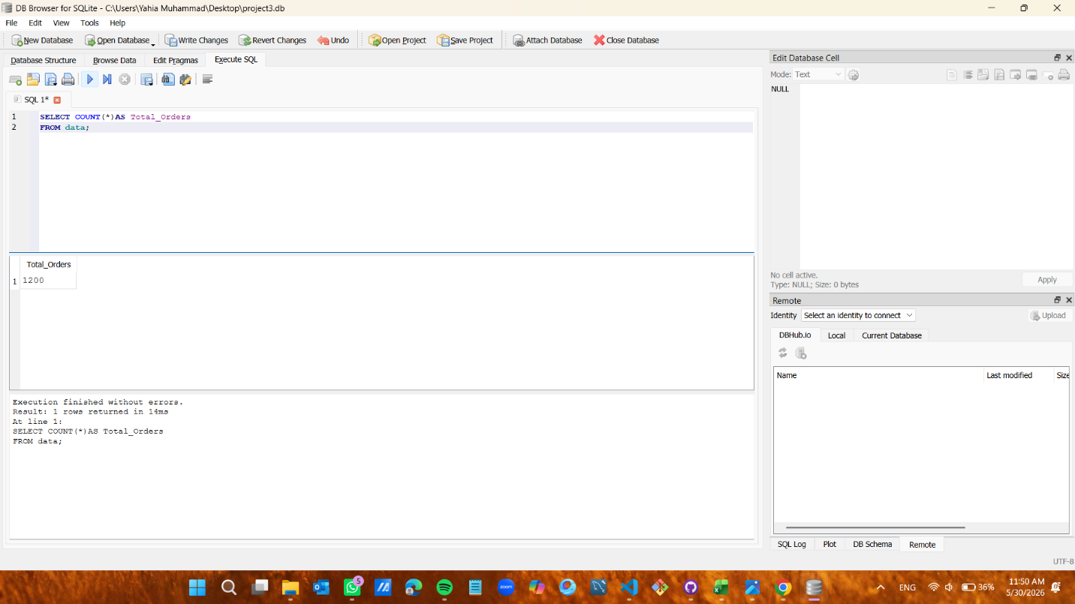
Key Insight:
Total orders = 1,200.

Query 3: Orders per Product
Purpose:
Find the number of orders for each product, sorted in descending order.
SQL Code:
SELECT Product, COUNT(*) AS Total_Orders
FROM data
GROUP BY Product
ORDER BY Total_Orders DESC;
Result Screenshot:
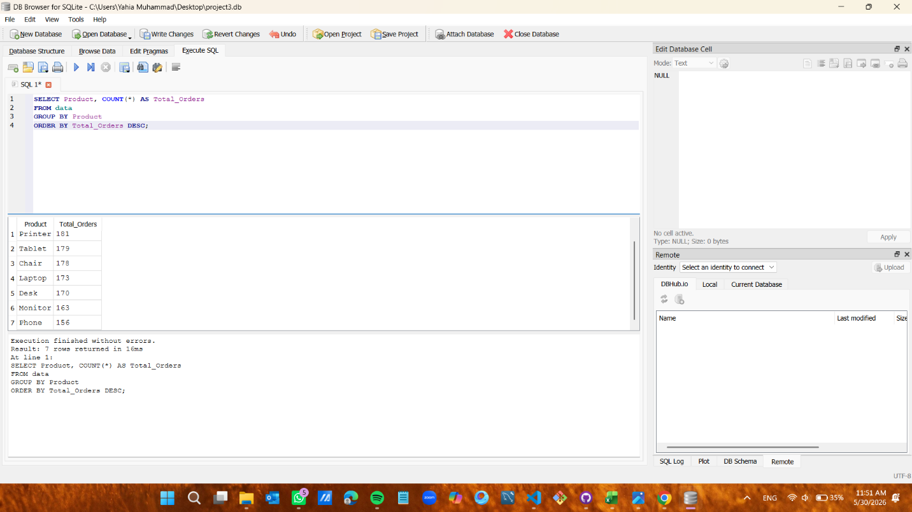
Key Insight:
Printer is the most ordered product with 181 orders, followed by Tablet (179), and Phone is the least with 156.

Query 4: Total Revenue per Product
Purpose:
Calculate the total revenue generated by each product.
SQL Code:
SELECT Product, SUM(TotalPrice) AS Total_Revenue
FROM data
GROUP BY Product
ORDER BY Total_Revenue DESC;
Result Screenshot:
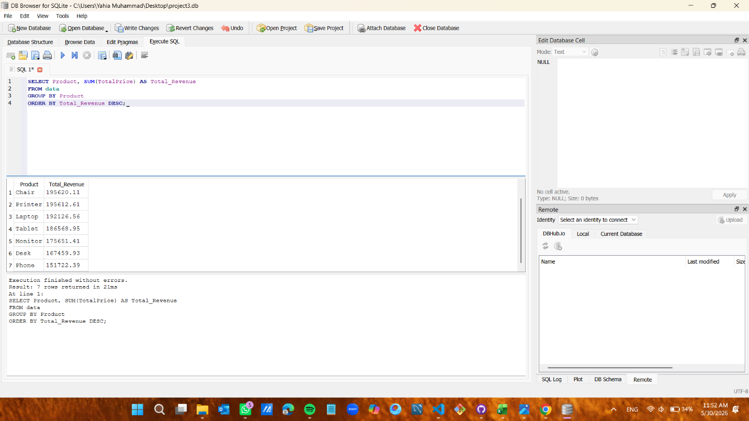
Key Insight:
Chair generated the highest revenue at 195,620, while Phone had the lowest at 151,722.

Query 5: Average Order Value per Product
Purpose:
Calculate the average order value for each product.
SQL Code:
SELECT Product, AVG(TotalPrice) AS Avg_Order_Value
FROM data
GROUP BY Product
ORDER BY Avg_Order_Value DESC;
Result Screenshot:
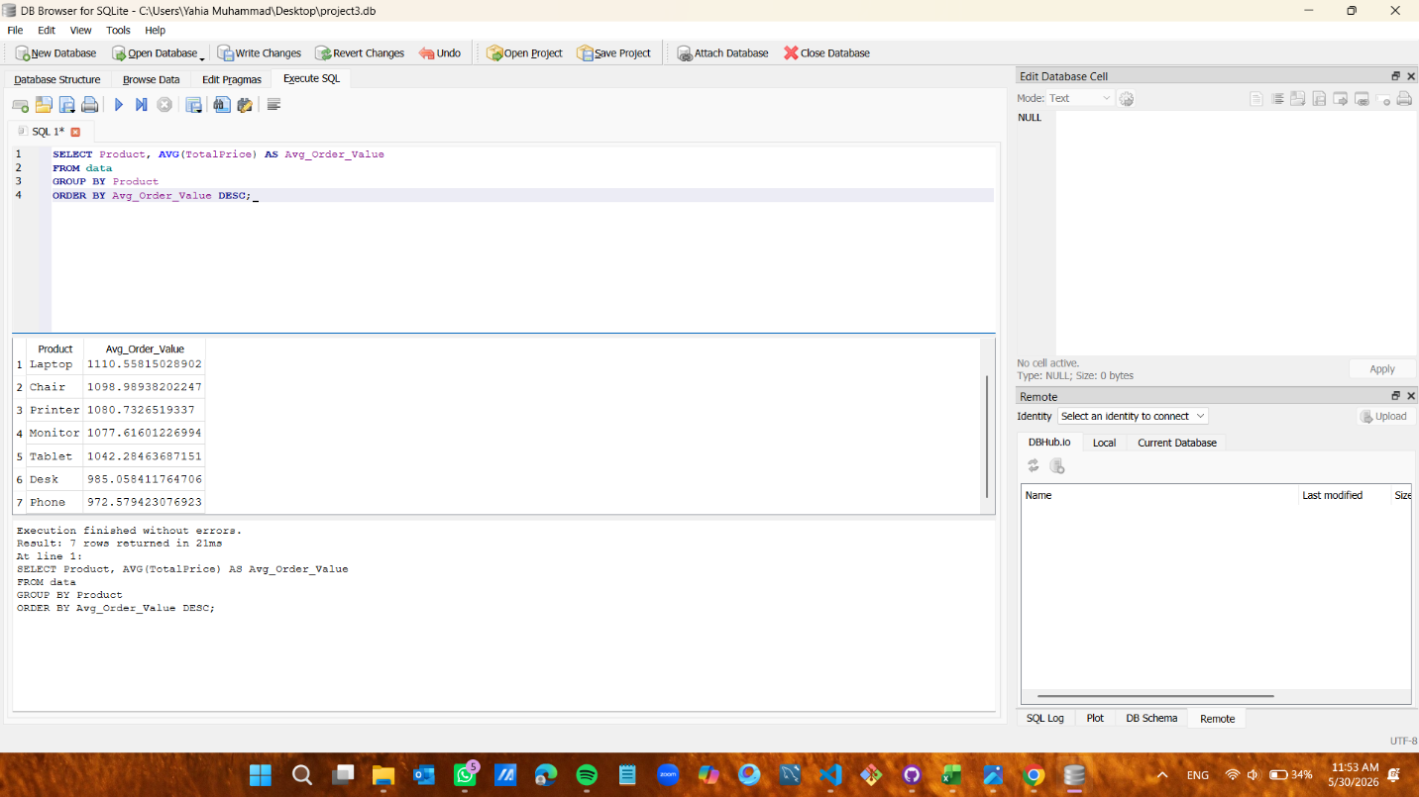
Key Insight:
Laptop has the highest average order value at 1,110, while Phone has the lowest at 972.

Query 6: Orders by Status
Purpose:
Analyze the distribution of orders by their current status.
SQL Code:
SELECT OrderStatus, COUNT(*) AS Count
FROM data
GROUP BY OrderStatus
ORDER BY Count DESC;
Result Screenshot:
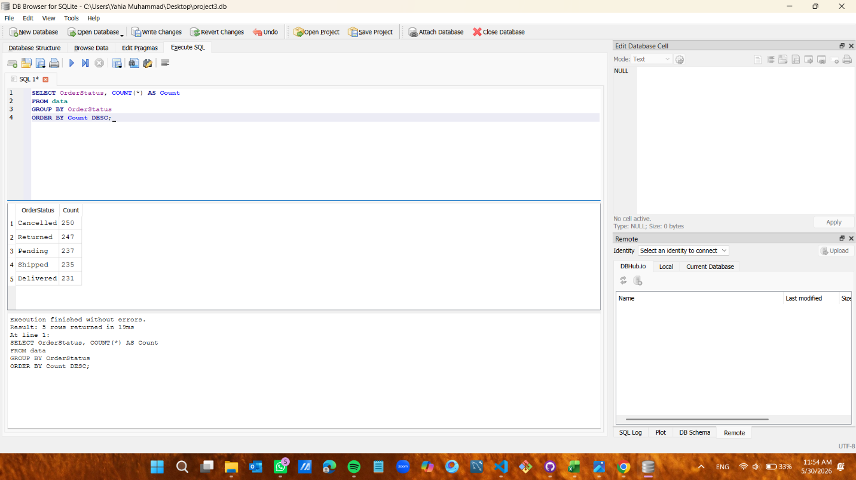
Key Insight:
Cancelled is the highest at 250, and Delivered is the lowest at 231 — a high cancellation rate worth investigating.

Query 7: Orders by Referral Source
Purpose:
Identify which referral source brings the most customers.
SQL Code:
SELECT ReferralSource, COUNT(*) AS Total
FROM data
GROUP BY ReferralSource
ORDER BY Total DESC;
Result Screenshot:
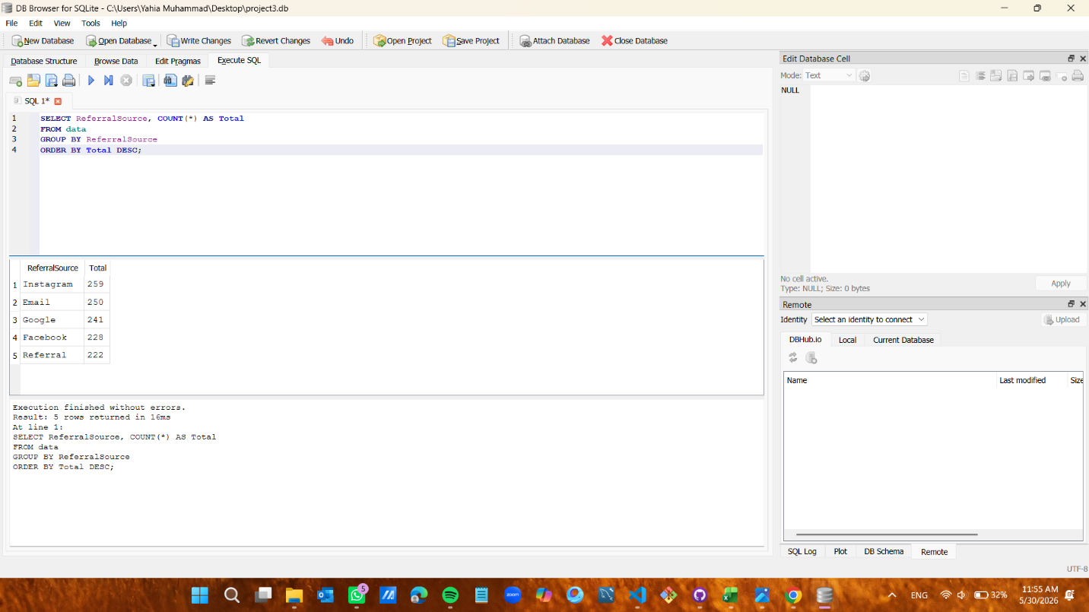
Key Insight:
Instagram leads with 259 orders, followed by Email (250), and Referral is last with 222.

Query 8: Orders by Payment Method
Purpose:
Determine the most commonly used payment methods.
SQL Code:
SELECT PaymentMethod, COUNT(*) AS Total
FROM data
GROUP BY PaymentMethod
ORDER BY Total DESC;
Result Screenshot:
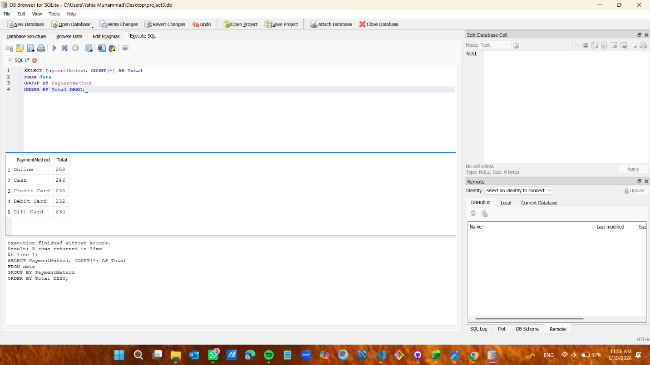
Key Insight:
Online is the most used payment method with 258 orders, and Gift Card is the least with 230.

Query 9: Delivered Orders by Price
Purpose:
Display all delivered orders sorted from highest to lowest price.
SQL Code:
SELECT * FROM data
WHERE OrderStatus = 'Delivered'
ORDER BY TotalPrice DESC;
Result Screenshot:
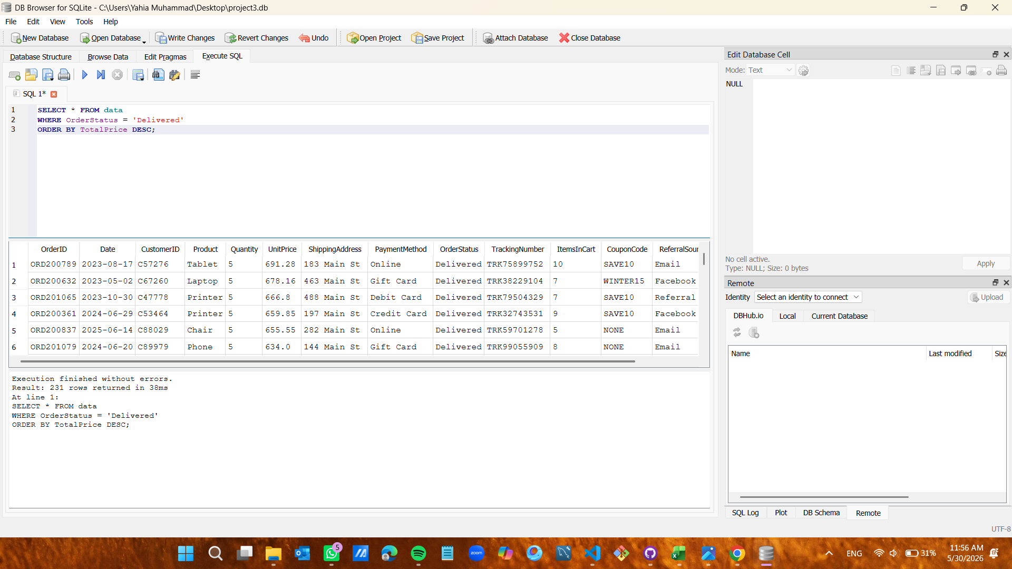
Key Insight:
231 delivered orders found, with the highest valued Tablet order at 3,456 EGP.

Query 10: High-Value Orders (Above 1000)
Purpose:
Extract all orders with a total price greater than 1,000.
SQL Code:
SELECT * FROM data
WHERE TotalPrice > 1000
ORDER BY TotalPrice DESC;
Result Screenshot:
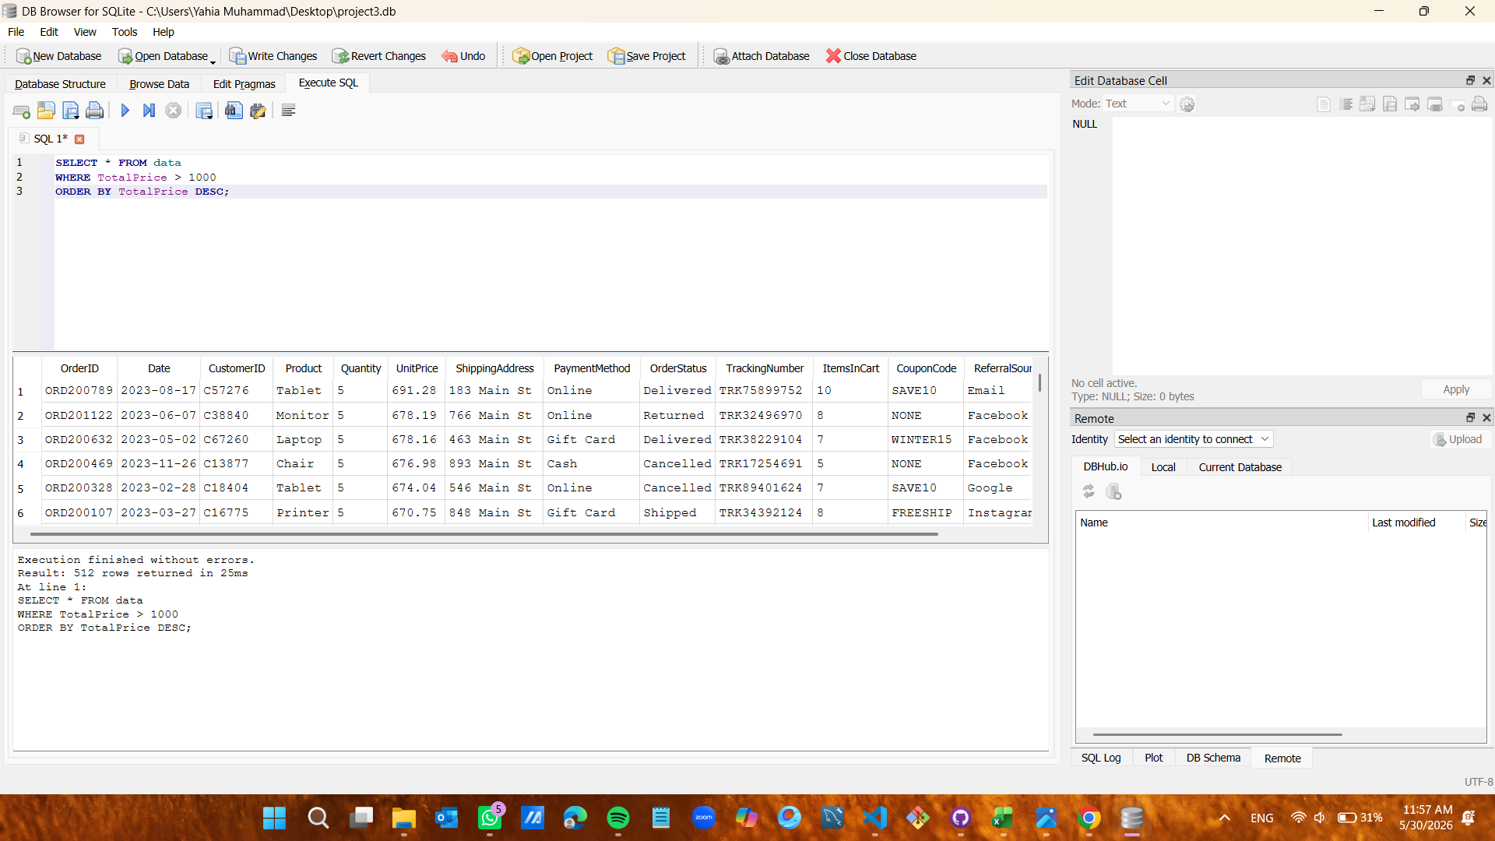
Key Insight:
512 orders exceeded 1,000 EGP — representing 42.6% of total orders.

Summary of Findings
• Total Orders: 1,200 orders analyzed.
• Top Product by Orders: Printer (181 orders).
• Top Product by Revenue: Chair (195,620 EGP).
• Highest Avg Order Value: Laptop (1,110 EGP avg).
• Most Used Payment Method: Online (258 orders).
• Top Referral Source: Instagram (259 orders).
• Most Common Order Status: Cancelled (250) — requires business attention.
• High-Value Orders (>1,000 EGP): 512 orders = 42.6% of total.

