Breast Cancer Classification Using k-NN
Ahmed Mohamed Ahmed Abdelhafez
Student ID: 2023023783
Course: Bioinformatics
Date of Submission: 08 March 2026
Table of Contents
- Introduction
- Methods
- Results
- Discussion
- Conclusion
- Appendix

3. Introduction
The goal of this project is to classify breast tumors as Benign or Malignant using the Breast Cancer Wisconsin dataset.
Early classification of breast tumors helps doctors make accurate treatment decisions and reduce health risks.
The k-Nearest Neighbors (k-NN) algorithm was used to classify the data after splitting it into training and testing sets, with performance metrics such as Accuracy, Precision, Recall, and F1-score.

4. Methods
Dataset Description:
Number of samples: 569
Variables: 32 features including Diagnosis and tumor characteristics such as Radius_mean, Area_mean, Perimeter_mean, etc.
Data Preprocessing:
1. Removed the ID column as it is not relevant for classification
2. Converted Diagnosis to a categorical variable
3. Split the dataset into 70% training and 30% testing
4. Checked for missing values (none found)
Model Selection and Training:
Algorithm: k-NN (k = 5)
Trained on the training set and tested on the test set
Evaluation Metrics:
Accuracy, Precision, Recall, F1-score, Confusion Matrix

5. Results
Data Exploration Findings:
Benign: 357 samples
Malignant: 212 samples
No missing values
Visualizations:
Figure 1: Diagnosis Distribution (Bar Plot)
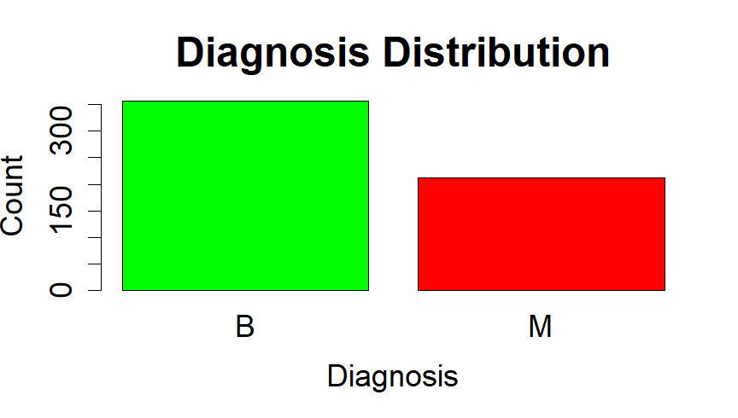
Figure 2: Scatter Plot of Radius_mean vs Area_mean
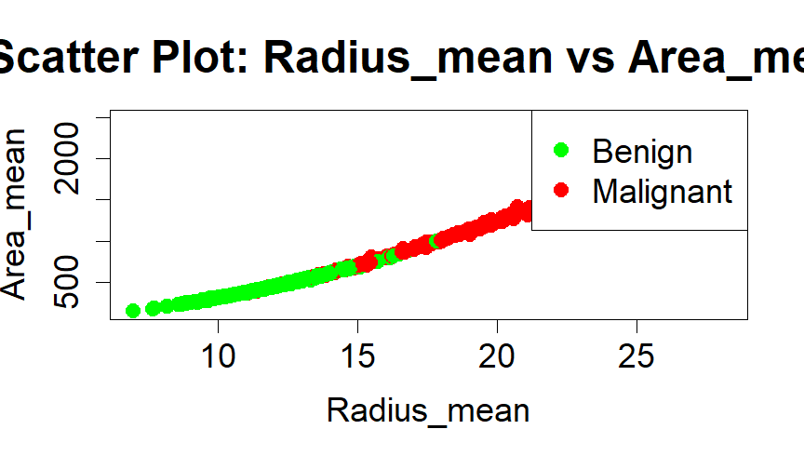
Confusion Matrix:
Predicted \ Actual | Benign | Malignant
Benign | 105 | 7
Malignant | 2 | 56
Performance Metrics:
Accuracy: 94.71%
Precision: 88.89%
Recall: 96.55%
F1-Score: 92.56%
The model performs very well with minimal errors in tumor classification.

6. Discussion
Interpretation of Results: The model accuracy is high (94.7%).
Strengths: k-NN is simple and effective on medium-sized datasets.
Limitations: k-NN can be sensitive to outliers.
Medical Implications: Accurate classification helps doctors make better treatment decisions.
Suggestions for Improvement: Try algorithms such as Random Forest or SVM.

7. Conclusion
The k-NN model successfully classified breast tumors with high accuracy.
Visualizations helped understand patterns in the dataset.
k-NN provides good results for binary classification problems.

8. Appendix
R Code:
(

library(kknn)
library(caret)

bc_data <- read.csv("wdbc.data", header = FALSE)

colnames(bc_data) <- c("ID", "Diagnosis",
"Radius_mean", "Texture_mean", "Perimeter_mean", "Area_mean", "Smoothness_mean",
"Compactness_mean", "Concavity_mean", "ConcavePoints_mean", "Symmetry_mean", "FractalDimension_mean",
"Radius_se", "Texture_se", "Perimeter_se", "Area_se", "Smoothness_se",
"Compactness_se", "Concavity_se", "ConcavePoints_se", "Symmetry_se", "FractalDimension_se",
"Radius_worst", "Texture_worst", "Perimeter_worst", "Area_worst", "Smoothness_worst",
"Compactness_worst", "Concavity_worst", "ConcavePoints_worst", "Symmetry_worst", "FractalDimension_worst")

head(bc_data)
str(bc_data)
summary(bc_data)
sum(is.na(bc_data))
table(bc_data$Diagnosis)

par(mfrow=c(1,1))
barplot(table(bc_data$Diagnosis),
main="Diagnosis Distribution",
xlab="Diagnosis",
ylab="Count",
col=c("green", "red"),
cex.names=1.5,
cex.axis=1.5,
cex.lab=1.5,
cex.main=2)

plot(bc_data$Radius_mean, bc_data$Area_mean,
col = ifelse(bc_data$Diagnosis == "B", "green", "red"),
pch = 19,
xlab = "Radius_mean",
ylab = "Area_mean",
main = "Scatter Plot: Radius_mean vs Area_mean",
cex.lab=1.5,
cex.axis=1.5,
cex.main=2,
cex=1.5)
legend("topright", legend=c("Benign","Malignant"), col=c("green","red"), pch=19, cex=1.5)

# part2

bc_data$Diagnosis <- as.factor(bc_data$Diagnosis)

bc_data$ID <- NULL

set.seed(123)
train_index <- createDataPartition(bc_data$Diagnosis, p = 0.7, list = FALSE)
train_data <- bc_data[train_index, ]
test_data <- bc_data[-train_index, ]

cat("Training set:", nrow(train_data), "instances\n")
cat("Testing set:", nrow(test_data), "instances\n")

features <- names(bc_data)[names(bc_data) != "Diagnosis"]

knn_model <- kknn(Diagnosis ~ .,
train = train_data[, c("Diagnosis", features)],
test = test_data[, c("Diagnosis", features)],
k = 5, kernel = "rectangular")

summary(knn_model)

pred <- fitted(knn_model)

pred[1:10]

# Part 3

conf_mat <- table(Predicted = pred, Actual = test_data$Diagnosis)
cat("Confusion Matrix:\n")
print(conf_mat)

TN <- conf_mat["B","B"]
FP <- conf_mat["B","M"]
FN <- conf_mat["M","B"]
TP <- conf_mat["M","M"]

accuracy <- (TP + TN) / sum(conf_mat)

precision <- TP / (TP + FP)

recall <- TP / (TP + FN)

f1_score <- 2 * (precision * recall) / (precision + recall)

cat("\nModel Performance Metrics:\n")
cat("Accuracy :", round(accuracy, 4), "\n")
cat("Precision:", round(precision, 4), "\n")
cat("Recall :", round(recall, 4), "\n")
cat("F1-Score :", round(f1_score, 4), "\n"))

