**SMART HOME BASED BLUETOOTH**

In this project, a home automation system is designed which can be controlled by any smartphone. The automation system connects with the smartphone through Bluetooth. The smart phone sends control signals to switch home appliances ON or OFF by an android app through Bluetooth interface.

The project used first MCU AVR Atmega32 interfaced to Bluetooth HC-06 to pair with the smart phone to receive data from app.

The first atmega32 MCU send data that received from UART(Bluetooth) to second atmega32 MCU via SPI.

The second atmega32 MCU check received data to do correct action like toggle led or turn of led (Actuators)

An app named “Bluetooth Terminal” is used on the smart phone which is capable of sending text strings to a paired device. Either of the app will pair with the home automation system through HC-06 Bluetooth Module.

Components Required –

Home Automation System:

1. two ATMEGA32 MCUs

2. Bluetooth module (HC-06)

3. two actuators (LEDs)

4. 330-ohm resistor

5. virtual terminal

Mobile Command:

1. Any Android phone

2. Android app (Bluetooth terminal)

*****

We used software programs.

1. Atmel studio to implement code
2. Proteus to simulation project

Project Steps of

1. install programs
2. add Bluetooth lib to proteus
3. Integrate module by module
4. Write code
5. Simulation all project

Project Flowchart:

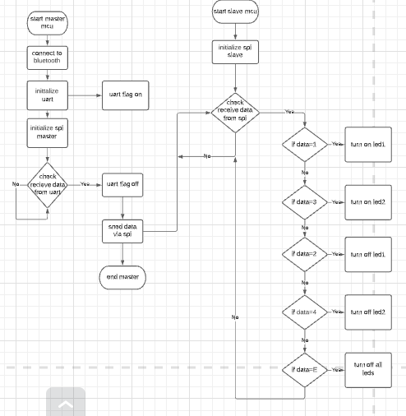

Proteus Schematic:

