HealOps Server Guardian
Self-healing DevOps infrastructure with full-server monitoring and security detection
Project version - English
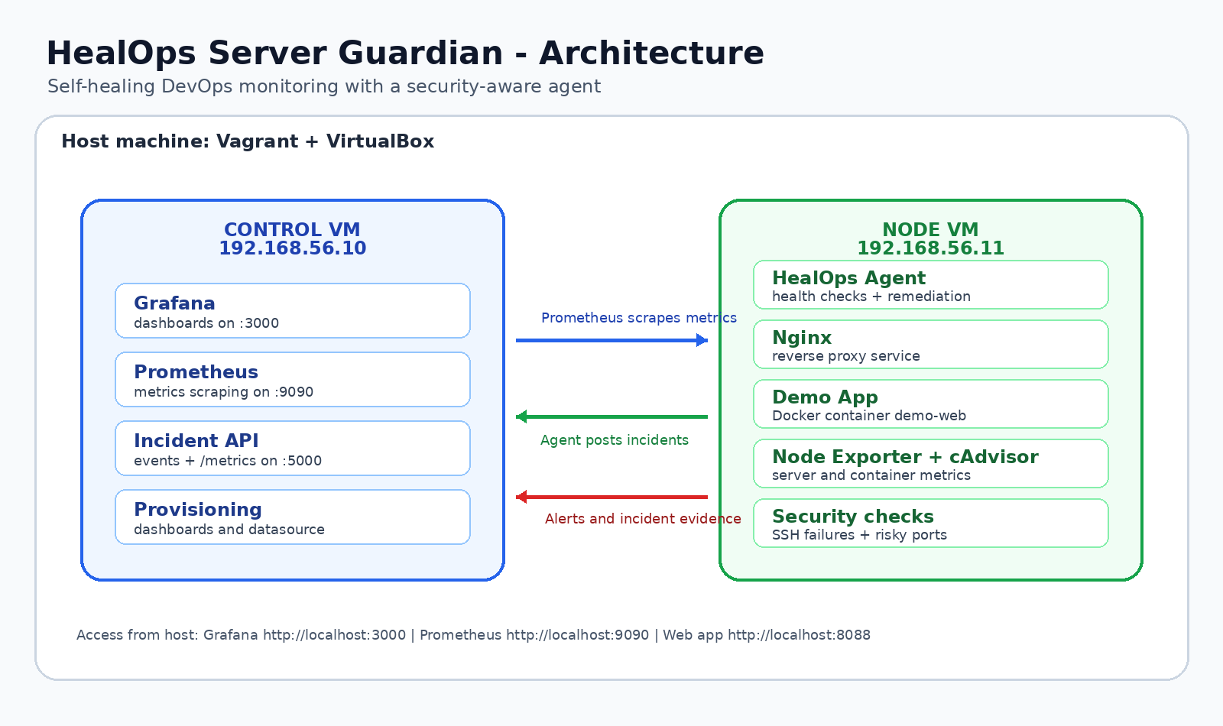

1. Executive summary
HealOps Server Guardian is a DevSecOps project that turns simple monitoring into a self-healing platform. The system monitors a complete Linux server: systemd services, Docker containers, resources, network ports and SSH logs. When a failure or a security signal is detected, the agent triggers a controlled action: service restart, container recovery, incident creation and alerting.
- DevOps objective: improve availability and reduce MTTR through automation.
- Security objective: detect simple attack signals such as repeated SSH failures and suspicious ports.
- Presentation objective: provide a clear, measurable and professional live demo in two days.

2. Problem statement
In a real infrastructure, an application may be packaged correctly in Docker but still become unavailable because the reverse proxy stops, a container is down, the disk is nearly full or suspicious SSH activity appears. A classic project only displays an alert. HealOps adds a more advanced layer: automated remediation.
- Detection: check the server, services and containers.
- Decision: classify incidents by impact: medium, high or critical.
- Remediation: apply only safe actions such as restart Nginx or docker start.
- Observability: centralize metrics and incidents in Prometheus and Grafana.

3. Project goals
Goal | Description | Impact
Full monitoring | CPU, RAM, disk, Nginx, Docker, ports, SSH | Complete server visibility
Self-healing | Automatic restart of critical components | Reduced MTTR
Security-aware | SSH brute-force and risky port detection | Visible DevSecOps layer
Dashboard | Grafana + Prometheus | Clear demo
Automation | Vagrantfile + provisioning scripts | Reproducible lab

4. Global architecture

The architecture separates the control role from the protected application server role. The control VM centralizes Prometheus, Grafana and the Incident API. The node1 VM runs the application, reverse proxy, exporters and the HealOps agent.

5. Virtual machines and network
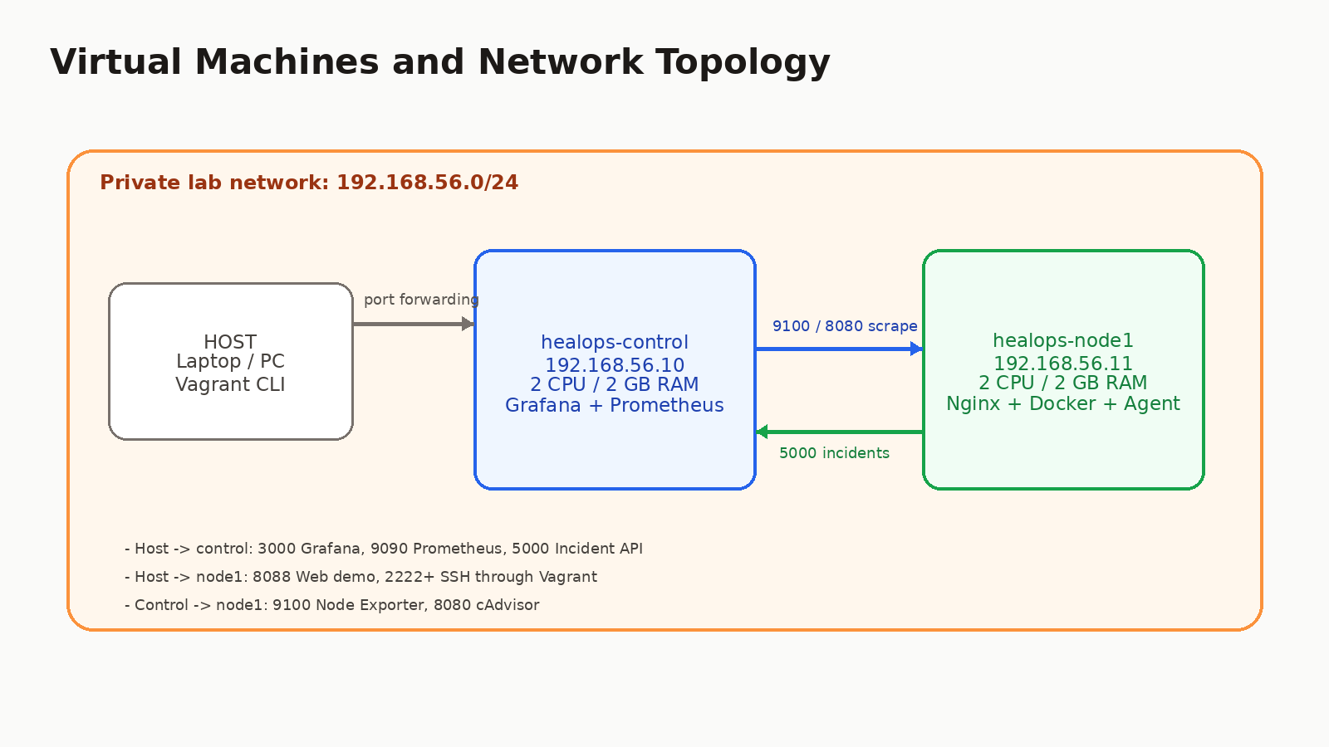

VM | Address | Role | Main ports | Resources
control | 192.168.56.10 | Monitoring and centralization | 3000 Grafana, 9090 Prometheus, 5000 API | 2 CPU, 2 GB RAM
node1 | 192.168.56.11 | Protected application server | 80 Nginx, 9100 metrics, 8080 cAdvisor | 2 CPU, 2 GB RAM

The host accesses services through port forwarding: Grafana on localhost:3000, Prometheus on localhost:9090, Incident API on localhost:5000 and the demo application on localhost:8088.

6. Technical components
Component | Function
Vagrant | Creates the two VMs and runs the provisioning scripts
VirtualBox | Local hypervisor used to run the lab
Docker | Runs the demo app, Node Exporter, cAdvisor, Prometheus and Grafana
Nginx | Reverse proxy in front of the demo-web container
Prometheus | Collects server, container and incident metrics
Grafana | Visualizes CPU, RAM, disk, containers and incidents
HealOps Agent | Detects failures, remediates them and sends incidents
UFW / Fail2ban | Basic network hardening and security signal support

7. How the HealOps agent works
The agent is installed as a systemd service on the node1 VM. It runs in a loop and executes checks every 15 seconds. Each incident is logged locally, posted to the control API and then exposed to Prometheus.
Check | Condition | Action
Nginx | systemctl is-active nginx fails | systemctl restart nginx
Docker app | demo-web is not running | docker start demo-web
CPU/RAM/Disk | High threshold reached | Alert and incident
SSH | Several Failed password entries from the same IP | Alert, optional UFW block
Suspicious ports | Port 4444, 5555, 1337 or 31337 listening | Security alert

8. Two-day implementation plan
Day | Work | Expected result
Day 1 - Morning | Build the project structure, Vagrantfile, private network and VMs | vagrant up creates control and node1
Day 1 - Afternoon | Install Docker, Nginx, demo app, Prometheus and Grafana | Dashboard accessible and demo app online
Day 1 - End | Validate exporters and metrics collection | CPU/RAM/Disk visible in Grafana
Day 2 - Morning | Install the HealOps agent and Incident API | Incidents posted to the control VM
Day 2 - Afternoon | Add demo scenarios: stop Nginx, stop container, SSH failures, CPU stress | Complete live demo
Day 2 - End | Clean README, screenshots, report and presentation | Project ready for presentation

9. Ready-to-use automation file
The package contains a Vagrantfile and shell scripts. The following command creates the VMs, installs dependencies and prepares the full working environment:
unzip healops_server_guardian_lab.zip
cd healops-server-guardian-lab
vagrant up
Provisioning automatically installs Docker, Docker Compose plugin, Python, Nginx, UFW, Fail2ban, Prometheus, Grafana, Node Exporter, cAdvisor, the demo application and the HealOps services.

10. Package structure
healops-server-guardian-lab/
Vagrantfile
scripts/
provision_common.sh
provision_control.sh
provision_node.sh
requirements.txt
demo_scenarios.sh
healops/
agent.py
incident_api.py
compose/
control/
node/
README_FR.md
README_EN.md

11. Demonstration scenarios

Scenario A - Nginx failure
vagrant ssh node1
sudo systemctl stop nginx
sudo journalctl -u healops-agent -f
Expected result: the agent detects that the service is down, restarts Nginx, creates a high-severity incident and sends it to the control VM.

Scenario B - Stopped Docker container
vagrant ssh node1
sudo docker stop demo-web
sudo docker ps --filter name=demo-web
Expected result: the agent automatically starts the container again.

Scenario C - Simulated SSH brute force
for i in {1..6}; do
sudo logger -p authpriv.warning "sshd[12345]: Failed password for invalid user admin from 192.168.56.99 port 55${i} ssh2"
done
Expected result: the agent detects repeated SSH failures from the same IP and creates a security-aware incident.

12. Why the project looks professional
- It does not monitor only one application: it monitors the complete server.
- It does not stop at alerting: it applies controlled remediation.
- It clearly demonstrates DevOps: VMs, Docker, Nginx, Prometheus, Grafana, systemd and automation.
- It adds a security layer without excessive complexity: SSH failures, suspicious ports, UFW and incidents.
- It is reproducible thanks to the Vagrantfile and provisioning scripts.

13. Current limits and future improvements
Current limit | Future improvement
Simple security detection | Add Falco or Wazuh for advanced runtime detection
Single application node | Add node2 and simulate high availability
IP blocking disabled by default | Production mode with a validated response playbook
No CI/CD included | Add GitHub Actions pipeline for the demo app
Initial dashboard | Add incident timeline and SLA uptime panels

14. Presentation sentence
"I designed a self-healing DevSecOps infrastructure that monitors a complete Linux server, detects failures and security signals, then applies remediation actions with real-time observability."

