Analysis Questions:

1. What is the correlation (R2 value) between sales and income?
2. What is the correlation (R2 value) between customer ratings and product return rate?
3. What are the linear regression formulas to predict customer sales and customer incomes?
4. Which customer do you predict has the highest income?
5. Which product will be advertised the most?

After Analysis Answers :

1. What is the correlation (R2 value) between sales and income?

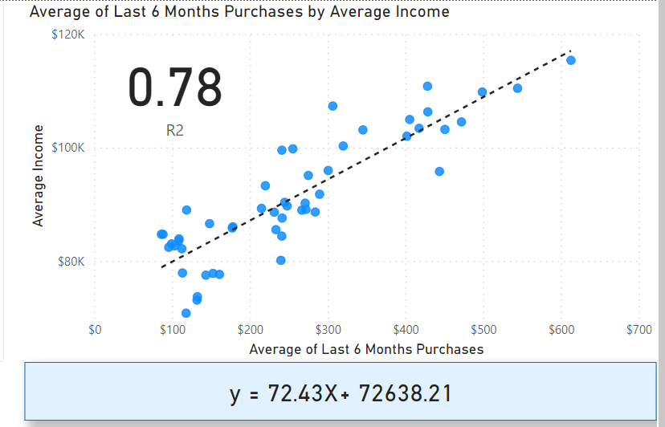  
 the correlation is .78

1. What is the correlation (R2 value) between customer ratings and product return rate?  
    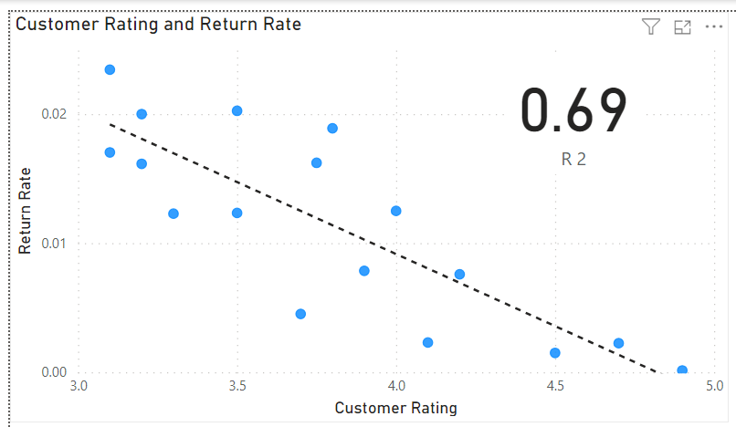

the correlation is 0.69

1. What are the linear regression formulas to predict customer sales and customer incomes?



1. Which customer do you predict has the highest income?

A Customer who is most likely to have the highest income is the one who is having the highest sales

And according to the data provided his ID would be “JLit30836”

1. Which product will be advertised the most?

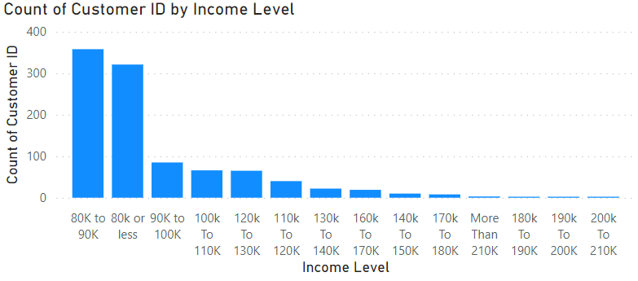

As we can see here , the lowest Income Levels have The Largest Count of customers

So , If we focus on the lowest 5 levels we can get the majority of the market share of consumers

There for , as we are targeting only the number of sales without having clear data about the profit margins , I’d Recommend to Focus our advertisement on Shirts