CS 340 Project Two README

Grazioso Salvare Animal Rescue Dashboard
Created by: Ahmed Ahmed
Course: CS 340 –
Project: Project Two –

Project Overview
The purpose of this project was to develop a client-facing web dashboard for Grazioso Salvare, an animal rescue training organization. The dashboard connects to a MongoDB database containing Austin Animal Center Outcomes data and allows users to identify dogs that meet specific criteria for search-and-rescue training.
Grazioso Salvare is interested in dogs that may be suitable for different types of rescue, including water rescue, mountain or wilderness rescue, and disaster or individual tracking. The dashboard provides an intuitive way for users to filter the animal data and visualize the results.
The application uses MongoDB as the database, a Python CRUD module to communicate with the database, and Dash to create the interactive web dashboard. The dashboard includes a data table, interactive filtering options, a pie chart, and a geolocation map.

Required Functionality
The completed dashboard provides the following functionality:
- Displays the Austin Animal Center Outcomes data.
- Provides an interactive data table.
- Allows users to filter the data by rescue type.
- Provides a Water Rescue filter.
- Provides a Mountain or Wilderness Rescue filter.
- Provides a Disaster or Individual Tracking filter.
- Provides a Reset option that returns the dashboard to the unfiltered dataset.
- Updates the data table based on the selected filter.
- Updates the pie chart based on the filtered data.
- Provides a geolocation map for a selected animal.
- Displays the Grazioso Salvare logo.
- Includes a unique identifier containing the creator's name.
The dashboard follows the requirements provided in the Dashboard Specifications Document. The specifications require the dashboard to include interactive filtering, a dynamic data table, a geolocation chart, and a second chart that respond to the selected rescue type.

Dashboard Filters
The dashboard includes four filtering options.

Water Rescue
The Water Rescue filter searches for dogs with the following characteristics:
- Labrador Retriever Mix
- Chesapeake Bay Retriever
- Newfoundland
- Intact Female
- Between 26 and 156 weeks old

Mountain or Wilderness Rescue
The Mountain or Wilderness Rescue filter searches for:
- German Shepherd
- Alaskan Malamute
- Old English Sheepdog
- Siberian Husky
- Rottweiler
- Intact Male
- Between 26 and 156 weeks old

Disaster or Individual Tracking
The Disaster or Individual Tracking filter searches for:
- Doberman Pinscher
- German Shepherd
- Golden Retriever
- Bloodhound
- Rottweiler
- Intact Male
- Between 20 and 300 weeks old

Reset
The Reset option removes the rescue-specific filtering and returns the dashboard to the complete animal dataset.
These breed, sex, and age requirements are based on the Rescue Type and Preferred Dog Breeds table provided in the Dashboard Specifications Document.

Tools and Technologies Used

Python
Python was used as the primary programming language for the project. It was used to connect the dashboard to MongoDB, process database results, create the dashboard components, and control the interactions between the filtering options and dashboard widgets.

MongoDB
MongoDB was used as the database component of the application. The animal shelter data is stored in a MongoDB database named aac, using the animals collection.
MongoDB was useful for this project because it stores the animal records as documents and works effectively with Python through the PyMongo library. The CRUD Python module provides the database interface used by the dashboard to create, read, update, and delete records.
For the dashboard, the most important CRUD operation is the read operation because the application retrieves animal records from MongoDB based on the selected rescue criteria.

PyMongo
PyMongo was used to establish the connection between Python and MongoDB. The AnimalShelter class in the CRUD Python module creates the MongoDB connection and provides methods for interacting with the animals collection.
The module contains methods for:
- Creating records
- Reading records
- Updating records
- Deleting records
- Retrieving Water Rescue dogs
- Retrieving Mountain/Wilderness Rescue dogs
- Retrieving Disaster/Individual Tracking dogs

Dash
Dash was used to create the client-facing dashboard. Dash provides interactive components that allow the user to select a rescue type and immediately see the corresponding database results.
The dashboard uses components such as:
- Dropdown menus
- Data tables
- Graphs
- Maps
- HTML components
The Dash callbacks act as the controller for the application by responding to user selections and updating the dashboard components.

Plotly
Plotly was used to create the pie chart. The pie chart displays the distribution of dog breeds in the currently displayed dataset.
The chart changes when a different rescue filter is selected.

Dash Leaflet
Dash Leaflet was used to create the geolocation map. When a user selects an animal from the data table, the dashboard uses the animal's latitude and longitude values to place a marker on the map.
The marker also displays information about the selected animal, including its breed and name.

JupyterDash
JupyterDash was used to run the Dash application within the JupyterLab environment provided for the course.

Project Development Steps

Step 1: Connect Python to MongoDB
The existing CRUD Python module from Project One was used to establish a connection to the aac MongoDB database and the animals collection.
The AnimalShelter class was used to perform database operations.

Step 2: Retrieve the Animal Data
The dashboard creates an instance of the AnimalShelter class and performs a retrieve-all query.
The results are converted into a Pandas DataFrame so they can be displayed in the dashboard.
The MongoDB _id field is removed from the displayed table because it is not necessary for the user interface.

Step 3: Create the Dashboard Layout
The dashboard layout was created using Dash components.
The layout includes:
- Grazioso Salvare logo
- Creator name
- Rescue type dropdown
- Interactive data table
- Pie chart
- Geolocation map
The logo also contains a link to the SNHU website as specified by the dashboard requirements.

Step 4: Create MongoDB Rescue Queries
Three custom database queries were added to the CRUD Python module.
The queries identify dogs that meet the requirements for:
- Water Rescue
- Mountain or Wilderness Rescue
- Disaster or Individual Tracking
Each query uses MongoDB filtering criteria for breed, sex, and age.

Step 5: Create the Interactive Filter
A Dash dropdown menu was added to allow the user to select a rescue type.
When the user selects an option, a Dash callback calls the appropriate method from the CRUD Python module.
For example, selecting Water Rescue calls:
db.water_rescue()
Selecting Mountain or Wilderness Rescue calls:
db.mountain_rescue()
Selecting Disaster or Individual Tracking calls:
db.disaster_rescue()
Selecting Reset calls the general read operation:
db.read({})

Step 6: Update the Data Table
The data table receives the records returned by the selected MongoDB query.
This allows the table to dynamically change whenever the user changes the rescue type.
The table also includes pagination and sorting to make the data easier to navigate.

Step 7: Create the Pie Chart
A Plotly pie chart was created to display the breeds represented in the currently filtered dataset.
The chart receives the same data displayed by the interactive table, allowing it to update when the user changes the rescue type.

Step 8: Create the Geolocation Map
A Dash Leaflet map was created to display the location of a selected animal.
When a user selects an animal from the table, the dashboard retrieves the animal's:
- location_lat
- location_long
- breed
- name
The map then displays a marker using the animal's latitude and longitude.

Step 9: Test the Dashboard
The dashboard was tested by running each of the required filter options.
The following states were tested:
- Starting/reset state
- Water Rescue
- Mountain or Wilderness Rescue
- Disaster or Individual Tracking
- Reset
The table and pie chart successfully changed when filters were selected, and the map displayed the location of selected animals.

Testing Results and Screenshots
The following screenshots demonstrate that the dashboard functions correctly.

Screenshot 1 – Starting Dashboard
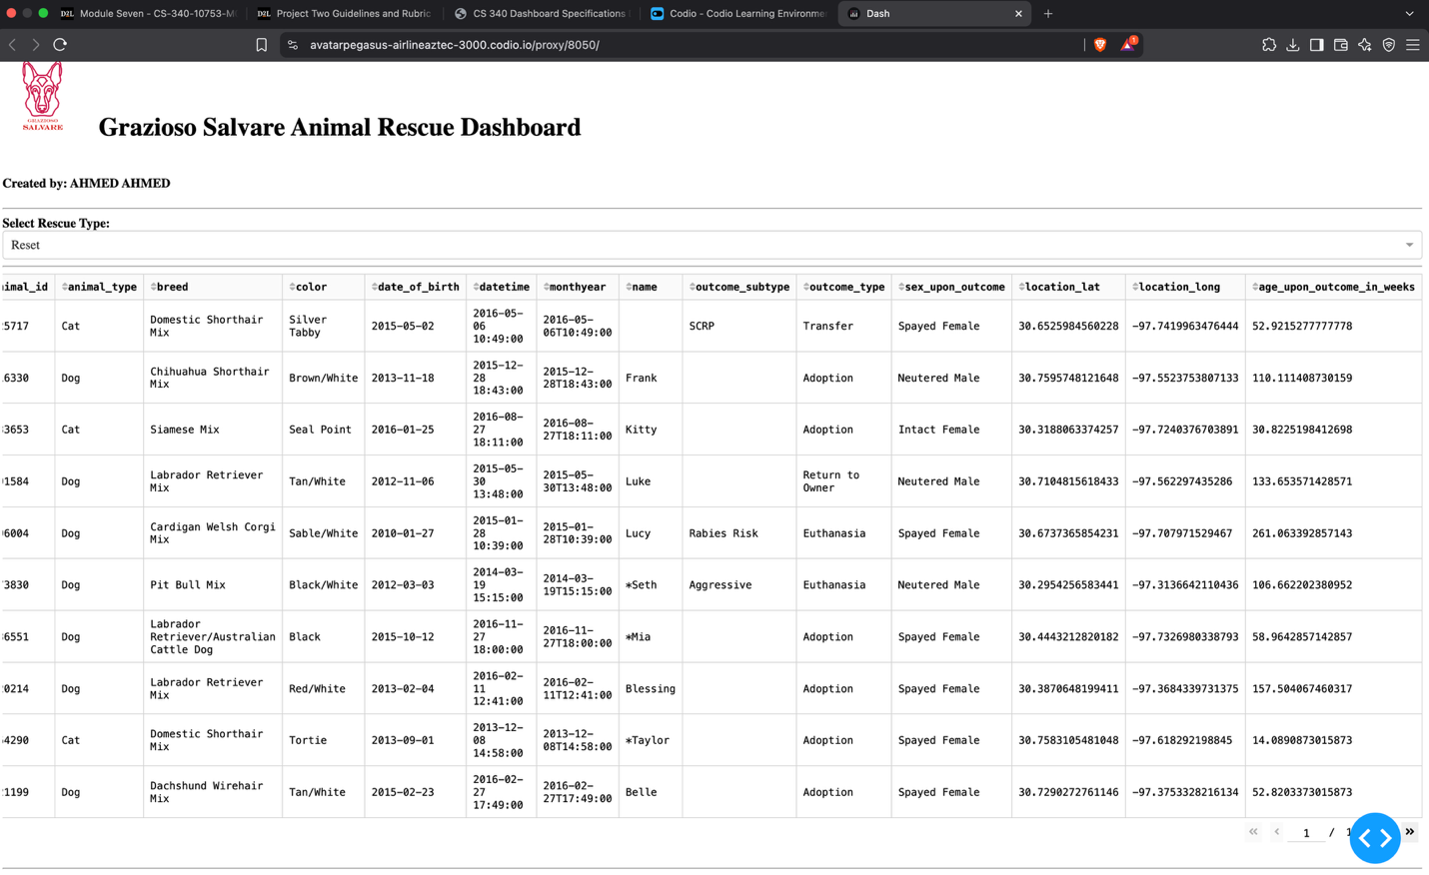The starting dashboard displays the Grazioso Salvare logo, creator identifier, rescue filter, complete data table, pie chart, and map area.

Screenshot 2 – Water Rescue
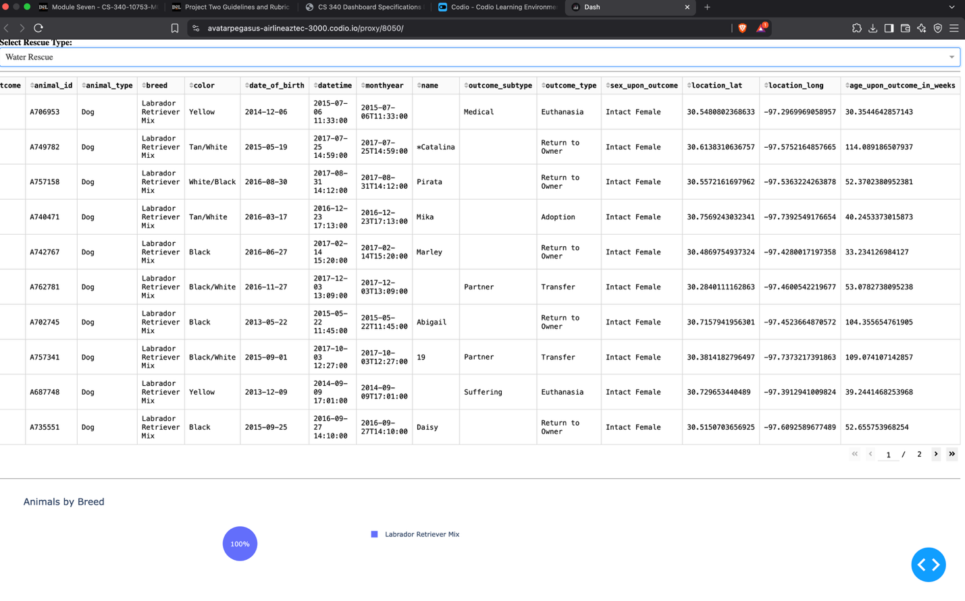
The Water Rescue filter displays dogs matching the required breed, sex, and age criteria. The data table and pie chart update to reflect the filtered results.

Screenshot 3 – Mountain or Wilderness Rescue
The M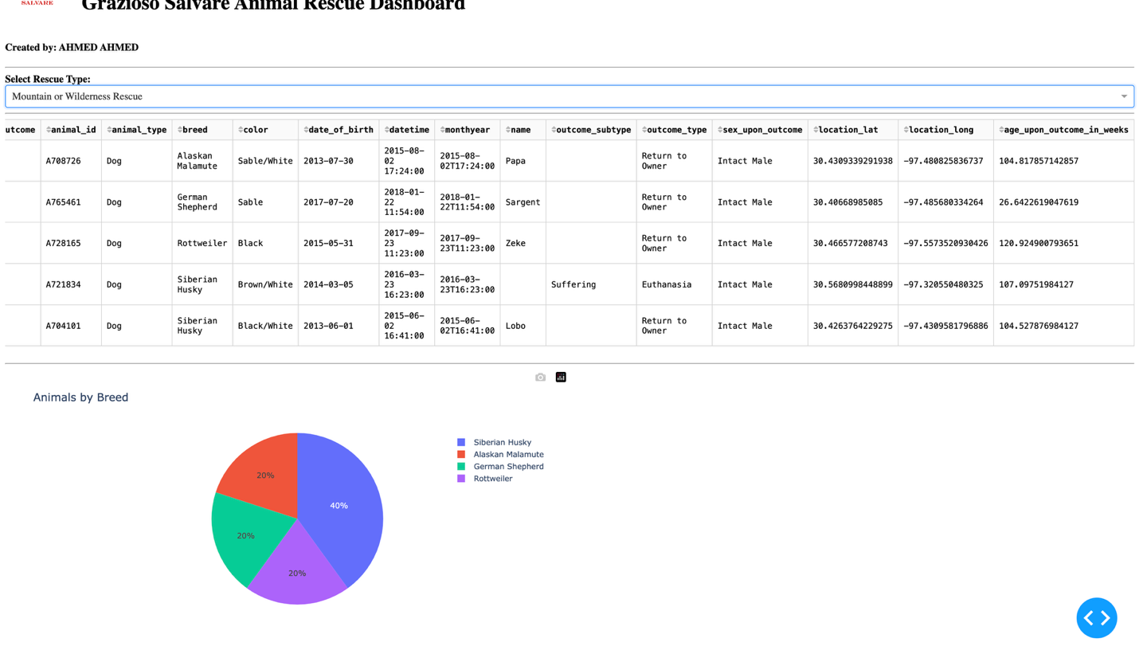ountain or Wilderness Rescue filter displays dogs matching the required rescue criteria. The dashboard widgets update based on the filtered data.

Screenshot 4 – Disaster or Individual Tracking
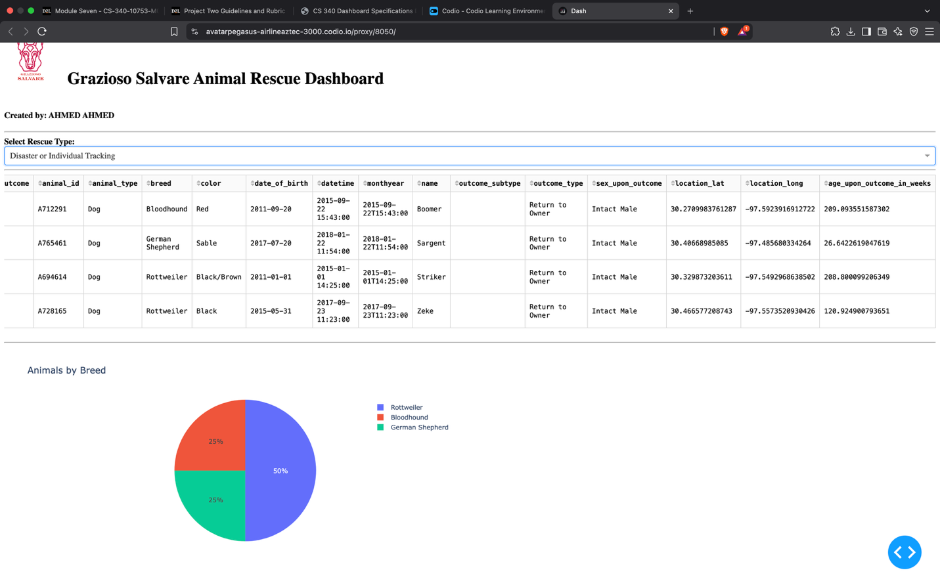

Screenshot 5 – Reset
The Reset option returns the dashboard to the original unfiltered animal dataset.
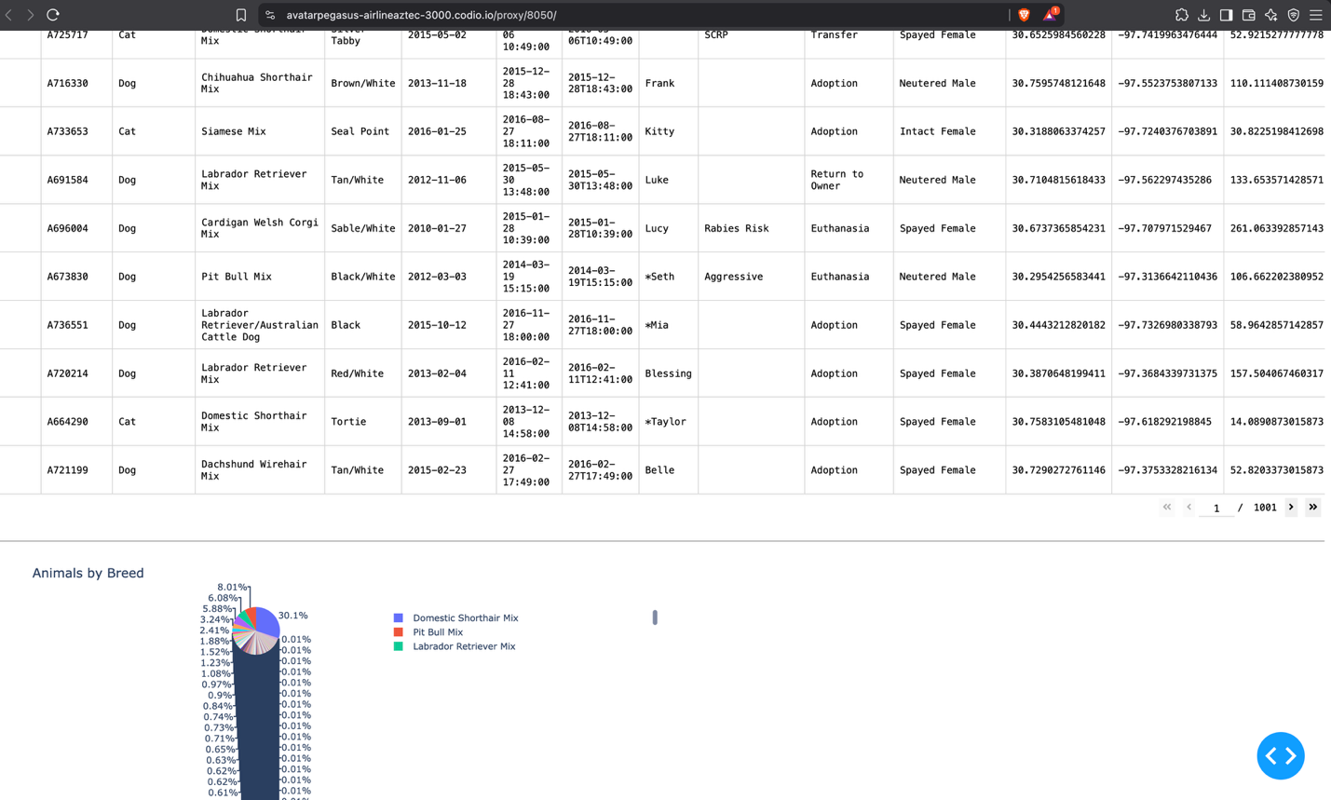

Challenges Encountered
One challenge encountered during development was connecting the dashboard filtering functionality to the existing CRUD Python module. The dashboard needed to use the MongoDB queries from the CRUD module instead of performing unrelated filtering directly in the dashboard.
Another challenge was making sure the dashboard components updated when a filter was selected. The data table, pie chart, and map needed to work together so that the user could interact with the filtered results.
I also encountered an indentation issue while organizing the rescue methods in the CRUD Python module. Some of the rescue methods were duplicated and were not correctly placed inside the AnimalShelter class. This was resolved by organizing the methods into the class and removing the duplicate versions.
A layout indentation error also occurred in the dashboard when the Grazioso Salvare logo was changed to include a URL link. The error was resolved by correctly organizing the nested html.Div and html.A components.
Testing each filter individually helped verify that the MongoDB queries and dashboard callbacks were working correctly.

Conclusion
The completed Grazioso Salvare Animal Rescue Dashboard provides an interactive interface for identifying dogs that may be suitable for different types of search-and-rescue training.
The application successfully connects a MongoDB database to a Python CRUD module and a Dash web dashboard. Users can filter animal records by rescue type, view the filtered records in a data table, visualize breed information with a pie chart, and view the location of a selected animal using the geolocation map.
The project demonstrates the use of database systems, Python, MongoDB, PyMongo, Dash, Plotly, and Dash Leaflet to create a client-facing database application.
=

