Cs340

AHMED AHMED
07/11/26
CRUD

STEP 1: ACCESS DATA
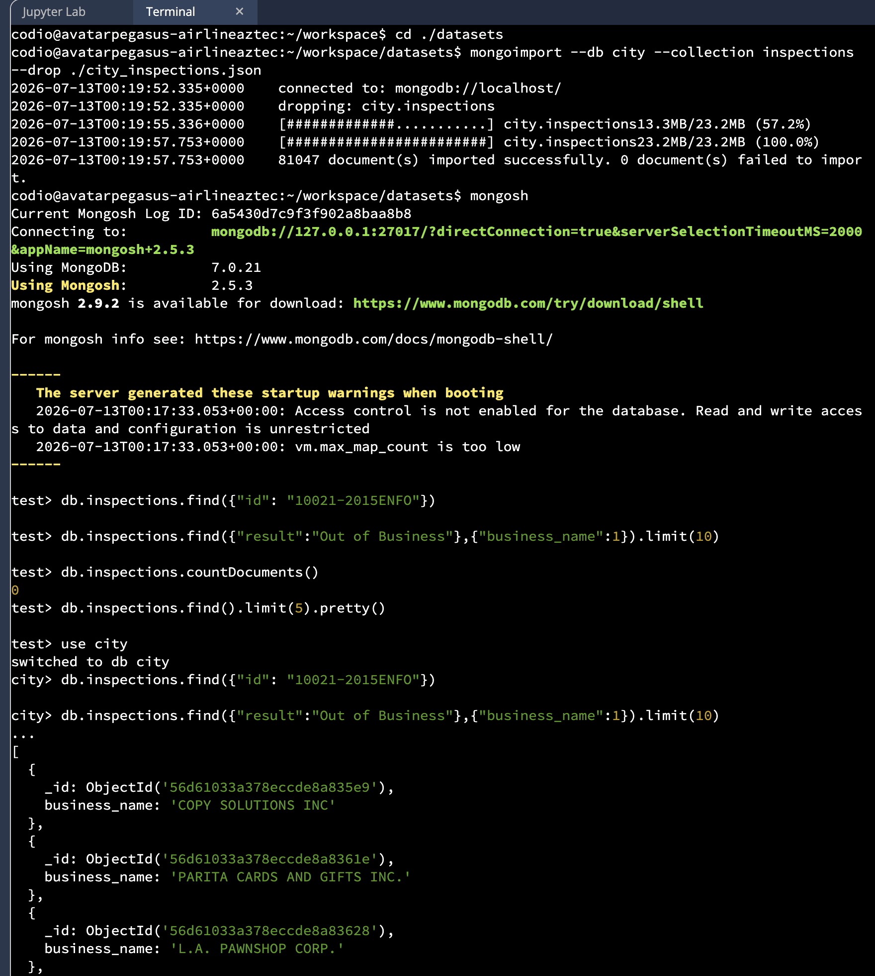
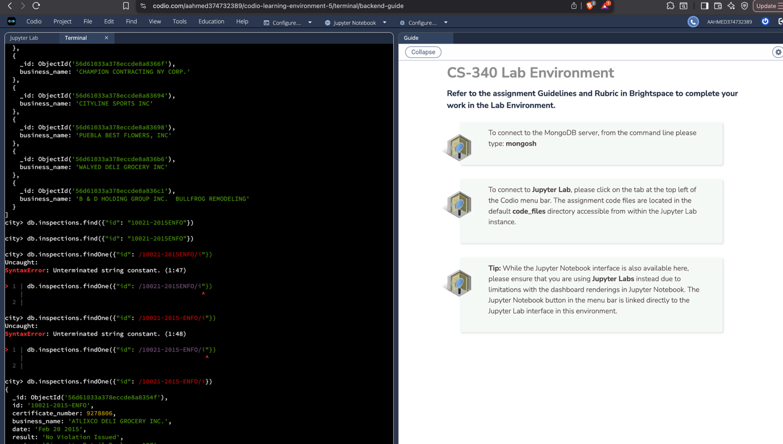
2.VERIFICATION
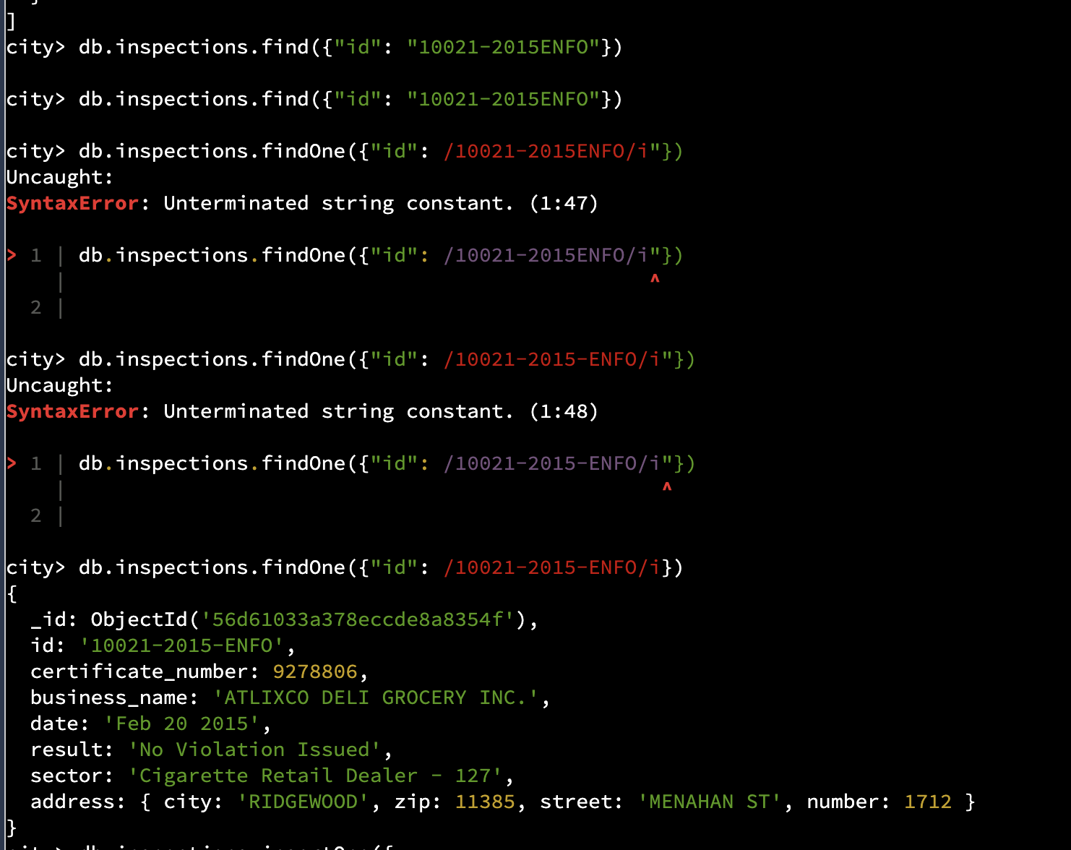

3. INSERT AND VERIFY NEW DOCUMENT
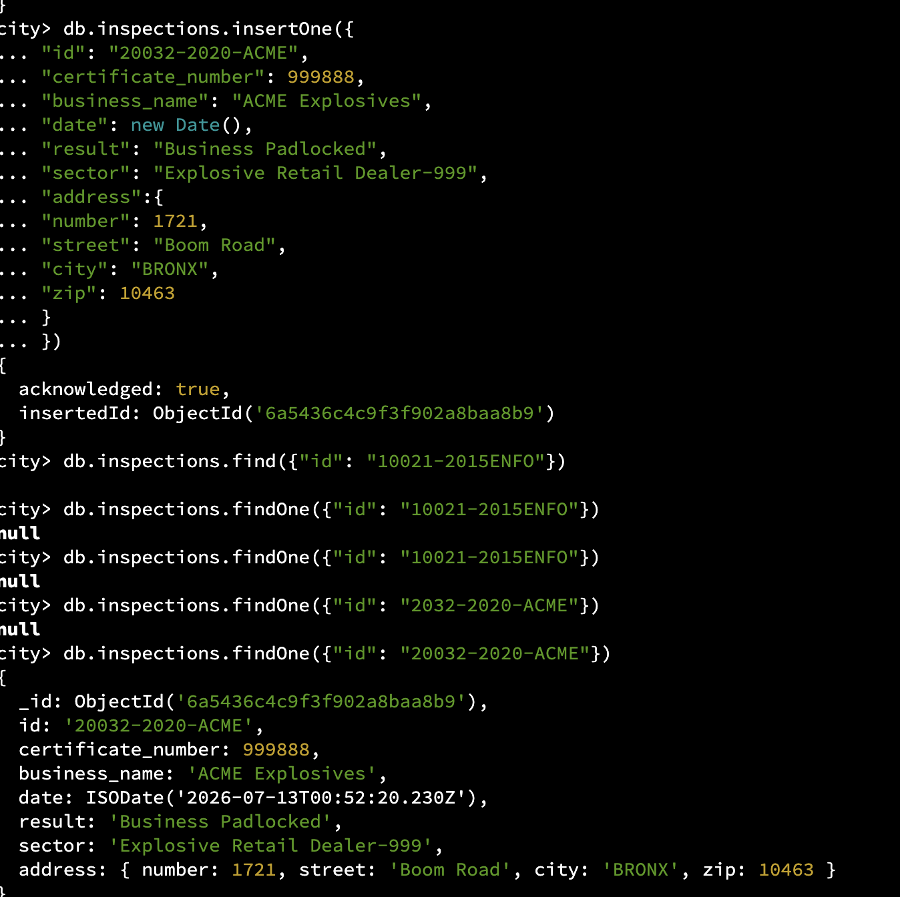

4. QUERIES AND ANYLYSIS
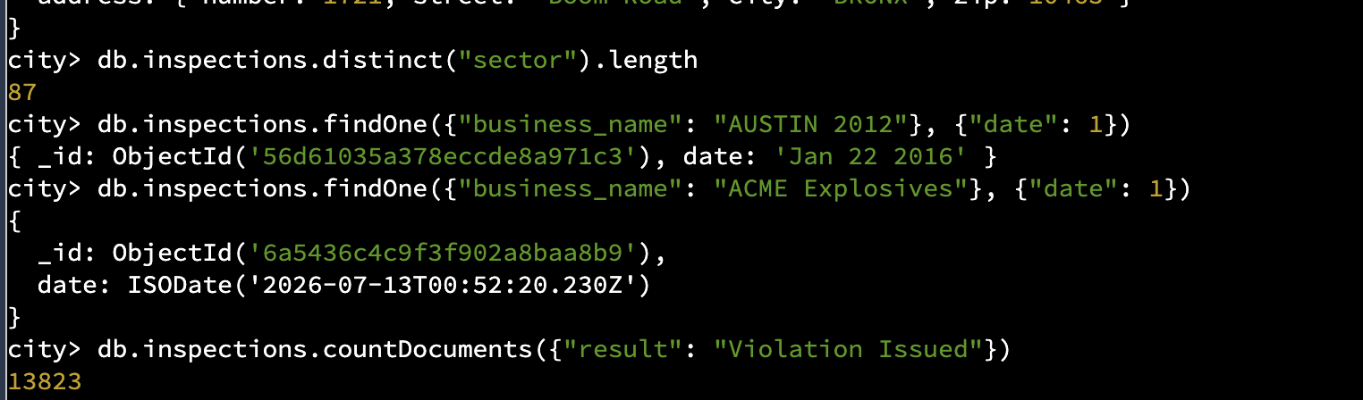

4a. Number of Unique Inspection Sectors
Query Used:
db.inspections.distinct("sector").length
Result: 87 unique sectors
Explanation:
The query shows that the inspection database contains 87 different business sectors. These sectors represent the various types of businesses that the city inspects, including restaurants, retail stores, offices, manufacturing facilities, and other industries. Having a large number of unique sectors demonstrates that inspections cover a wide range of businesses throughout the city. This information helps provide a better understanding of the diversity of businesses included in the database.

4b. Comparing Date Formats
Queries Used:
db.inspections.findOne({"business_name":"AUSTIN 2012"},{"date":1})
db.inspections.findOne({"business_name":"ACME Explosives"},{"date":1})
Results:
- AUSTIN 2012 stores its inspection date as a text string ("Jan 22 2016").
- ACME Explosives stores its inspection date using the ISODate format (ISODate("2025-03-17T00:35:56.427Z")).
Explanation:
The results show that the inspection records do not use a consistent date format. One document saves the date as plain text, while another uses the standard MongoDB ISODate format. This inconsistency can create problems when sorting records, filtering by date, or performing date calculations. Using the ISODate format throughout the database would make the data easier to manage and produce more reliable query results.

4c. Number of Businesses with "Violation Issued"
Query Used:
db.inspections.countDocuments({"result":"Violation Issued"})
Result: (Enter the number returned by your query.)
Explanation:
This query counts the number of inspection records where the inspection result was "Violation Issued." These records represent businesses that did not meet inspection requirements and were cited for violations. Knowing how many businesses received violations can help identify overall compliance trends and may reveal industries or business types that require additional attention or enforcement.

Summary
The inspection database includes 87 unique business sectors, showing that inspections are performed across many different industries. The data also reveals inconsistent date formats, with some records storing dates as text instead of the preferred ISODate format. Standardizing date storage would improve data quality and make future analysis more accurate. Finally, counting the number of businesses that received violations provides useful insight into compliance levels and can help identify areas where businesses may need to improve.

5.UPDATE DOCUMENTS

6. PERFORM BULK UPDATE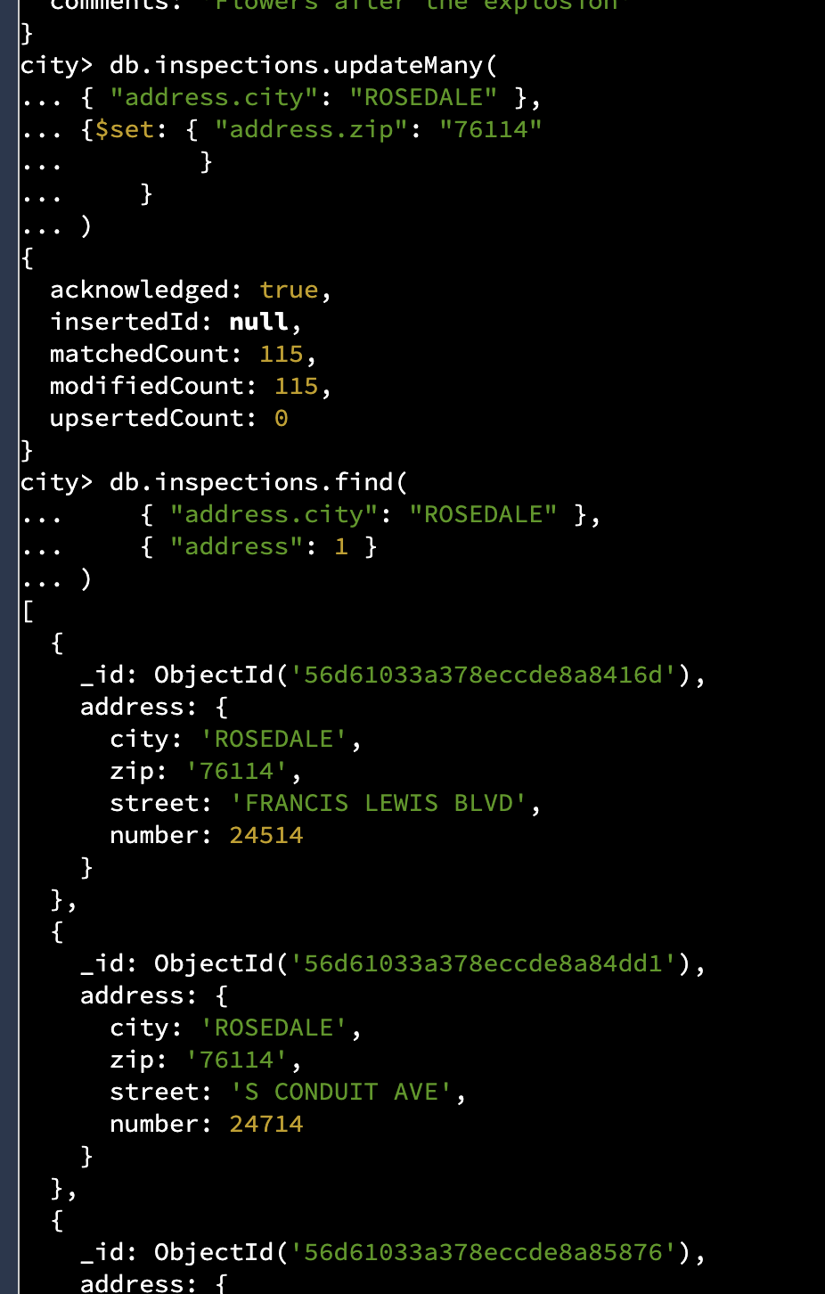
6.DELETION
