Cs340
July 25 26
Ahmed ahmed
4-1 MILESTONE

1: CRUD Python Module
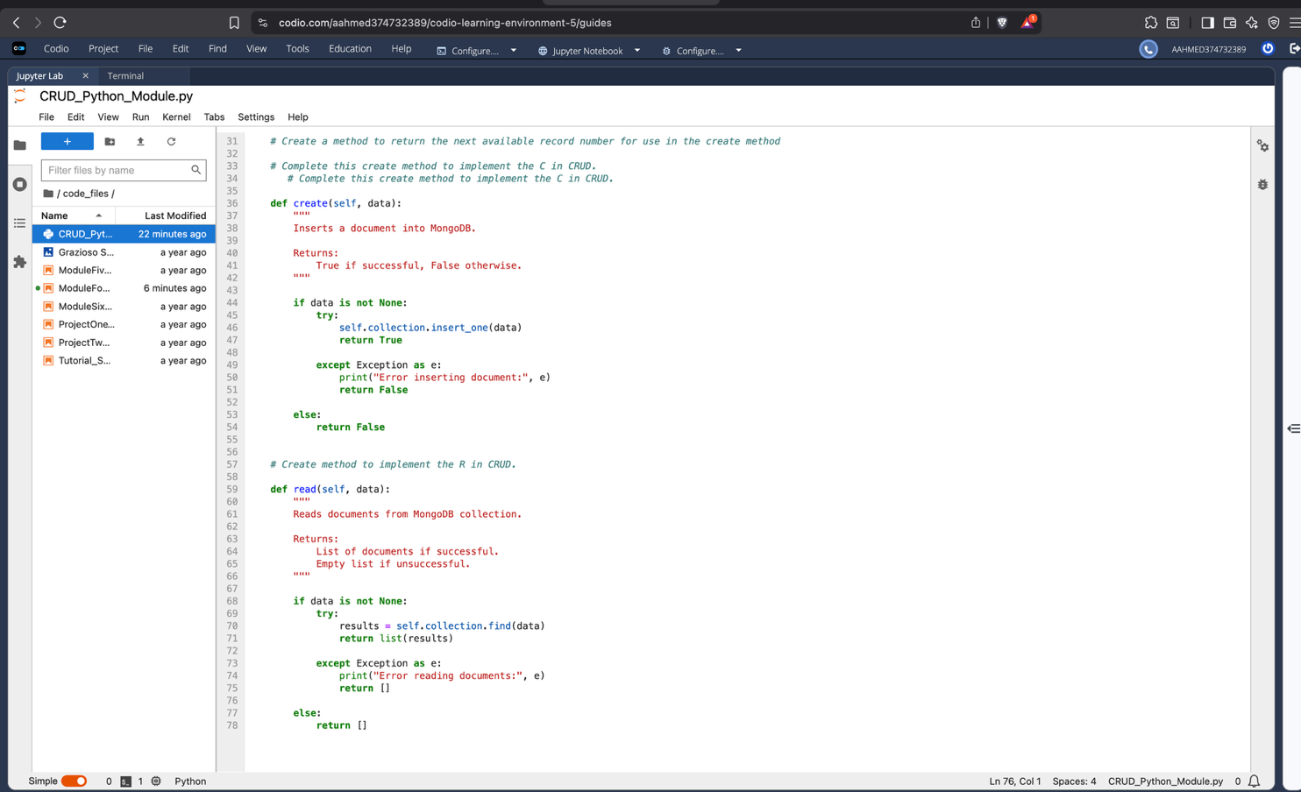
Description:
This screenshot shows the CRUD Python module containing the MongoDB connection, create method, and read method. The module uses the PyMongo driver to communicate with the AAC database.

Screenshot 2: CRUD Object Initialization
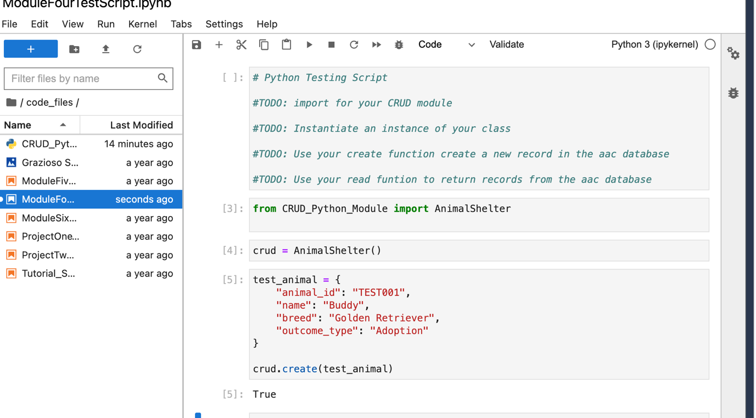

Screenshot 4: Read Function Test
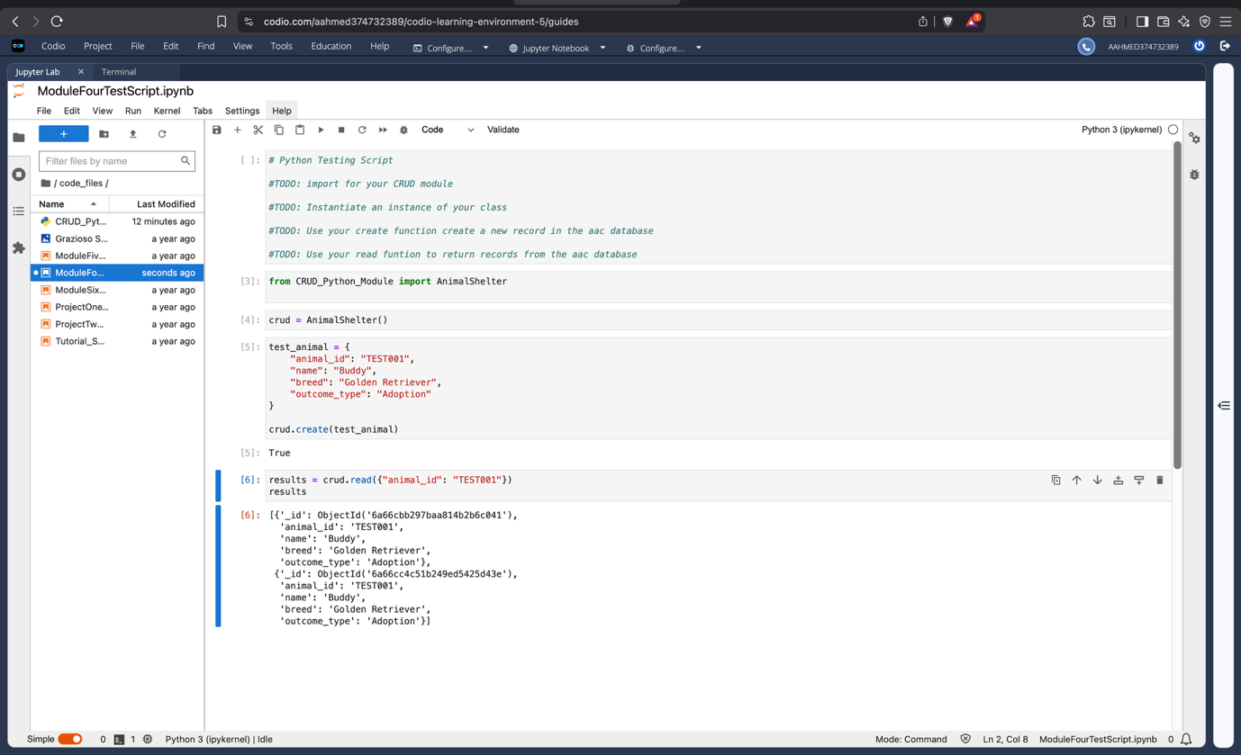
Description:
This screenshot demonstrates the read functionality using the MongoDB find() method. The returned list contains the matching document from the animals collection.

