Ahmed Ahmed
CS340
08/01/26
MODULE 5 Assignment
STEP 1: UNIQUE IDENTIFIER
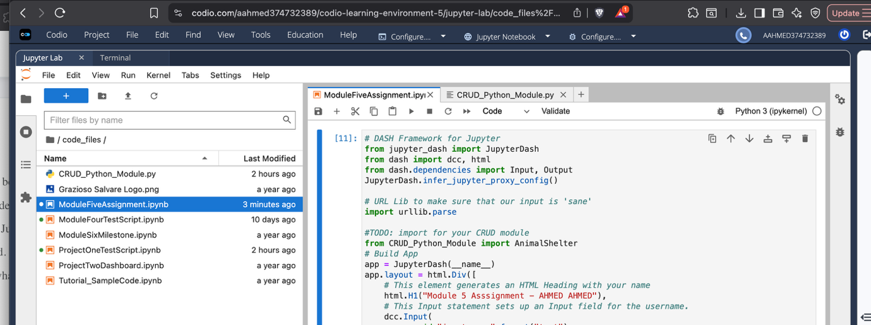
STEP 2 : PLACEHOLDERS
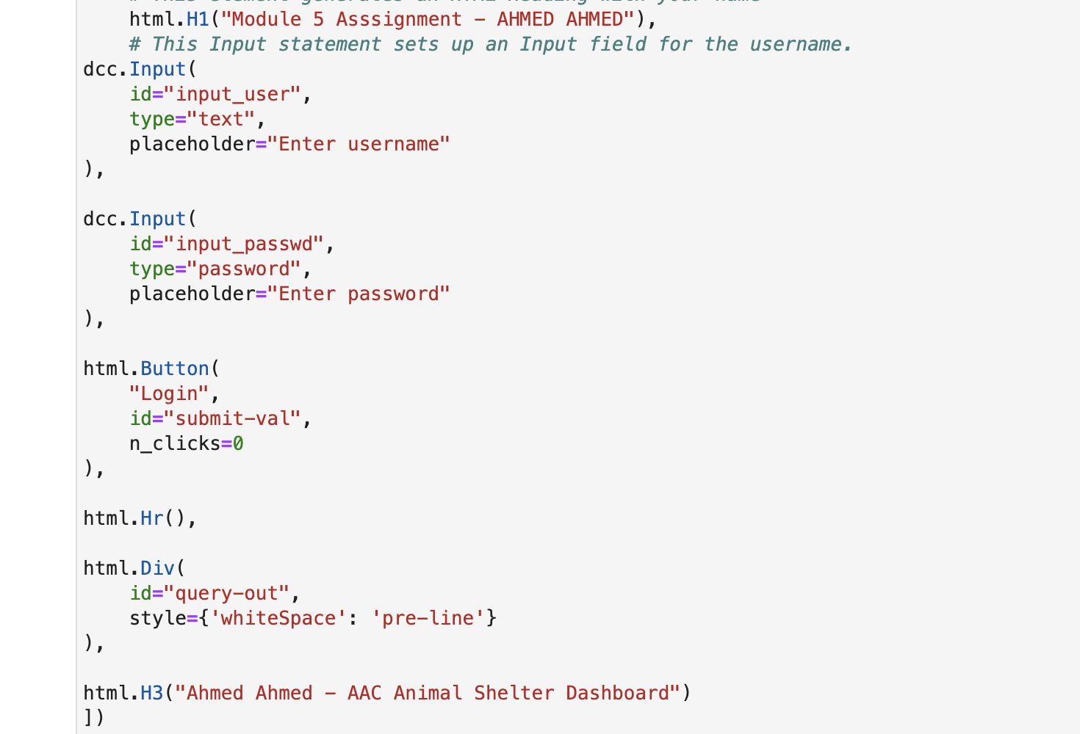
STEP 3 FUNCIONALITY
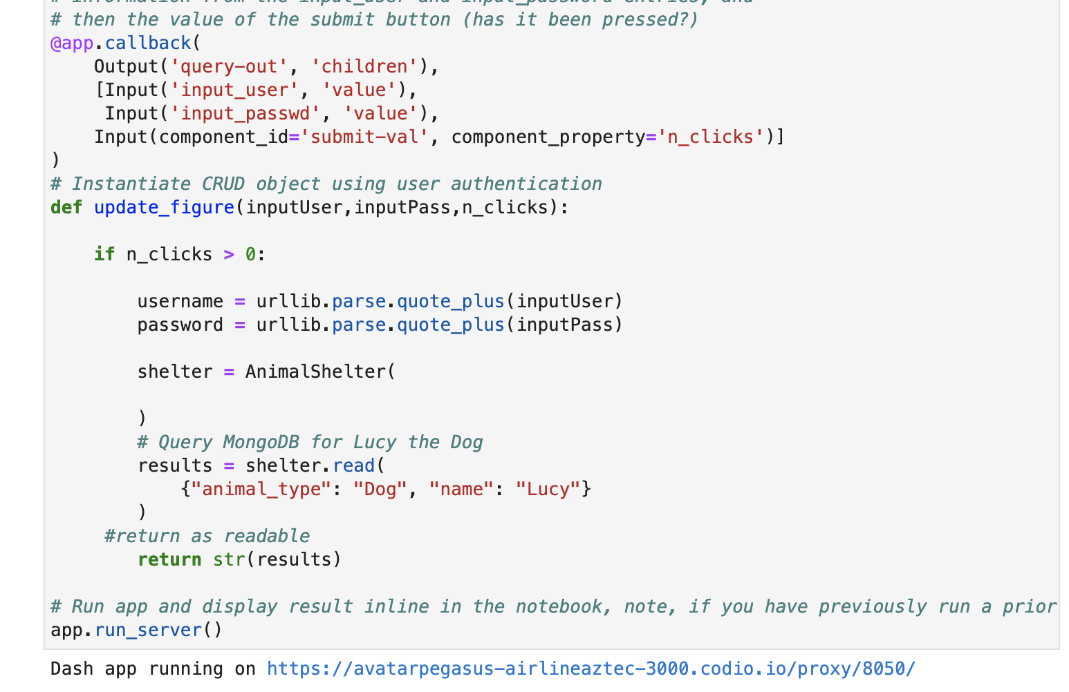
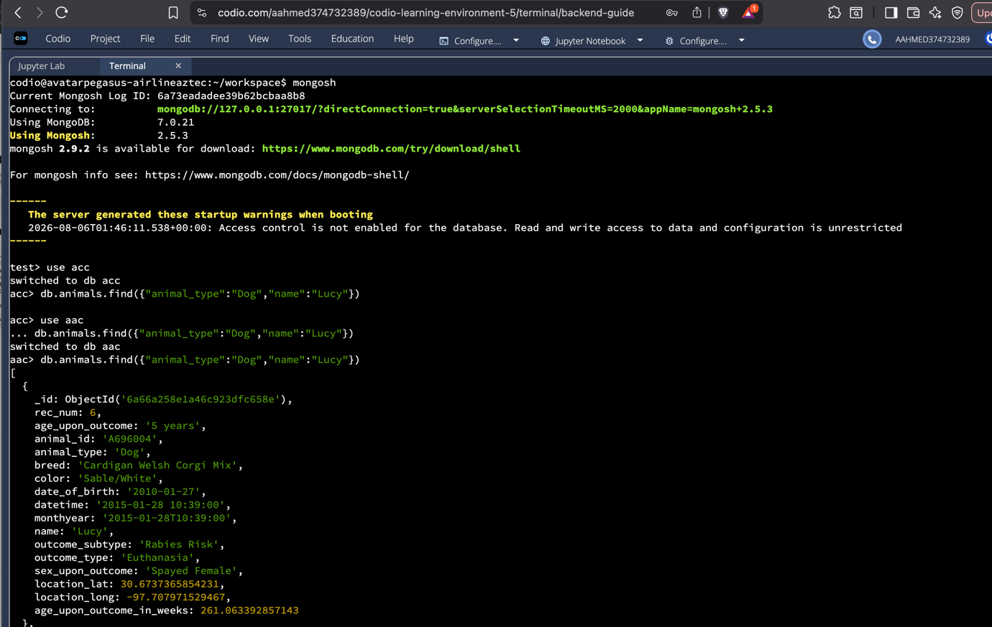
STEP 4 LOGIN
