MongoDB Advanced Queries Assignment

1. Creating and Verifying the Database
I created the companies database by importing the companies.json file into a collection named research. I then verified that the data was successfully loaded by searching for companies with the name AdventNet and by searching for companies founded in 1996. The second query displayed only the company names and limited the results to the first 10 companies.
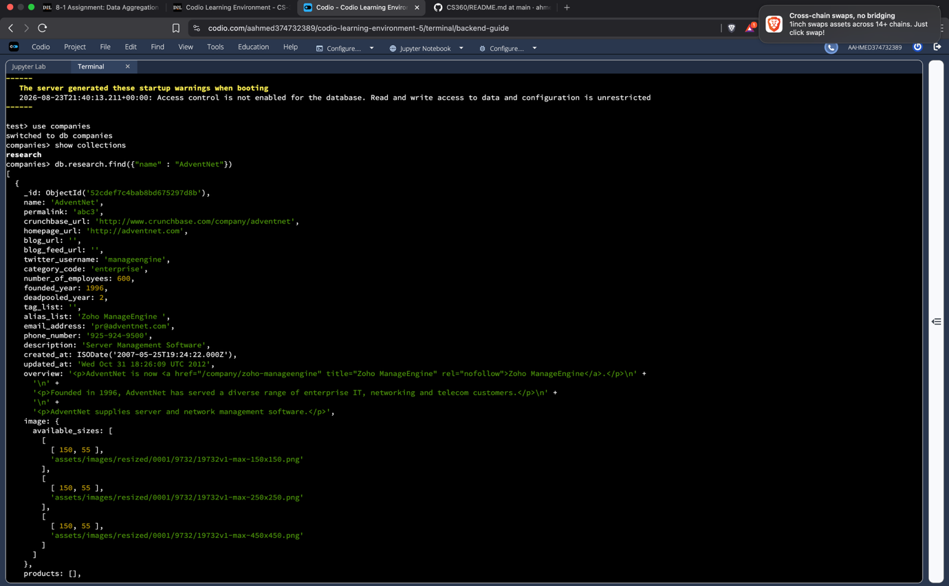
: Companies founded in 1996 query and results]
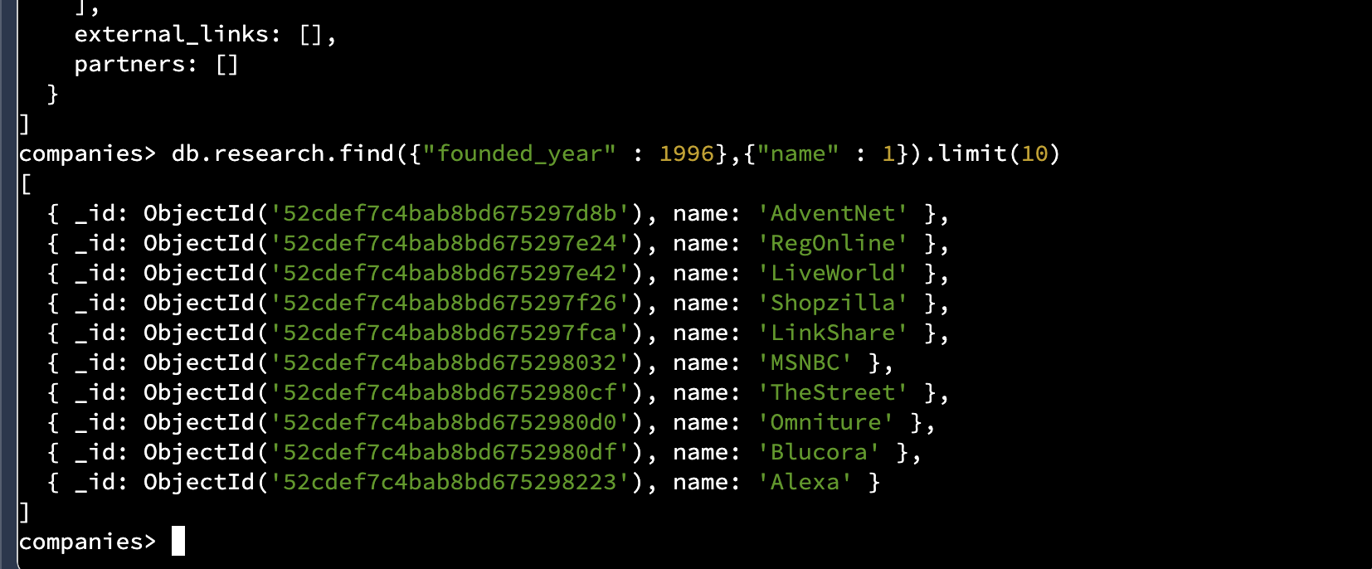

2. MongoDB Queries
For the first query, I searched for companies that were founded after 2010. I used the $gt operator to find companies with a founded_year greater than 2010. I displayed only the company names, sorted them alphabetically, and limited the results to the first 20 companies.
[: Companies founded after 2010]
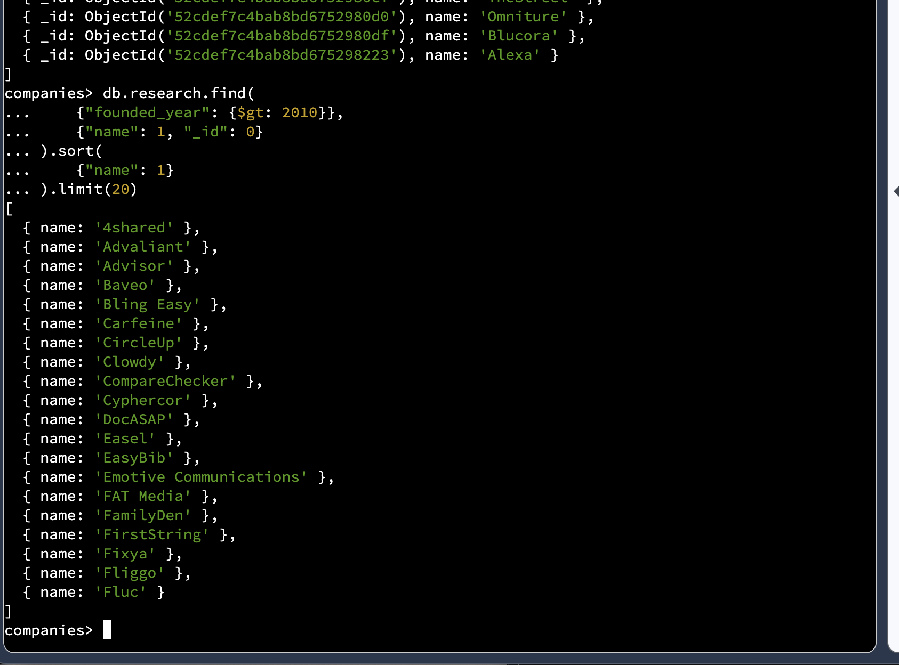
For the second query, I searched for companies that have offices in either California or Texas. The dataset uses state codes, so I used CA for California and TX for Texas with the $in operator. I displayed the company name and number of employees, sorted the companies by number of employees from largest to smallest, and limited the results to 20 companies.
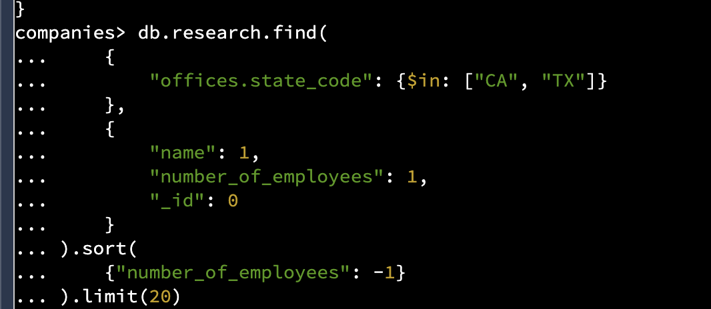
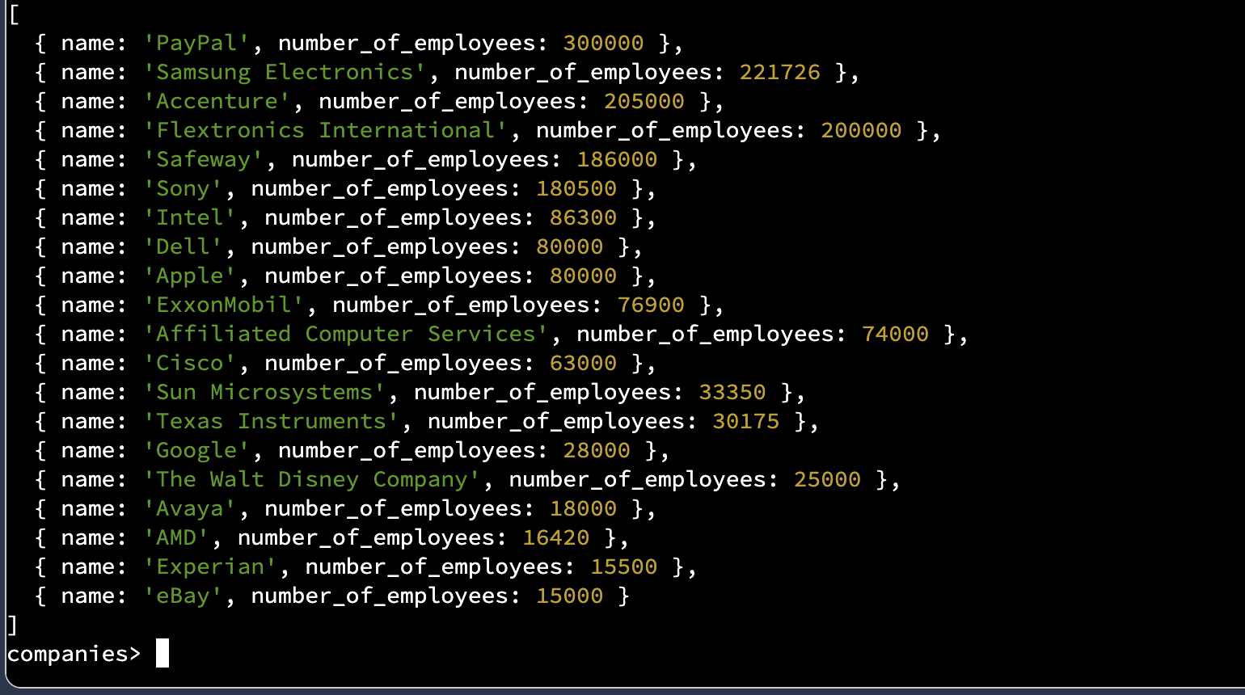

3. Aggregation Pipeline
For the aggregation pipeline, I used several MongoDB aggregation stages to calculate the total number of offices in each U.S. state. First, I used $unwind on the offices array to separate each office into its own document. This is important because a company can have multiple offices in different states, and each office needs to be counted separately.
Next, I used $match to keep only offices where the country_code was USA and where a state code was available. I then used $group to group the offices according to their state_code. Within each group, $sum: 1 counted the individual offices. Finally, I used $sort to order the states from the greatest number of offices to the smallest.
The results showed that California had the most offices, with 3,903, followed by New York with 1,084, Massachusetts with 623, and Texas with 500. This pipeline accounts for companies with multiple offices because $unwind processes each office separately before the offices are grouped and counted.
[: Aggregation pipeline and results]
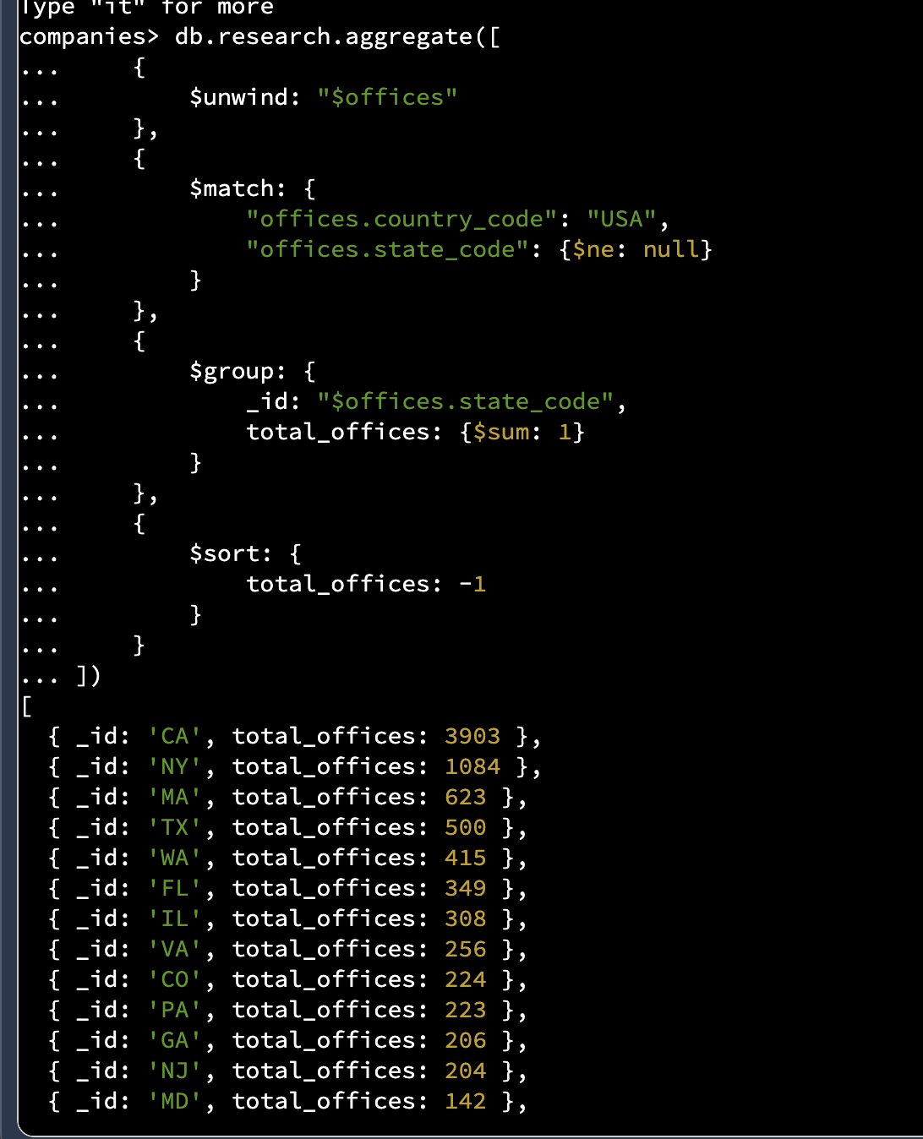
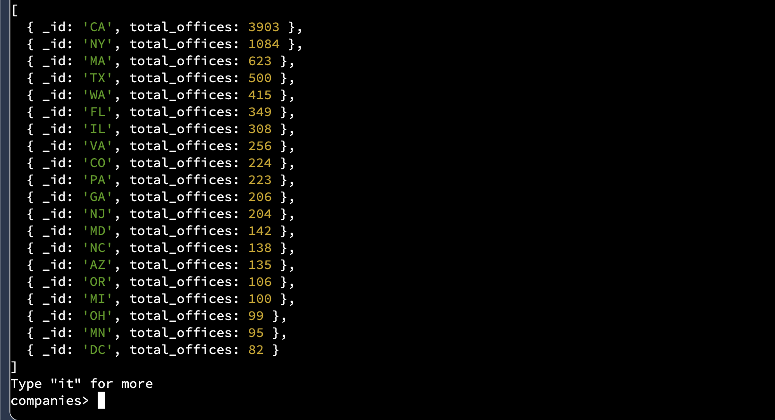
Overall, these queries demonstrate how MongoDB can be used to filter, sort, limit, and aggregate data. The aggregation pipeline was especially useful for analyzing the nested office information and calculating totals across multiple states.

