Ahmed Ahmed
CS360
08-10-26
SensorManager
Purpose of SensorManager
SensorManager is an Android system service that allows an application to access the device's available hardware sensors. It provides a way for an app to find a specific sensor, register a listener, receive sensor events, and respond when sensor values change. For this project, I used SensorManager with the accelerometer sensor. The accelerometer measures acceleration along the device's X, Y, and Z axes. This makes it possible for the application to detect changes caused by moving or rotating the Android device or emulator.
How My App Uses SensorManager
In my MainActivity, the application obtains the SensorManager by calling getSystemService(SENSOR_SERVICE). It then uses getDefaultSensor(Sensor.TYPE_ACCELEROMETER) to obtain the emulator's accelerometer. The activity implements SensorEventListener so it can receive updated sensor readings. In onResume(), the app registers the listener with SENSOR_DELAY_NORMAL, which allows the application to receive accelerometer updates while the screen is active. In onPause(), the listener is unregistered so the app does not continue receiving sensor updates when it is not in the foreground. When onSensorChanged() is called, the application reads event.values[0], event.values[1], and event.values[2] for the X, Y, and Z values. Those values are placed into sensorText and displayed on the screen using Jetpack Compose. This keeps the app simple while directly demonstrating how SensorManager works.
Testing and Breakpoint
I tested the application in the Android Emulator using the Pixel 7 virtual device. I opened the Extended Controls and used the Virtual Sensors Device Pose controls to change the device's rotation. The accelerometer values on the application screen changed when the emulator's position was changed. For example, the screenshot shows the app displaying X: 6.49, Y: 7.31, and Z: 0.79 while the emulator's virtual sensor controls show the same accelerometer values. This demonstrates that the app is receiving the sensor data correctly rather than displaying fixed numbers. I also placed a breakpoint inside onSensorChanged(), immediately before the X, Y, and Z values are read. When the emulator changes the sensor value, execution reaches this method, allowing me to inspect the event and its values in Android Studio. This helped confirm when and where the sensor data is being updated.
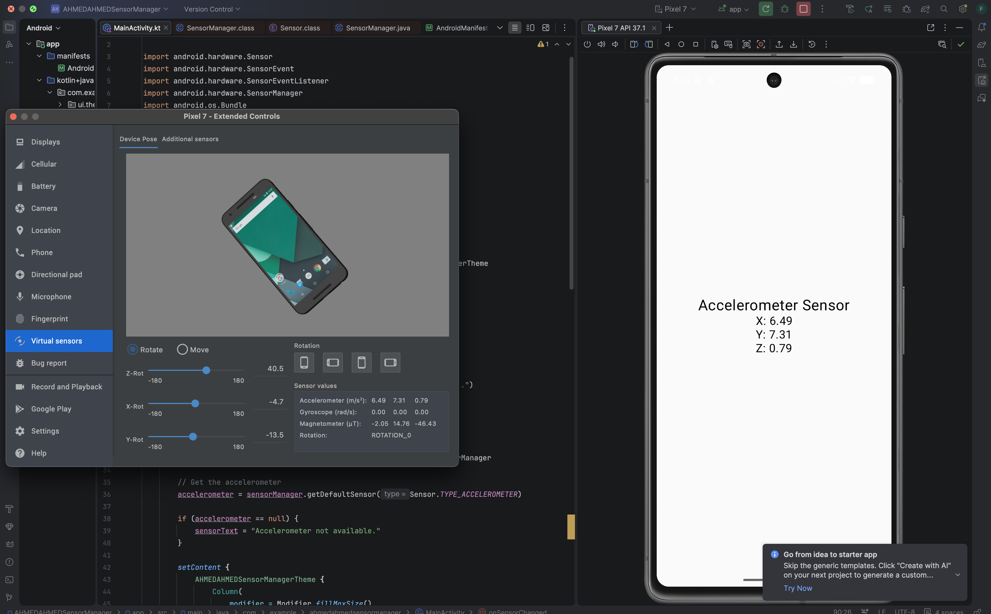
Uses of SensorManager
SensorManager has many practical uses. One example is gaming, where an accelerometer can detect tilting or moving a phone so the player can control an object. A second use is fitness and activity tracking. Sensor readings can help an application detect movement and contribute to step-counting or other activity measurements when combined with appropriate sensors and algorithms. A third use is screen or interface behavior. Sensors can help an application respond to device orientation or motion, such as changing an interface layout when the device is rotated. These examples show why SensorManager is useful: it provides applications with access to real-time information from the device's hardware sensors.
Conclusion
Creating and testing this application helped me understand that SensorManager acts as the connection between an Android application and the device's available sensors. The accelerometer example showed how sensor data can change continuously and how an application can react to those changes. The emulator's virtual sensor controls also made it possible to test the app without physical hardware. Overall, the project demonstrated the basic process of obtaining a sensor, registering a listener, receiving updated values, displaying those values, and debugging the sensor event callback.

