AHMED AHMED
CS-360
JULY 4, 2026
Assignment one
Discord is a mobile and desktop communication app designed to help users connect through text, voice, and video communication in organized online communities. While the platform originally became popular among gamers, it has expanded into a broader social and professional communication tool used by students, content creators, businesses, hobby groups, and friend communities. The overall design of Discord suggests that its primary purpose is to create spaces where people can communicate and collaborate in real time. The app uses a clean interface with organized servers, channels, and navigation menus that immediately communicate to users that they can join conversations, interact with groups, and access multiple communities in one place. The layout emphasizes accessibility and connection by making communication tools easy to locate and use.
One of the major user needs Discord addresses is the need for instant communication between individuals and groups. Users can send direct messages, participate in voice chats, or communicate through video calls. This flexibility allows people to stay connected whether they are casually talking with friends, studying for school, or coordinating activities in gaming communities. Another important need the app supports is community organization. Discord allows users to create servers with separate channels dedicated to different topics, which helps organize discussions efficiently. For example, a college study group could have separate channels for homework help, announcements, and general conversation. A third need Discord addresses is accessibility across devices and lifestyles. Since the app works on mobile phones, tablets, and computers, users can continue conversations and access information from almost anywhere. Notifications and synchronization features also help users remain updated in real time.
The app is clearly designed for users who value communication, collaboration, and social interaction. Students may use Discord for study groups and project collaboration, while online communities use it to share information and maintain active discussions. Content creators and streamers also use Discord to build communities around their audiences. Discord supports these goals by offering customizable servers, moderation tools, voice channels, and file sharing features. The app also encourages user engagement through notifications, friend requests, and server recommendations, which persuade users to remain active within communities. From a business perspective, Discord benefits by maintaining a large active user base and offering subscription services such as Discord Nitro, which provides additional customization and streaming features.
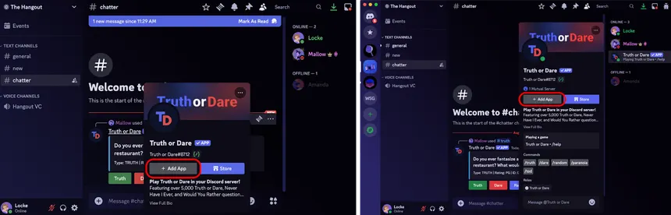
Several design features within Discord effectively support user needs. The navigation system is simple and visually organized, with servers displayed on the side of the screen and channels grouped clearly underneath them. Buttons for joining calls, sending messages, and sharing files are easy to recognize and accessible without overwhelming the user. The dark themed interface reduces visual strain and gives the app a modern appearance that appeals to many users. Features such as pinned messages, search functions, and role management further improve usability by helping users quickly locate information and manage large communities efficiently. Above is a screenshot of Discord running on a mobile device or desktop application demonstrating how the interface organizes communication tools into a streamlined and user friendly layout.
Before designing an app like Discord, developers would need detailed information about their users’ habits, goals, and communication preferences. Understanding the age groups, interests, and technical experience levels of users would help developers create features that feel intuitive and engaging. Developers would also benefit from learning how often users communicate, what devices they use most frequently, and what frustrations they experience with other communication apps. Accessibility information would also be important to ensure the app is usable for individuals with different needs and abilities. Collecting this type of user data allows developers to create a platform that feels personalized, efficient, and adaptable to a wide range of communities and communication styles.
Overall, Discord demonstrates how thoughtful interface design and user centered features can create a successful communication platform. Its combination of organization, accessibility, and real time interaction allows it to meet the needs of many different users while maintaining a simple and effective user experience.

