Food lover

Welcome to Food Lover, where culinary artistry meets warm hospitality. Indulge in a fusion of Eastern and Western food flavors, crafted with the freshest ingredients and a passion for excellence. Join us for an unforgettable dining experience in a cozy, elegant setting.  
  
System Requirements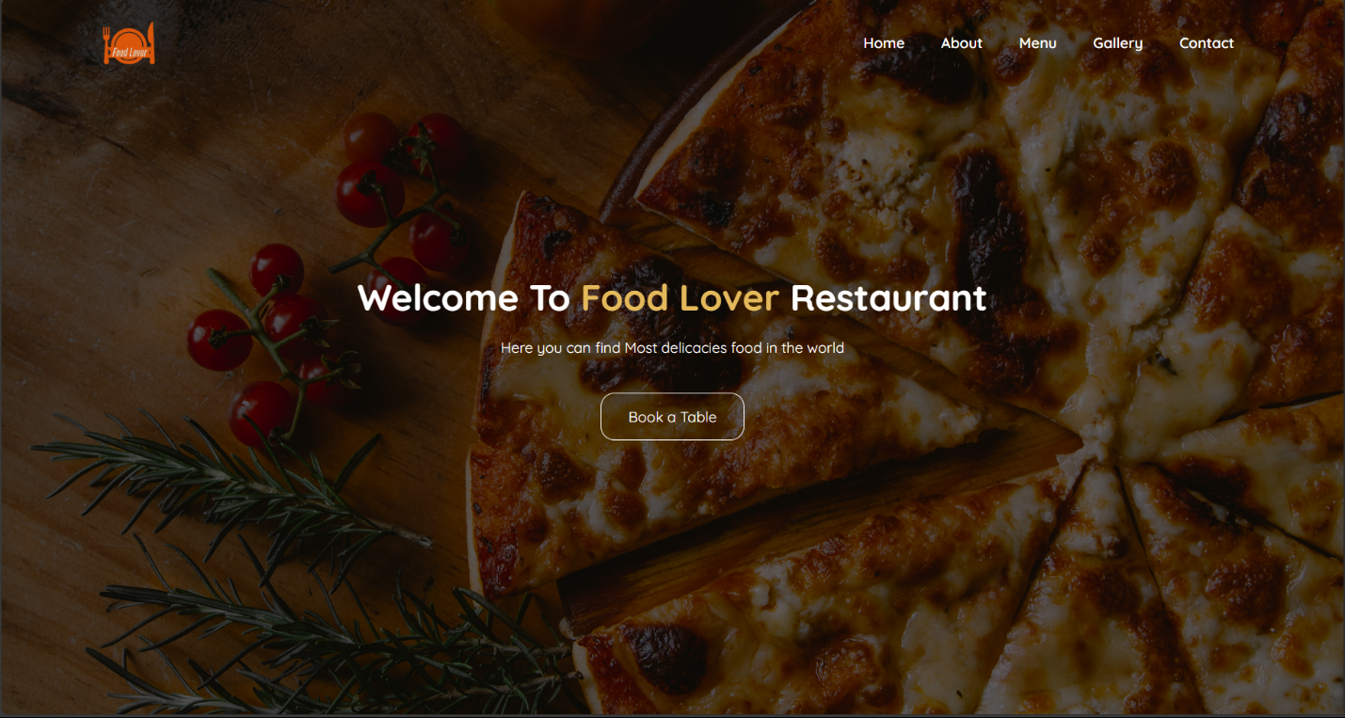:

**Home Page**:

**Dynamic Content Display**: The home page should dynamically showcase featured dishes, upcoming events, and special promotions with a visually appealing layout.

**Navigation**: Provide easy navigation links to all major sections of the website, including the menu, special offers, gallery, and contact information.

**History of the Restaurant**:

**Content Management System (CMS)**: Include a section dedicated to the history of the restaurant, which can be easily updated through a CMS. This section should feature text, images, and possibly video content.

**Storytelling Integration**: Incorporate a timeline or story-based layout to effectively communicate the restaurant's journey and heritage.

**Special Offers**:

**Promotions Management**: Enable the restaurant to create, update, and remove special offers easily. The section should allow customers to view current promotions and access detailed terms and conditions.

**Subscription Option**: Offer a subscription service for customers to receive notifications about new special offers via email or SMS.

**Special Menu**:

**Interactive Menu Display**: Feature a section for special menus, such as seasonal dishes or limited-time offers, with detailed descriptions and high-quality images.

**Filtering Options**: Allow customers to filter the special menu based on dietary preferences, allergens, or meal types (vegetarian, gluten-free).

**Meal Times (Breakfast, Lunch, Dinner, Dessert)**:

**Schedule Display**: Clearly display the timings for breakfast, lunch, dinner, and dessert service, with an option for customers to view the specific menu available during each meal time.

**Our Food Gallery**:

**Image Gallery**: Implement a visually appealing gallery that showcases high-resolution images of the restaurant's dishes, ambiance, and events. The gallery should support categorization (e.g., appetizers, mains, desserts).

**Contact Us**:

**Contact Form**: Provide a contact form where customers can send inquiries, make reservations, or provide feedback. The form should include fields for name, email, phone number, and message.

**Location and Social Media Links**: Display the restaurant’s physical address, Google Maps integration, phone number, email address, and social media links.

**Performance**:

The website should load quickly, with a target page load time of under 3 seconds, even with high-quality images and media content on the gallery and menu pages.

**Security**:

Implement HTTPS encryption to ensure secure data transmission, especially for the contact form and any subscription services.

Protect against common web vulnerabilities such as SQL injection, XSS, and CSRF.

**Usability**:

The website must be user-friendly, with an intuitive layout that allows users to easily navigate between sections and find information without difficulty.

**Scalability**:

The website should be able to handle increased traffic, especially during promotional periods or events, without compromising performance or user experience.

The backend systems should be scalable to accommodate future additions, such as new sections, more gallery images, or additional special offers.

**Mobile Responsiveness**:

The website must be fully responsive, providing an optimal browsing experience on various devices, including desktops, tablets, and smartphones.

**Reliability**:

Ensure the website has high availability with minimal downtime, supported by reliable hosting and regular backups.

Content updates, such as new special offers or changes to meal times, should be reflected on the website in real-time.