Student Record Management System
README | Week 1: C++ Assessment
Name: Ahmed Shahbaz
Programme: BS Computer Science, University of Gujrat

About the Project
A console application written in C++ that manages student records. It uses object-oriented programming with two classes, the STL (std::vector and std::sort), and file handling to keep the records between runs.
Features
- Add a student (roll number, name, department, semester, CGPA)
- View all students
- Search by roll number or by name
- Update a student's record
- Delete a student, with a confirmation question
- Sort students by CGPA (highest first) or by name (A to Z) using std::sort
- Statistics: total students, average CGPA and the top 3 students
- Records are saved to students.txt on exit and loaded again on start
- Input validation: no duplicate roll numbers, CGPA must be 0.0 to 4.0, semester must be 1 to 8, empty input is rejected, and typing letters instead of numbers does not crash the program

Project Structure
File | Purpose
main.cpp | Menu and program loop
Student.h / Student.cpp | Student class (private data, getters, setter, display) and the sort comparison functions
StudentManager.h / StudentManager.cpp | StudentManager class: stores students in a std::vector and handles all operations and file handling
InputHelpers.h / InputHelpers.cpp | Functions that read and validate user input
students.txt | Sample data file

How to Run
main.cpp includes the other .cpp files, so only main.cpp needs to be compiled.
Using Dev-C++:
- Open main.cpp and press F11 (Compile and Run).
Using g++ from the command line:
g++ main.cpp -o StudentRecordSystem
StudentRecordSystem

Keep all the files and students.txt in the same folder. If students.txt does not exist, the program starts with no records and creates the file when you exit.
Important: always exit using option 8 (Save and Exit). Closing the window with the X button does not save your changes.

Menu Options
1. Add Student
2. View Students
3. Search Student
4. Update Student
5. Delete Student
6. Sort and Display Students
7. Show Statistics
8. Save and Exit

Data File Format
students.txt stores one student per line, with the fields separated by commas:
roll,name,department,semester,cgpa
101,Ali Khan,Computer Science,3,3.60

Screenshots.
- Main menu

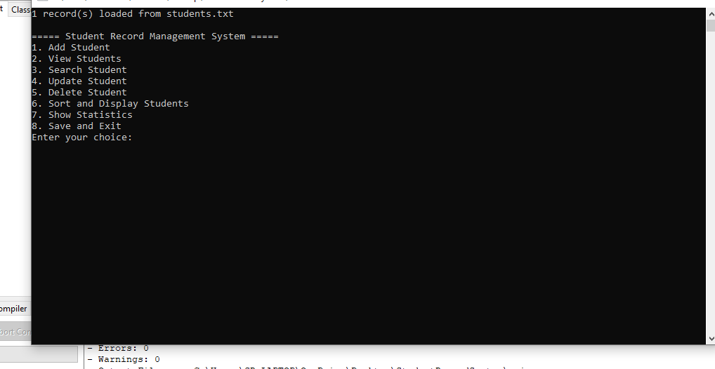

- Add student

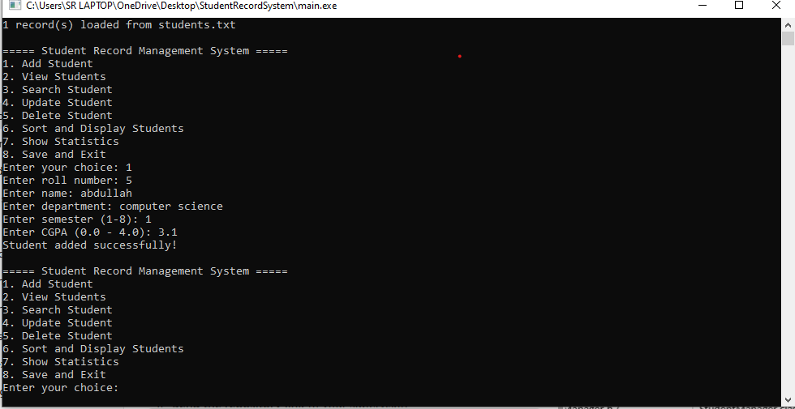

3. View students
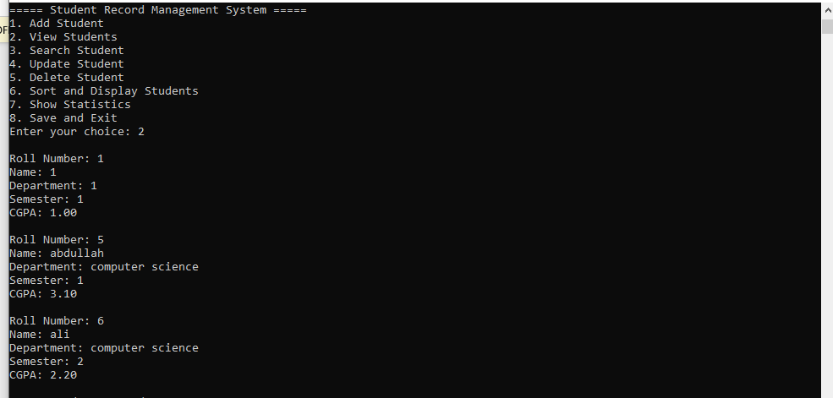
4. Search student
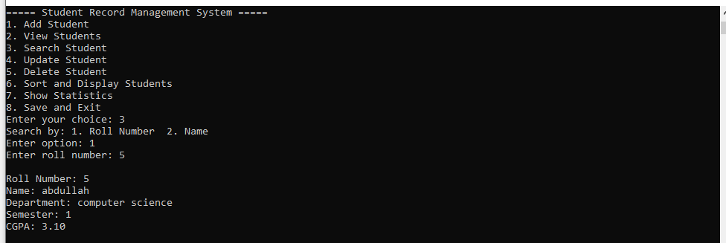
5. Sort and display
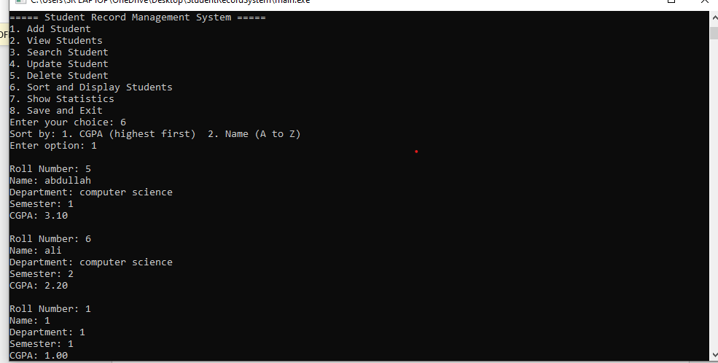
6. Statistics
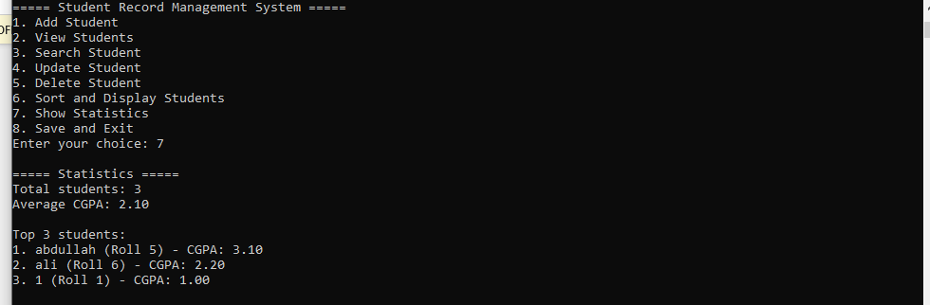
7. Input validation error (for example, letters instead of a number)
