Task A — Explore the “Risk Sectors” Dataset
For the project “Real Estate Analysis in Paris”, several datasets about environmental and urban risk zones are used. These datasets help identify areas in Paris that may be affected by flooding, underground instability, or heavy rainfall. Such risks are important because they can directly influence property prices, insurance costs, construction projects, and investment decisions.
The “Risk Sectors” category includes the following datasets:
- PLU bioclimatique – Secteurs de risque – Carrières
This dataset shows areas with former underground quarries and cavities in Paris. These zones may create ground instability, land subsidence, or structural damage to buildings.
- PLU bioclimatique – Secteurs de risque – PPRI / Flood Risk
This dataset identifies flood-risk areas along the Seine River and other vulnerable zones. These sectors are considered high-risk areas during flooding events and are regulated by the Flood Risk Prevention Plan (PPRI).
- Zonage pluvial
This dataset contains information about stormwater and heavy rainfall risk zones in Paris. It shows areas where intense rain may cause flooding or problems in the drainage and sewage systems.
The datasets contain geographic information such as risk zones, surface areas, coordinates, arrondissement numbers, and descriptions of each type of risk. The datasets include multiple mapped geographic records across Paris.
These datasets are very useful for our real estate analysis project because environmental and flood risks can strongly affect the safety, attractiveness, and value of properties. Buyers and investors usually prefer properties located in safer areas with lower environmental risk. In addition, the datasets help compare safe and vulnerable neighborhoods in Paris and support better real estate investment decisions.
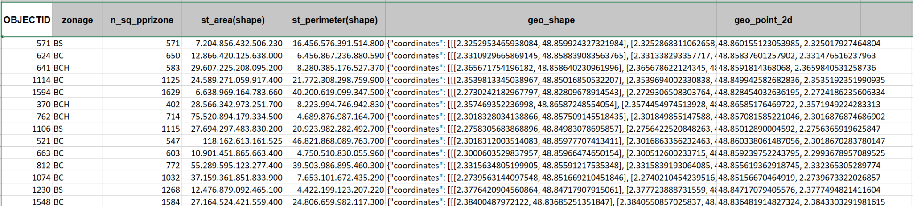

Main Columns in the Dataset
Column Name | Meaning
gid | Unique identifier for each geographic zone
objectid | Internal object number
zone | Type or category of flood-risk zone
libelle | Name or description of the area
surface | Surface area of the zone
arrondissement | Paris district number
geometry | Geographic polygon data used for maps
geo_point_2d | Geographic coordinates (latitude/longitude)
type_risque | Type of environmental risk

