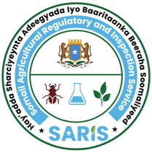

JAMHUURIYADDA FEDERAALKA SOOMAALIYA
HAY’ADDA SHARCIYEYNTA ADEEGYADA
& BAARITAANKA BEERAHA SOOMALIYEED
XAFIISKA HAY’ADDA

ﺟﻤﻬﻮرﻳﺔ اﻟﺼﻮﻣﺎل اﻟﻔﻴﺪراﻟﻴﺔ

الهيئة الصومالية للتنظيم

وتفتيش الخد مات الزراعية
ﻣﻜﺘﺐ الهيئة
Federal Republic of Somalia
Somali Agricultural Regulatory & Inspection Service (SARIS)
Office of SARIS

APPLICATION FORM FOR LICENSING OF PEST CONTROL PRODUCTS COMPANIES
(Issued under Agrochemicals Control Law No. 33/2024)
To:
Director General
Somali Agricultural Regulatory and Inspection Services (SARIS)
Mogadishu, Somalia

Section 1: Company Information
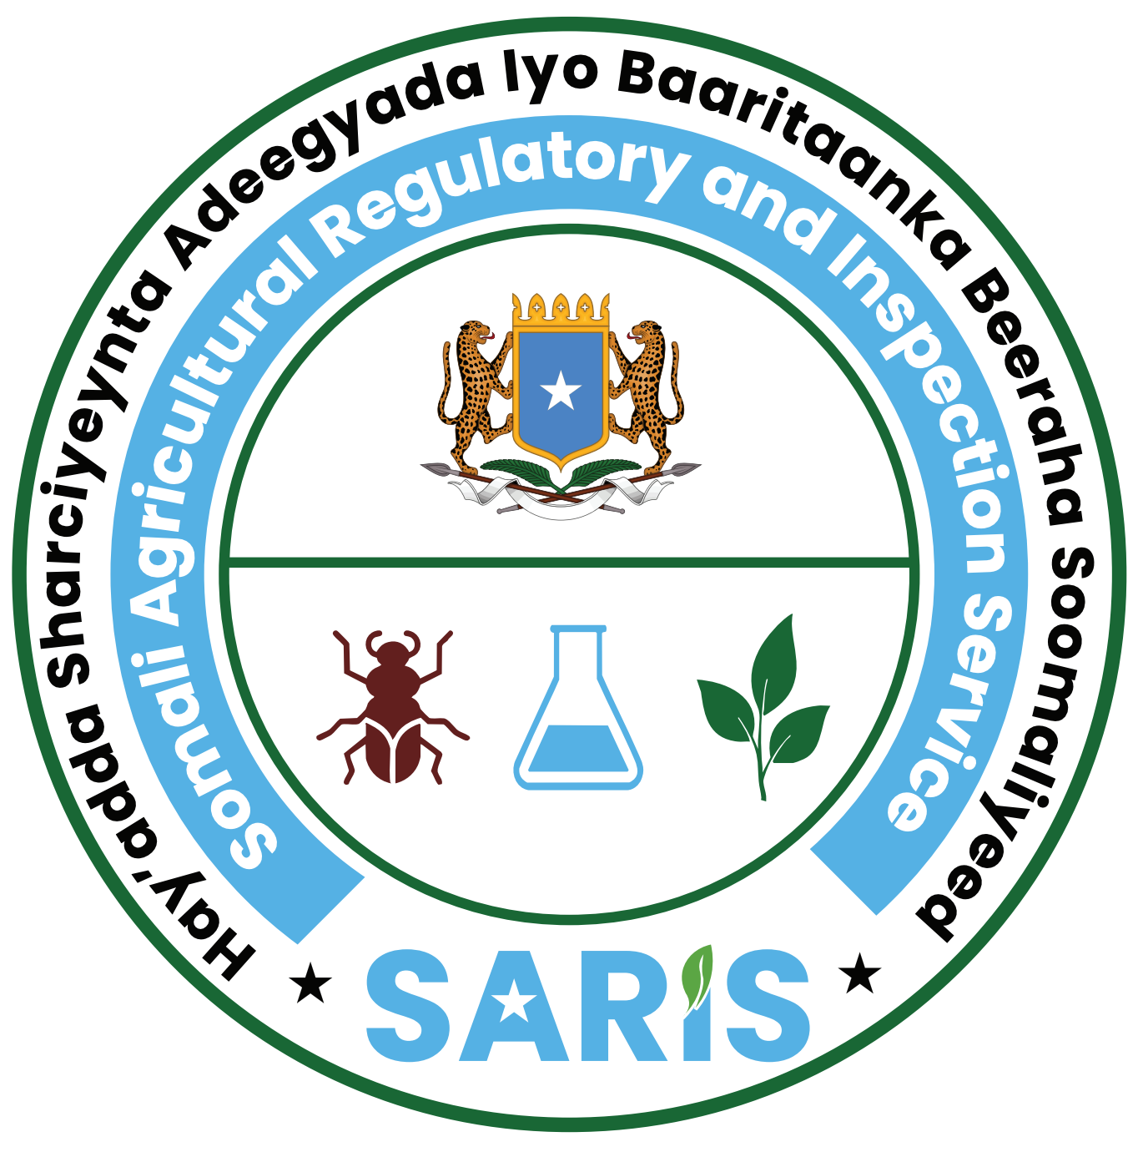
- Company Name: ___________________________________________________________
- Physical Location: _________________________________Street: _____________________
- Town /market: _____________________________________FMS: __________________________
- Email address: ________________________________________ Telephone: _________________
- Business Registration No. from Ministry of Commerce: _____________________________
- Tax Compliance Certificate No. from Ministry of Finance): ___________________________
Section 2: Ownership/Management Information
- Owner/Managing Director full name: _________________________________________________
- Nationality: _________________ 3. National Identification No.: ________________
- Address: _______________________________________________________________________
- Email address: ________________________________ Telephone: ________________________
Section 3: Technical Personnel Information
Qualified Technical Person (Minimum BSc in Agronomy, Plant Protection, Public Health, Toxicology or related field):
- Full Name: _____________________________________________________________________
- Qualification: ___________________________________________________________________
- University/Institution______________________________________________________________
- Years of Experience: _____________________________________________________________
- Training related to the handling of Pest control Products: ________________________________
- Contact: _______________________________________________________________________

Section 4: Facilities & Safety
- Storage/Warehouse Address: ____________________________________________________
- Evidence of:
  - Proper ventilation [ ]
  - Fire extinguishers [ ]
  - PPE availability [ ]
  - Spill management system [ ]
  - Waste disposal system. [ ]
  - First Aid & Emergency Plan [ ]
Section 5: Required Attachments (Tick √ if attached)
☐ Copy of Valid Company Registration Certificate from Ministry of Commerce
☐ Copy of Valid Tax Compliance Certificate from Ministry Finance
☐ Copy of Valid Identification Document of the Owner/Managing Director (National ID).
☐ Copy of Company Profile including management structure and technical responsibilities.
☐ Copies of degree certificate & CV of Technical Personal

Section 6: Declaration
I/We hereby declare that the information provided in this form is true and correct to the best of my/our knowledge. I/We agree to comply with all regulations, guidelines, and directives issued by the Somali Agricultural Regulatory and Inspection Service (SARIS) regarding pesticide handling, safety, and environmental protection. I/We understand that:
- Submission of false or misleading information shall lead to disqualification.
- Non-compliance with licensing requirements may result in suspension or revocation of the license.
Name of Applicant: ___________________________________________________________
Designation: _________________________________________________________________
Signature & Date: ____________________________________________________________

