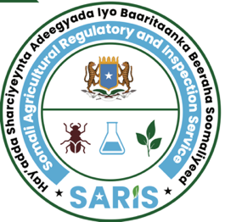

JAMHUURIYADDA FEDERAALKA SOOMAALIYA
HAY’ADDA SHARCIYEYNTA ADEEGYADA
& BAARITAANKA BEERAHA SOOMALIYEED
XAFIISKA SARIS

ﺟﻤﻬﻮرﻳﺔ اﻟﺼﻮﻣﺎل اﻟﻔﻴﺪراﻟﻴﺔ

الصومالية الهيئة وتفتيش لتنظيم الخدمات الزراعية
ﻣﻜﺘﺐ الهيئة
Federal Republic of Somalia
Somali Agricultural Regulatory & Inspection Service (SARIS)
Office of SARIS

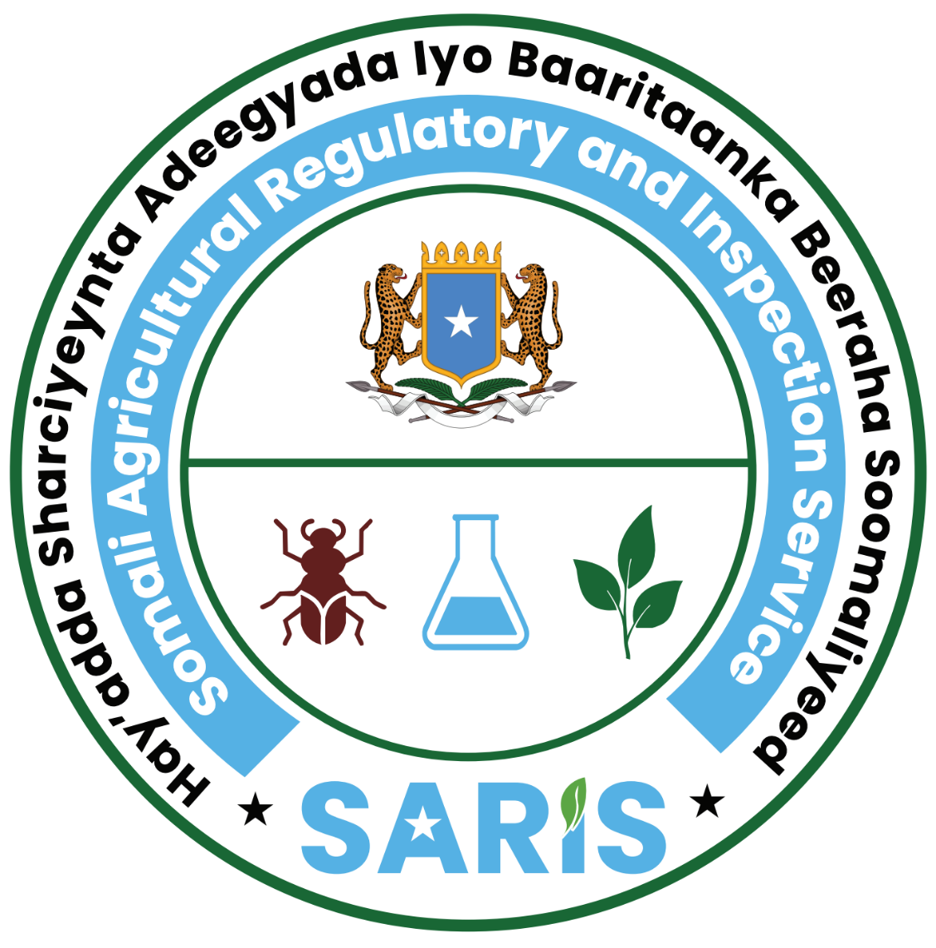
Shati Lam/ License No: PCPIL-DATE YEAR 0000

SHATIGA SOO DEJINTA DULINDILAYAASHA
IMPORTATION LICENSE FOR PEST CONTROL PRODUCTS

Magaca Shirkadda  Name of the company | XXXX
Taariikhda la diiwan geliyey  Registered date | XXXX
Nooca Ganacsi  Type of Business | Importation of Pest Control Products
Cinwaanka Shirkadda  Company Address | XXXX
Jinsiyadda  Nationality | XXX
Telefoonka lamb  Cell phone no | XXXXX
Caddeyn/Declaration
Hay’adda Sharciyeynta Adeegyada & Baaritaanka Beeraha Soomaliyeed waxay caddeyneysaa in ogolaanshahan soo dejinta (dulindilayaasha) ay ku saleysantahay qodobka 21aad ee Sharciga SARIS lam. 32/2024, iyo qodobada 5aad, 6aad iyo 7aad ee sharciga Xakameynta Kiimikooyinka Beeraha lam. 33/2024. Somali Agricultural Regulatory & Inspection Service (SARIS) has approved the legality of this license in accordance with article 21 of SARIS Law No. 32/ 2024 and articles 5, 6 and 7 of Agrichmical Control Law No. 33/2024.

Shaabada Hay’adda /Stamp of the Agency | Magaca sarkaalka idman & saxiixa/Name & signature of authorized officer  Mr. Abdi Mohamed Hussein  Maareeyaha Guud Hay’adda SARIS /Director General of Somali Agricultural Regulatory & Inspection Service (SARIS) | Taariikda ay soo baxdey/ Date of Issue | 00/00/0000
Shaabada Hay’adda /Stamp of the Agency |  | Taariikhda ay dhaceyso/Expiry Date | 00/00/0000
Shaabada Hay’adda /Stamp of the Agency |  | Goobta laga soo saarey/Place of Issue | Mogadishu- Somalia
Note: No financial liability with respect to this license shall attach to Somali Agricultural Regulatory & Inspection Service (SARIS) or to any of its officers and representatives in Somalia.

