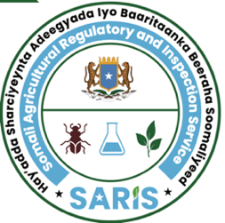

JAMHUURIYADDA FEDERAALKA SOOMAALIYA
HAY’ADDA SHARCIYEYNTA ADEEGYADA
& BAARITAANKA BEERAHA SOOMALIYEED
XAFIISKA SARIS

ﺟﻤﻬﻮرﻳﺔ اﻟﺼﻮﻣﺎل اﻟﻔﻴﺪراﻟﻴﺔ

الصومالية الهيئة وتفتيش لتنظيم الخدمات الزراعية
ﻣﻜﺘﺐ الهيئة
Federal Republic of Somalia
Somali Agricultural Regulatory & Inspection Service (SARIS)
Office of SARIS

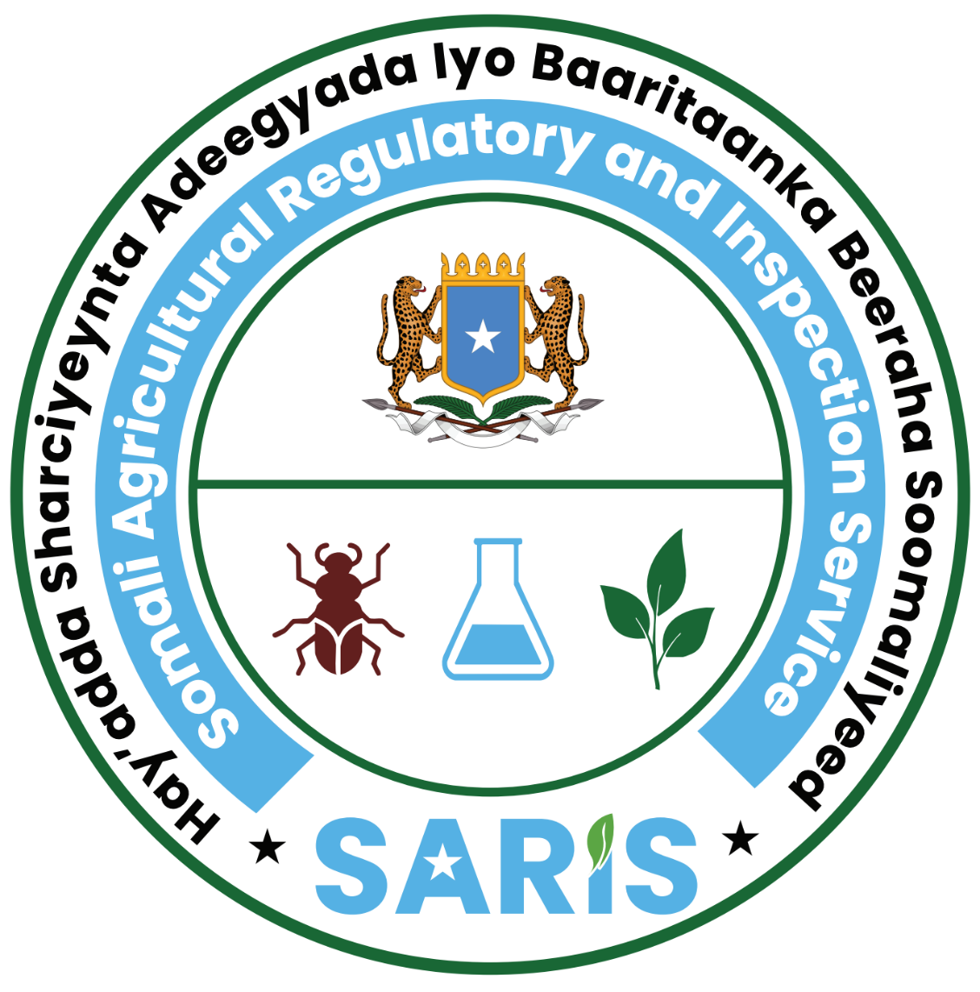
No: PCPIP-DDYY0000
RUQSAD SOO DEJINTA DULINDILAYAASHA
PEST CONTROL PRODUCTS IMPORT PERMIT
(Issued under Agrochemicals Control Law No. 33/2024)

The Importer whose details appear above is permitted under Somali Agricultural Regulatory and Inspection No. 32/2024 and the Agri-Chemical Control law No. 33/ 2024 to import in one consignment the pesticide(s) whose particulars appear below:
Importer details:
CompanyName.............................................................………………………………………………………………… Address......................................................................................................................………………………… ……
Email................................................................................. ..............
Telephone:.....................................................................................SARISLicense No:....................................
DESCRIPTION OF PEST CONTROL PRODUCTS(S)
Commercial Name: |  | The number of pesticides arriving in this consignment:
Name of Active Ingredient (a.i%): |  | Manufacturing country/Origin:
Formulation type: |  | Registration No. in country of origin:
Adjuvant: |  | Point of entry:
SARIS registration number of PCP: |  | Means of entry:
Permitted Quantity (L/Kg): |  | Purpose (commercial/Sample):
This permit is issued subject to the following conditions:-
(1) This permit is valid for single consignment only.
(2) The quantity imported shall not exceed the quantity specified under the description of the pest control product(s) in the permit.
Stamp of the Agency | Name & signature of authorized officer  Mr. Abdi Mohamed Hussein  Director General of Somali Agricultural Regulatory & Inspection Service (SARIS) |  | Date of Issue | 00/00/0000
Stamp of the Agency |  |  | Expiry Date | 00/00/0000
Stamp of the Agency |  |  | Place of Issue | Mogadishu- Somalia
Note: No financial liability with respect to this import permit shall attach to Somali Agricultural Regulatory & Inspection Service (SARIS) or to any of its officers and representatives in Somalia.

