Scrum management system

Project description
Scrum management system is a software project that aims to build a web application to handle the internal processes of a scrum system.
The project is considered a simple low risk system due the availability of time and resources.

Problem description
The system consist of:
Actors
Members
Scrum master

Backlogs
Product backlog
Sprint backlog

Scenarios : it includes:
- Authorities and capabilities of different actors on different parts of the projects
- Modifications made on data
- Flow of data

Our aim is to successfully implement the cross relation between those entities in a way that meet the customer needs(User stories)

Goal / Objectives / Strategy

Build a Scrum Management System software that meets the user’s needs within available time
- Requirement Analysis
  - Analyze the given user stories
  - Build the needed illustration diagrams
  - Assume the missing critical parts of the software
- Project the activities on time plan
  - Understand the different available resources
  - Estimate each activity time duration and their dependencies on each other
  - Build the needed illustration diagrams (pert and gantt chart)
  - Use github to facilitate communication
  - Build the minimum viable production

Risk Analysis
Moderate Risk
High Risk
Risk | Impact | Prevention | If happened solution
Miscommunication |  | Choose leader  Set up meetings with clear goal  Time box each person presentation in the meetings  Listen well  Share personal goals  Choose communication platform | Open up with problems  Leaders should act
Add extra features |  | Validate each new feature(state its importance and difficulty)  Think of the minimum viable product | Drop the extra feature if you can  concentrate on the task of the highest priority
Competence |  | Start early  consult and expert from the team Share knowledge | Use status updating reports  Ask for help

Work Breakdown Structure
This section aims to represent the critical phases and deliverables that should be implemented both on managerial level and technical level in order to carry out a software with the required quality within the available time.

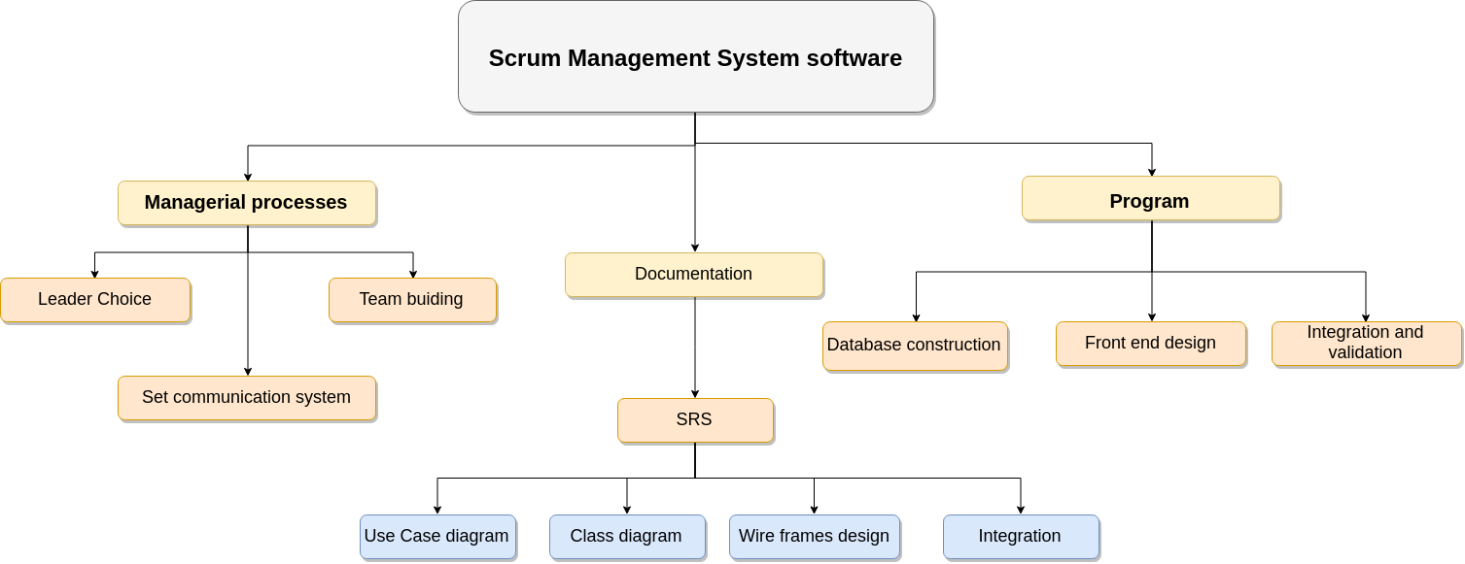

The operations is divided into 3 main groups:
Managerial processes : it includes the preparation for technical work and team building, Mainly it’s a preparation for human resources and team structure in order to facilitate the upcoming actions.

Documentation : One of the two shares of software it initiates the basic work needed for the program tasks to start and then both work parallel together.
It includes all types of documentations needed.

Program : technical implementation of the project which depend on basic designs made and documented.
It includes database construction, design of interface and gathering all parts together.
Action plan
Group of tasks that are carried out from breaking down the most critical deliverables to tasks that one or two can do.

Phase | Tasks | Dependability | Time  /hour
Initiate | - Start | -- | --
Set up the first meeting | - Set up time and goals | 0 | 3
Team building | - Share backgrounds and visions around the project  - Ice breaking activities | A  B | 1.5  1
Leader choice | - Short presentations  - Voting | D  E,C | 1  0.25
Set communication System | - Discuss various methods (Whatsapp , Telegram,github,….)  - Choose a method and install it | A  G | 0.5  8
Review the user stories | - View User stories  - Break down User stories to set of simple features | H  I,F | 1  2
Use Case diagram | - Brainstorming and simple designing  - Display using CAD | J  K | 1.5  2
Class diagram | - Brainstorming and simple designing  - Display using CAD | J  M | 5  2
Wire frames design | - Brainstorming and simple designing  - Display using CAD | J  O | 3  1
Documentation integration | - 0 | 0 | 8
Database construction | - Construct database  - Implement Classes fields and methods | K,M,O  M | 5  5
Front-end design | - Implement the front-end  - Enhance if needed | O  T | 8  --
Integration and validation | - Put all of the implemented components together  - Check if generally the software achieves the user stories | R,S,T  V | 2  1
Closure | - 0 | 0 | 0
Pert Chart
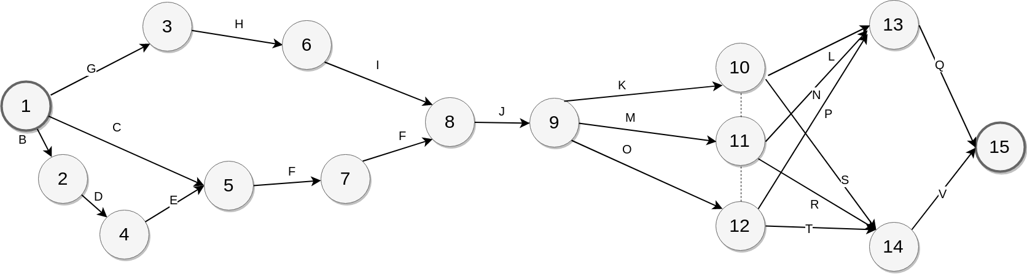
Gantt Chart
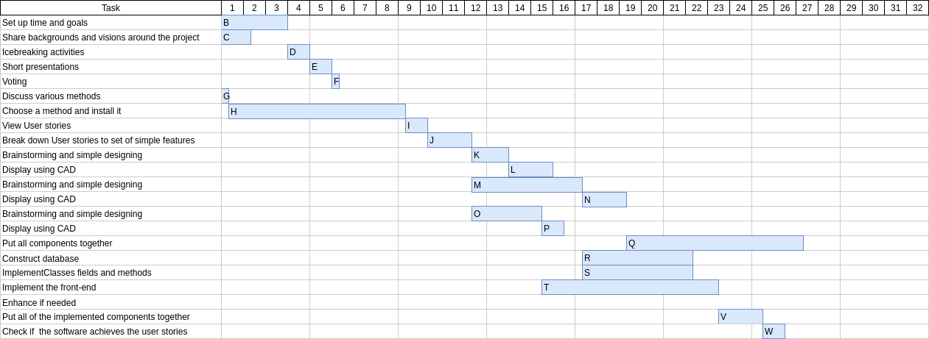
A diagram that shows the tasks Vs. time clarifying their dependencies, critical path and the available extra time on other tracks.

Critical path | G H I J M N Q
Expected time needed | 26.5 hours
Notes | The phase 8 is considered a very important phase as there is no progress could occur in the second part without completing it,  It should take extra attention during implementation

HR Plan
This section aims to determine the human resources available in the team.
The available team is diverse from both the point of view of personality and backgrounds, In way that could enhance the quality of the project.
Integration is a key player in the project.
Name | Background | Personality type
Ahmed Hesham | Django  Python  Game development | Interaction-Oriented
Hosam Hasan | Java | Self-Oriented
Remon | Software | Task-oriented
Ahmed | Web development | Self-Oriented
Amr | Documentation | Interaction-Oriented

