Software Requirements Specification

Scrum management system

Table of contents
1-introduction.
1-1 purpose.
1-2 definitions.
2- overall Description.
2-1 function Requirements and Specifications.
2-2 Non function requirements.
3- requirements specification.

1-introduction

1-1 purpose

1-2 Definitions

User | Regular user has a user name and password can sort or view or add task
Admin / Administrator | Can do what any regular user can do plus  he can modify task or add back log.

2-overall description

2-1 function Requirements and Specifications

2-1 wire fram
define what needs to be done and also to have a clear picture of where we are going.
this is an over view of the system on how it should be look like it , it may or may not be as same as the system in gui but it has to be identical to the system in functions.
So this how our system will be look like starting from the starting page to every like in our system

1- login page
this is the starting page of our system the visitor has to
sign in to see the home page of our system .We have two types of users either be a regular user or admin.
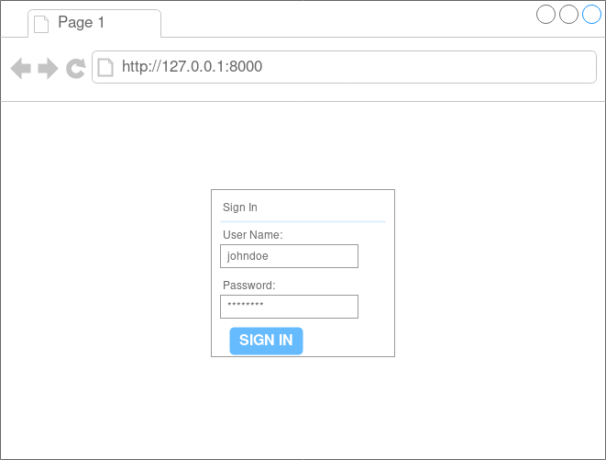

2-home page
after the user or admin login to our system he will see this page which consisting of list of backlogs , sprints , tasks , starting date and ending date.
he can create a backlog or open of this backlogs

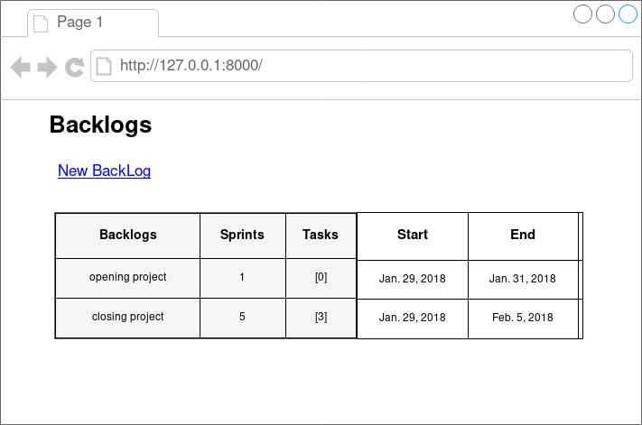

3- choose a backlogs
if the user chose opening Project he will see a list of sprints and IDs each sprint has starting and ending date.
He can choose either opening the sprint or make new one by pressing on New sprint button.
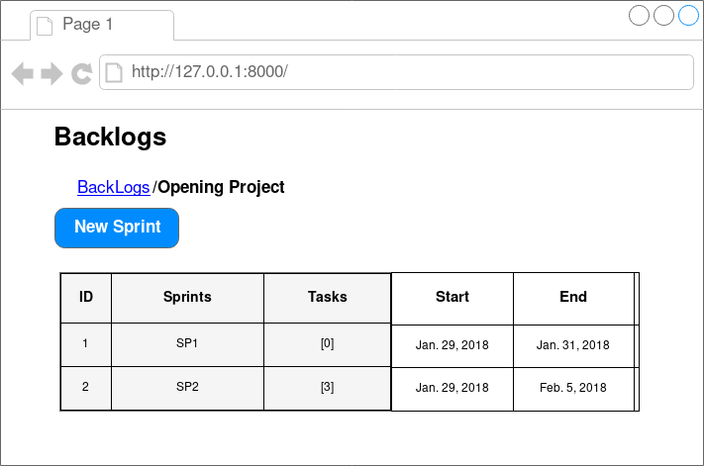
3- new sprint
after the user choose new sprint he will has to fill the following requirements which consist of Sprint name and Dead line.
when the user click on dead line he will see a small of squares to choose the date from.

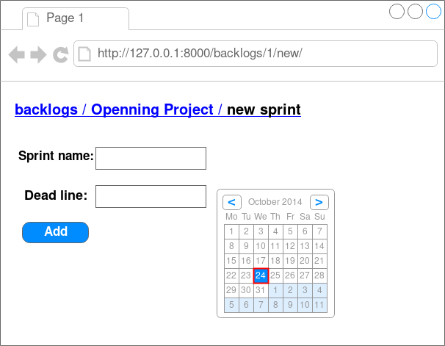

5- choosing sp1
after choosing SP1 the user will see a list of tasks each task has it’s own id plus two new things Description and status
Description: a brief description of the task
status : to determine the status of each task
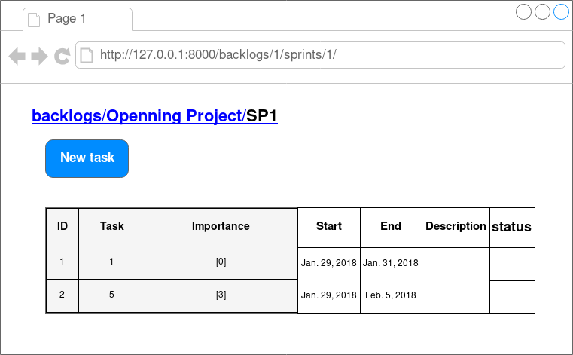

2-2 use cases
this is the use cases which has two actors Team member and Scrum master

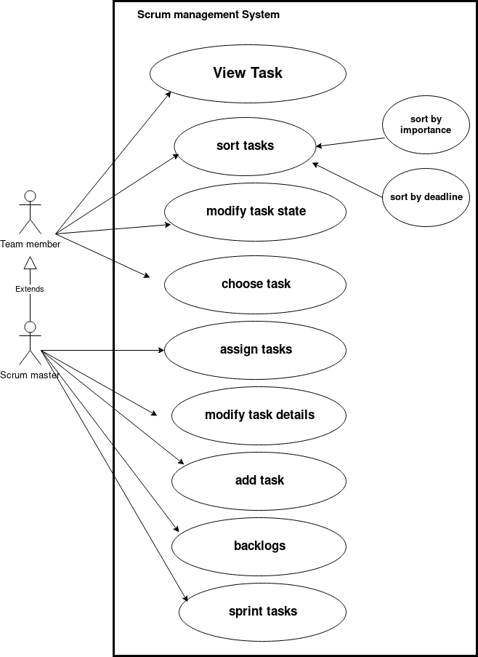
scrum master can do what team member can do but he has more power than him he can assign or add tasks, and he can add sprints.
(note: sort tasks can be done either by importance or by deadline)

2-3 class diagram
our system has four classes User, Backlog, Task, Sprint
the user can create back log, and each backlog consist of sprint and task.
User can add a task or backlog as described in the class diagram , the arrow mention that backlog created by the user so that means each backlog is associated with the creator (user) and also we see [0….*] which means a user can create any number of backlogs, and also from the diagram backlog can has any number of Sprints.
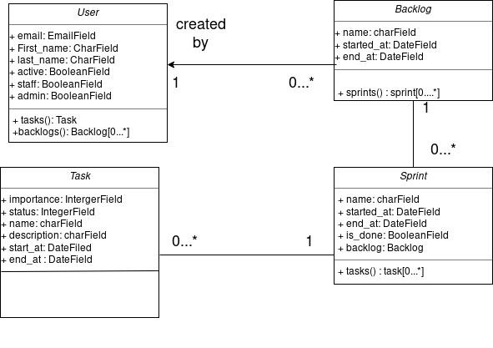
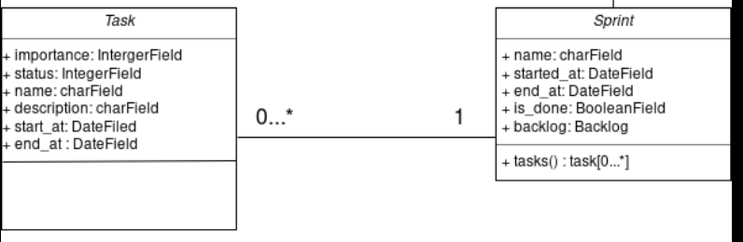
- A task must be associated with exactly one (1) Sprint

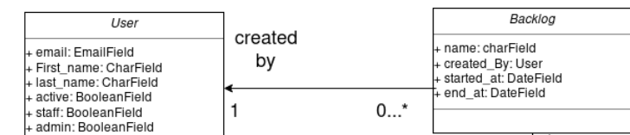

- A user is associated with backlogs
which he created

3- Non function requirments

4- priorities and release plan

