Software Requirements and Design Document
for
Host-A-Life
Prepared by Ahmed and Usman
Devsincs
27/11/2022
Table of Contents
Table of Contents ii
1. Introduction 1
1.1 Purpose 1
1.2 Product Scope 1
1.3 Title 1
1.4 Objectives 1
1.5 Problem Statement 1
2. Overall Description 2
2.1 Product Perspective 2
2.2 Product Functions 2
DFD for Hostel Management System: 3
2.3 List of Use Cases 3
2.4 Extended Use Cases 3
4. De-allocate room 6
5. Manage mess 7
6. Login: 7
7. Eat at Mess: 8
8. View Fees Status: 9
9. Pay Fees: 10
2.5 Use Case Diagram: 11
3. Other Nonfunctional Requirements 11
3.1 Performance Requirements 11
3.2 Safety Requirements 12
3.3 Security Requirements 12
3.4 Software Quality Attributes 12
3.5 Business Rules 12
3.6 Operating Environment 12
3.7 User Interfaces 13
4. Domain Model 25
5. System Sequence Diagram 26
6. Sequence Diagram 30
7. Class Diagram 34

Introduction

Purpose
To provide a technical solution for a hostel management’s day to day tasks which are usually done manually on registers and ledgers and contain much duplicity and inconsistency. This is an initial version of our desktop application which performs all the tasks which a professional hostel management application should perform. The scope of this application includes an admin and hostelites.

Product Scope
Product has an admin interface and a student interface in which both types of users can perform their relative tasks. Products objectives include fast and free of inconsistency software for all types of use cases relevant to hostel management. This will be much beneficial to hostel or hotel management businesses.

Title
Host-A-Life hostel management system.

Objectives
To manage hostel activities like:
- Hostel admission
- Calculation and payment of fees
- Checking of room availability
- Allocation of room and seat
- Management of mess

Problem Statement
The Hostel Management system is developed for automating all of the activities that take place at a hostel on both student and administrative levels. It will be a great relief for both students and administration. It will help administration in registering and allocating rooms to student with its data consistently stored online automatically instead of doing all that work manually which was the case prior to the development of this software.
Further it will also automate a student’s activities like ordering food from while automatically incrementing his/her fee, further it will provide functionality of calculation and payment of fees. All of this work was done manually prior to the development of this software.
The existing procedure was highly manual and involved a lot of paperwork, calculations, and errors. Also, there was a high chance of the data stored on paper being lost or stolen. Also, it was difficult to perform CRUD operations on paper manually.

Overall Description

Product Perspective
Due to the extremely manual nature of hostel management previously, it was decided to automate these functionalities which is why in SRS document the main requirement was an automated management system. This product is a replacement for existing manually management of hostels and is a self-contained software.
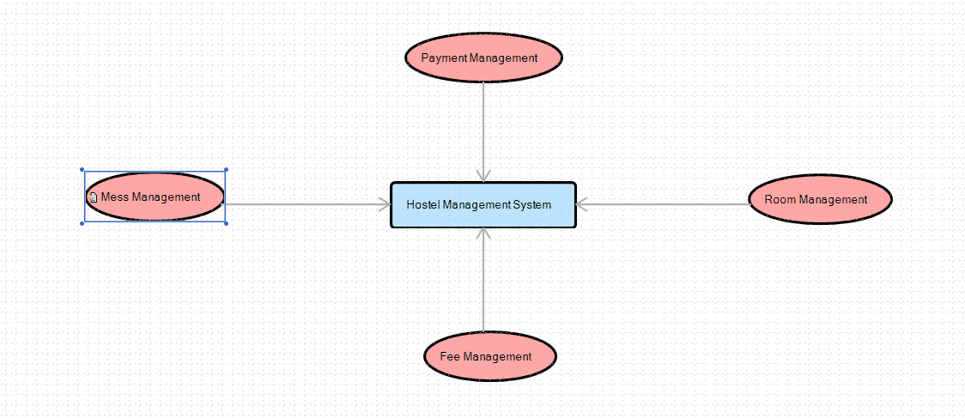

Product Functions
Some major functionalities provided by the hostel management system include:
- Registration of student
- Allocation of room to student
- Management of mess
- Order of food from mess for a single student
- Calculation of fees for a single student
- Payment of fees

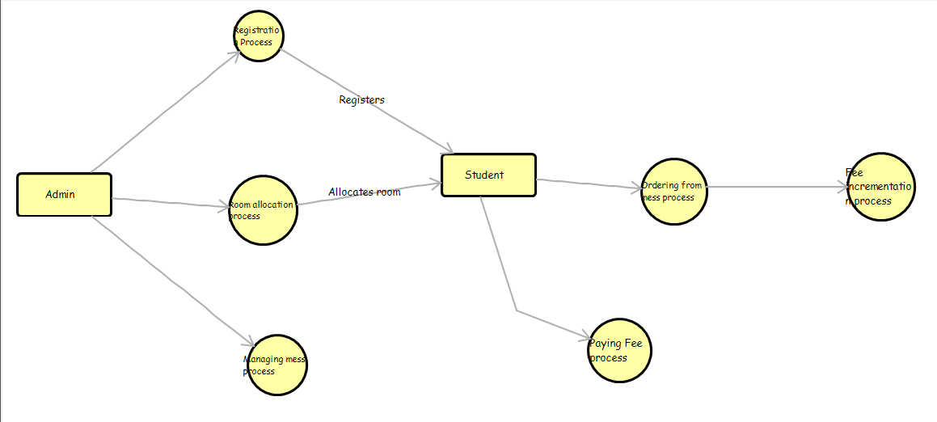
DFD for Hostel Management System:

List of Use Cases
Following is the list of use-cases for Hostel Management System:
- Check room availability
- Register student
- Allocate room
- Manage mess
- Order from mess
- Calculate fees
- Pay fees
- Login student

Extended Use Cases
- Check room availability:

Use Case Section | M. Usman (20i-0937)
Use Case Name: | Check room availability
level: | User-Goal
Scope: | Hostel management application
Primary Actor: | Admin
Stakeholders: | Hostel owner, admin
Pre-condition: | 1-Admin should be logged in.  2-System is running.
Post-condition: | Room is available and system gets updated.
Main Success Scenario
  Actor Action
  System Response
Main Success Scenario |  | 1- Student arrives at the hostel and asks admin for room availability.
Main Success Scenario |  | 2- He enters the details of the required rooms.
Main Success Scenario |  |  | 3-Admin searches for available rooms and shows the available rooms to the student.
Main Success Scenario |  | 4- Student selects the room preferable to him.
Main Success Scenario |  |  | 5- Admin allocates the room.
Main Success Scenario |  |  | 6- The system is updated.
Extensions | - System fails at any time.  - Room is not available for allocation.  - Admin doesn’t update the system after allocating the room.
- Register student

Use Case Section | M. Usman (20i-0937)
Use Case Name | Register student
level | User-Goal
Scope | Hostel management application
Primary Actor | Admin
Stakeholders | Hostel owner, admin
Pre-condition | 1-Admin and student should be logged in.  2-System is in running state.
Post-condition | 1-Student successfully gets registered.  2-Student list gets updated.
in Success Scenario
  Actor Action
  System Response
in Success Scenario |  | 1-Student arrives at hotel and asks admin for registration.
in Success Scenario |  | 2- he presents his details to the admin.
in Success Scenario |  |  | - 3- Admin enters registration option and adds the details of the student.
in Success Scenario |  | - 4-Student gets registered.
in Success Scenario |  |  | 5-The students list is updated.
Extensions | - 1-System fails at any time.  - 2-Student list did not get updated.
- Allocate room:

Use Case Section | M. Usman (20i-0937)
Use Case Name | Allocate room
level | User-Goal
Scope | Hostel management application
Primary Actor | Admin
Stakeholders | Hostel owner, admin
Pre-condition | 1-Admin should be logged in.  2-System is in running state.
Post-condition | 1-Room is successfully allocated to student.  2-System is updated.  3-Student and admin receive confirmation message.
Main Success Scenario
  Actor Action
  System Response
Main Success Scenario |  | - 1-Student arrives at hotel for allocation of room.
Main Success Scenario |  | - 2-He provides his details to the hostel admin.
Main Success Scenario |  |  | - 3-The admin uses students’ details and searches for room availability.
Main Success Scenario |  |  | - 4-He allocates a room for the student.
Main Success Scenario |  | - 5-The students get the message of allocation.
Main Success Scenario |  |  | - 6-The system is updated.
Extensions | - 1-System crashes at any time.  - 2-Room is not available for allocation.  - 3-The system is not updated.

De-allocate room

Use Case Section | M. Usman (20i-0937)
Use Case Name | De-allocate room
level | User-Goal
Scope | Hostel management application
Primary Actor | Admin
Stakeholders | Admin, hostel owner
Pre-condition | 1-Admin is logged in.  2-System is in running state.
Post-condition | 1-Room is successfully de-allocated.  2-System gets updated.
Main Success Scenario
  Actor Action
  System Response
Main Success Scenario |  | 1-Student arrives at hotel to de-allocate room.
Main Success Scenario |  | 2-He enters the details.
Main Success Scenario |  |  | 3-The admin searches the room and de-allocates it.
Main Success Scenario |  | 4-The students get confirmation message of successful de- allocation.
Main Success Scenario |  |  | 5-The system is updated.
Extensions | - System crashes at any time.  - The system is not updated.

Manage mess

Use Case Section | M. Usman (20i-0937)
Use Case Name | Manage mess
level | User-Goal
Scope | Hostel management application
Primary Actor | Admin
Stakeholders | Admin, hostel owner
Pre-condition | 1-Admin is logged in.  2-System is in running state.
Post-condition | 1-Hostel mess is maintained successfully.  2-System is updated.
Main Success Scenario
  Actor Action
  System Response
Main Success Scenario |  | 1-Admin selects the manage mess option.
Main Success Scenario |  | 2-Admin updates the daily inventory of the mess (including all food, crockery items).
Main Success Scenario |  |  | 3-Inventory is successfully updated.
Extensions | - System crashes at any time.  - System is not updated.

Login:

Use Case Section | Ahmed (20I-1893)
Use Case Name | Login
level | User-Goal
Scope | Hostel Management Application
Primary Actor | Student
Stakeholders | Student, Admin
Pre-condition | System is in working condition
Post-condition | Student is successfully logged in.
Main Success Scenario
  Actor Action
  System Response
Main Success Scenario |  | 1- Student opens the application and selects the login option
Main Success Scenario |  |  | 2-System displays empty ID and Password fields.
Main Success Scenario |  | 3- Student Enters his ID and password
Main Success Scenario |  | 4- Student selects the submit option
Main Success Scenario |  |  | 5- Student’s ID and password are correct and he is successfully logged in.
Extensions | - System fails at any time.  - Student didn’t provide any credentials.  - Student provided incorrect credentials.

Eat at Mess:

Use Case Section | Ahmed (20I-1893)
Use Case Name: | Eat at Mess
level | User-Goal
Scope: | Hostel Management Application
Primary Actor: | Student
Stakeholders: | Hostel owner
Pre-condition: | It should be within the mess timings.  Student should be logged in.
Post-Condition: | Order has successfully been placed at mess.
Main Success Scenario
  Actor Action
  System Response
Main Success Scenario |  | Student selects eat at mess option.
Main Success Scenario |  | 1-student selects available items from the menu.
Main Success Scenario |  | 2- Student places the order.
Main Success Scenario |  |  | 3-Order is successfully placed on the system.
Main Success Scenario |  |  | 4-Monthly food count of student is updated.
Extensions | - Student selects an unavailable item from the menu.  - Student selects items more than the limit allocated for one person.

View Fees Status:

Use Case Section | Ahmed (20I-1893)
Use Case Name | View Fees Status
level | User-Goal
Scope | Hostel Management Application
Primary Actor | Student
Stakeholders | Student, Hostel owner
Preconditions: | Student should be logged in
Postconditions | Student has successfully viewed his fees status.
Main Success Scenario
  Actor Action
  System Response
Main Success Scenario |  | 1-Student selects view fees status option.
Main Success Scenario |  |  | 2-System shows the status as paid or unpaid.
Extensions | - Student is not logged in.

Pay Fees:

Use Case Section | Ahmed (20I-1893)
Use Case Name | Pay fees
level | User-Goal
Scope | Hostel Management Application
Primary Actor | Student
Stakeholders | Admin, Student & Hostel owner.
Preconditions | Student should be logged in.
Postconditions | Student successfully pays his fees.
Main Success Scenario
  Actor Action
  System Response
Main Success Scenario |  | 1- Student selects the pay fees option
Main Success Scenario |  |  | 2- System provides a form containing fields necessary for online payment.
Main Success Scenario |  | 3-Student provides all the details.
Main Success Scenario |  | 4- Student selects pay now option.
Main Success Scenario |  |  | 5-Payment is recorded by system and system is updated.
Extensions | - Student provides incorrect information.  - Student’s balance is insufficient.

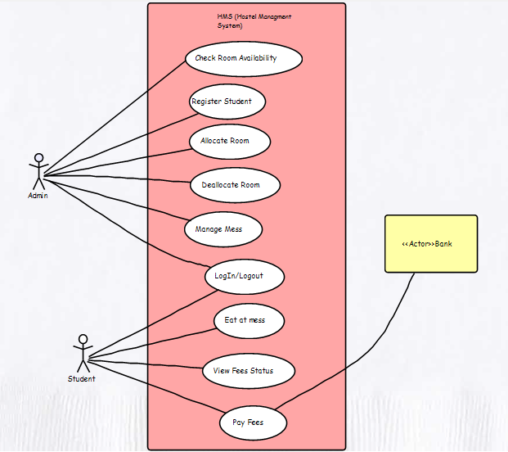
2.5 Use Case Diagram:

Other Nonfunctional Requirements

Performance Requirements
Following is some of the performance requirements for the HMS to run smoothly:
- The system should have a 24/7 electric power supply.
- There should be a qualified operator as admin who is operating the system.
- System should be installed on a virus and bug free environment.
- System shall support multiple users at a time.

Safety Requirements
Following is some of the safety requirements for the HMS to run and perform smoothly:
- System may crash or stop working at any time, so it is necessary to maintain a regular backup of the database.
- There should only be a single admin operating the system and only should know the credentials of the admin.
- No one should know the records stored in the database except the records and credentials related to him.
- No one should be allowed to peek into the database.

Security Requirements
Following is some of the factors which will protect the system from any accidental or malicious activity, access, destruction, modification, or disclosure:
- There should be a restriction on the code for communication between different areas of the program.
- Certain functionalities should be assigned to certain classes.
- Data integrity of different data structures should be checked and ensured.
- There should be encryption techniques applied onto sensitive data and information in later versions of the system.

Software Quality Attributes
Following is some of the software quality attributes which should always be in the mind of the developer:
- The system should always be available, and it should be tried to keep the server and database alive all the time.
- Developed system should developed in such a way that it is adaptable to change, that is the modules of system should be generic and reusable.
- The developed system should be portable in such a way that it should run on any PC which is satisfying the system requirements.

Business Rules
Business rules for the developed system area as follows:
- Administrator of system or admin can perform functions such as registration of student, checking of room availability, allocation of a specific room and seat in that room to student and management of mess inventory etc.
- A specific student uses the developed system has access to functionality such as ordering food from mess, calculating his current fees and the paying the fees online without have to go to admin etc.

Operating Environment
Following is some of the performance requirements for the hostel management system:
- The system on which HMS has to run should have a processor of core i7 or higher with base GHZ 2.2 processor speed.
- The system should have RAM of 8GB or higher.
- System should recent version of JAVA installed onto it.
- The system should have MySQL Database installed and connected to the HMS.
- The system should have Windows 10 or higher running onto it.

User Interfaces
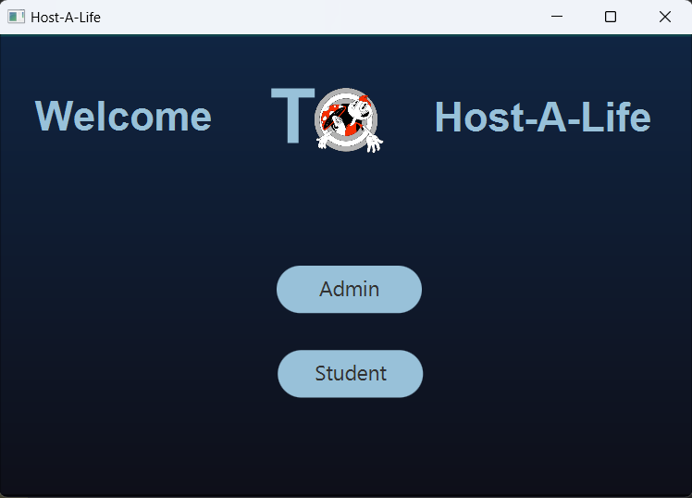
Following buttons take the user to their required interface
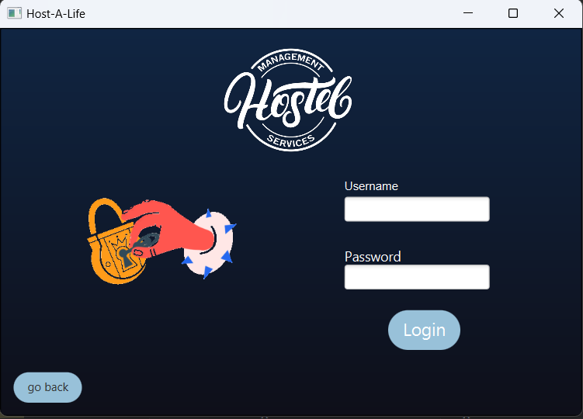
The upper fields are for admin login and by pressing login button next interface shows up.
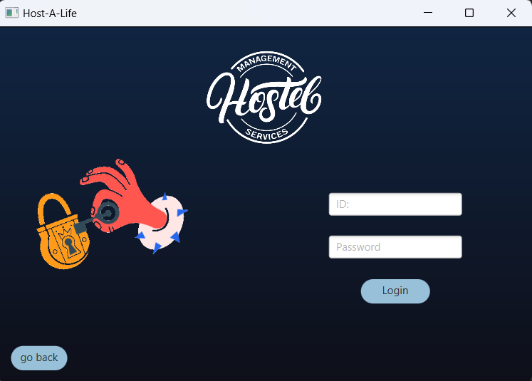
The upper fields are for student login and by pressing login button next interface shows up.
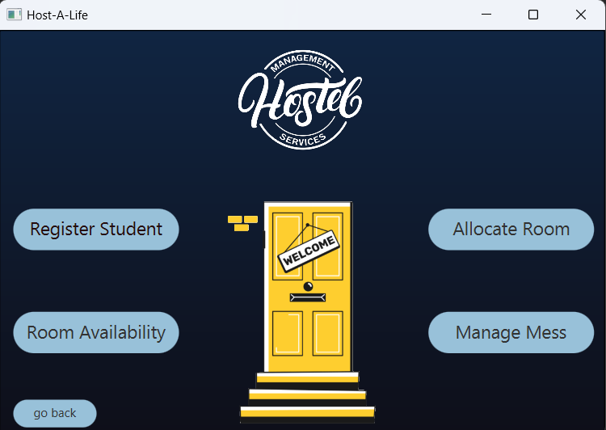
Upper interface is for admin to register student, allocate room, check room availability, manage mess.
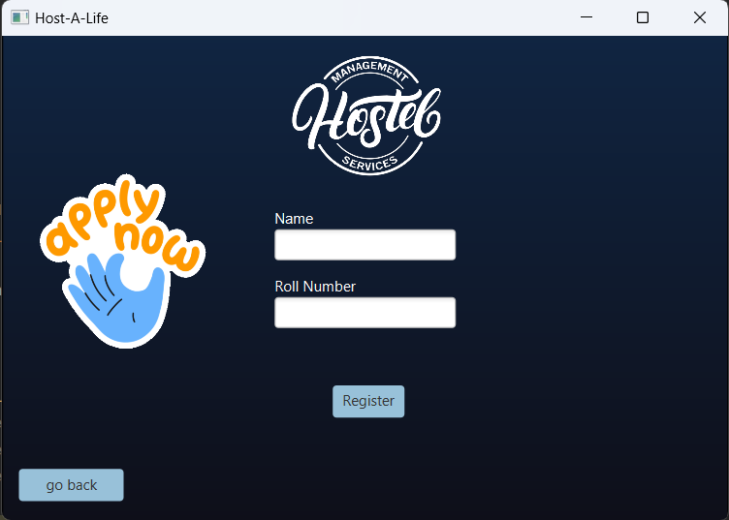
This interface allows admin to register a new student to the hostel. He has to provide name and rollno of student.
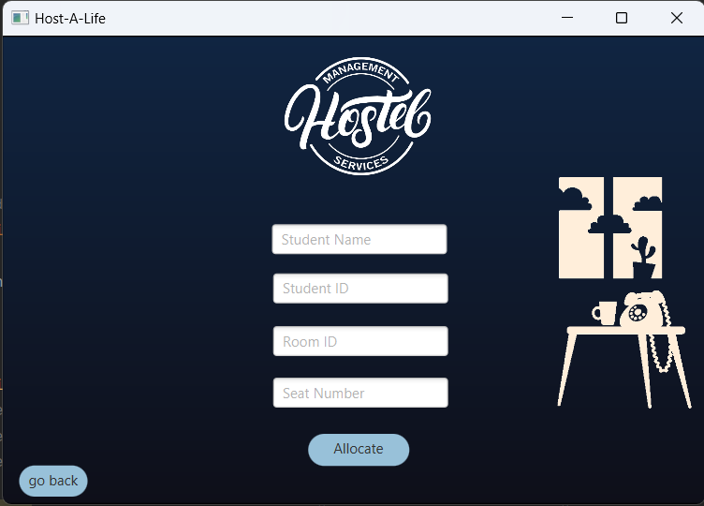
This interface is also for admin. Here he allocates a room to a student by entering student and room’s credentials into the fields.
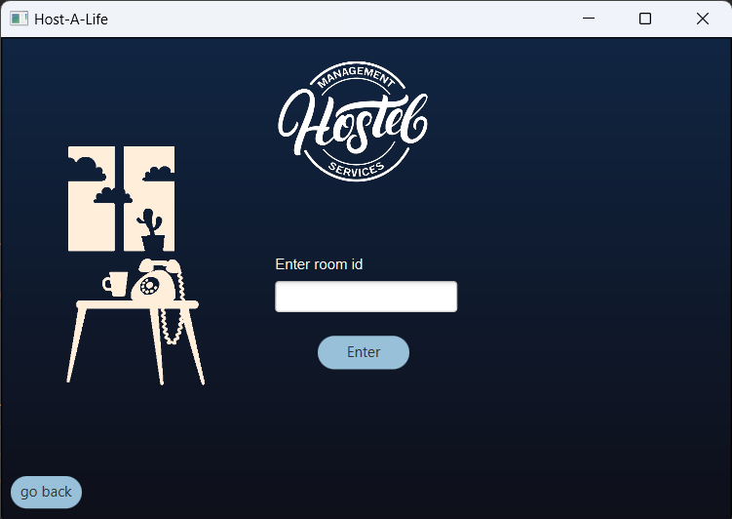
This interface is also for admin. Here he finds the availability of a perticular room for the student.
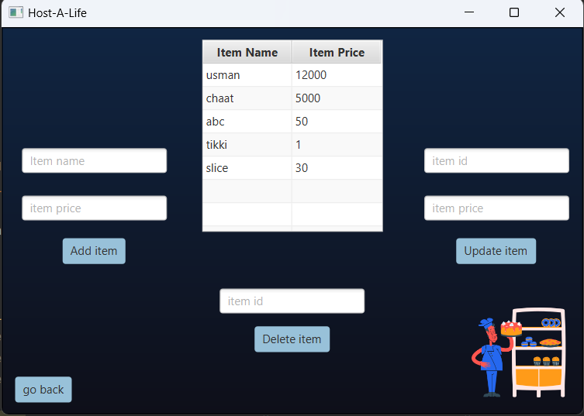
This is also an admin’s interface. Here admin can perform CRUD operations on menu of mess.
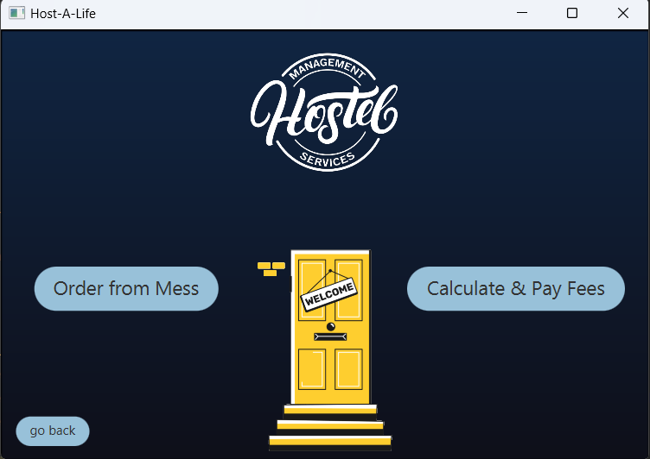
This is a student interface. Here student has choice to order meal from mess or calculate and pay his fees.
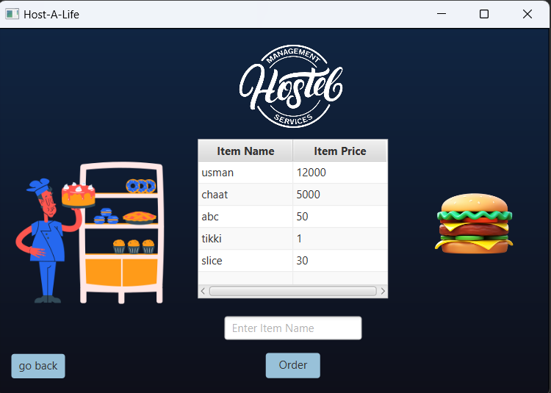
This is a student interface. Here student can choose from available menu and place his order.
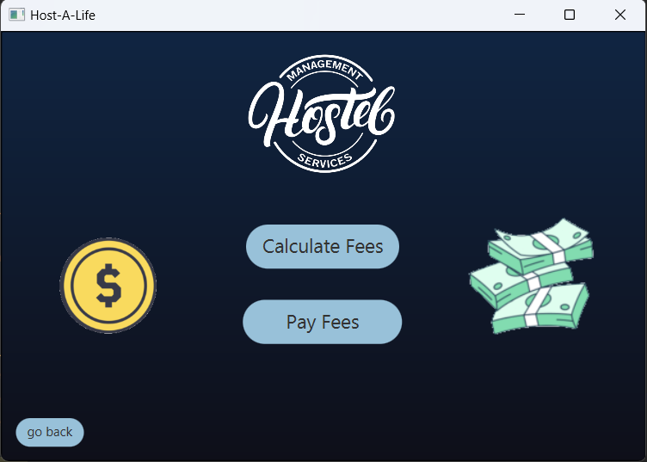
This is a student interface. Here student choose to view his current fees and then click on pay fees option to procees to paying fees.
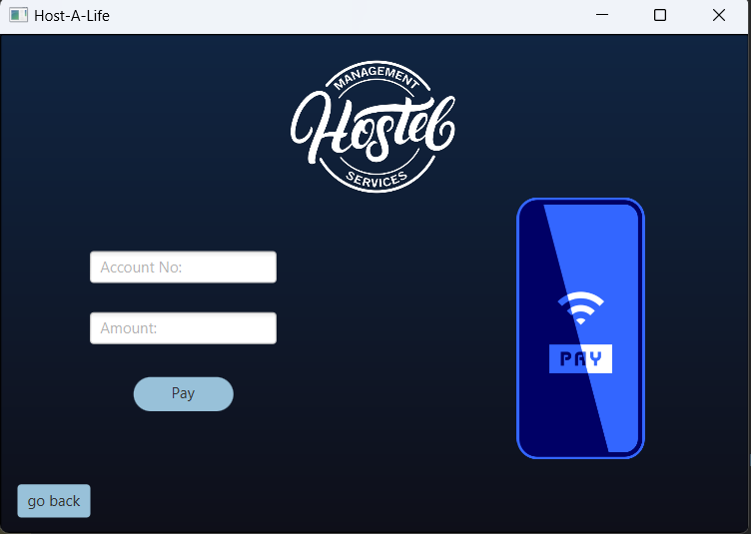
This is a student interface. Here student provides his his bank’s account number and the fee amount and then click on pay button to procees to paying his fees.

Domain Model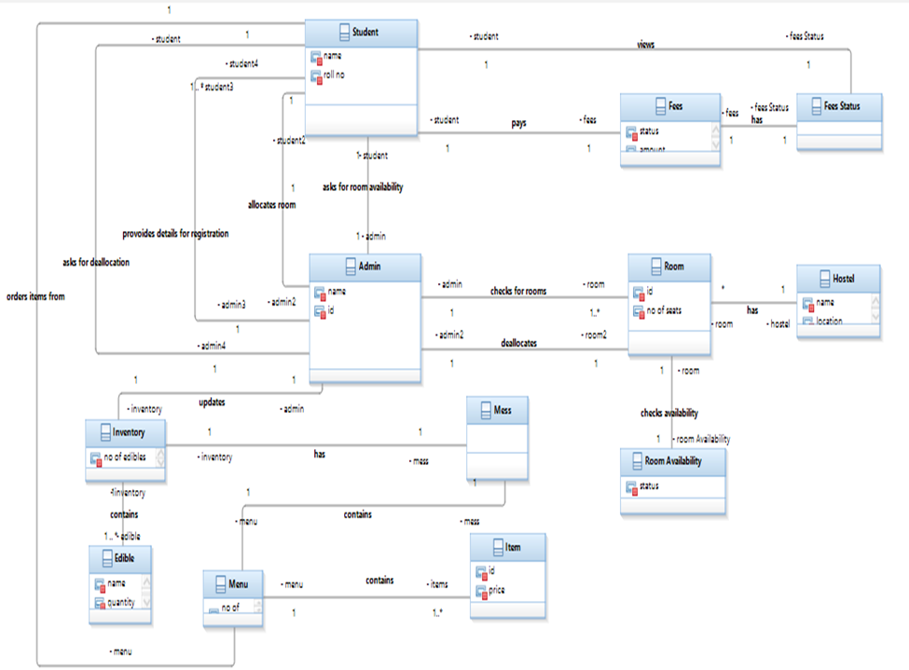

System Sequence Diagram

SSD1: Calculate fees
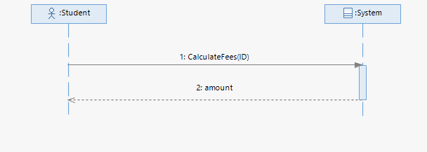
SSD2: Pay fees
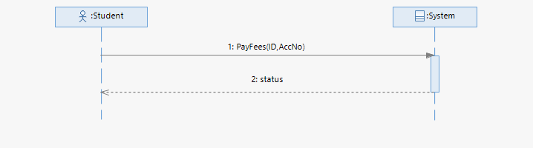

SSD3: Order from mess
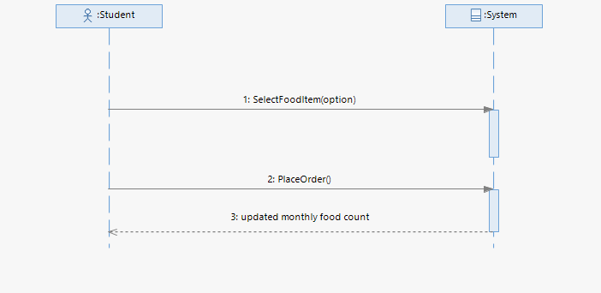

SSD4: Manage student
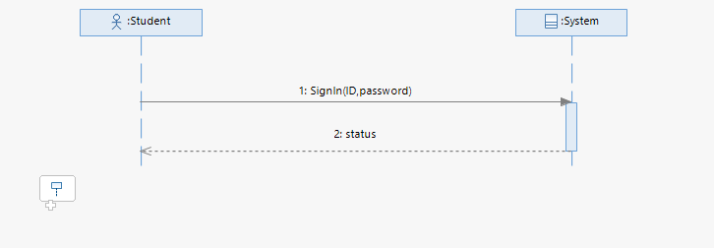

SSD5: Check Room Availability
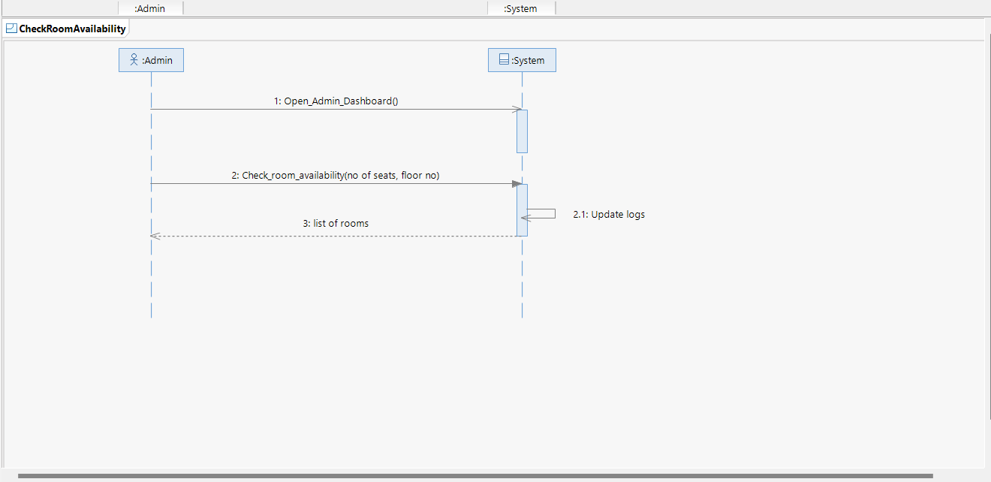
SSD6: Register Student
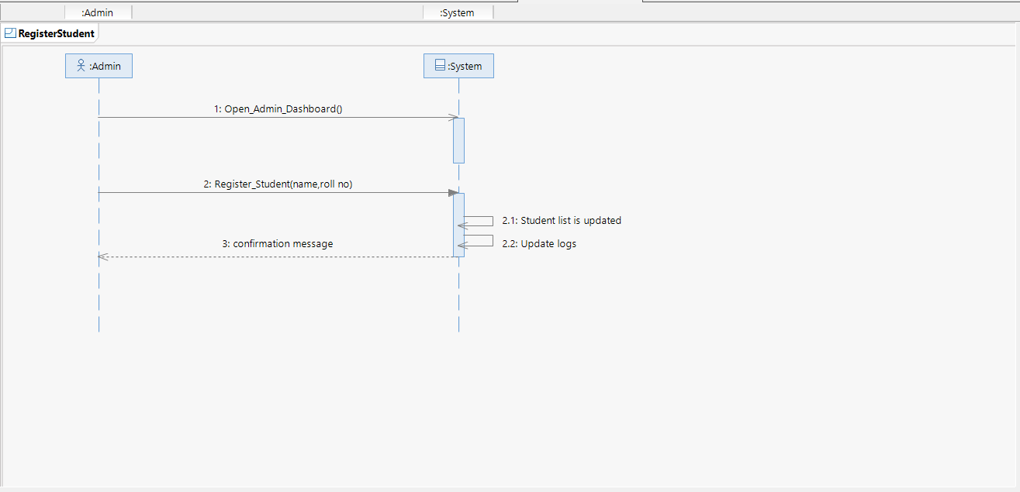

SSD7: Allocate Room
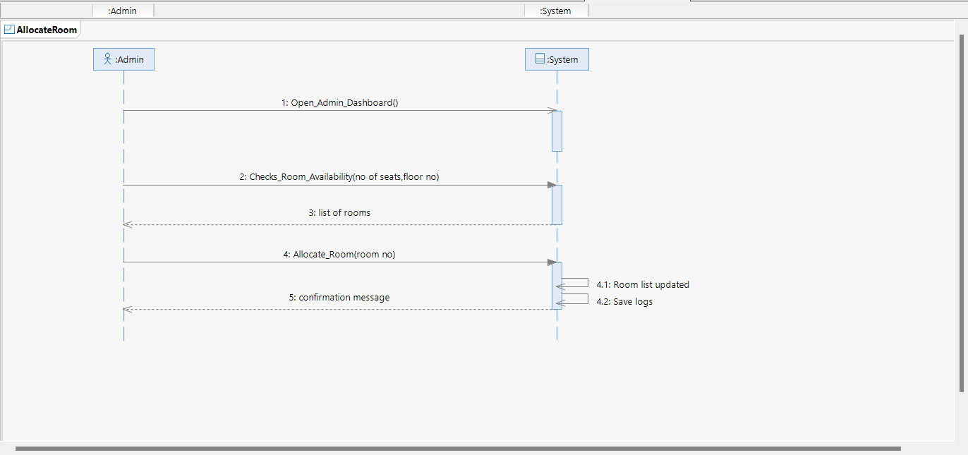
SSD8: Manage Mess

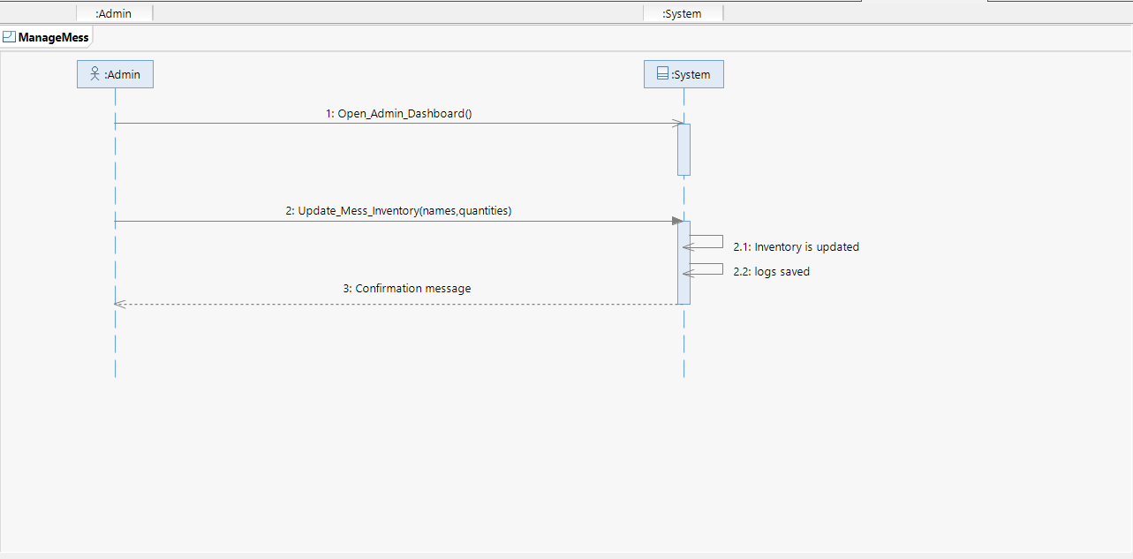

Sequence Diagram
- Calculate fees
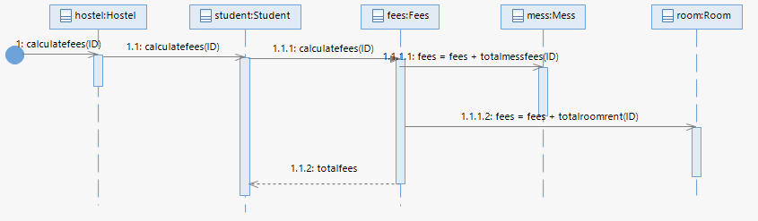

- Pay fees
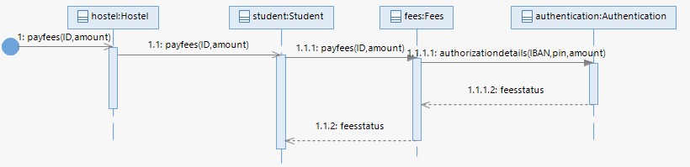

- Order from mess
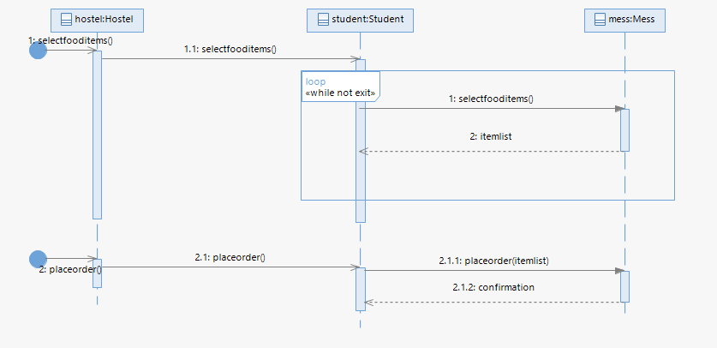

- Manage student

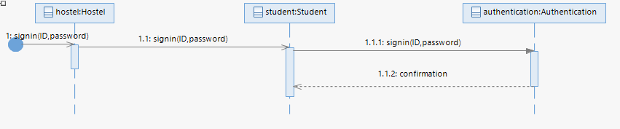

- Check Room Availability
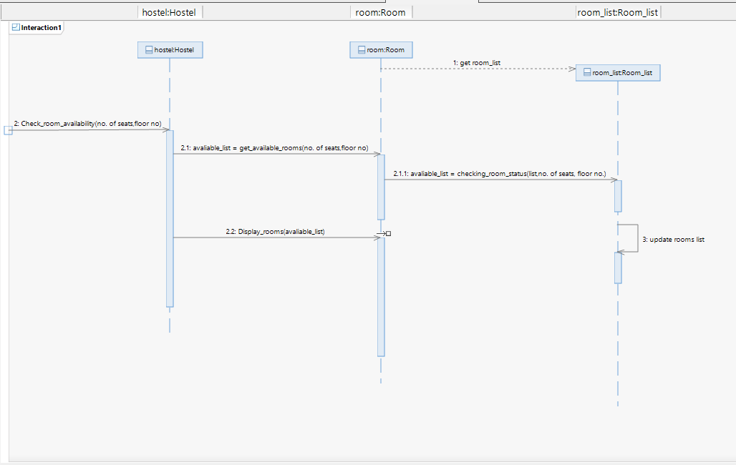
- Register Student
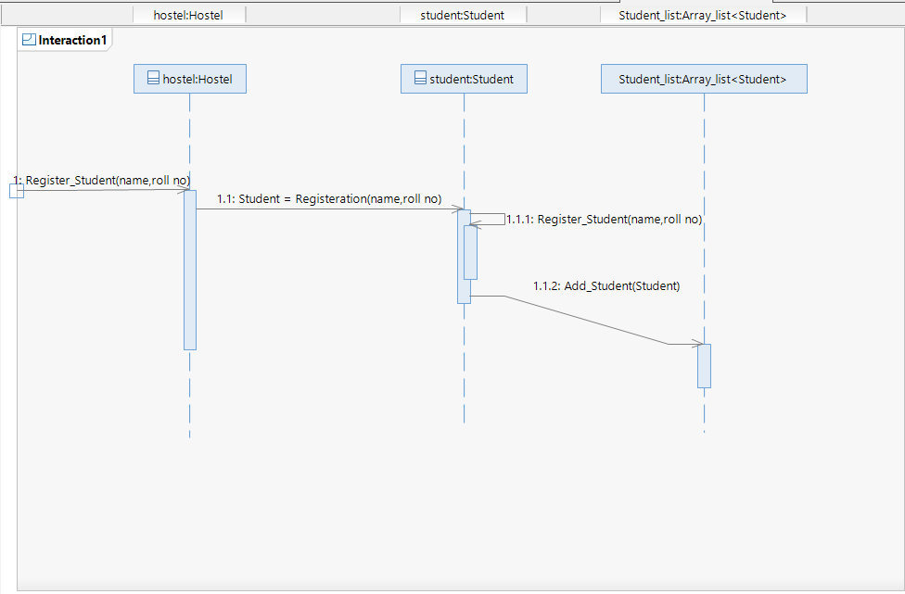
- Allocate Room
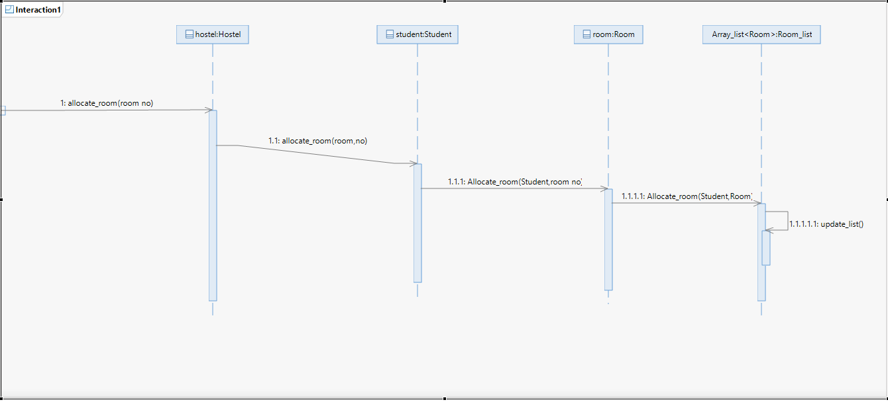
- Manage Mess
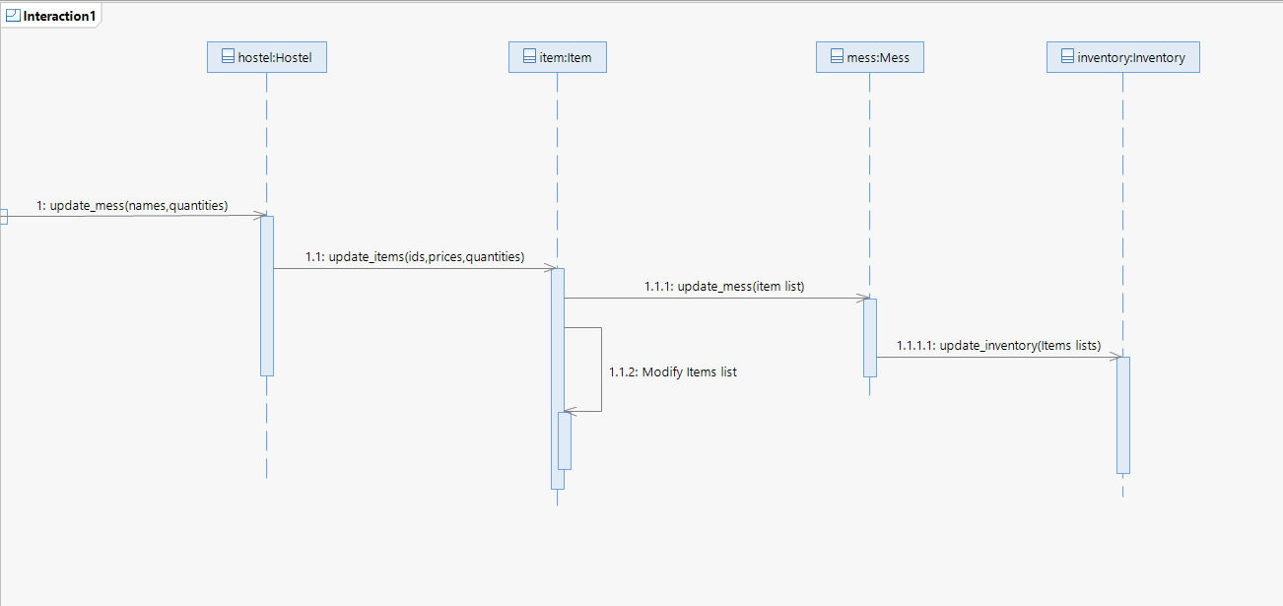

Class Diagram

