1. **Import Required Libraries**

• **pandas**: Handles data loading and manipulation.

• **StandardScaler**: Standardizes feature values.

• **KMeans**: Applies K-Means clustering.

• matplotlib **/ seaborn**: Visualizes data and clustering results.

• PCA: Reduces feature dimensions for 2D visualization.

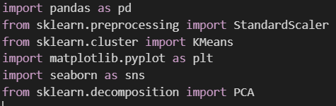

1. **Load Excel Sheets**

1. **Merge Transactions with Account Data**

* To combine transactions with their corresponding accounts



1. **Aggregate Customer Features**

• Total amount spent

• Number of transactions

• Average transaction amount

• Total balance across accounts

• Number of distinct accounts

1. A graph with a line

   AI-generated content may be incorrect.**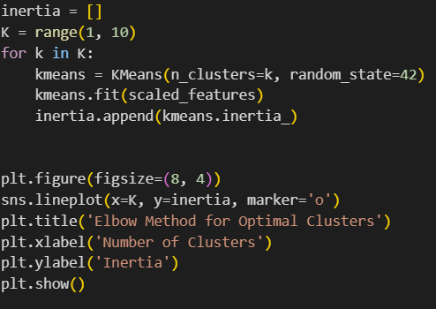Determine Optimal Number of Clusters (Elbow Method)**
2. **Apply K-Means Clustering**

With k = 3, Regarding to the Elbow method at k = 3, The decrease of inertia sharply slows.

1. A computer screen shot of a program

   AI-generated content may be incorrect.**A diagram of a diagram

   AI-generated content may be incorrect.Visualize Clusters using PCA**